**DIAGNOSTIC ULTRASOUND SYSTEM**

**USG PREMIERE-02**

**MANUAL BOOK **



**Intellectual Property Statement**

**Intellectual Property Rights**

All copyright, trademark, domain name, patent, trade secret and other intellectual property rights existing in our product and this Manual will remain the sole property of PT. SINKO PRIMA ALLOY (Surabaya) Co., Ltd.(hereinafter referred to as “ELITECH”).

 is the trademark of ELITECH, All rights reserved.

Without prior written consent by ELITECH, any reproduction, modification, storage in a retrieval system or retransmission or otherwise in any form or by any means, regarding any part of intellectual property rights herein, are illegal and strictly prohibited.

Any infringement of the intellectual property rights will be pursued vigorously and ELITECH may seek injunction, relief and indemnifications available under all applicable laws and regulations.

**Confidential Information**

All or part of the materials and information contained in this Manual, which are created or developed on the basis of ELITECH’s intellectual property rights, are strictly confidential and privileged. You should keep the Manual confidential until all such confidential information becomes available to the public.

Disclosure of the information in this Manual in any manner or by any means without prior written permission of ELITECH is strictly forbidden. Without prior written consent by ELITECH, any reproduction, modification, storage in a retrieval system or retransmission of the information or otherwise making it available to the public in any form or by any means is illegal and strictly prohibited.

**Disclaimer**

ELITECH assumes no liability for use of this document if any unauthorized changes to the content or format have been made.

Every care has been taken to ensure the accuracy of the information in this document. However, ELITECH assumes no responsibility or liability for errors, inaccuracies, or omissions that may appear in this document. ELITECH reserves the right to modify the product without further notice to improve reliability, function or design. This manual is provided without warranty of any kind, implied or expressed, including, but not limited to, the implied warranties of merchantability and fitness for a particular purpose.

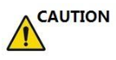**In the United States, Federal law restricts this device to sale, distribution, and use by or on order of a licensed physician.**

TABLE OF CONTENTS

1. GENERAL 6

1.1 Introduction 6

1.2 Contact Information 6

1.3 About this document 6

1.4 Product Description 7

1.5 Mechanical System 8

1.6 Display Annotation 11

2. SAFETY 14

2.1 Introduction 14

2.2 Owner responsibility 14

2.3 Regulatory Notice 14

2.4 Label Icon Description 15

2.5 Network Security Features 18

2.6 Safety and Warning notices 19

2.7 Residual Risk Disclosure 32

3. START THE SYSTEM 35

3.1 General 35

3.2 Safety Warnings 35

3.3 Power on / Boot up 35

3.4 Power off / Shutdown 36

3.5 Probe and Application Selection 36

3.6 Image Storage 38

3.7 Freeze image 38

3.8 Patient data 38

3.9 Image Annotation 39

3.10 Cine Mode 41

3.11 Zoom Function 41

3.12 ECG Trace (Optional) 42

3.13 Card Sound 44

3.14 Pulse 45

3.15 Multiple display formats 45

3.16 2D Image size change 46

3.17 Customized UI layout 46

3.18 VWork 46

4. Prepare for an Examination and Patient Data Archive 48

4.1 Beginning a New Patient 48

4.2 Archive 55

5. 2D B mode, M mode 63

5.1 2D Mode 63

5.2 Operation 66

5.3 M mode 70

6. CF (Color Flow Mode) / PDI (Power-Doppler Mode) 73

6.1 CF mode operation 73

6.2 Power Doppler (PDI) 77

7. PW and CW mode (Spectral Doppler Mode) 78

7.1 PW mode (Pulsed Wave Doppler) 78

8. 3D/4D 83

8.1 Static 3D 83

8.2 4D (real time) 95

8.3 MCut 98

8.4 STIC 100

9. Other Modes 101

9.2 Tissue Doppler Imaging (TD) 101

9.2 Tissue Velocity Imaging (TVI) 101

9.2 Elastography 103

9.4 Contrast Agent Imaging 104

9.5 Stress Echo 105

9.6 Strain 109

9.7 VShear 110

10. Measurement and calculation 112

10.1 Introduction 112

10.2 Abdominal measurements 144

10.4 Vessel measurements 154

10.5 Gynecology Measurements 162

10.7 Pediatric Measurements 174

10.8 Obstetrics Measurements 178

10.9 Cardiac Measurements 208

11. Probes 253

11.1 Probe overview 253

11.2 Probes 253

11.3 Probe connection and disconnection 256

11.4 Probe Surface Temperature Measurements 257

11.5 Biopsy 259

12. System Setting 261

12.1 General 261

12.2 Monitor Tests 265

12.3 Measurement 265

12.4 Extended key 270

12.5 Network 273

12.6 DICOM 274

12.7 Service Tool 276

12.8 Features 278

12.9 User Management 278

12.10 About 279

13. Accessories and Peripherals 280

13.1 Introduction 280

13.2 Printing 280

13.3 Approved Peripherals 280

14 Operator maintenance and technical data 282

14.1 System maintenance 282

14.2 Technical Data 287

15. Probe Maintenance 319

15.1 Inspecting the probe 319

15.2 Special handling instructions 319

15.3 Probe handling and infection control 320

15.4 Probe Safety 320

15.5 Cleaning and disinfecting probes 321

15.6 Coupling gels 322

# GENERAL

## 1.1 Introduction

**Principles of operation**

Medical ultrasound images are created by computer and digital memory from the transmission and reception of mechanical high-frequency waves applied through a probe. The mechanical ultrasound waves spread through the body, producing an echo where density changes occur. For example, in the case of human tissue, an echo is created where a signal passes from an adipose tissue (fat) region to a muscular tissue region. The echoes return to the probe where they are converted back into electrical signals.

These echo signals are highly amplified and processed by several analog and digital circuits that use filters with many frequency and time response options to transform the high-frequency electrical signals into a series of digital image signals which are stored in memory. Once in memory, the image can be displayed in real-time on the image monitor.

A probe is an accurate, solid-state device, providing multiple image formats. The digital design and use of solid-state components provides highly stable and consistent imaging performance with minimal required maintenance.

## 1.2 Contact Information

For additional information or assistance, please contact your local distributor or the appropriate support resource shown below:

PT. SINKO PRIMA ALLOY

TAMBAK OSOWILANGON PERMAI BLOK E8

JALAN OSOWILWANGON NO. 61

SURABAYA 60191 - INDONESIA

Tel:+62-31-7482816

## 1.3 About this document

* Before attempting to use this device, read and fully understand all contents in the document to properly operate this device, paying particular attention to all: Warnings, Cautions, Notes, and Notices. Due to space limitations, this manual does not make perfect, any problem please contact Elitech technical staff.
* In order to use the device correctly, keep this manual with the device at all times.
* The most extensive configuration is described within this manual, including the maximum number of the options and the accessories. Not every function, option or accessory described may have been purchased or licensed on your device.
* This manual forms part of the accompanying documentation for this product.

## 1.4 Product Description

This device is a professional, premium performance real-time scanning system. The various probes make many applications possible. This device provides the following diagnostic possibilities:

* B mode, M mode
* CF and PDI mode
* Spectral Doppler: pulsed wave and continuous wave (PW and CW)
* Tissue Doppler (TD)
* Tissue Velocity imaging (TVI)
* Volume mode: 3D and 4D (real time 3D)

**Intended use:**

This device is indicated for Abdominal; Fetal/Obstetrics; Gynecology; Transvaginal; Urology (including prostate); Transrectal; Cardiac (adult and child); Peripheral Vascular; Small Organs/Parts ( thyroid, breast, testicle, Musculo-skeletal Conventional and Superficial ); Pediatrics(including neonatal cephalic); interventional(nerve block and vascular access); Intraoperative (abdominal, brain) and Adult Cephalic diagnostic Ultrasound applications. The device output is a valuable assisting medical tool for the diagnosis of disease, abnormality or follow-up. The systems support a complete family of curved, endocavity, linear, phased array, intra-operative, and mechanical 3D probes.

This device is intended to use by, or by the order of, and under the supervision of a licensed physician qualified to direct the use of the device.

**Patient population :**

Age: all ages (incl. embryos and fetuses)

Location: worldwide

Sex: male and female

Weight: all weight categories

**Contraindication**

The products are not intended for ophthalmic use or any use causing the acoustic beam to pass through the eye.

## 1.5 Mechanical System

### 1.5.1 System Layout

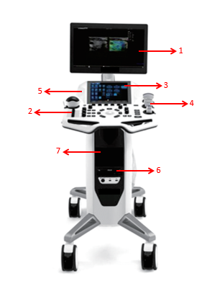

1. Monitor: display images
2. Control panel (keyboard): keys or buttons for operating the device
3. Touch panel: touch screen for operating the device
4. Probe holder: place probes
5. Speaker: play the PW mode sound or other device sound
6. DVD drive: read or write data from optical discs
7. Place for printer: Printer placement

### 1.5.2 Mechanical adjustment

* The control panel allows to rotate, moved forward and backward and adjusted to different heights. The rear latch allows the locking and unlocking of forward and backward movements and rotation of the control panel. A switch allows the adjusting of the height by pushing the up or down key.
* The touch panel can adjust the angle as required.
* The image screen panel allows to move forward and backward and tilted to different degrees. It can also be laid down into a flat position in order to be convenient and protected during transportation.
* There are caster breaks in all casters.

When the control panel shakes from left to right or rotates freely under force, please check whether the rear latch is locked.

### 1.5.3 Keyboard

**Touch panel**

Except for the functions triggered by the control panel, the touch panel represents the main operator interface for operation.

The touch panel is highly sensitive and consists of a flat monitor. It is easy to operate even under dim light conditions and allows for comfortable access to the control menu.

Notes:

This touch panel can be blocked by a strong magnetic field. Avoid magnetic field interference. The touch panel may be impacted by any foreign body lying on it. To guarantee maximum performance, it is recommended to clean the touch panel regularly.

**Control Panel**

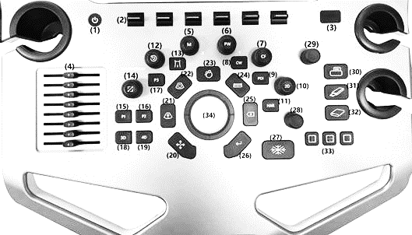

1. Power key: switches the device on and off.
2. Up/down keys: Push up or down these keys to increase or decrease the value of the relevant parameters.
3. USB port.
4. TGC: Adjust TGC (Time Gain Control) in 8 different sections.
5. M: press this key to enter M mode.
6. PW: press this key to enter PW mode.
7. CF: press this key to enter CF mode.
8. CW: press this key to enter CW mode.TD: press this key to enter TD mode.
9. PDI: press this key to enter PDI mode.
10. 2D: press this key to enter 2D mode.
11. HAR: press this key to enter HAR mode
12. Rotation/Steer: in 3D/4D mode, this key allows operator to rotate 3D images. In 2D mode, this key can steer linear image or ROI box.
13. Body Pattern: press this key to enter “Body Pattern”.
14. Zoom: press this key to enter zoom mode, then rotate it to zoom in/out the image in the selected area.
15. P1: the function of this key can be defined in system setting, the default function is TD.
16. P2: the function of this key can be defined in system setting, the default function is TVI.
17. P3: the function of this key can be defined in system setting, the default function is Comments.
18. 3D: press this key to enter 3D mode.
19. 4D: press this key to enter 4D mode.
20. Cursor: press this key to display cursor on the main screen, it can be moved by the trackball.
21. M/D line: press this key to display M/D line, it can be moved by the trackball.
22. ROI: ROI stands for range of interest. Pushing this key allows the operator to change the size of ROI by operating the trackball (up or down movement allows to enlarge or reduce the ROI size vertically, right or left movement to enlarge or reduce the ROI size horizontally).
23. Auto: automatically optimizes the image.
24. Measure: press this key to enter “Measure”.
25. Clear: to erase the annotation, body pattern or measurement result on the display.
26. Pushed once, it will erase the last one. If held for a longer period (minimum 2 seconds), it will erase all results.
27. Enter: to confirm the action identified by the cursor.
28. Freeze: freeze and unfreeze scanning.
29. Depth/Angle: pushing this key to allows to change the image depth and angle (up or down movement allows to change the depth, right or left movement to change the image angle).
30. Focus: push it up or down to change the position of the focus(focuses).
31. Print: the function of this key can be defined in system setting, the default function is print.
32. Save to USB: the function of this key can be defined in system setting, the default function is storing images to the U disk.
33. Save to HDD: the function of this key can be defined in system setting, the default function is storing images on the clipboard to the Hard disk. Press this key before freeze the system, it will store the cine loop from the most recent session (the cine loop time can be changed in the system setting). Press this key after freeze the system, it will store the last frame single image.
34. Dual/Quad/Single: switch the display format by these 3 keys. Press “Dual” key to enter dual display format, press it again to change the active image. Press “Quad” key to enter quad display format, press it again to change the active image.
35. Trackball: operator can use the trackball to move the cursor, or M/D line, or the ROI box, etc.

## Display Annotation

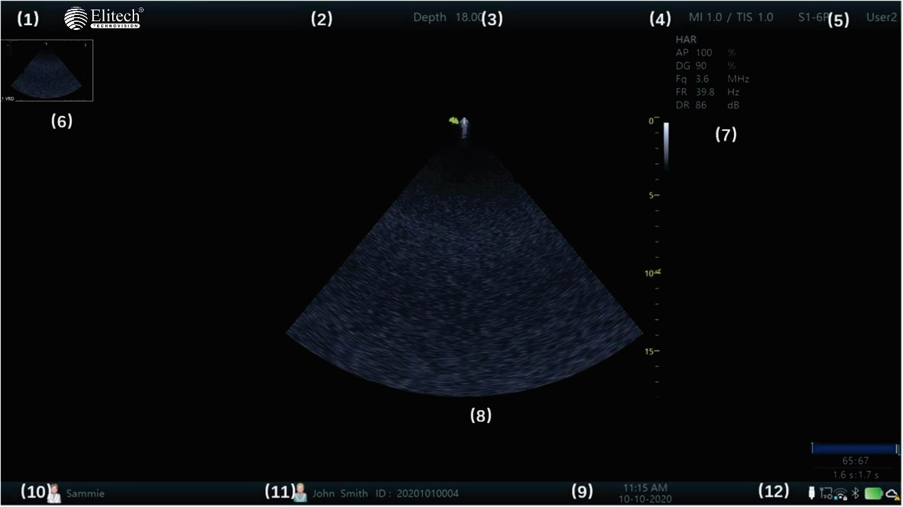

1. ELITECH: manufacturer’s trade mark.
2. Hospital Name: it can be modified by the operator to enter a particular name. The default is empty.
3. Depth: indicates how deep the scan image is reaching.
4. MI, TI: indicate the size of Acoustic Mechanical and Thermal Index.
5. Probe and application: show what the current probe and application are selected and used.
6. Clip board images: this field displays the batch of the temporarily stored images, which are stored in HDD.
7. This field indicates some of the parameters such as digital gain, frequency, frame rate, acoustic output power. The displayed parameters are different in different modes.
8. Image area: it is the field where the image is displayed, including all mode images such as B, CF/PDI, M, and PW/CW.
9. Date, Time: this field indicates the current date and time.
10. This date and time can be modified in the system setting menu.
11. Perf. Physician: this field shows the performing physician’s name.
12. Patient information: this field shows the current patient name and ID. If there is some information of OB input when new the patient, display “GA” too. USB/Network status: Show USB icon, file server icon, network icon and Bluetooth icon.

### 1.6.1 Parameter term explanation

All parameters in the parameter field are abbreviated and stand for the following meanings.

* AP: Acoustic Power
* DG: Digital Gain
* Fq: Frequency
* WF: Wall Filter
* DR: Dynamic Range
* FR: Frame Rate
* SD: Sample Depth

# 2. SAFETY

## 2.1 Introduction

This device is designed for the safety of the patient and operator. Before operating the device, read this chapter thoroughly with care please. The manufacturer guarantees the safety and reliability of the device only if all cautions and warnings are followed. Strictly observe all Warnings, Cautions, Notes and Safety markings within this document and on the machine.

Icon description:

Several levels of safety precautions may be found in this manual. Different levels of concern are identified by one of the following icons with signal words.

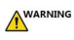Indicates a hazard which, if not avoided, could result in death or serious injury.

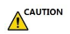Indicates a hazard which, if not avoided, could result in moderate or minor injury and property damage.

## 2.2 Owner responsibility

**Notice against operator modification:**

Never modify this device, including the system components, the software, the cables and any other device components or accessories. A safety hazard may occur resulting from unauthorized modification. Do not attempt to disassemble the device if you are not trained and authorized by the manufacturer.

The operator must familiarize themselves with these safety measures and avoid situations that can result in injury or damage.

Do not dispose of this system (or any parts of it) with industrial or domestic waste. The system may contain materials such as lead, tungsten, or oil, or other hazardous substances that can cause serious environmental pollution. The system also contains privacy-sensitive information, which should be properly removed (scrubbed). Please contact ELITECH before disposing of this system.

Do not use this device during service or maintenance.

## 2.3 Regulatory Notice

This device has been tested to meet all applicable requirements.

According to 93/42 EEC(Medical Devices Directive) amended by 2007/47/EC, it is a class IIa medical device.

**Conformity to Standards:**

The following standards have been used and the product is therefore certified in compliance with:

IEC 60601-1:2005/A1:2012 Medical electrical equipment - Part 1: General requirements for basic safety and essential performance

IEC 60601-1-2:2014 Medical electrical equipment - Part 1-2: General requirements for basic safety and essential performance - Collateral Standard: Electromagnetic disturbances - Requirements and tests

IEC 60601-1-6:2010/A1:2013 Medical electrical equipment - Part 1-6: General requirements for basic safety and essential performance - Collateral standard: Usability

IEC 60601-2-37:2007/A1:2015 Medical electrical equipment - Part 2-37: Particular requirements for the basic safety and essential performance of ultrasonic medical diagnostic and monitoring equipment

IEC 61157:2007/AMD1:2013 Standard means for the reporting of the acoustic output of medical diagnostic ultrasonic equipment

ISO 10993-1:2018 Biological evaluation of medical devices -- Part 1: Evaluation and testing within a risk management process

IEC 62304:2006/A1:2015 Medical device software - Software life cycle processes

IEC 62366:2007/A1:2014 Medical devices - Application of usability engineering to medical devices

Council Directive 93/42/EEC amended by 2007/47/EC on Medical Device WEEE according to 2012/19/EU

RoHS according to 2011/65/EU

## 2.4 Label Icon Description

|  |  |  |
| --- | --- | --- |
| **Label** | **Description** | **Location** |
|  | This is the indicator for company address. | Rear of unit |
|  | This is the indicator for part number. | Rear of unit |
|  | This is the serial number indicator. | Rear of unit |
|  | This indicates manufacture time. | Rear of unit |
|  | Unique Device Identification. | Rear of unit |
|  | General Warning Sign. | Rear of unit |
|  | MUST read the document accompanying the device! | Rear of unit |
|  | This is type BF equipment, in which protection against the electric shock does not rely on the basic insulation only. (The operator shall) Provide additional safety precautions such as double insulation or reinforced insulation for protective earthing or reliance upon installation conditions. | Rear of unit |
|  | Equipment Type CF, indicates the equipment which has a floating applied part, possessing a degree of protection suitable for direct cardiac contact. | Rear of unit |
|  | This symbol indicates that the waste of electrical and the electronic equipment must not be disposed as unsorted municipal waste and must be collected separately. Contact an authorized representative of the manufacturer for information concerning the decommissioning of your  equipment. | Rear of unit |
|  | ON/OFF button  Warning: system shutdown using the “On/off” button does not disconnect the ultrasound unit from the main voltage. To disconnect the ultrasound unit from the main voltage after the system shutdown, set the circuit breaker close to  the main inlet to OFF as described in 3.3. | Control panel |
|  | Warning: dangerous voltage.  This is a warning mark for an electric shock hazard to indicate there is a potential electric shock risk. | Rear of unit |
|  | This is the mark for no-line bound during packing. | Rear of Monitor |
|  | Do not put hands here. There is a risk of hands crush. | Rear of console |
|  | This is the warning mark for no swivel when monitor is in flat position | Rear of Monitor |
|  | This is the equipotential connection mark. The operator needs to connect the equipotential points of the device in  order to reach the same potential. | Rear of unit |
|  | This is the protective earthing mark to indicate which  device or part is protected by earthing. | Inside of unit |
|  | This is the transportation position warning mark. During the long distance device transportation or movement on an incline, more than two persons are required to move the device along, with the device facing front and rear  direction. | Rear of unit |
|  | CAUTION: Do not push this device sideways when casters are in the brake position, as the device will become unstable. | Top console (both side) |
|  | These symbols are for China RoHS. Not applicable for other countries. | Probe connect  or |
|  | Rear of unit |
|  | GOST Symbol. Russia Regulatory Country Clearance. | Rear of unit |
| ClASS Ⅰ | This indicates the electrical safety classification of the  product | Rear of unit |
| CLASSEⅠ | Portuguese translation of the electrical safety classification. | Rear of unit |

## 2.5 Network Security Features

### 2.5.1 Operating Environment

The software for the digital color ultrasound diagnostic apparatus is an embedded software component, but its application still has certain operating environment requirements, which include hardware requirements, software requirements, and network environment requirements.

* Hardware Requirements
* CPU: Intel i5 dual-core 3GHz and above
* Hard disk: 120G and above
* Memory: 4G and above
* Display: Resolution 1920*1080 and above
* Software Requirements
* Windows 10 and above
* 64 bit
* Network Environment
* 100M/1000M adaptive

### 2.5.2 Software Version

Release version: 1

### 2.5.3 Access and Control, Software and Updates

To ensure the safety of this software, this device is equipped with a professional firewall Windows Defender for this purpose. The data of this software includes health data and device data. Health data includes basic patient information, measurement results, scan images, etc., while device data includes running logs, user-defined information, etc.

According to the operation of the software and the needs of customers, the device opens the corresponding interface and controls the user access mechanism.

Software environment and the updates of security software follow ELITECH’s relevant specifications, manage and control software maintenance, carefully analyze and evaluate the risks that may arise from software maintenance in accordance with risk control procedures to ensure that software maintenance may cause risks acceptable.

* Device interface
* USB
* RJ45
* S-Video/DVI
* Data interface transmission protocol: DICOM3.0, FTP, USB3.0
* Storage format: VRD, DCM, MP4, PNG
* User Access Control
* User identification method: user account and password login.
* User type: administrator or standard user.
* User authority: administrator authority (you can access all management settings, including adding users, modifying user passwords) or standard user authority.

## 2.6 Safety and Warning notices

During using this device, anyone find any serious incident should report to manufacturer and competent authority.

### 2.6.1 Acoustic output

**Definition of the acoustic output parameters:**

**Thermal Index:** TI is an estimate of the temperature increase of the soft tissue or bone. There are three thermal index categories:

* + - * **TIS:** soft tissue thermal index, the main TI category. Used for the applications that does not image (or visualize) bones.
      * **TIB:** bone thermal index (bone located in a focal region). Used for the fetal application.
* **TIC:** cranial bone thermal index (bone located close to the surface). Used for the transcranial application.

**Mechanical Index:** MI is the estimated likelihood of tissue damage due to the cavitations.

**Safety statement:**

 Although no harmful biological effects have been demonstrated for ultrasound frequencies, intensities and exposure times, we recommend the operator to use the lowest acoustic output settings producing acceptable diagnostic information.

**System controls affecting acoustic output:**

The TI and MI show the highest possible acoustic intensity for a given mode, obtainable only when the combination of control settings that results in maximum output is selected. Most settings result in a much lower output.

There are several notes as follows:

* The duration of an ultrasound examination is as important as the acoustic output, since the patient exposure to output is directly relevant to the ultrasound scanning time.
* The better image quality can accelerate the clinical result, reducing the overall duration of an examination. Therefore, any image quality improvement can help to reduce patient exposure.

**Probe selection:**

As long as the appropriate application is available, any probe of this device can be used and meet the limitation of the acoustic output requirement.

**Application selection:**

Selecting the probe and application will provide the acoustic output within the limitation of the acoustic output requirement.

**Changing imaging modes:**

Acoustic output depends on the imaging mode selected. The choice of mode will greatly affect the energy absorbed by the tissue. After a combined mode is completed, such as 2D and CF mode, the total acoustic output comprises contributions from each individual mode.

**Concerning surrounding fetal exposure:**

Always be aware of the acoustic output level by observing the acoustic output display. The operator is recommended to become familiar with this device’s controls affecting the acoustic output.

**OB examination:**

 Prior to an ultrasound examination, the patient should be informed of the clinical applications which include specific benefits, potential risks and alternatives. In addition, if the patient requires information about the exposure time and intensity, they should be provided. An ultrasound examination should not be performed to satisfy the family’s desire to know the fetal sex: according to several countries’ laws, which include China, using an ultrasound examination to detecting the fetal sex (gender) is prohibited.

### 2.6.2 Patient Safety

The concerns listed in this section can seriously affect the safety of the patient undergoing a diagnostic ultrasound examination.

**Patient Identification:**

Always include proper identification with all patient data and verify the accuracy of the patient’s name and/or the identity number after entering the data. Ensure all recorded data has the correct patient ID. Identification errors can result in an incorrect diagnosis.

**Diagnostic Information:**

The images and calculations provided by this device are intended for use by the competent the operator, as a diagnostic tool. They are explicitly not to be regarded as the sole basis for the clinical diagnosis. The operator is encouraged to study the literature and reach their own professional conclusions regarding the clinical utility of this device.

Special care is required to ensure the maximum privacy of the patient information.

### 2.6.3 Probe Safety

**Mechanical hazards:**

 Damaged probes or the improper use of probes may result in injury or increased the risk of infection. The operator needs to frequently inspect the probe for damage, in particular looking for sharp or rough surface damage.

Never use intensive force when manipulating the intra cavity probes. The operator is required to be familiar with all instructions and precautions provided with probes.

**Electrical Hazard:**

 Probes are powered by electricity and can injure the patient or operator when exposed to contact with the conductive solution. A damaged probe may increase the risk of electric shock. Inspect probes frequently for cracks or openings in the housing and holes in and around the acoustic lens, or other damage.

### 2.6.4 Personnel and equipment safety

**Explosion hazard:**

 Never operate this device in the presence of flammable or explosive liquids, vapors or gases. The operator should be aware of the points to prevent such explosion hazards as follows:

* If flammable substances are detected in the environment, do not plug in or turn on this device. In addition, do not unplug or turn the device off if it has been turned on before.
* If flammable substances are detected, evacuate and ventilate the area before turning off this device.

**Electrical Hazard:**



* Internal circuits of this device use high voltages, capable of causing serious injury or death by the electric shock.
* The OPERATOR MUST NOT touch accessible LIVE parts of USB, DVI, Audio ports and the PATIENT simultaneously.
* USB, DVI and Audio ports: ONLY connect the PARTS or DEVICES which DO NOT have the external electrical hazard risk.
* USB port max output 5V 0.5A.

Any configurations by such connection must comply with the requirements of the IEC60601-1. It is the responsibility of the person who connects the parts or devices and configures a medical system to verify that this device complies with the requirements of the IEC60601-1. If you have any questions, contact your service representative for information.

**To avoid injury:**



* Do not remove this device's protective covers. No operator-serviceable parts are inside. If servicing is required, contact a qualified technician.
* Connect the attachment plug to a hospital-grade earthing socket to ensure adequate earthing.
* To avoid the risk of electric shock, this equipment must only be connected to a supply main with protective earth.
* Never use any adaptor or converter of a three-prong-to two-prong type to connect with a main power plug. The protective earth connection will be lost.
* Do not place liquids on or above this device. Conductive fluids seeping into the active circuit components may cause a short circuit, which can result in an electrical fire.
* An electrical hazard may exist if any light, monitor or visual indicator remains on after this device is turned off.

Do not use this device if a safety problem is known to exist. This device needs to be verified by qualified service personnel before returning to

use.

**Biological hazard:**

 Beware of biological hazards after performing trans-vaginal procedures. To avoid the risk of disease transmission:

* Use protective barriers such as probe glove.
* Thoroughly clean the probes after each patient examination and disinfect as needed.
* Follow all in-house infection control policies as they apply to the personnel and equipment.

**Pacemaker hazard:**

 The possibility of this device interfering with pacemakers is minimal. However, as this device generates high frequency electrical signals, the operator should be aware of the potential hazard.

**Monitor:**



* DO NOT place a finger, hand or any object on the joint of the monitor or monitor arm to avoid injury after moving the monitor and monitor arm.
* To avoid injuries or system damage, NEVER place any object or liquid on the monitor.
* DO NOT place any object on the ventilation slots on the upper rear side of the monitor. Blocking the ventilation slots obstructs proper airflow and may result in fire, electric shock, or equipment damage.
* DO NOT scratch or press on the panel with any sharp objects, such as a pencil or pen, as this may result in damage to the monitor.

### 2.6.5 Electrical Safety

**Internally connected peripheral devices:**

 This device, together with the internal connected peripheral devices, such as the printers or the DVDRW, meets all the standards listed in chapter 2.1. This statement is applicable only when tested peripherals listed in chapter 14 are plugged into the AC outlets provided in this device.

**External connection of other peripheral devices:**

 Other external devices, such as laser cameras, printers and external monitors, usually exceed the medical standard allowable current leakage. If they are plugged into separate AC outlets and then connected to this device, it represents a violation of patient safety standards. Suitable electrical isolation of such external AC outlets may be required to meet the electrical leakage limit requirement.

**Device movement:**

When moving this device, rotate the control panel to be in the middle from the left and right view, and also push the control panel as far back as possible then move it to the lowest position.

**ECG Use:**

 Do not use this device’s ECG wave for diagnosis and monitoring. Only use an ECG cable which is approved by ELITECH.

**Defibrillator Use:**

Do not use this device with a defibrillator.

**Use of Electrosurgical unit:**

 DO NOT use high-frequency surgical equipment with the device.  Keep the Electrosurgical unit away from ECG leads to avoid the potential interference to the ECG wave. To avoid a burn hazard, do not use this device with high-frequency surgical equipment.

**Electromagnetic Compatibility (EMC):**

This device can produce and use the radiation RF energy.

All types of electronic equipment may characteristically cause the electromagnetic interference with other equipment, either transmitted through air or connecting cables. The term EMC indicates the capability of this device to curb the electromagnetic influence from other equipment and at the same time not affect other equipment with the similar electromagnetic radiation from itself.

This product is designed to fully comply with the EN60601-1-2 (IEC60601-1-2), Class A, in medical electric equipment EMC regulations.

Proper installation following the service manual is required in order to achieve the full EMC performance of the product.

In the event of issues relevant to EMC, (turning on/off this device is able to evaluate whether an EMC-relevant problem has occurred), the operator (or qualified service personnel) should try the measures (one or more) to address and solve the problem as follows:

Determine the identity of the affected equipment and replace the affected equipment (one or more).

Relocate this device or the affected equipment to increase the distance in between. Use a different power supply source from the affected equipment for this device’s power supply.

Call your service personnel for more advice please.

**General Information**

1. Products equipped with a power source plug should be plugged into a fixed power socket that features the protective earthing conductor. Never use any adaptor or converter to connect with a power source plug (i.e. three prong–to–two prong converter).
2. Locate this device as far away as possible from other electronic equipment. These products are suitable for hospitals or clinics except for near active HF surgical equipment and the RF shielded room of and medical system for magnetic resonance imaging, where the intensity of EM disturbances is high.
3. Be sure to use only the cables provided by or designated by ELITECH company. Connect these cables following the installation procedures (i.e. wire power cables separately from signal cables).
4. For designation of the Peripheral Equipment Connectable to this Product, refer to the operator manual. These Peripherals can be connected to the product without compromising its EMC performance.
5. Avoid using equipment not designated for this device. Failure to comply with this instruction may result in poor EMC performance of the product.
6. Notice against Operator Modification:

Never modify this product. Unilateral operator modification may cause the degradation in EMC performance and may lead to the serious hazards for the patient and the operator.

Modification of the product includes:

1. Changes in the cables (length, material, wiring etc.)
2. Changes in the system insulation/layout.
3. Changes in the system configuration/components.
4. Changes in the securing system parts (cover open/close).
5. Operate this device with all covers closed. If a cover is opened or any reason, ensure that is shut before starting/resuming operation.

NOTE: Operating this device with any cover open may affect EMC performance.

**Essential performance**

The ability to display physiological images as input for diagnosis by trained physician.

The ability to display physiological traces as aid for diagnosis by trained physician.

The ability to display quantified data including distance, angle, square, etc, as input for diagnosis by trained physician.

The display of ultrasound indices as aid for safe use of the unit.

The applied parts of the device, i.e. probes, ECG, shall not produce excessive leakage currents, as defined by IEC 60601-1.

The device shall not produce unintended or excessive ultrasound output energy that exceeds safe limits defined by IEC 60601-2-37

The device shall maintain contact temperatures of applied parts at safe limits, as defined by the IEC 60601-2-37

The device shall not produce nor be influenced by electromagnetic interference that

exceeds safe limits, as defined by IEC 60601-2-37.

The applied parts of the device, i.e. transducer assemblies, shall be protected against ingress of liquids for a min. rating of IPX7, as defined by IEC 60601-2-37.

Do not use the following devices near this ELITECH Ultrasonic system: Devices which transmit radio waves such as cellular phones, radio transceivers, mobile radio transmitter, radio–controlled toy, etc. Use of these devices can cause this ELITECH Ultrasonic system to perform outside the certified specifications. Keep these devices powered off when kept near this device.

Medical staff in charge of this device is required to instruct technicians, patients and other people who may be around this device to fully comply with the above regulations.

Endocavity probes can’t be used on body surface, if the probe is energized, it will not meet the electromagnetic compatibility requirements, may cause harmful interference to other devices in the environment.

All endocavity probes are certificated by EMC.

Use of this equipment adjacent to or stacked with other equipment should be avoided because it could result in improper operation. If such use is necessary, this equipment and the other equipment should be observed to verify that they are operating normally.

Use of accessories, transducers and cables other than those specified or provided by the manufacturer of this equipment could result in increased electromagnetic emissions or decreased electromagnetic immunity of this equipment and result in improper operation.

|  |  |  |  |  |  |
| --- | --- | --- | --- | --- | --- |
| **Information of all the cables** | | | | | |
| **Port No.** | **Name** | **Type\*** | **Cable Max. >3m** | **Cable Shielded** | **Comments**  **(Sip/Sop lines must include description of use)** |
| 0 | Enclosure | N/E | — | — |  |
| 1 | Mains | AC | >3m | Unshielded | AC mains port |
| 2 | Probe | PC | <3m | Unshielded | Ultrasound diagnostic |
| 3 | ECG | PC | >3m | Unshielded | Only to be used for reference purposes in  normal ultrasound scanning |
| 4 | USB (5 pcs) | SIP/SOP | <3m | Shielded | USB port for data transmission, for  connection with USB device |
| 5 | DVI | SIP/SOP | <3m | Shielded | DVI port for connection to external display |
| 6 | LAN | SIP/SOP | >3m | Unshielded | For connection of the EUT to local area  network |
| 7 | USB port for printer | SIP/SOP | >3m | Shielded | For connection to external printer |
| 8 | Foot switch | SIP/SOP | >3m | Unshielded | Signal port for connection to foot switch |
| 9 | VCR audio output | SIP/SOP | <3m | Shielded | Audio port for connection to external sound  box |
| 10 | S - VIDEO | SIP/SOP | <3m | Shielded | S-Video port for connection to external  display |
| Supplementary information:  *Note: AC = AC Power Port; DC = DC Power Port; N/E = Non-Electrical; Batt=Battery  Sip/Sop = Signal Input/output Port; PC – Patient-Coupled Cable; TP = Telecommunication Ports | | | | | |

Even though this product comply with EMC requirements for a Group 1, Class A Medical device as stated in IEC 60601-1-2, this equipment still can be electromagnetic influenced by other electronic equipment. The EMISSIONS characteristics of this equipment make it suitable for use in industrial areas and hospitals (CISPR 11 class A). If it is used in a residential environment (for which CISPR 11 class B is normally required) this equipment might not offer adequate protection to radio-frequency communication services. The user might need to take mitigation measures, such as relocating or re-orienting the equipment.

**Electromagnetic emission:**

|  |  |
| --- | --- |
| **Guidance and manufacturer’s declaration – electromagnetic emissions** | |
| This device is suitable for use in the specified electromagnetic environment and it has  meets the following standard’s emission requirements. | |
| **Phenomenon** | **Professional healthcare facility environment** |
| Conducted and radiated RF emissions | CISPR 11, Group 1, Class A |
| Harmonic distortion | IEC 60601-3-2, Class A |
| Voltage fluctuations and flicker | IEC 61000-3-3 |

 Radiated, conducted electromagnetic signals or electrical fast transient pulse group can cause distortion, degradation, or artifacts in the ultrasound image which may impair the ultrasound system’s essential performance.

**Electromagnetic immunity:**

|  |  |  |  |
| --- | --- | --- | --- |
| **Guidance and manufacturer’s declaration – electromagnetic immunity** | | | |
| This device is suitable for use in the specified electromagnetic environment and it has meets the following immunity test levels. Higher immunity levels may cause the  device’s essential performance lost or degraded. | | | |
| **Phenomenon** | **Basic EMC**  **standard or test method** | **Professional healthcare facility environment** | |
| Electrostatic  discharge | IEC 61000-4-2 | +/- 8 kV contact  +/- 2 k V, +/- 4 k V, +/- 8 k V, +/- 15 k V air | |
| Radiated RF EM fields | IEC 61000-4-3 | 3V/m  80MHz-2.7GHz  80%AM at 1 kHz | |
| Proximity fields from RF wireless communications  equipment | IEC 61000-4-3 | See the RF wireless communication equipment table in “Recommended minimum separation distances” | |
| Rated power  frequency | IEC 61000-4-8 | 30A/m; 50 Hz or 60 Hz | |
| Electric fast transients | IEC 61000-4-4 | ±2kV, 100kHZ repetition frequency | |
| For input a.c. power port; d.c. power lines or signal  input/output lines whose length exceeding 3m | |
| Surges | IEC 61000-4-5 | Line to line:±0.5kV, ±1kV  Line to earth: ±0.5kV,±1kV,±2kV | |
| For input a.c. power port; all d.c. power ports connected  permanently to cables > 3m; Output signal output lines connected directly to outdoor cables | |
| Conducted disturbances induced by RF fields | IEC 61000-4-6 | 3 V in 0.15 MHz - 80 MHz  6 V in ISM and/or amateur radio bands between 0.15 MHz and 80 MHz  80% AM at 1 kHZ or 2 Hz  (test performed at 2 Hz is worst case as identified for risk management)  (system compliant to 10 V immunity test level) | |
| For:  input a.c. power port;  All d.c. power ports connected permanently to cables > 3 m All patient-coupled cables  SIP/SOP whose maximum cable length ≥ 3m | |
| Voltage dips | IEC 61000-4-11 | 0% UT: 0.5 cycle  at 0°, 45°, 90°, 135°, 180, 225°, 270° and 315° | |
|  |  | 0% UT: 1 cycle and 70% UT: 25/30 cycle sine phase  at 0°. | |
| Voltage  interruptions | IEC 61000-4-11 | 0% UT: 250/300 cycle | |
| UT: rated voltage(s); E.g. 25/30 cycles means 25 cycles at 50Hz or 30 cycles at 60 Hz | | | |

Portable RF communications equipment (including peripherals such as antenna cables and external antennas) should be used no closer than 30 cm (12 inches) to any part of the device, including cables specified by the manufacturer. Otherwise, degradation of the performance of this equipment could result.

**Recommended separation distances:**

|  |  |  |  |  |  |  |
| --- | --- | --- | --- | --- | --- | --- |
| **Recommended separation distances between**  **portable and mobile RF communications equipment and this device** | | | | | | |
| Nowadays, many RF wireless equipments have being used in various healthcare locations where medical equipment and/or systems are used. When they are used in close proximity to medical equipment and/or system’s basic safety and essential performance may be affected. This ELITECH has been tested with the immunity test level in the below table and meet the related requirements of IEC 60601-1-2: 2014. The customer and/or user should help keep a minimum distance between RF wireless communications equipment and this ultrasound diagnostic system as recommended below. | | | | | | |
| Test frequency  (MHz) | Band (MHz) | Service | Modulation | Maximum power (W) | Distance (m) | Immunity test level  (V/m) |
| 385 | 380-390 | TETRA 400 | Pulse modulation  18 Hz | 1.8 | 0.3 | 27 |
| 450 | 430-470 | GMRS 460  RFS 460 | FM  ±5 kHz  Deviation 1 kHz sine | 2 | 0.3 | 28 |
| 710 | 704-787 | LTE Band 13, 17 | Pulse modulation 217 Hz | 0.2 | 0.3 | 9 |
| 745 |
| 780 |
| 810 | 800-960 | GSM 800/900; TETRA 800; iDEN  820; CDMA 850;  LTE Band 5 | Pulse modulation 18 Hz | 2 | 0.3 | 28 |
| 870 |
| 930 |
| 1720 | 1700-1990 | GSM 1800; CDMA 1900;  GSM 1900; DECT;  LTE Band  1,3,4,25; UMTS | Pulse modulation 217 Hz | 2 | 0.3 | 28 |
| 1845 |
| 1970 |
| 2450 | 2400-2570 | Bluetooth, WLAN, 802.11  b/g/n,  RFID 2450, LTE B | Pulse modulation 217 Hz | 2 | 0.3 | 28 |
| 5240 | 5100-5800 | WLAN  802.11 a/n | Pulse modulation  217 Hz | 0.2 | 0.3 | 9 |
| 5500 |
| 5785 |

## 2.7 Residual Risk Disclosure

### 2.7.1 Energy Hazards

**Electrical**

* + - * Leakage occurs when the patient touches the application part.
      * The network port on the device is directly connected to the external network.
      * Operator without training use
      * Liquid spill caused electric leakage in equipment
      * Power cord plugged into other devices
      * Probe housing damaged or insulation performance decline
      * Electrical terminal filters have a high voltage power supply

**Electromagnetic**

* + - * Failure caused by external interference
      * Interference with other devices resulting in other device failure.
      * Patient was fitted with a pacemaker

**Acoustic energy**

* + - * The acoustic output exceeds the specified value of cavitation effect.
      * The acoustic output may cause thermal damage to fragile tissue etc.

**Thermal**

* + - * Touch the overheated equipment box etc.

**Mechanical energy**

* + - * Display turn upwards
      * Push handle broken
      * Probe connector pull out the device failure.
      * Printer to fall
      * Probe shelf falls off and the probe is broken
      * Whole machine slides or topples
      * Touch screen crush
      * Equipment was damaged in transit

### 2.7.2 Operational hazards

**Use Error**

* Data/Patient mismatch
* System/probes are used outside of the intended use
* Data is deleted by mistake etc.

**Functio**n

* System can't normal start
* Touch screen can't use etc.

**Manufacturing**

* Device cannot work properly
* Some functions are lost etc.

### 2.7.3 Information hazards

**GUI:** An error in text or missing text in the software GUI

**Function**

Button is invalid, or the wrong operation

No PCIE equipment, software can't operate normally

Error in text or missing text in Labeling

**Cyber-Safety**

* Be logged in maliciously by others, modify the patient's health data, or steal the patient's related personal information
* User data lost or accessed illegally during output etc.

### 2.7.4 Environment hazards

Contamination

### 2.7.5 Biological and chemical hazards

**Biological:** Applied part with germs and virus

**Biocompatibility:** Lack of compatibility between the contact materials used and biological tissues

After risk control measurements has been carry out, all of them are acceptable.

# 3. START THE SYSTEM

## 3.1 General

The first installation must only be performed by authorized personnel. The system has a default setting which is applicable for most cases. Experienced operator can change the default setting and store it as an operator-defined setting.

This device must be in the proper environment. This applies to in the operation, storage and transport. Requirements of the environments are listed as shown below:

|  |  |  |  |
| --- | --- | --- | --- |
| **Requirement** | **Temperature** | **Humidity** | **Air pressure** |
| **Transport/shippin**  **g** | -5°C ~ 50°C | 10% ~ 80% | 700 ~ 1060 hPa |
| **Storage** | -5°C ~ 50°C | 10% ~ 80% | 700 ~ 1060 hPa |
| **Operation** | 10°C ~ 40°C | 30 ~ 75% | 700 ~ 1060 hPa |

## 3.2 Safety Warnings

When this device is moved from a cold environment such as the stock room into a warm room, it is necessary to wait several hours for the machine to dehumidify before starting the machine due to the temperature change of the environment.

Don't use the push handle to lift the device.

## 3.3 Power on / Boot up

1. Connect the power cable to the rear of this device.
2. Plug the power cable into a hospital grade power socket with the proper rated voltage.
3. Switch on the main switch at the rear of this device.

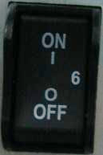

1. Push the “Standby” button switch on the top right side of the control panel. After the system is switched on and booted up for a couple of minutes, the 2D image for the previously selected transducer is displayed. If no probe is connected in the previous selected transducer, the “Probe & App” menu will appear the touch panel screen so that select probes operator. All peripherals which are connected to the outlets of this device can be switched on only after the system is switched on.

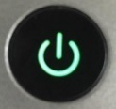

1. The color of “Standby” button: Orange means standby, green means on.

 The MAINS plug or an appliance coupler is used as the disconnect device, the disconnect device shall remain readily operable

## 3.4 Power off / Shutdown

To avoid loss of the current patient data as well as all the measurement data, it is necessary to save the data to one patient in any mode menu of the touch panel screen before switching off this device. If not saved, this device will display a warning after re-booting.

1. Push the “ON/OFF” switch on the top right of the control panel.
2. If want to switch off electrical power, the operator needs to turn this device “OFF” in the rear panel of this device.

## 3.5 Probe and Application Selection

### 3.5.1 Plug probe connector into this device

The probe plug process is as follows:

1. Plug the probe connector into an available probe slot.
2. Push the lock on the top of the probe connector to lock the connector.

### 3.5.2 Probe and application selection

“Probe & App” UI is as below.

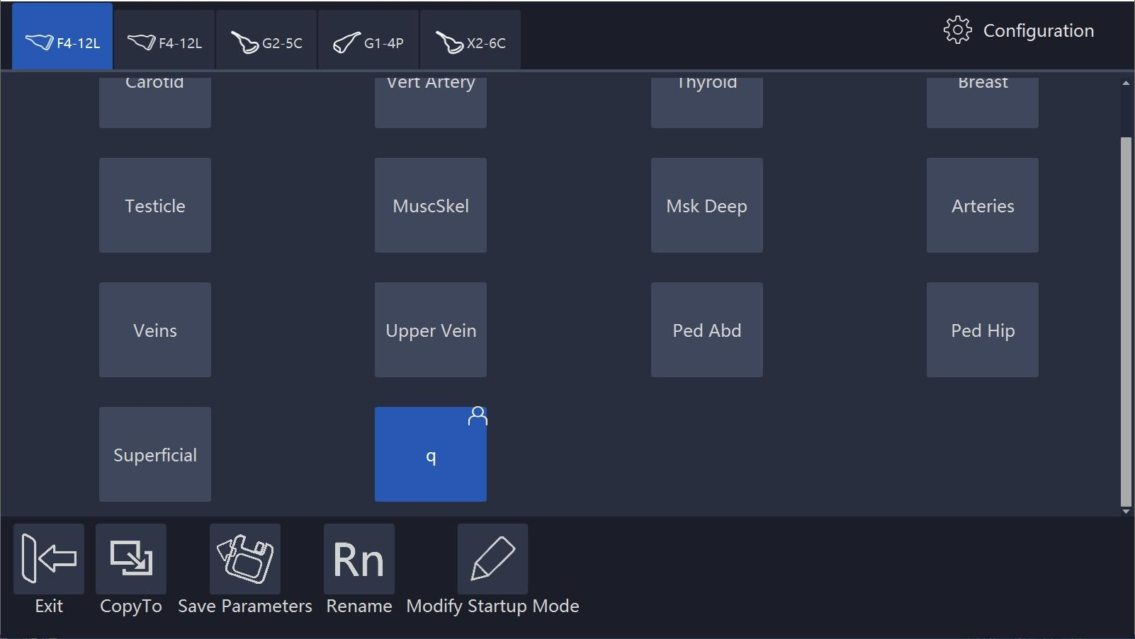

**Workflow:**

After entering the “Probe & App” menu, the system will go to the frozen mode. Select probes, but the system will not switch probe right away until the system enters real time scan mode. Select any application button or press “Freeze” to go back to real time scan mode.

**Operator defined setting:**

In this page the operator can rename the user-defined application, set one application as default, and reset all changes.

And also add one user-defined application, or delete one user-defined application.

The application edit menu is as shown below.

Touch “Edit”, applications can be hidden by un-selecting them.

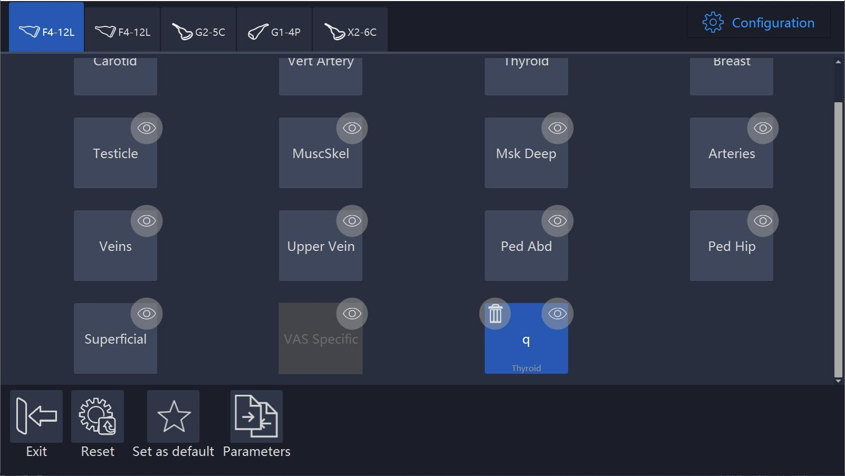

## 3.6 Image Storage

Select “Store to HDD” to save VRD, DICOM or AVI image to the system hardisk, select “Store to USB” to save VRD, DICOM or AVI image to the connected USB device. In system setting, the format of storing image can be configured, please refer 12.4. In 3D/4D mode, the operation of image storage is similar.

The image saved in the hardisk will be displayed in the clipboard. The operator can select the saved images after enable “Cursor” to replay. Save the image during scanning, it will be cine. Save the image after freeze the system, it will be one frame. When replay one cine image saved in 3D/4D mode, the operator needs to select “Auto Rotate” or “Auto Cine”.

Please use the specified USB device.

Show “<” and “>” at the bottom of the clipboard. Click “<” to replay the previous image, click “>” to replay the next image.

## 3.7 Freeze image

Pressing “Freeze” on the bottom right of the control panel enables the system to switch from the scan mode to the frozen mode. When the key is orange backlit, it is in frozen mode which means the image is static. When the key is green backlit, it is real scan mode in which the scan image is in real time.

Select “New Patient”, “Archive”, “Probe & App”, “Sys Setting” or “Body Pattern”, the system will switch to frozen mode.

## 3.8 Patient data

Normally the operator needs to input a new patient’s information before scanning the new patient. Alternatively, pull up an old patient’s data from the archive for a new examination of the old patient. Read chapter 4 for reference.

## 3.9 Image Annotation

### 3.9.1 Character Annotation

In the main touch panel screen, there is a “Comments” button. This button is for annotation.

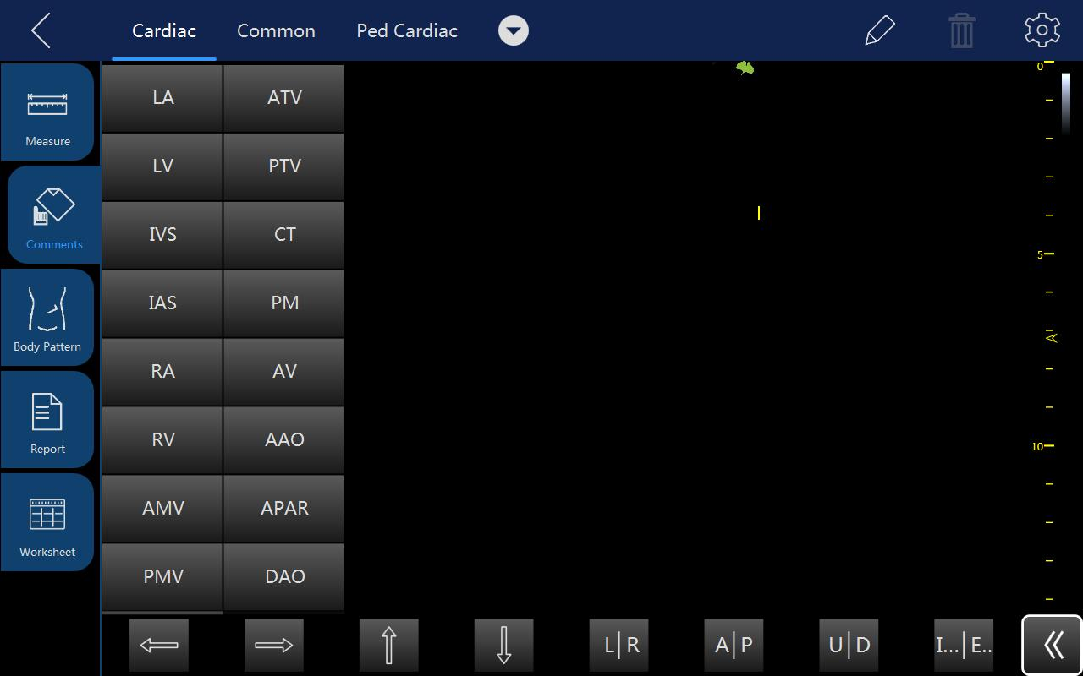

After the “Comments” is selected, the touch screen will display as above. On the left side there are some frequent terms to be selectable in order to quickly add those comments to the image screen by dragging those terms. Those words will be different based on different applications and probes.

Select and hold a certain section of the image area, and after that an alphanumeric keyboard will appear for adding annotations. By touching and holding the previous comment, it can be edited. After the other field is selected, the previous annotation will become a confirmed annotation.

The operator can add their own terms in configuration page.

After the trash icon is selected, this button will be highlighted and there will be a delete sign appearing besides each comment, the comment can be deleted by touching the delete sign. After the “Delete” is selected again, this key will return to normal and the delete sign for each comment will disappear.

Alphanumeric keyboard shown as shown below

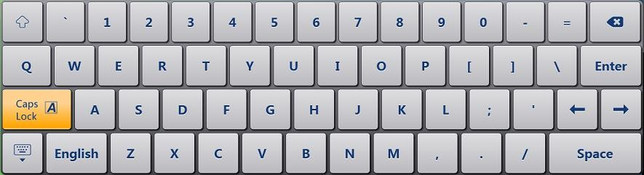

Notes:

1. Select “CapsLock”, operator can input capitals.
2. Select “”, operator can input symbols.
3. Select , the alphanumeric keyboard will be closed.

### 3.9.2 Arrow Indicator

Drag arrow indicators on the comment screen to move them to the image area to indicate the nidus. Arrow can be rotated after it is selected.

### 3.9.3 Body Pattern

After the “Body Pattern” is selected, all body patterns will display for the operator to select. After one of those patterns is selected, the body pattern box will turn green and the body pattern will appear on the bottom-right side of the image screen for reference. Now, rotate “Rotation/Steer” key to change the probe indicator’s orientation in the body pattern. Use the trackball to move the probe indicator in the different position of the body pattern symbol. The touch panel will go back to the previous menu by selecting “<”. Enable “Cursor” key, and put the cursor on the body pattern, then move the trackball to change the body pattern’s position. Press “Enter” to fix the body pattern’s position.

The touch panel screen after entering the body pattern status is as shown below:

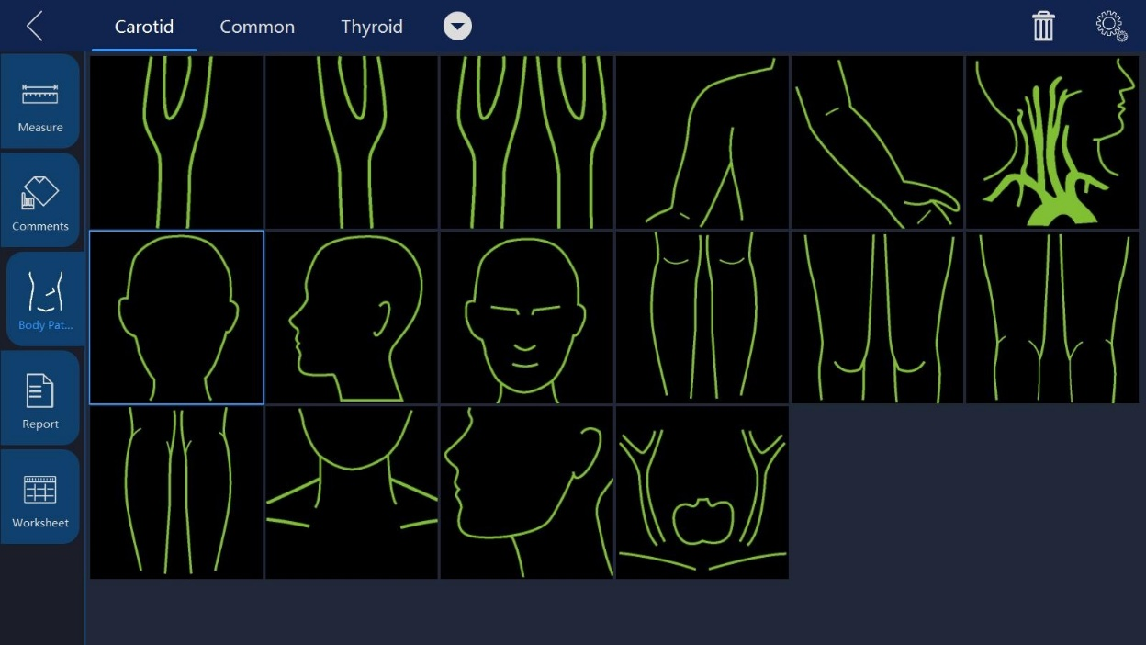

Select different applications can show different body patterns.

Select  to enter configuration page, select  to import body patterns from a USB memory stick. In this case, the operator has to copy a body pattern from his own PC in JPEG, BMP, PNG format.

In system setting, the size of body pattern can be adjusted, please refer 12.1.

### Use Finger to draw comments

1. Touch  and then use finger to draw comment mark in free style. The mark color, thickness, and opacity can be adjusted.

## 3.10 Cine Mode

While scanning a certain number of frames, the most recent examination images sequence will be stored in the cineloop memory after “Freeze” key is pressed.

The sequence will be replayed continuously. By moving the trackball horizontally the sequence can be reviewed frame by frame. This length of cineloop depends on the number of the scan lines, the scan depth and other parameters.

In freeze mode, the touch panel UI is as shown below.

Adjusting the parameters on the touch panel UI can manage the image.

## 3.11 Zoom Function

After “Zoom” is pressed on the control panel, the system will enter zoom mode. In zoom mode, there are two image displays. The normal image with ROI is on the left. The zoomed image is on the right. Use the trackball to move the ROI position. Rotating the “Zoom” key can make the amplification smaller or larger. If enable “Use BodyPattern key” in system setting, the operator can enter zoom mode by pressing “Depth” key. Rotate “Depth” key to zoom in/out.

## 3.12 ECG Trace (Optional)

The ECG module consists of a single connector into which a set of electrode cables can be inserted. The scanning image is synchronized with the ECG traces. In M or PW/CW mode, the trace is synchronized to the particular scanning.

Adjust parameters such as the gain, position and scanning rate of the trace using the relevant keys in the main menu of each mode.

 Do not use the ECG waveform of this device for diagnosis or

monitoring. It is only to be used for reference purposes in normal ultrasound scanning.

Connecting the internal ECG:

The ECG cable is a modular cable consisting of two different cable parts:

* The Trunk: a single cable connecting to this device is at one end with a six-pin plug, and a cable splitter device at the other end.
* A triple color-coded electrode cable: each electrode cable is attached to the corresponding electrode by a color-coded press-on type connector.

The electrode complies with IEC standards. Names and color codings refer to the following description:

Yellow (L): p/n 412680-106

Red (R): p/n 412680-108

Black (N): p/n 412680-107

Connect the ECG trunk cable into the circular socket marked “ECG” on the I/O panel on the front of the device, as shown below:

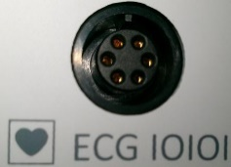

### 3.12.1 ECG Trace Operation

ECG: There is an ECG button in the menu of every mode. The operator can enable or disable it. After it is enabled, the button is highlighted and ECG menu will display. It is enabled by default in Cardiac applications.

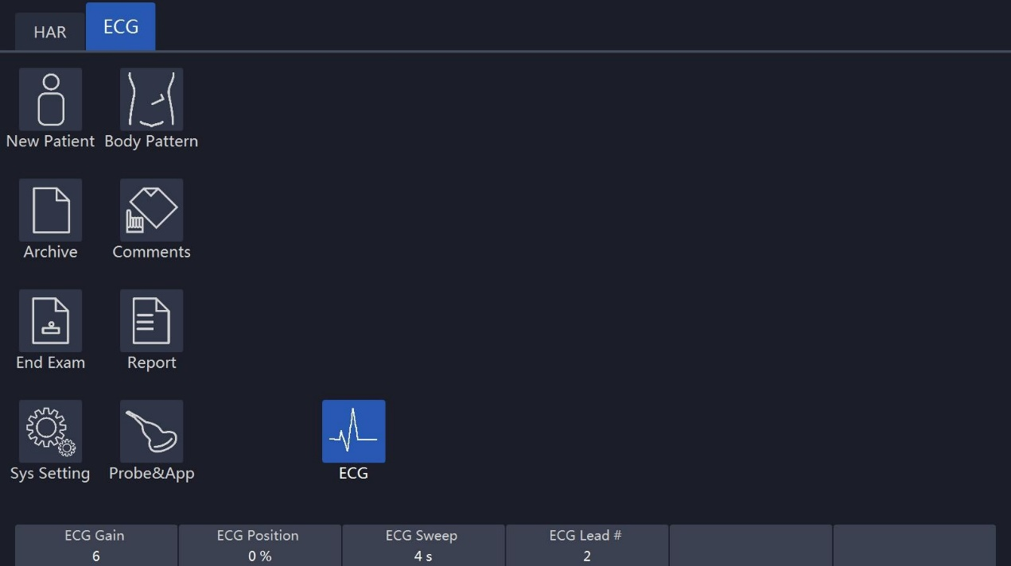

In ECG menu, adjust several parameters by up/down buttons, such as the ECG Gain, the ECG position, the ECG Sweep, and the ECG Lead#.

**ECG Gain:** The amplitude of the ECG wave can be changed by pushing the up/down key.

**ECG Sweep:** To change lateral scan, adjust the speed of the ECG wave. This function is available only in 2D and CF mode. This parameter is adjusted by selecting the “ECG sweep” button on the touch panel. ECG sweep speed is the same as M mode and PW lateral scan sweep speed. Alternatively, sweep speed can be adjusted in M and PW mode.

**ECG Position**: This can be moved up and down in order to position the ECG of the relevant imaging as desired.

**ECG Lead #:** This allows the operator to select which lead’s ECG wave to display on the screen.

The ECG wave of different leads can be selected as follows: Lead I: Record ECG between the right arm and the right leg. Lead II: Record ECG between the right arm and the left leg. Lead III: Record ECG between the left arm and the left leg.

The ECG signal input can be either from an internal or external ECG device. The internal input is to connect the standard electrode leads to this device, so that the operator can access the ECG wave in the system. The external input means that connect one special cable to connect with an external ECG device which inputs the ECG signal to this device.

Note: To connect an external ECG device, a special cable is available. Please contact ELITECH to obtain.

The ECG trace image displays in the screen as shown below:

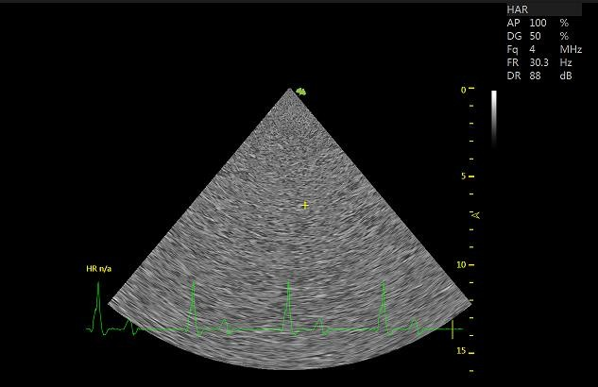

## 3.13 Card Sound

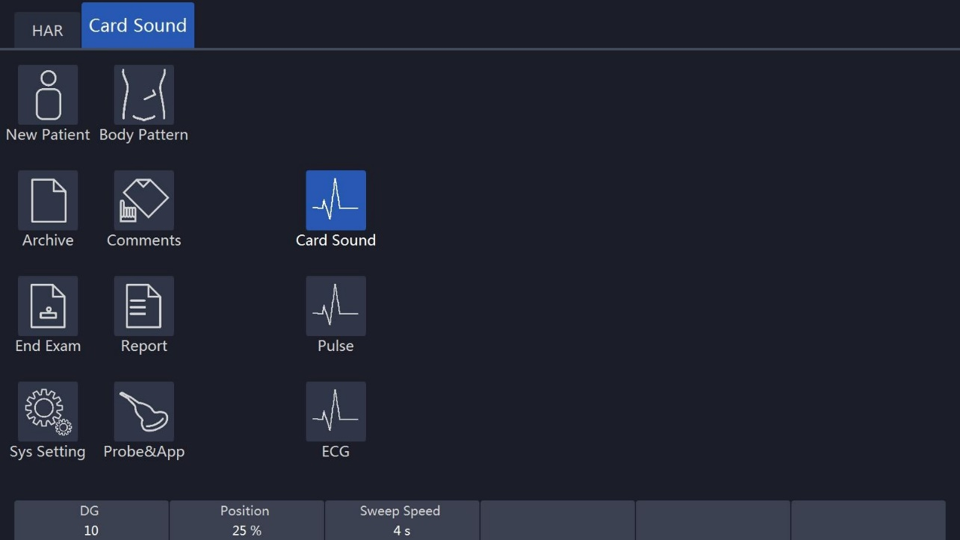

The heart app is generally set to on by default.

Gain, scan speed, heart sound display position should be adjustable in heart sound mode.

## 3.14 Pulse

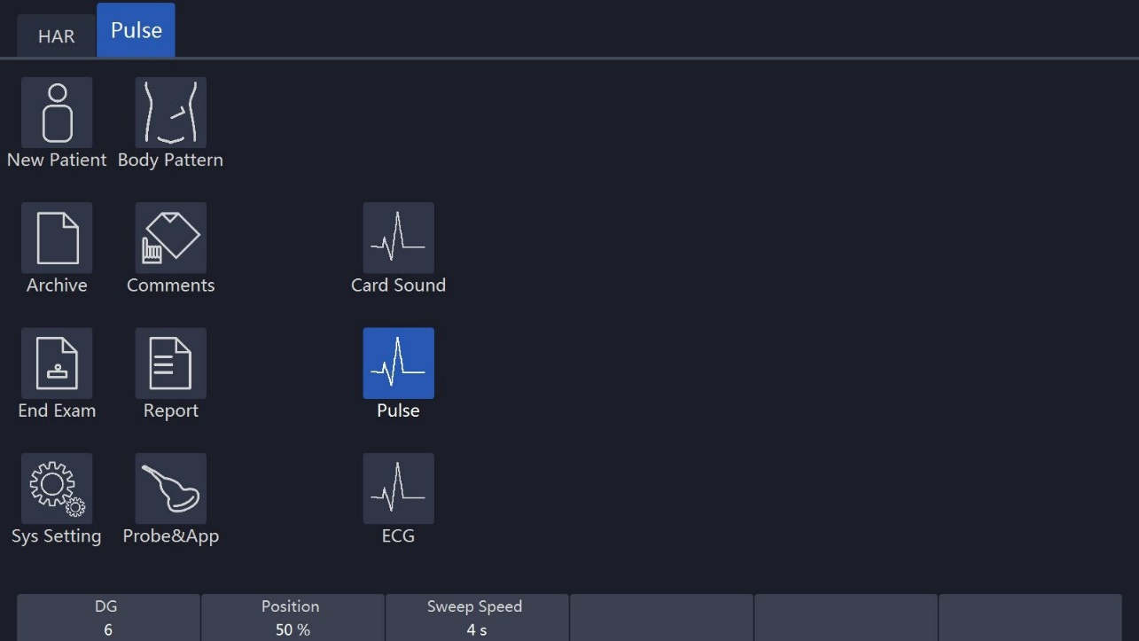

The heart app is generally set to on by default.

Gain, sweep speed, and pulse position should be adjustable in pulse mode.

## 3.15 Multiple display formats

This operation which described hereby is only for 2D mode, CF/PDI mode, PW/CW mode and M mode. 3D and 4D mode operations are different from these operations; the operator can refer to the 3D and 4D chapters accordingly.

Select different display formats on this set of buttons:

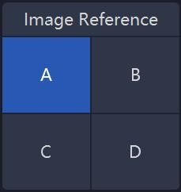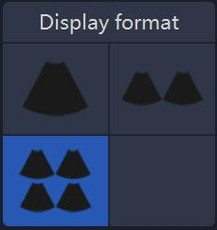If select “Dual” or “Quad” display format, select “A”/ “B”/ “C”/ “D” to change the active image.

Another method to change display format is pressing “Dual/Quad/Single” key on the keyboard. Please refer chapter 1.5.3.

## 3.16 2D Image size change

In 2D mode, adjust “Image Angle” to change the image size.

## 3.17 Customized UI layout

Users can enable it from this interface:

"System Setting->UI style->Adjust Param Layout"

It mainly realizes the following functions:

* Redefine the layout of buttons on the interface.
* Redifine the size of probe application area.
* Redefine the parameters corresponding to the spin buttons.
* Different applications can define different layouts.

## 

## 3.18 VWork

VWork can be enabled from this interface "System Setting->Optional functions->VWork", which supports to add twelve kinds of commonly used interfaces and functions into the step.

Users can perform the following operations:

* Define a workflow, unit or steps, and then the machine will automatically run according to predefined steps.
* Run/Ignore/Redo specific steps
* Clone the factory sample and modify the unit/steps, or create new steps from stretch.

# 4. Prepare for an Examination and Patient Data Archive

Before starting an examination, it is recommended to enter a new patient’s information before begin to scan. The patient information can also be entered while scanning, but the operator has to determine whether the corresponding image belongs to the patient or not before storing. The operator can pull out the patient’s information from the archive and start a new examination. The patient information is the same as before.

For new patient information, the recommendations are as follows:

1. Patient ID.
2. Patient name.
3. Birth date/age, gender.

This is stored together with the patient’s images and will be transferred with the images of the corresponding patient to the archive.

The information and application data below may differ in different examinations and we recommend that it should also be entered.

1. Physician, operator.
2. Basic data in relevant application category.

## 4.1 Beginning a New Patient

After “New Patient” on the touch panel is selected, the system will be in frozen status and the “Freeze” key on the control panel is highlighted to show this. The patient screen will be displayed as shown below. Press “Freeze” on the control panel or select “X” on the touch panel to go back to the main menu without saving the information. If the operator inputs some information on this page, and select “√” the system will create a “new patient” record and store this information to start scanning.

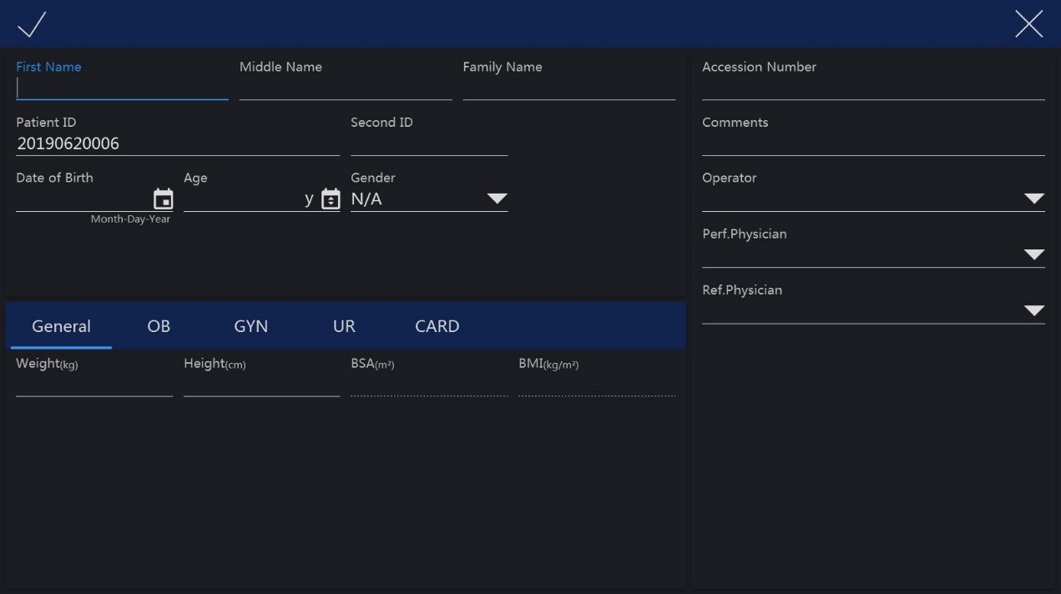

When enter “New Patient” page, there will be an auto ID in “Patient ID”, the operator can use this ID or input her/his own one. If set “prefix” in system setting, the prefix will be added.

Note:

1. BSA is body’s surface area, and will be automatically calculated when the data above (weight and height) is filled in.
2. The empty box is the data input field. After the relevant place is selected, the alphanumeric keyboard will appear and the alphanumeric keyboard can be selected to input data or characters.
3. Either birth date or age needs to be keyed in, the other one will be automatically calculated based on the time of the system. For this reason it is very important that the system time be correct. There are three gender options: N/A, male or female.
4. If the inputted ID is the same with the exited one, the system will give one warning message: There're some patient records match the creating patient, do you want to view details? The operator selects different options to continue: “Yes, review and select existed record”, “No, create new record”, “Go back new patient”.

If there is no patient ID or name, select “√” on the touch panel and the system will display a message for three options to select from. The options are: “Exit without new patient”, “New patient with auto ID’’ and “Go back to patient page”. Select “New patient with auto ID” and the system will automatically give a number for new patient ID. Select “Exit without new patient” and the system will go back to real scan mode without patient ID. If “Go back to patient page” is selected, the system will go back to the new patient page.

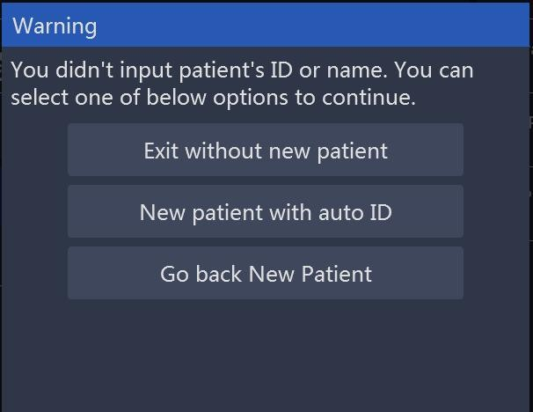

### 4.1.2 General data section

Patient ID: ID number, max 30 characters.

Second ID: ID number, max 15 characters.

Family Name: patient’s family name, max 20 characters.

Middle Name: patient’s last name, max 20 characters.

First Name: patient’s first name, max 20 characters.

Birth Day: patient’s date of birth.

Age: patient’s age (the age is calculated and displayed automatically after entering birth date).

Sex: N/A, female, male (pull down menu).

Perf. Physician: Name of the performing physician, max 30 characters. Ref. Physician: Name of the referring physician, max 30 characters.

Operator: Name of the operator, max input is 30 characters.

### 4.1.2 Application data information section

General: This category has the basic patient information for many applications which include Abdomen, Cardiology, Vascular, Neurology, Small parts, Pediatrics and Orthopedics. In this section, enter height and weight, and then BSA (body surface area) will be calculated automatically.

OB: patient information for obstetrics. GYN: patient information for gynecology. UR: patient information for urology.

CARD: patient information for cardiac.

The OB application patient information section is as shown below:

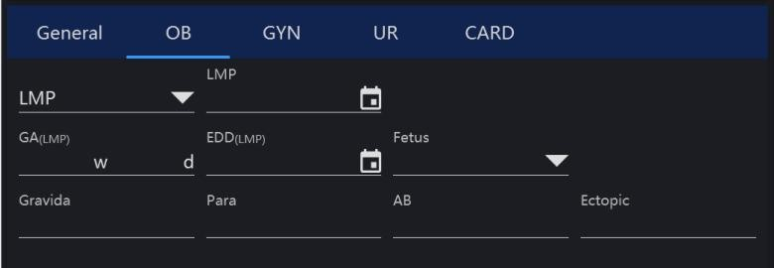

Note:

1. LMP: last menstrual period, enter the first day of the last menstrual period.
2. BBT: basal body temperature, enter the date of the most recently recorded basal body temperature before the last menstrual period. Data cannot be entered in this field if LMP data was entered before. It is possible to enter data for either LMP or BBT. Then the EDD and GA will be calculated based on the LMP or BBT.
3. EDD: Physician should either enter the estimated date of delivery, or this can be automatically calculated after entering the LMP or BBT. If “EDD” is entered, the “LMP” and “GA” can be calculated.
4. GA: gestational age, automatically calculated after entering the LMP or BBT. Or input GA manually, then get EDD automatically.
5. Gravida: enter the patient’s history of pregnancies.
6. Para: enter the patient’s history of live births.
7. AB: enter the patient’s history of abortions.
8. Ectopic: enter the patient’s history of ectopic pregnancies.
9. Fetus: select the number of fetus(es) (1 to 4).

GYN application patient information section is as shown below:

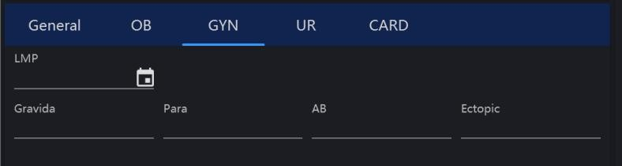

UR application patient information field is as shown below:

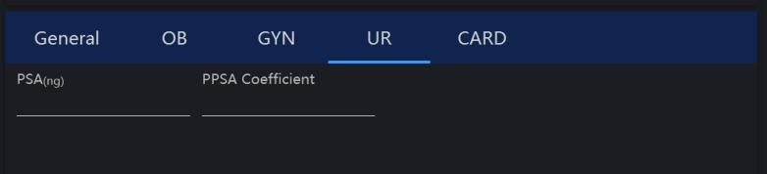

Note:

1. PSA: prostate specific antigen, enter the value of it.
2. PPSA Coefficient: enter the value of the predicted PSA coefficient.

CARD application patient information field is as shown below:

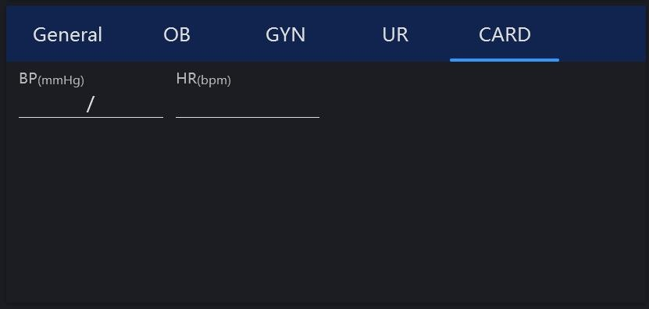

If the operator does not want to enter all the data, the examination can be started by selecting “B” or “Freeze” on the control panel or selecting “Save & Exit” on the touch panel.

Note:

If there is a temporary measurement and the image without entering any patient’s information and without storage, after “New Patient” or “Archive” is selected, an information dialog for option will appear. Select “OK”, enter “New Patient” page, input patient information to create one new patient, and the current image and the measurement will be stored in the new patient’s archive.

### 4.1.3 Indication Messages

|  |  |  |
| --- | --- | --- |
| **ID** | **Scenario** | **Indication message** |
| 1 | Touch “Save&Exit” button with no patient’s ID or name inputted in New Patient page. | You did not input patient’s ID or name. You can select one of below options for continue. Exit without new patient. New patient with auto ID. Go back to New Patient. |
| 2 | Touch “Save&Exit” in New Patient page if inputted patient ID is the same as one existed patient ID. | Patient ID already exists, do you want to continue? Yes, review and select exist record. No, create new record. Go back New Patient. |
| 3 | Touch “Archive” or “New Patient” if there is some unsaved data. | Do you want to attach the previous exam data to this new patient? |
| 4 | Select one or more patients, touch “Delete Patient” in Archive page. | Are you sure to selected patient(s)? |
| 5 | Select one exam, touch “Delete Exam” in Archive page | Are you sure to delete the selected exam(s)? |
| 6 | Export the same patients to the USB device. | There is exported data on the device and they will be totally deleted by following operation, do you want to continue? |
| 7 | There is no enough space on USB device when export patients data. | Export failed, no enough space left on USB or the device is removed. |
| 8 | The first time to use bluetooth. | New Bluetooth dongle plugged in, system will shut down for changes to take effect.  Do you want to continue? Please wait for 10 seconds, then start the machine again. |
| 9 | Send one or more images through email in Archive, but email setting is not completed. | Email setting is not completed, please check it in "Sys Setting". |
| 10 | In Sys Setting / network, email body is empty, touch “Test”. | Email body is empty, continue to send? |
| 11 | In Sys Setting/network, email subject is empty, touch “Test”. | Email subject is empty, continue to send? |
| 12 | Change language, time zone and so on. | System will shut down for changes to take effect. Do you want to continue?  Please wait for 10 seconds, then start the machine again. |
| 13 | In Sys Setting/Features, the inputted license is not valid. | System detects that the input license is invalid or is not for this machine, please contact manufacturer for support. |
| 14 | In Sys Setting/Features, the inputted license is valid. | Following options will be activated:  Do you want to apply?  If you choose OK, then license will be applied. |
| 15 | The system occurs unexpected exception. | Unexpected exception happens, the system will be shutdown.  We are sorry about this. |
| 16 | Print one report while the printer is not connected. | Failed to print report, please check whether the printer is installed properly. |
| 17 | Touch “Reset” in Probe&App page. | The presets of current probe will be restored to factory default value, do you want to continue? |
| 18 | Save the changes in Probe&App page, or add one user-defined application. | Confirm to save? |

## 4.2 Archive

“Archive” UI will be as shown below and the image screen is in the frozen status. Pressing “Freeze” at any time in this mode, the system will go back to the scan mode.

### 4.2.1 Initial Archive Exam

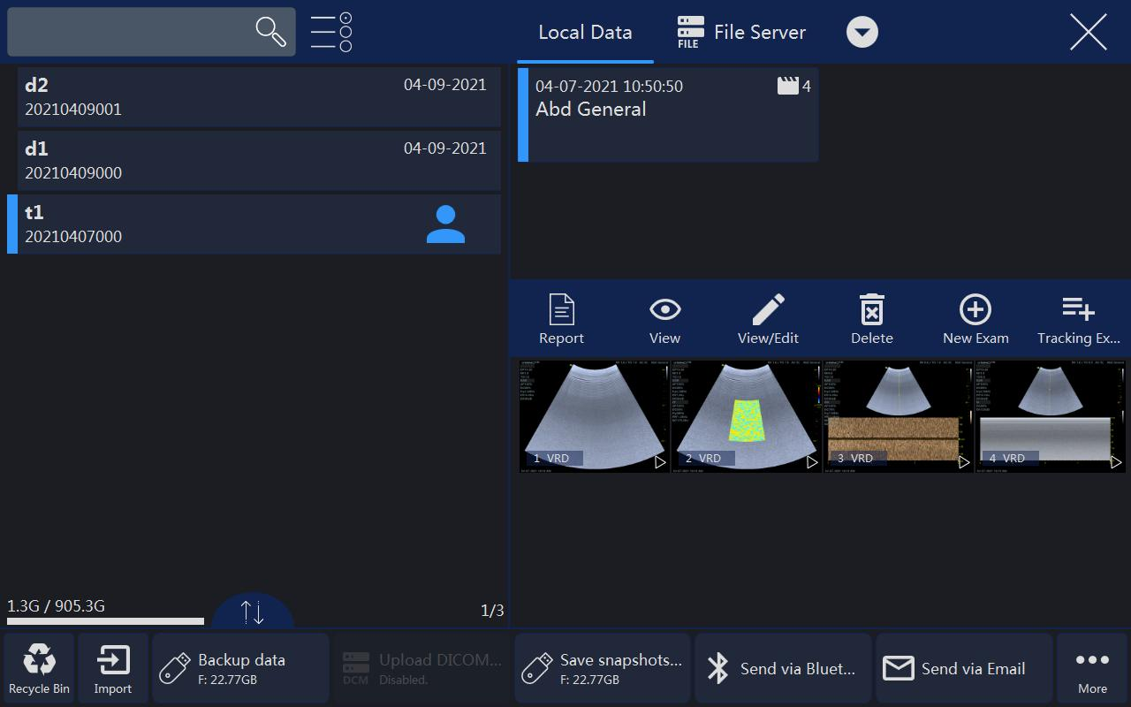

Note:

**Patient/Exam:**

1. After “End Exam” in main menu is selected, the current patient’s examination will cease the progress, at this moment there is no any patient is selected. The report of this examination cannot be stored, but can be printed, the information of this exam can’t be edited in Archive, and the button “Edit” in worksheet will be gone. New exam can be added in “Archive”, or new a patient to do examination.
2. Select “View/Edit”, all patient information can be edited if the selected exam is not ended and the patient is added in 24 hours. But only relevant application category’s data can be edited if the patient is added 24 hours ago.
3. Enable this button , more than one patient can be selected.
4. In the initial entering, the latest patient’s information will be displayed. In order to search certain files, input the information in the search input field, and then select “Search” on alphanumeric keyboard to search according to the input data. Touch , then select “Patient ID”, “Name”, “Last Scan” or other
5. tabs, all patients in the list will be ordered as ascending or descending.
6. “Easy Compare”: Select one image of one patient, select , the system exit “Archive” and enter dual display format, live scanning image is on the right
7. or the image selected on the clipboard before enter “Archive”, the image selected in “Archive” is on the left.
8. Select one image, click the trash icon to delete the image.

**Management:**

1. Save patient data or snapshots & video to USB, DVD or Server. Please refer chapter “Export patient or examination data”.
2. Delete the selected patient file or files by selecting “Delete Patient” on the touch panel.
3. Delete the selected examination file or files by selecting “Delete Examination” on the touch panel.

**Other Data Sources:**

1. Select one or more patients and click the download button, patient data in USB, DVD or Sever can be download into patient list.
2. In order to search certain files, input the information in the search input field,
3. and then select “Search” on alphanumeric keyboard to search according to the input data.
4. Images saved in other data sources can be played back and viewed.
5. Click the drop-down box to switch between different data sources.

### New Examination from Archive menu

“New Exam” UI will be shown as shown below.

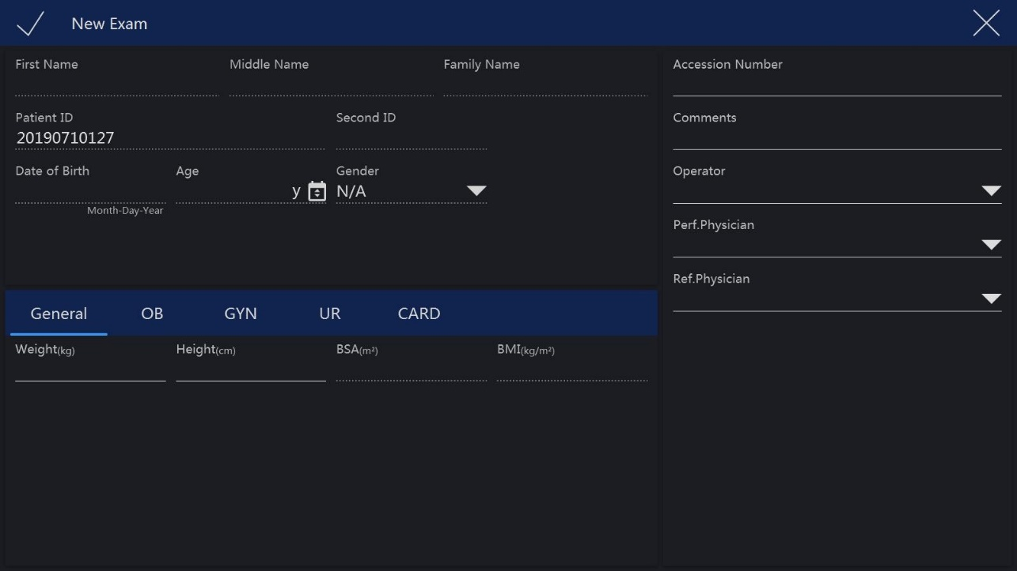

Note:

* + - 1. After “X” is selected, the system will go back to the “Archive” menu.
      2. At any time after “Freeze” is pressed, the system will go to the scan mode in the original examination (not the new examination).
      3. The previous information about the “Examination Physician”, the “Ref Physician” and the “Operator” data will display in the relevant areas by default. The operator can also edit them by selecting these fields. After these fields are selected, the alphanumeric keyboard will appear for input.

### 4.2.6 Bluetooth

Plug in one Bluetooth dongle, select one patient in “Archive”, touch “Bluetooth Send” button to enter Bluetooth page.

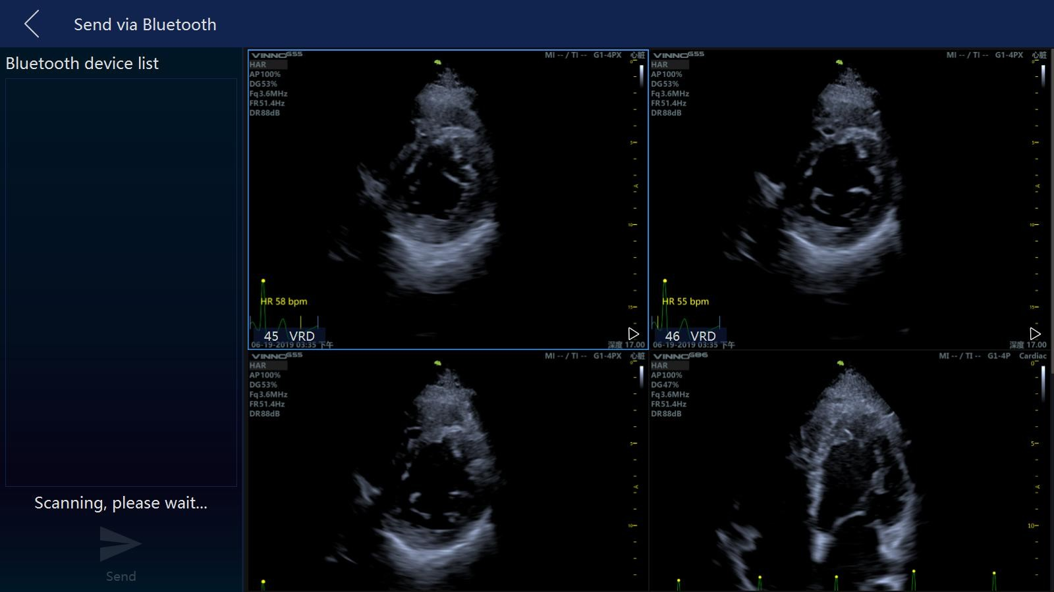

After scanning, list all nearby Bluetooth devices. Select one device, and select one or more images, touch “Send” to send the images to the selected device. Before send the images, the system will pair with the remote device first.

If power saving mode of the system is on, the operator need to restart the system when using Bluetooth at the first time. There is one bluetooth icon at the right bottom corner of the main screen when plug in the bluetooth dongle.

### 4.2.7 Email

Before use Email, the operator need to enable the network and set email settings in “Sys Setting”.

Select one patient in “Archive”, touch “Email Send” button to enter Email page. Input one or more addressees, then select images, touch “Send” to send the images by email.

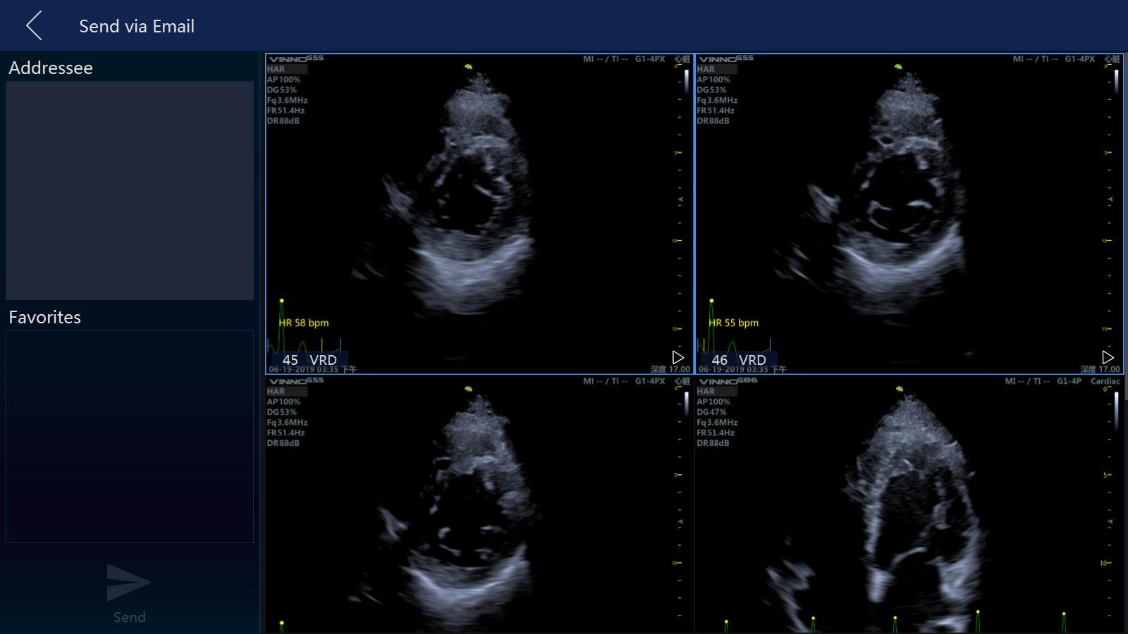

After send successfully, the addressee(s) will be saved in the list.

### 4.2.8 View menu

After “View” in the “Archive” is selected, the system goes to the view function and menu as shown below.

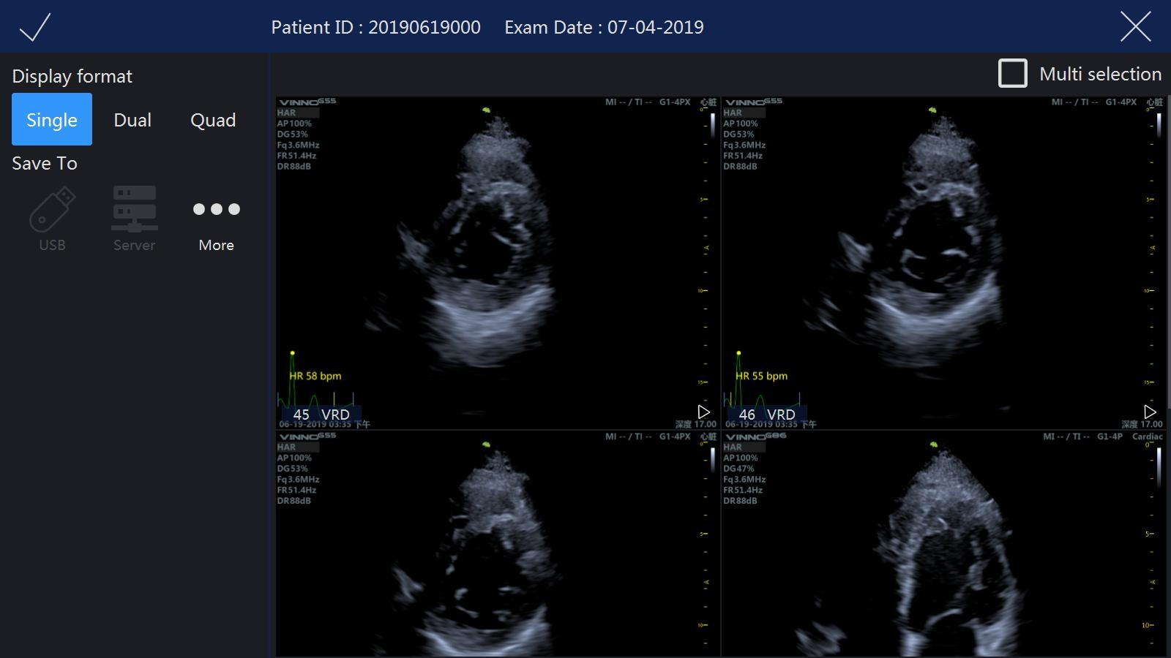

Note:

1. After entering the view mode, select the images, and then select “Single”, or “Dual”, or “Quad” to display the images in the different formats. Select the other images and the different view modes to be displayed. “Single” means that the image screen will display the first selected image. “Dual” means that the image screen will display the last two selected images as the dual image display format. “Quad” means that the image screen will display the last four selected images as the quarter image display format.

Only VRD images can be displayed in dual or quad formats

1. After small images are selected, the image box will be highlighted. If “Multi selection” is enabled, the first select in the relevant image means selection, the second select means un-selection.
2. Select button “More” to enter “More” page, the operator can send images via Bluetooth/Email or save images to DVD. Touch these buttons to enter relevant pages.
3. By selecting “Back”, go back to the “Archive”.
4. By selecting “Exit” on the touch panel or pressing “Freeze” on the control panel, go back to the previous scan mode.

### 4.2.9 Worklist

After enable “Worklist” in system setting, there is a “Worklist” tab in “Archive”. And there is another tab “Local Data”, display all patients created on the local machine.

The system get the patients from worklist server automatically when enter “Archive” if enable “Auto Load Worklist”. Choose one patient, select “Select Current” to start the exam. If capture some images, do some measurements or add some comments, the current patient will be saved to local data.

Choose the start and end date, then select “Search” to load all patients in this period. If select “Reset”, only load the patients of the day. If input patient ID or name then select “Search”, download the searched patient(s) from the worklist server.

### 4.2.10 Recycle Bin

Click the icon of Recycle Bin  in the lower left corner of the interface to enter the function. The deleted patient files will appear in the Recycle Bin.

**Restore**: Select the patient information in Recycle Bin, if you click the Restore button, the selected file will be restored to the patient management list, if you click the delete button, the information will be permanently deleted.

**Search**: Users can enter keywords in the search input field, such as patient name, ID, application and probe name, then click the search button to search the patient information according to the keywords.

**View and replay**: Click the image saved in patient data to play back and view.

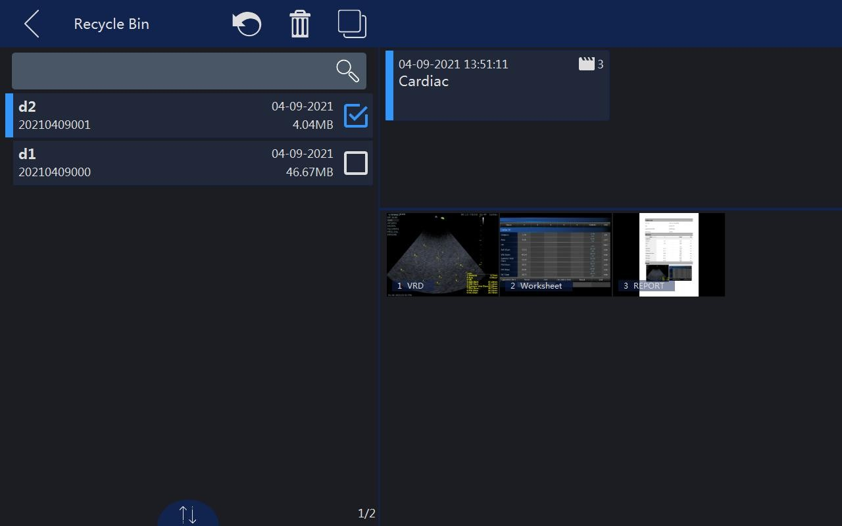

# 5. 2D B mode, M mode

## 5.1 2D Mode

### 5.1.1 Main menu

2D mode menu is as shown below. The parameters can be adjusted, such as “Frequency”, “Focus Position”, and slide the touch panel to the second and third page, more parameters can be adjusted.

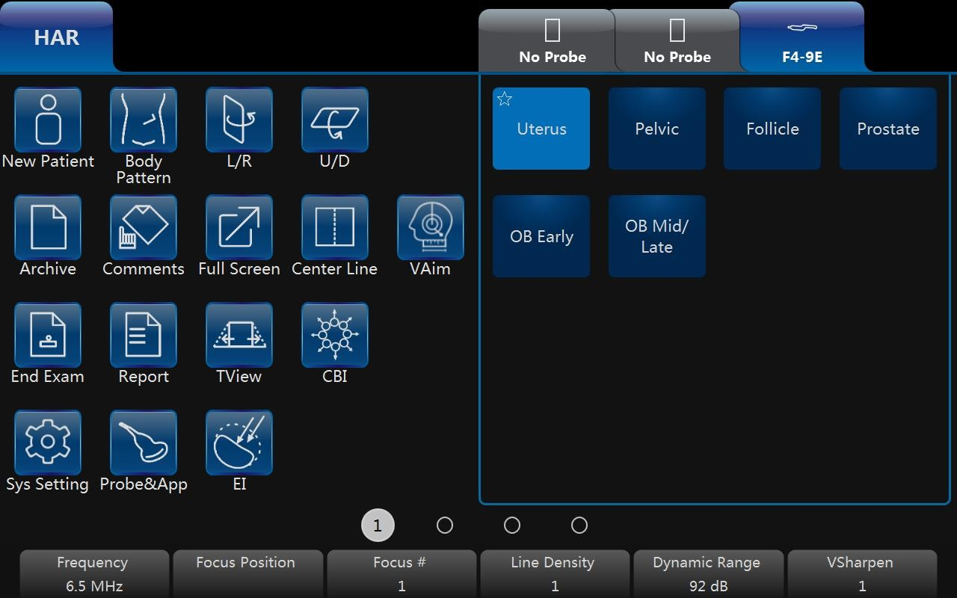

Note:

1. All the scanning operations should be performed through the control panel, while all the image optimizing operations such as the image adjustment, annotation, settings, and data base management should be performed through the touch panel.
2. The numbers indicate the adjustable parameter. The default number depends on the application setting.
3. Enable “TView”, the image will be wider in the bottom than the top to obtain a wider vision.
4. “L/R” means to fold image from the left to the right or the right to the left.
5. U/D means to fold image from the up to the down or the down to the up.
6. “Full Screen” can make the image to be zoomed as full screen size in order to enlarge the image. The image size is from the top to the bottom of the screen and the width is enlarged accordingly.
7. “VTissue” can automatically calculate the best acoustic velocity in tissue on the basis of the scanning data to improve the image quality. After this button is selected, it will be highlighted to show this function is active. Touch it again to remove this function and the echo speed will return to pre-set one.
8. The operation of HAR is similar to B. No “VTissue” in HAR mode.
9. “Vaim” means intelligent measurement. The feature only can be used under these items: OB, Pelvic, Uterus, Follicle and Ped Hip.

The up/down key parameters are as follows:

**Frequency**:

By regulating this parameter, the operator can strike a balance between resolution and penetration. High frequency generally means a better resolution at the cost of a worse penetration.

**Focus Position**:

It is to select the depth of current focus or foci. The focus position is indicated on the right-hand side.

**Focus #:**

This allows the operator to select the number of foci. The number of foci depends on the probe selected.

**Dynamic Range**:

This allows the operator to enhance the grayscale to make the image easier to display.

**Line density**:

This helps to keep a balance between the image resolution and the frame rate. A higher line density means a better resolution, but a slower frame rate.

**VSharpen**:

By this function, the edge of the image can be more easily observed with the naked eye. The higher the level of VSharpen, the better the edge of the image can be.

### 5.1.2 Additional B mode menu

When the operator wants to adjust the image quality by more parameters, slide the touch panel to the left, then the touch panel UI will display more parameters. The system goes back to the main 2D mode menu by sliding the touch panel to the right.

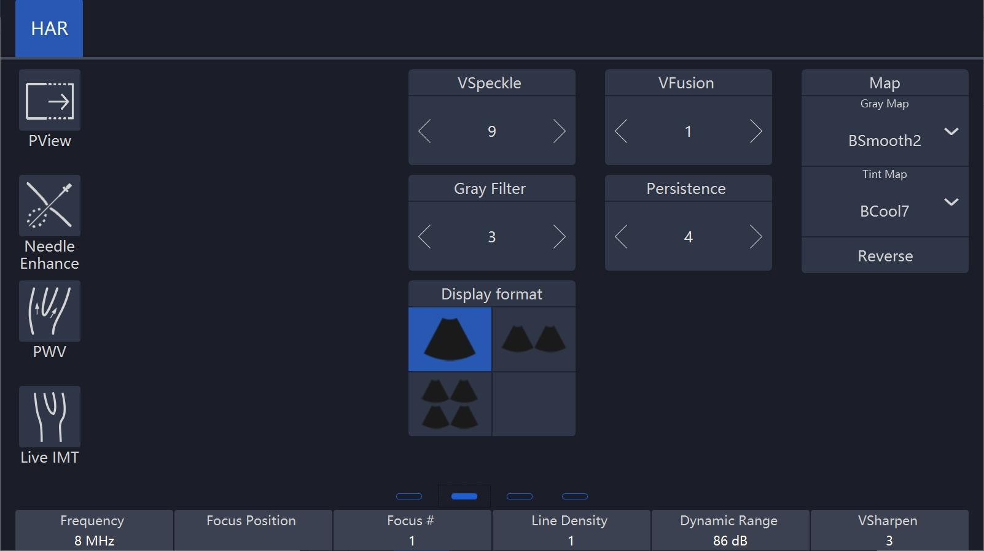

**Image Angle:**

This function can be used to change the scanning angle. A small angle can provide a faster frame rate, but the scanning area is smaller.

**Persistence**:

Frame averaging can eliminate the image speckle of the 2D images. Several frame averaging levels can be set in this menu.

**Gray Filter:**

Certain echo signals can be filtered by this function to avoid noise.

**Smooth**:

This smoothens out the image by reducing the number of pixels.

**Focus Width**:

Using this key change the focus zone width.

**Acoustic Power**:

This allows the operator to change the transmitted acoustic power.

**Biopsy**:

After this button is selected, the biopsy guide line will display on the image screen. Some biopsies have different angles to be selected. If this is the case, the system will display the selectable angles for the operator to select from. Different probes feature different biopsy guide lines.

**VNear**:

In the 2D touch panel menu, use the arrow in the “VNear” key to increase or decrease or switch off the level of compounding. When the level is 0, this function is switched off. When the level is 1, 2, 3, one more focus will be added if the position of the current focus(es) is >5 cm. If there are the most focuses, this function doesn’t work.

**EdgeEnhance:** Improving image quality and contrast by enhancing its edge and detail information and decreasing noise to improve SNR by diffusion filter.

**NeedleEnhance:** Only works with linear probes. To enhance the needle image when do biopsy. When this function is enabled, a red boundary line will be displayed to show the effective border which should not be crossed, rotating key “Rotation/Steer” changes its angle to match the needle, make sure the angle between the red line and the needle is 90°. Pressing key “Rotation/Steer” changes the direction.

**TI:** Select thermal index display which is one of TIS, TIB and TIC. TIS is the Soft Tissue Thermal Index. TIB is Bone Thermal index. TIC is Cranial Bone Thermal Index.

**SGC (Scanline gain compensation):** Gain compensation for tissue image scan line.

**VShear**: It only works under **B/HAR** mode, and then use these probes: X4-12L/ F4-12L/ U5-15L/ U5-15LE/ X6-16L/ F2-5C/ F2-5CP/ G2-5C/ X2-6C/ S1-8C/

S2-9C/ S2-9CE to enter the function.

### 5.1.3 Freeze mode

In freeze mode, the touch panel UI appears as shown below. The stored image can be optimized by adjusting the parameters or changing the maps when needed.

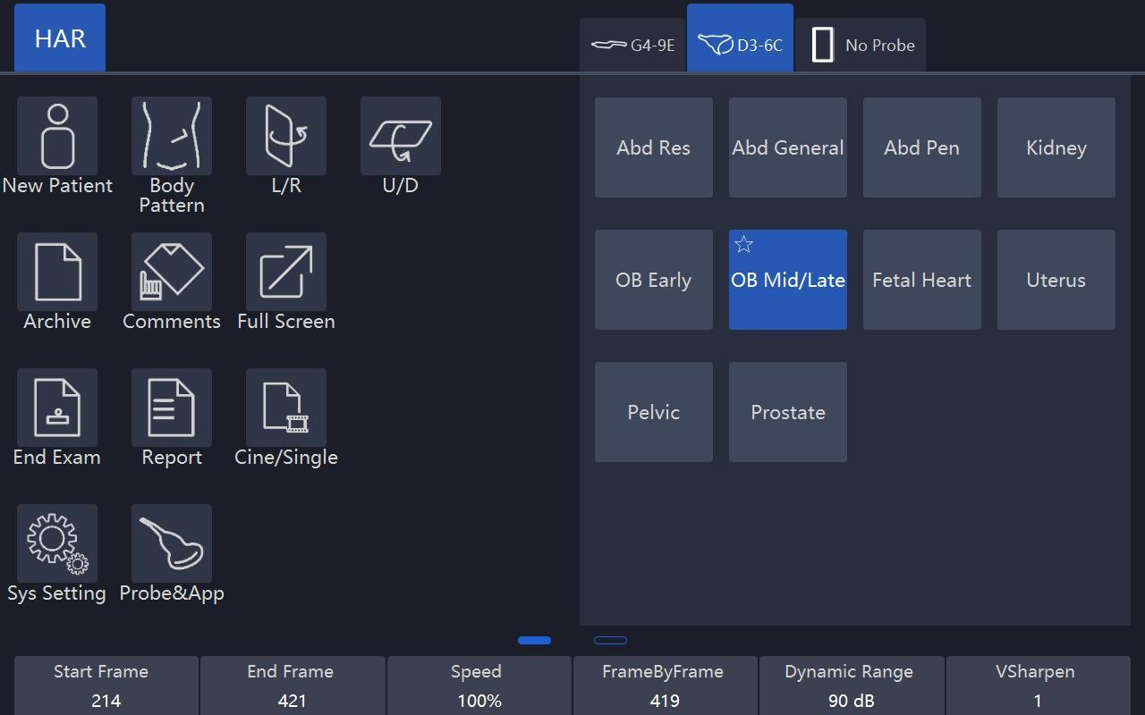

Note:

1. In Freeze mode, no adjustment is available for the “Frequency”, “Focus Position”, “Focus #”, “Line Density”, “VSharpen”, unlike the live B image.
2. Cine/Single: allows images to be switched to display as either cine mode or single-image mode. The highlighted button means the cine mode and non-highlighted button means the single-image mode.
3. Start Frame, End Frame: controls which frame to start from and which to end in order to display continuously as a loop.
4. Speed: controls the cine speed as 400%, 200%, 100%, 60%, 50%, 40%, 20%.
5. In freeze mode, switch to CF/PDI or PW/CW freeze mode (if available) for adjustment by selecting mode buttons on the upper section of the screen.

## 5.2 Operation

### 5.2.1 General operation

**Gain**: With rotation of the “B” key on the control panel, the overall brightness of 2D image is adjusted. All incoming echoes are amplified with the same digital gain value regardless of the depth. Turning “Gain” control clockwise makes the entire image brighter, and counterclockwise makes the image less bright. The digital gain value is displayed on the screen.

**Depth**: Rotating “Depth” on the control panel can move the different depth of the image. This change can only be in real time scan mode. When turned clockwise, the depth range of the 2D image is enlarged and the display size of the image is reduced to display the entire depth range. When turned counterclockwise, the depth range of the image is reduced and the display size of the image is magnified.

Note:

1. Maximum and minimum depth varies according to the different probes used.

2. Actual depth is displayed in the information header.

**TGC slides controls**: Using the “TGC” slides control keys on the control panel can vary the gain in the certain depth of the 2D image. Sliding to the left decreases the gain in the corresponding specific 2D depth. Sliding to the right increases the gain in the corresponding specific 2D depth.

**B Steer**: 2D image can be steered right direction, center (no steer), left direction. The drawing below is shown as reference. B steer only exists in the linear probes.

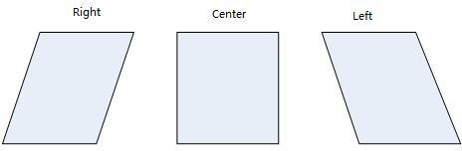

**2D Automatic Optimization**: The “Auto” key on the control panel can optimize the contrast resolution according to the histogram of the scan area. After “Auto” is pressed, this causes the automatic optimization of the gray scale to enhance the contrast. After “Auto” is pressed again, the automatic optimization function is switched off. When the auto function is active, the key is highlighted.

**Harmonic Imaging**: The harmonic imaging reflects the harmonic of the nominal transmitted frequency, such as double, threefold and fourfold. It gives the better grayscale contrast compared to the standard ultrasound imaging. Pressing “HAR” leads harmonic imaging. After switched on, this key is highlighted.

**Frequency:** This is an indicator and a non-touchable key on the touch panel UI. It can be adjusted by the corresponding up/down key which is located below the indicator. The “Frequency” is receiver frequency. The range allows for the fast adjustment of the resolution and the penetration. The high frequency has better resolution, but less penetration. Different probes have different ranges of frequencies.

**Focus Position:** The focus zone improves the depth range of the optimized sharpness of ultrasound beam. It helps resolution of the depth image. Using the up/down key on the control panel with corresponding position, the focus position can be changed.

**Focus #:** Using Focus # up/down key to select the number of focal zones. The max of the focal number is 8. The more level of focal zones, the lower the frame rate is.

**VFusion:** This function enhances the contrast resolution with better tissue differentiation and clear organ borders. In the 2D touch panel menu, use the arrow in the “VFusion” key to increase or decrease or switch off the level of compounding. When the level is 0, this function is switched off.

**VSpeckle:** This function reduces the speckle noise in the ultrasound image. In the 2D touch panel menu, use the arrow in the “VSpeckle” key to increase or decrease or switch off the level of speckle noise reduction.

Notes: This process smoothes the image, so potentially some structures can be smeared out.

**Dynamic Range:** It enhances a part of the grayscale and makes it easier to display pathology.

**Line Density**: More line density will have better resolution, but will impact the frame rate.

**VSharpen**: This allows the operator to sharpen or smooth the image edge

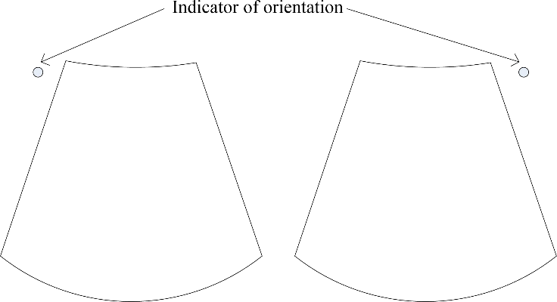 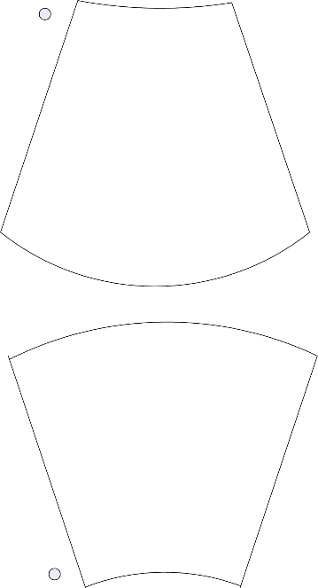

**Left/Right**  **Up/Down**

**L/R and U/D**: They allow the operator to fold the image from left to right or right to left and up to down or down to up as shown below for reference.

### 5.2.2 Trapezoid View

Trapezoid view will enlarge the scanning area in order to let the operator see more. For example, the linear probe scanning image is a rectangle, but after this function works, the scanning image will change to a trapezoid which has a larger scanning view in the bottom.

After “TView” on 2D mode menu is selected, this button will be highlighted and the scanning image will be trapezoid shape to have a wider view in the bottom.

### 5.2.3 PView

Panoramic view function provides the ability to construct and view a static 2D image which is wider than the field of view of the selected probe. It constructs an extended image from the individual image frames as the operator moves the probe along the surface of the skin.

**Operation**

1. Select “PView” on the touch panel to enter “PView” mode.
2. To start acquiring the image, select “Start” on the control panel. Then move the probe slowly, steadily and in uniform motion lengthwise. Make sure that the probe stays in one plane throughout the scan. The image is stored as you perform the scan and can be monitored during acquisition.
3. To complete the scan, select “Stop”.
4. Press “Reacquisition” to clear the extended image and return to the normal image, and the operator can start again. Selecting the “Exit” on the touch panel goes back to the normal image scan.

The quality and usefulness of the extended images is impacted by the probe motion. The incorrect technique can generate a defective image. A good quality extended image is characterized by the smooth edges and a clear direction. All structures visible in properly scanned 2D images can be easily identified. A poor quality extended image can be recognized by its rough and curved edges. Also, it may contain sections showing noise and defects next to sections of clear structures.

If any poor quality extended image has been generated, the scan has to be repeated and the poor image considered as useless. Any measurement based on a poor image is to be considered not correct.

Note that the accuracy of measurement in the extended images is limited and can be lower than measurement on the B images. It is not recommended to use this measurement: be aware that any diagnostic conclusion must not be made based on panoramic image alone and needs to be checked with other diagnostic procedures.

Precaution for uniform motions as follows:

* Make sure that there is enough gel along the scan path.
* Move the probe slowly and steadily.
* It must be ensured that the probe during the acquisition of the extended image always remains in contact with the skin.
* Keep the motion within the same scan plane and do not change the direction of movement during the scan.
* Deeper scanning needs slower motion of the probe due to more data acquisition needed.

Display the speed of probe moving at the upper left corner of the main screen. The value of the speed is green if it is less than 3 cm/s. It is yellow if it is bigger than 3 cm/s and less than 5 cm/s. It is red if it is bigger than 5 cm/s.

If “Enable PView Advanced Features” is enabled in “Sys Setting” rotate “Zoom” key, PView image can be zoomed out/in, and its position can be changed by moving the trackball.

### 5.2.4 Map

The gray map determines the displayed brightness of an echo. With a different gray map, a harder or softer image can be obtained. Image gray can be adjusted both in the freeze and scan mode.

M Mode.

The “M” mode imaging provides the echo information of motion with change of time derived from a stationary ultrasound beam. “M” mode is used along with a 2D image, with one line through the 2D image which is called the “M” cursor. This cursor identifies the position of the ultrasound beam. The motion of the echo information at this position over time is to display “M” mode.

## 5.3 M mode

**Activation of M mode**: By pressing “M” on the control panel, the system goes to “M” mode. Use the trackball to move the “M” cursor left or right by moving the trackball left or right. 2D and “M” mode stopped by pressing “Freeze” on the control panel. The main menu on the touch panel is as shown below:

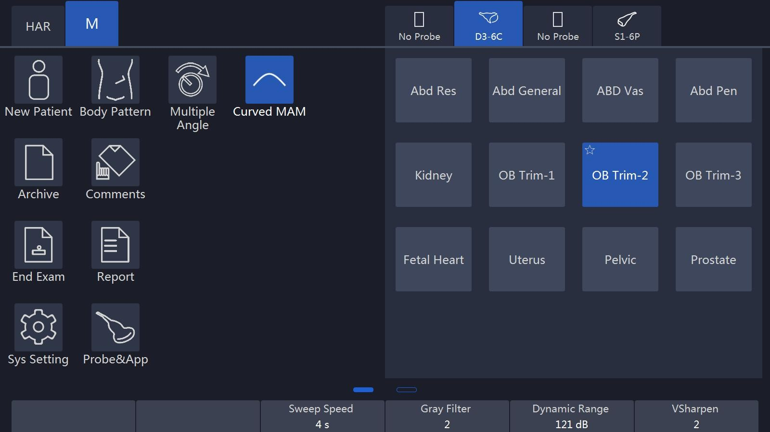

**Display format:** Operator can change the display format by selecting it on the t ouch panel. In format, there are two kinds of display. One is side by side, while t he other one is up and down. In each type of the format, different splits between “B” and “M” traces displays can be selected. In side by side format, there are thr ee kinds: “H 1/2”, “H3/4” and “Full”. In up and down, there are three kinds: “V2/3”, “V1/2”, and “V1/3”.

**Dynamic Range:** This allows the operator to enhance the grayscale range to make it easier to display pathology. Selecting the up/down key can change the different dynamic control curves.

**Acoustic Power:** This can adjust the transmit power by selecting the up/down key.

**Sweep Speed**: This can adjust the different sweep speeds by selecting the up/down key on the control panel which matches the relevant touch panel indicator.

**Gray Filter:** It determines the threshold above which the ultrasound echoes are displayed on the screen in order to suppress the smaller echoes. The Gray Filter value is displayed in the relevant information area on the touch panel.

**VSharpen:** This allows the existing information easily visible through the digitally processing.

**Gain:** This can adjust the overall brightness of the “M” mode trace. The adjustment of the “Gain” control determines the amplified amount which applied to the received echoes. “M” gain function only influences the M trace. With clockwise, the entire image becomes brighter. With counterclockwise, the entire image becomes less bright.

**Curve MAM**: The feature supports drawing smoothed curve for Multiline and

Color MAM . Multiline MAM supports to draw four lines at most

### 5.3.2 Freeze in M mode

After “Freeze” on the control panel is pressed, the image will be in the single frame display status. The operator can move the trackball horizontally to recall the stored M sequence. By selecting “Single/Cine” on the touch panel can be changed to the Cine mode. After this button is selected, this button will be highlighted. The 2D image will be automatically replayed. The start frame and end one can be changed in the 2D menu. By moving the trackball, the 2D image can be reviewed frame by frame.

# CF (Color Flow Mode) / PDI (Power-Doppler Mode)

The Color Flow imaging and Power Doppler imaging uses the Doppler principle to build the image. It gives the information about blood flow velocity, direction, quality and timing. This information is used to overlay a color image onto the 2D grayscale scan image.

## 6.1 CF mode operation

### 6.1.1 Main menus of CF mode

**The activation of CF mode:** Pressing “CF” on the control panel will activate the “CF” mode. Then, the “CF” box appears in the active 2D image. “Gain” is controlled by rotation of this key. After this key is pressed, the menu appears on the touch panel (scan mode) as shown below.

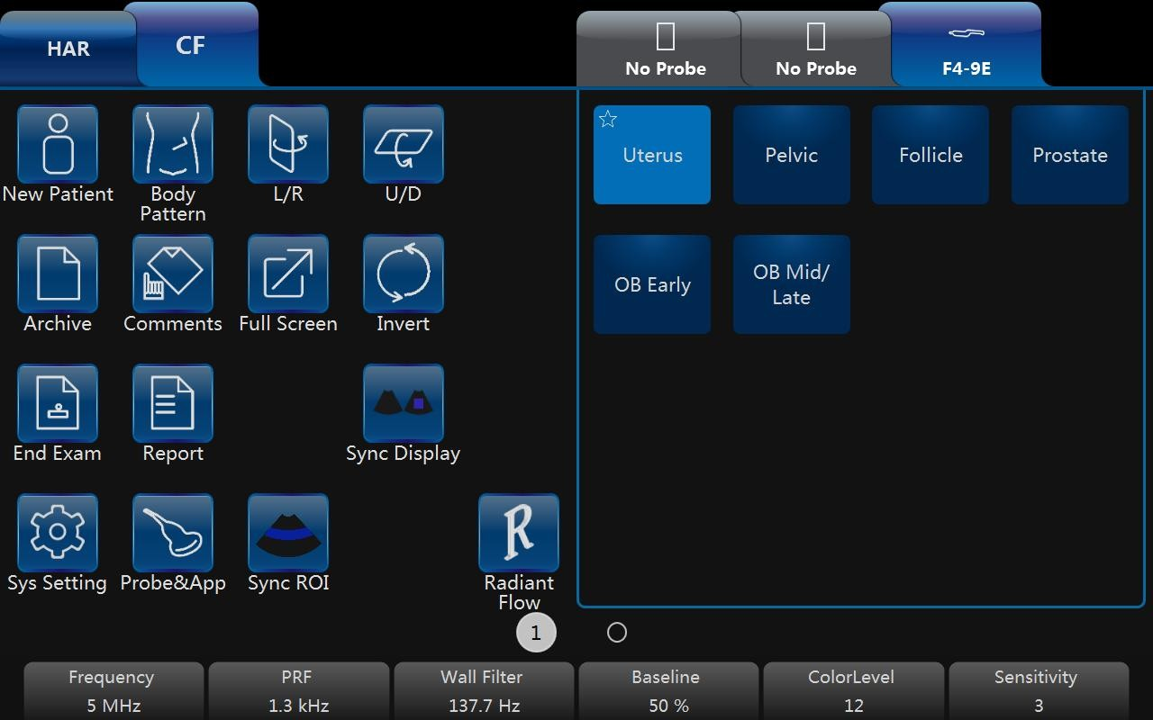

Note:

1. All main functions for scanning operations will come from the control panel.
2. The touch panel function keys are mainly focused on the image adjustment, annotation, setting, and database management.
3. The “B” button is for the operator to switch to 2D mode parameter change. If “PW” or “CW” is on, the “PW/CW” button on the touch panel can let the operator switch to “PW/CW” screen for parameter change.
4. The “PDI” mode does not have an “Invert” button.
5. Slide the touch panel to the left to obtain more parameters.

**Frequency:** This setting controls the transmit frequency. With a higher frequency, the lower flow velocities are displayed better at the given PRF, but the penetration depth is reduced. With a lower frequency, the sensitivity in depth will be increased.

**PRF:** The Pulse Repetition Frequency (PRF) governs the displayed velocity range. Increasing the PRF will increase the range of velocity. High PRF will avoid aliasing of blood. However, higher PRF will have a loss of sensitivity to low flow velocities.

**Wall Filter:** Wall motion filters are used to eliminate the vessel wall motion and the cardiac motion noise that is low in the velocity and high in the intensity.

**Packet Size:** It controls the number of samples gathered for a single color flow vector. This allows the operator to improve the color sensitivity and accuracy of color averaging if increasing the packet size or increase the frame rate if decreasing the packet size.

**Color Level:** This function eliminates the small color noise or motion artifact signals.

**L/R:** After this button is selected, the image will be folded from left to right and right to left.

**U/D:** After this button is selected, the image will be folded from up to down and down to up.

**Invert:** This function inverts the color display in relation to the direction of the flow. Normally the red color represents flow to the probe and the blue color represents away from the probe. After inverting, the color will represent different.

**Color map:** Those allow the operator to select different color-coding for blood flow display (similar to the post-processing curves with gray scale of B image).

**Line density:** It determines the line density within the “CF” box.

**Sync Display**: After this button is selected, there will be two images on main screen, the left one is 2D image, the right one is 2D+CF image.

**Radiant Flow**: The feature is only supported in **CF/PDI** mode. After this button is selected, the image of flow will be radiant and three-dimensional.

**Sync ROI:** After the button is selected, the width of image is the same as CF ROI.

In order to have more parameters to change, slide the touch panel to the left to enter the more parameter menu as shown below:

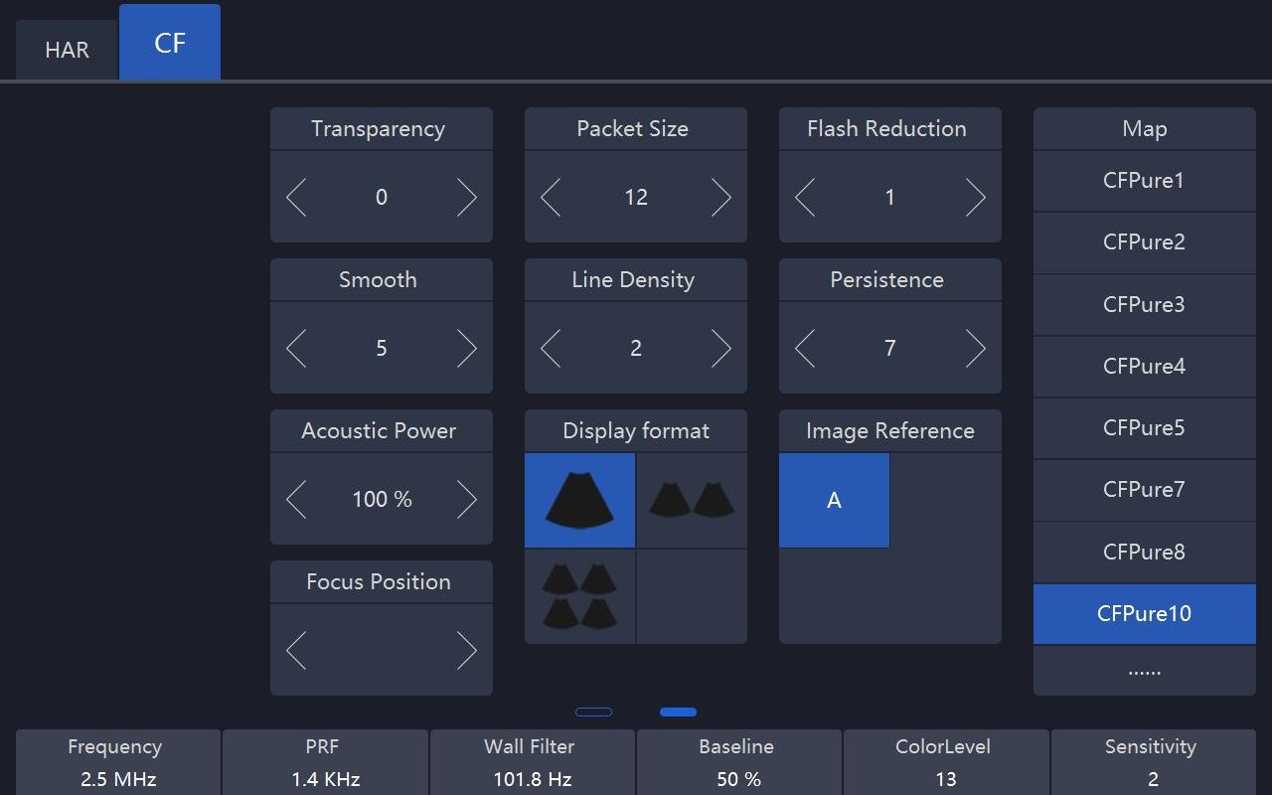

Note: Slide the touch panel to the right to go back normal “CF/PDI” mode menu.

**Persistence:** It smooths the image by performing a temporal averaging which improves the appearance of the color image.

**Flash Reduction**: It reduces movement artifacts in the image.

**Line density**: Higher line density will improve the resolution and the reduce frame rate.

**Base Line**: It can be used to prevent aliasing in one flow direction similar to the Doppler baseline shift. Shifting baseline will enlarge the velocity range in one direction.

**Transparency:** Indicates the visibility of background image.

**Acoustic Power:** It adjusts transmit acoustic power. The higher acoustic power has better penetration.

**Steer:** Steer the CF ROI box right direction, center (no steer), left direction.

**BiPlane probe:** It only supported BP4-9 probe, and can be used under these items: "Uterus/Rectum/Prostate". User can sync display and switch Linear/Convex probe by clicking line/Conv button on touch panel.

After “Freeze” on the control panel is pressed, the system enters frozen mode and the touch panel UI will change to the one below. Using the trackball reviews the image frame by frame similar to the 2D mode no matter whether it is in the cine or single mode. The image in the cine mode or single frame mode can be reviewed by selecting “Cine/Single” on the touch panel. In single mode, the last frame is displayed in the initial entrance.

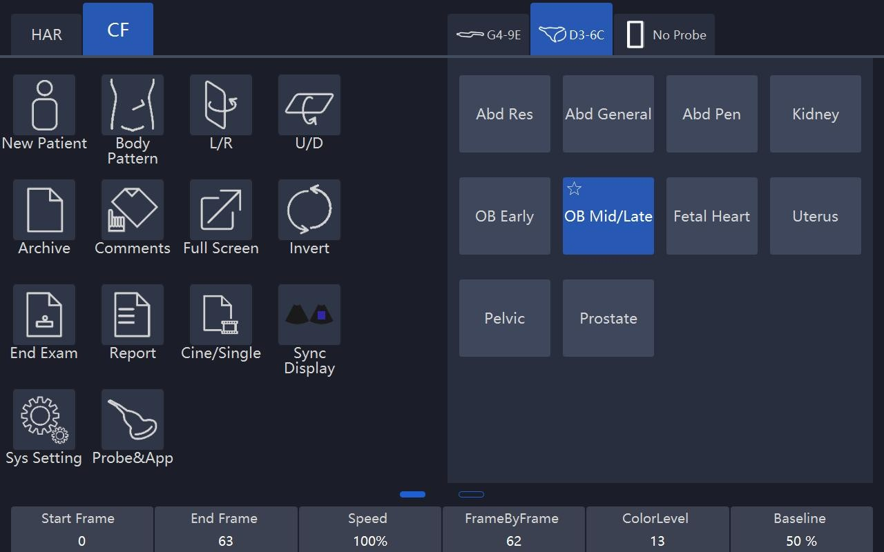

Note:

1. In Frozen mode, there will be no panoramic view function.
2. Start Frame, End Frame: control which frame to start from and which to end in order to display continuously as a loop.
3. Speed: control cine speed as 400%, 200%, 100%, 60%, 50%, 40%, 20%.
4. In frozen mode, “B” or “PW/CW” mode (if available) can be switched, for adjustment by selecting the mode buttons on the top left.

### 6.1.2 CF box position and size

The ability to change the “CF” mode box size and the position can provide the flexibility in imaging. After “ROI” highlighted (pressed from the normal status), trackball movement will change the box size. Right/left movement will increase/decrease the box size from side by side view. Up/down movement of the trackball will increase/decrease the box size from up and down view.

When “ROI” on the control panel is not highlighted (default status), the trackball movement will change the position of the color box.

### 6.1.3 CF mode gain control

Rotating “CF” can adjust the “CF” mode digital gain in order to change the sensitivity. If “CF” gain control is too low, it will be difficult to detect the small abnormalities in flow and will possibly result in an underestimation of the large flow disturbances. If “CF” gain control is too high, the noise will be introduced and disturb normal flow detection. So “CF” gain needs to be adjusted properly to ensure continuous flow display, and also be set as high as possible unless the random color speckle appears.

Similar to the other gain key, clockwise increases and counterclockwise decreases gain.

## 6.2 Power Doppler (PDI)

Power Doppler is intended to compensate some deficit of the Color Doppler. Its advantages comparing Color Doppler are less dependent on the incident angle, no aliasing, less dependent on the direction, and sensitive to slow flow.

After “PDI” on the control panel is pressed, the system will enter “PDI” mode.

The “CF” rotation key will impact gain of “PDI” by clockwise or counterclockwise rotation. Similar to the other rotators, clockwise increases the gain and counterclockwise decreases the gain.

The layout is similar with the color mode. However, the color bar will have a difference; in the color mode, the color bar has two colors to indicate the flow direction (To probe is red, away from probe is blue). “PDI” color bar does not have the direction information and it indicates the power of flow. “PDI” menu is similar with the color mode. However, all velocity-determined functions are not available in “PDI”; for example, there is no “Invert” button.

The operation of “PDI” is similar to Color Doppler too and can refer to “CF” mode operation.

# 7. PW and CW mode (Spectral Doppler Mode)

The spectral Doppler describes the Doppler shift signal within a sample volume. It displays scroll from left to right and displays the spectral distribution of Doppler shift frequency over time. The frequency or velocity values appear on the vertical axis and time along the horizontal axis. The strong or weak signal is displayed as varying shades of gray. The strong signals are displayed as bright while the weaker signals are less bright.

## 7.1 PW mode (Pulsed Wave Doppler)

A sample volume cursor is located on the “PW” cursor and it indicates where, along the ultrasound beam, the spectral analysis is being performed.

### 7.1.1 Operation of PW mode (main menu)

After “PW” on the control panel is pressed, the system will enter “PW” mode. “PW” rotation key will increase or decrease the gain by clockwise and counterclockwise.

The main menu is as shown below:

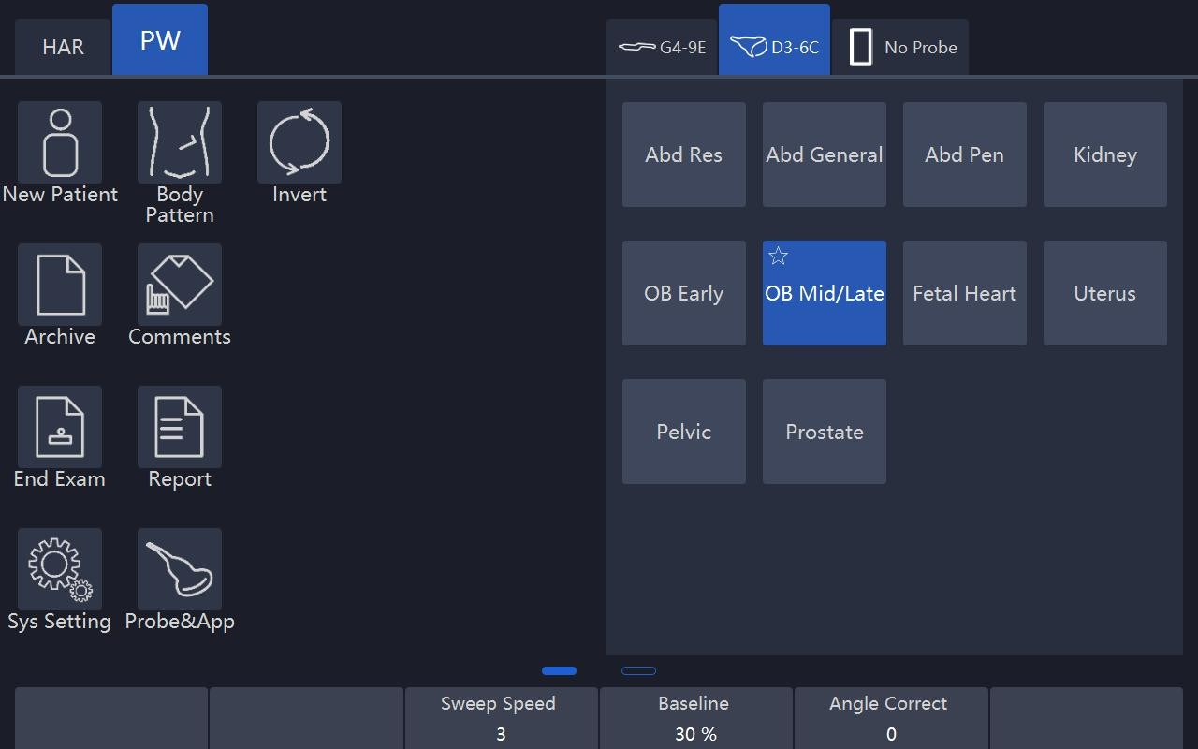

Note:

1. If “CF” or “PDI” mode is inactive, the relevant “CF/PDI” button will not be displayed. Only when “CF” or “PDI” is on, “CF/PDI” and “B” buttons on the top left are in active mode for ready to switch.
2. In three key group buttons ( “Auto Trace”, “Mode”, “Direction”), only one of the three button keys (such as “Off” or “Frozen” or “Live”, “Off” or “Mean” or “Max”, “Above” or “Both” or “Below”) can be activated and highlighted.
3. In the “Angle Correct” up/down key, if up or down is held, the angle will be adjusted by a large amount continuously.

**Duplex and Triplex:**

When the system is in “2D+ CF + PW” mode, it will have “Duplex” and “Triplex” scanning mode. “Duplex” mode means that the system only activates “2D + CF” or “2D + PW”. If “2D+ CF” mode is active and real time scanning, the “PW” will be a static image. In this time, the touch panel will go to the “CF” mode. By selecting the top left side mode keys can switch menu mode. If “2D + PW” mode is active and real time scanning mode, “CF” mode will be a static image. In this time, the touch panel will go to the “PW” mode. The operator can press “Enter” on the control panel to switch between one of them. “Triplex” mode means that the system will have real time scanning for both “2D+CF” and “PW”. The operator can select “Duplex” or “Triplex” button on the touch panel to activate the mode accordingly. Only one of “Triplex” and “Duplex” mode can be activated and highlighted in one time. The default setting (“Duplex” or “Triplex”) depends on the application.

**Sample volume position and width:**

In “PW”, a specific area along the ultrasound beam is sampled. This is called the sample volume, which is located on the ultrasound beam and is displayed as two lines perpendicular to the beam line. The location and the size of the volume can be changed.

The location can be adjusted by the trackball. Moving the trackball up, the sample volume will move up, and moving the trackball down, the sample volume will move down. Moving the trackball left or right will move the PW cursor left or right.

Select the up/down arrow in the “Sample Volume” button on the touch panel to change the sample volume size.

**PW automatic optimization:**

To perform the auto optimization by pressing “Auto” on the control panel. After this key is pressed, the system will automatically detect the highest flow velocity and adjust the velocity scale (PRF) accordingly in order to display the velocity in full scale properly. At the same time, the baseline will be shifted in order to display the full spectrum.

**Display format:**

Display format: Operator can change the display format by selecting it on the to uch panel. In format, there are two kinds of display. One is side by side, while th e other one is up and down. In each type of the format, different splits between “ B” and “PW” traces displays can be selected. In side by side format, there are th ree kinds:”H 1/2”,”H3/4” and “Full”. In up and down, there are three kinds: “V2

/3”,“V1/2” and “V1/3”.

**Invert:**

This function inverts the “PW” spectrum display in relation to the direction of flow. The displayed spectrum is inverted around the baseline. The velocity or frequency scale changes accordingly. After “Invert” on the touch panel is selected, this function will work. Spectrum above baseline is the blood flow towards the transducer and spectrum below baseline is the blood flow away from the transducer in normal orientation. In invert status, the orientation will be opposite.

**Trace Direction:**

The operator can also select different trace directions to be “Above”, “Below” or both of them. “Above” means that the trace will be along the curve of the spectrum above the baseline. “Below” means that the trace will be along the curve of the spectrum below the baseline. Selecting both of them means that the trace will be along the curve of the spectrum above and below the baseline. The corresponding evaluation is automatically displayed on the monitor and updated in every heart cycle.

There are vertical dotted lines to indicate the latest 1-5 cycle(s), the number of cycle is configured by “Heart Cycle” in PW page. “+” means the peak of the spectrum.

**Trace Mode:**

Operator can select trace mode to be “Max”, “Mean”, or both of them. If none of them is highlighted, auto trace is disabled.

**Heart Cycle:** 1-5 cycles can be selected.

**Trace Sensitivity:**

Select the trace sensitivity to balance the sensitivity and artifacts. The high sensitivity settings may cause artifacts. The low sensitivity may cause smoothing to some incident events.

**Acoustic Power:**

By pressing “Acoustic Power” on the touch panel can change the transmit power. The high acoustic power output has better penetration.

**PRF:**

The velocity range on display is controlled by the pulse repetition frequency (PRF). As the PRF increases, the velocity measurable range is increased too. As the display scale increases, the maximum Doppler shift information can be increased. The relevant up/down key increases or reduces PRF. Possible the maximum sampling frequency can be automatically adapted based on the sample volume depth.

After the certain level of PRF is exceeded, the system is activated into “HPRF” (high PRF mode) mode which can increase the maximum measurable flow velocity further.

The normal maximum measurable flow velocity is determined by the measuring depth of the sample volume. In order to further increase measurable flow velocity to reach the normal limitation, one or more additional sample volumes is added along with the ultrasound beam cursor as the virtual sample volume. The blood flows recorded by the virtual sample volume are overlaying the actual Doppler signal of the main sample volume.

**Baseline:**

The change of “PW” spectrum baseline can enlarge the velocity range in one direction. The displayed velocities or the frequencies on the upper and lower edge of the screen show the maximum measuring velocity range. The up/down key corresponding to baseline can change it up or down.

**Steer:**

PW line can be steered. Only works with linear probes.

**Angle Correct:**

To obtain the optimum resolution and the accuracy from the Doppler measurements, the angle which is between the ultrasound beam and the blood flow should be maintained between 0 and 20 degrees in order to display the vessel in longitudinal section and the angle cursor must be positioned parallel to the vessel axis. Rotating key “Rotation/Steer” the angle changes 1° at one time, or pressing it the angle changes 15° at one time.

**Sweep Speed:**

By pushing the relevant up/down key can adjust speed. The faster sweep speed may be useful to analyze flow curves.

**Others:**

“Frequency” and “Wall Filter” can be adjusted the same as color mode.

### 7.1.2 Operation of PW mode sub menu

Sliding the touch panel to the left, the submenu will display as shown below:

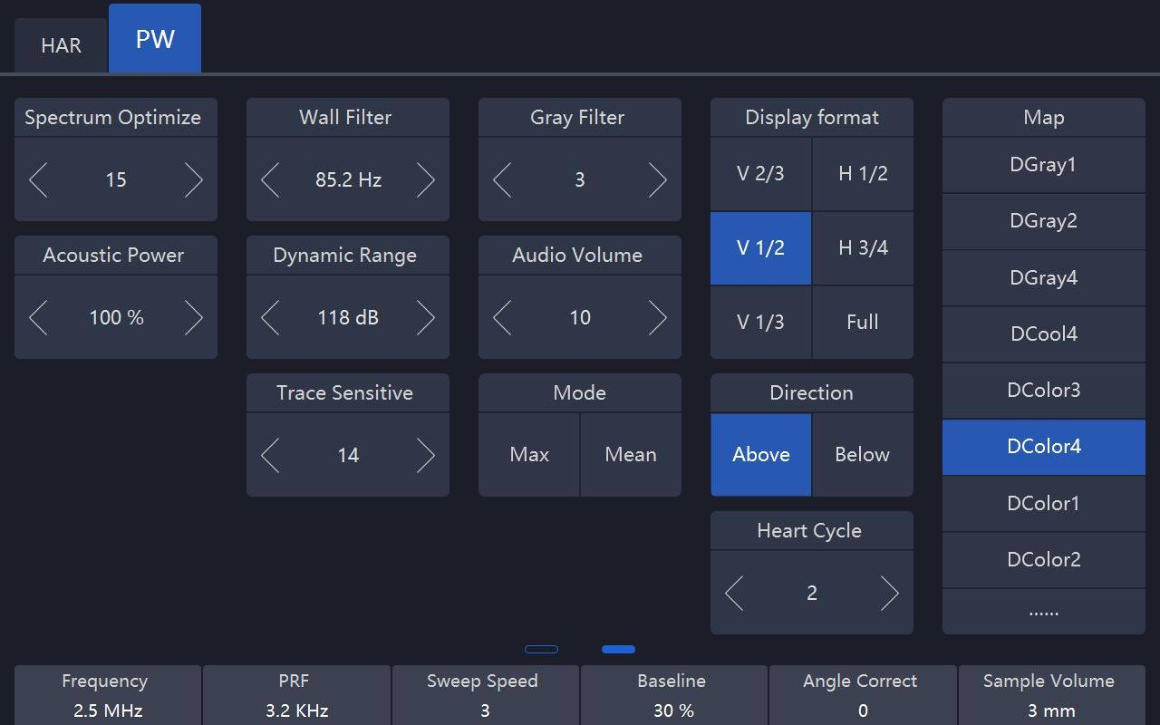

**Audio Volume:**

This allows change the volume of the audio signal for the “PW” spectrum.

**Gray Filter:**

In order to eliminate low level echoes caused by noise, the operator can adjust this value to remove the certain level of echoes before processing.

**Dynamic Range:**

The “Dynamic range” refers to the compression of the grayscale information into suitable range for the display. It can enhance a certain grayscale range which makes it easier to display pathology. When increasing dynamic range, this will decrease the brightness to more gray shades and less contrast. When decreasing the dynamic range, it will increase the brightness to be less gray shades and more contrast.

**Spectrum Optimize:**

It processes several near-by spectra to optimize spectrum display. The identified number indicates a number of spectra to be processed.

**CW mode (Continuous Wave Doppler)**

“CW” mode operation is same as “PW” mode, which can refer “PW” mode operation steps. The main difference between “CW” and “PW” is that “CW” can detect much faster flood shifts.

**Freeze in PW/CW**

After “Freeze” on the control panel is pressed, the image will be in single frame display status. To recall stored “PW/CW” sequence by moving the trackball horizontally. If selecting “Duplex”, and pressing “Freeze”, both the 2D and “PW” image will freeze. At this moment, selecting “B” on the top of the touch panel to switch to B menu, the “B” image loop can be recalled.

# 8. 3D/4D

## 8.1 Static 3D

### 8.1.1 Workflow

* Pressing “4D” on the control panel to enter “3D/4D” mode. In “4D” mode, select “3D”, “STIC”, “4D”, or “MCut” button to switch different modes. Entering one mode can adjust the ROI.

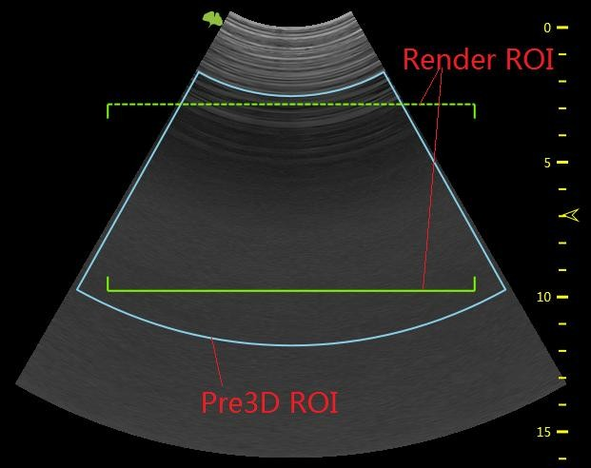

Pre3D ROI is blue, and render ROI is green. Move the trackball to change the position of pre3D ROI and render ROI. Enable “ROI” key, pre3D ROI becomes dotted line, at this moment, the sizes of both pre3D ROI and render ROI can be changed by moving the trackball.

Press “Enter” key to fix pre3D ROI, its color becomes yellow, and render ROI becomes blue. At this moment only render ROI’s position can be changed by moving the trackball. Press “Enter” key again, the below line of render ROI becomes dotted line too, and the size of render ROI can be changed by moving the trackball.

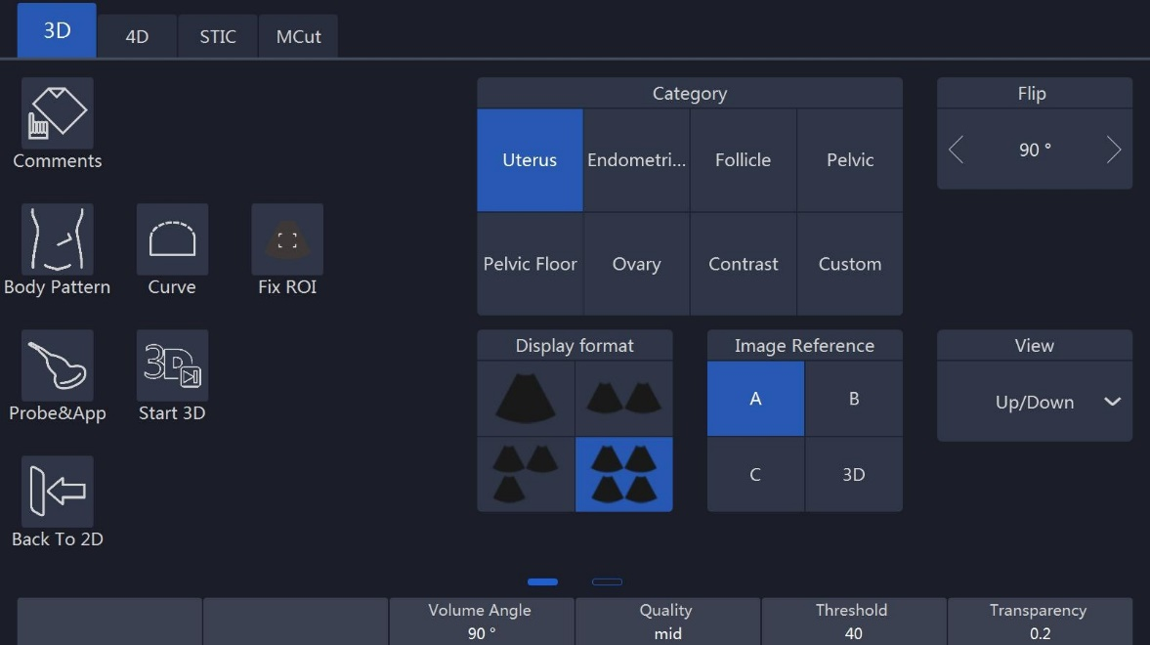

Notes:

1. Slide the touch panel from the left edge, more parameters can be adjusted.
2. VSpeckle: Speckle noise reduction level.
3. Threshold: This means the minimum level of gray displayed. The scan echo which is lower than the threshold will be suppressed in order to make the volume image cleaner and with less noise.
4. Transparency: This can adjust the transparency in detail during the surface rendering mode.
5. Volume Angle: This means 4D probe scanning angle in traditional 4D probe; it will control the overall scan area or thickness; if there is a very small angle with high quality, then it will have a high contrast volume image.
6. Quality: Resolution level – “high”, “good”, “mid”, “low”, the default setting is “good”. “Low” means a fast sweep speed and low scan density. High means a slow sweep speed and a high scan density, with have the best volume resolution.
7. After “Comments” on the touch panel is selected, the touch screen will go to the “Comments” menu. At this time, the touch panel image format is same as image screen. After finished, select “Exit” to go back to the previous menu.
8. After “Body pattern” on the touch panel is selected, the touch screen will go to the “Body Pattern” menu in order for the operator to select the body pattern and move the probe indicator direction in the body pattern.
9. Curve: Enable “Curve” to change the shape of render ROI by moving the trackball.

After data acquisition finished, render ROI’s shape can be changed as the same. Enable “ROI” key, change the size of render ROI by moving the trackball. But if “3D” is selected for “Image Reference”, neither render ROI nor curve ROI can be changed.

1. Fix ROI: Enable it, ROI can’t be edited ROI again, but the center point of the image can be moved.
2. Category: Different categories can be selected in the pull-down menu, the available categories are different with different applications.
3. Flip: The image can be flipped 90,180 or 270 degree.
4. The data acquisition mode can be selected. There are kinds of rendering modes: general and HQ.

* The 3D display format can be changed. One is the full screen image display mode, and the other consists of two or four image displays--- A, B, C plane and 3D rendering.
* The rendering view angle can be selected, from front to back, or from back to front, or from right to left, or from left to right, or from up to down, or from down to up. This selection button will be on the touch panel.
* Select “Start3D” on the touch panel to start 3D data acquisition or press “4D” on the control panel to start data acquisition. During data acquisition, the touch panel will show a status bar to indicate the progress of data acquisition. The image screen will only display the scanned images continuously at the same speed as the 4D probe sweep. The operator needs to hold the probe well in order to obtain a good data acquisition.
* Select a gray map by touching the relevant gray map button.
* Select a 3D map by touching the relevant 3D map button.

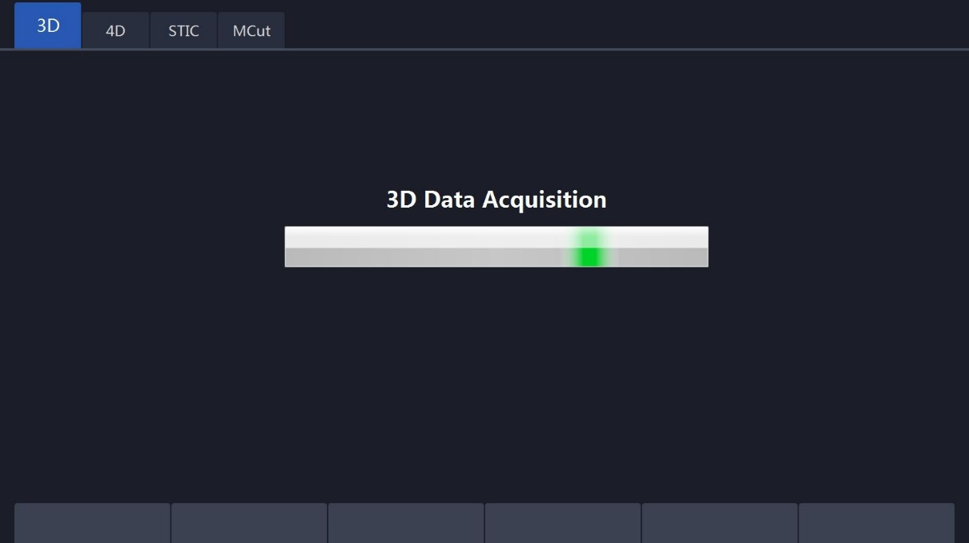

* After data acquisition has finished, the 3D image display format is based on the one which was selected before data acquisition.

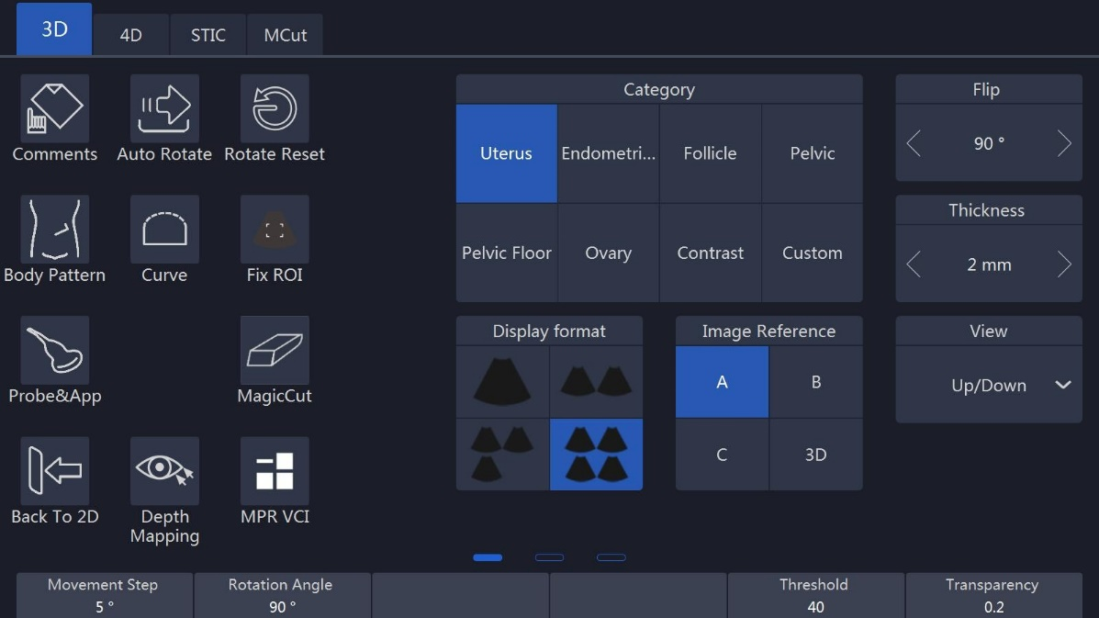

Notes:

1. After selected in “HQ Surface/HQ Grad/HQ Silhouette” acquisition mode, the touch panel menu is displayed as above. There is one adjustment button “DR Light” to adjust the rendering light position for a different rendering appearance, and a button ”Light Hue” to adjust the degree of transparency.
2. In this mode, other rendering modes still can be selected.
3. 3D Mesh: Support saving 3D data to external media for 3D printer.

If general acquisition mode is selected, the touch panel menu is displayed as shown below:

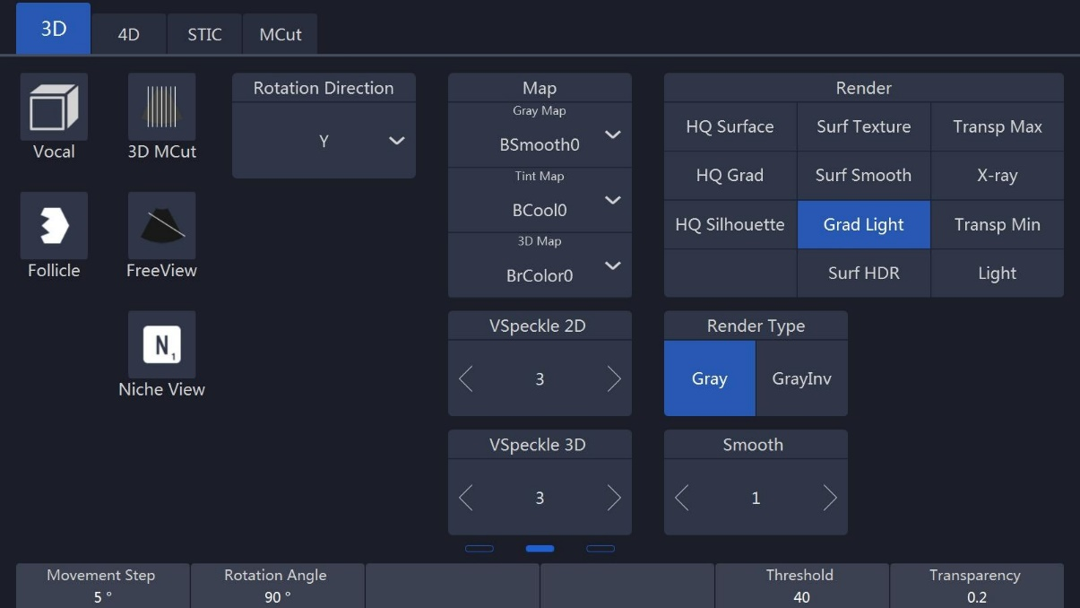

Notes:

1. Movement step: It will impact the rotation angle step in 3D image when enable “Auto Rotate”. By selecting a high number, the movement will be faster.
2. After the 3D image is activated and highlighted, one of the X, Y and Z directions will be active, while the others are inactive. The active one is highlighted and the “Rotation/Steer” key on the control panel can only rotate the 3D image in the corresponding direction accordingly (X, Y, or Z direction). The operator can select X, Y or Z direction by selecting the corresponding key. After “A”, “B” or “C” plane is activated and highlighted, the “Rotation/Steer” key can shift “A”, “B”, “C” plane and rotate 3D image.
3. Rotate M, PW, CF keys can also rotate the images, M is corresponding X direction, PW is corresponding Y direction, CF is corresponding Z direction.
4. The highlighted image position reference key (“A”, “B” or “C” plane, or “3D”) indicates which image is active for adjustment. Select the image on the main screen, the image reference on the touch panel will jump to the relevant plane.
5. The “Threshold” and “Transparency” can be changed after 3D data acquisition.
6. Speed: This controls playback speed; 100 will be same as a real scan, and then 75, 50, 25.
7. Slice position: allows a displacement of the center along the intersection lines of the sectional planes A, B or C. Rotating “Depth” to adjust slice position.

Reference image A: The sectional plane migrates from the front to the rear through the volume body.

Reference image B: The sectional plane migrates from the left to the right through the volume body.

Reference image C: The sectional plane migrates from the top to the bottom through the volume body.

1. View: These define the rendering orientation from which to view 3D.
2. Auto Rotate: It lets the 3D image continuously rotate along the rotation direction. After selected, this button will be highlighted. If it is selected again, it will be inactive. Speeding up/down key will change the rotation speed in order to give the operator more time to see the images.
3. After data acquisition, the system is in frozen status. After “Freeze” is pressed at this time, the system will go back to the 3D initial status.
4. There are two render types: Gray and GrayInv. The "Gray" type is rendering echogenic tissue structure. On the contrary, "GrayInv" rendering type intends to display hypoecho structures, bladder, uterus tec.

Rendering approaches: In the rendering group keys, there are two different rendering methods. One is “Surface mode”, the other is “Perspective mode”. Each method has several approaches. Only one of the approaches can be selected at one time. Each approach’s explanation is as follows:

* Surf Texture: Surface rendering mode based on Marc Levoy’s research, which displays the surface of the object.
* Surf Smooth: Apply smooth filter to the volume date, which displays a smoothed surface of the object.
* Grad Light: Surface rendering with the Phone light model, which displays the surface of the object with light on it.
* Transp Max: Displays only voxels with high echo response.
* X-ray: Displays all voxels with equal probability.
* Transp Min: Displays only voxels with low echo response.
* Light: Displays the object by its distance to the observer.

1. HQ Surface/HQ Grad/HQ Silhouette: Touch this button to obtain a high-quality rendering image.
2. Gray map: Select a gray map by touching the relevant gray map button.
3. 3D map: Select a 3D map by touching the relevant 3D map button.
4. Rotate Reset: Reset the image if it is rotated.

* The image position can be changed by moving the trackball, the direction is same as the trackball.
* To change the ROI size the same as other modes by using the “ROI” key on the control panel and trackball.
* In dual or quad image display format, there are rotation axes on image “A”,” B”, “C”.
* In single image display format, only 3D rendering image displays on the image screen
* Image Reference: After the reference position is touched and highlighted or in single display format, “Rotation/Steer” key will rotate the 3D image by X, Y or Z axis. X, Y and Z can be selected on the touch panel.
* There is a direction indicator in each plane image in order to identify the direction match with probe orientation. In A Plane, one mark indicates the scan start point against the probe mark.
* In 3D mode, “Comments” and “Body Pattern” can be activated.
* Slide the touch panel to the next page, select “Single” display format, drag the 3D image, it will rotate along the finger. Touch 3D image once, come out axis Z guide, drag the 3D image along the circle, it will rotate along Z axis. If select “Dual” or “Quad” drag the 2D image, it can be moved, drag the 3D image, it will rotate as in single mode. The 2D image and 3D image both can be zoomed in/out by two fingers.

### 8.1.2 3D MCut

* Touching “3D MCut” to go to multi-slices display.
* Interval: Adjusts the interval distance between each slice.
* Slice Number: Different slice number can be selected: 4x4, 3x3, 2x2.
* Cut Plane: Smaller image size due to display screen limitation. The operator can select which plane (A, B or C) is to be cut by “Cut Plane” group keys. The first displayed image is the selected plane with slice line.
* Rotation direction: “Rotation/Steer” key will rotate the MCut image by X, Y or Z axis. X, Y and Z can be selected on the touch panel.
* Rotate M, PW, CF keys can also rotate the images, M is corresponding X direction, PW is corresponding Y direction, CF is corresponding Z direction.
* Pressing “Freeze” on the control panel to go back to the initial 3D mode status. After data acquisition, the system is inthe frozen status as all operations are based on already acquired data.
* Touching “Back to 2D” on the touch panel or pressing “B” on the control panel to go back to the normal 2D mode.

### 8.1.3 Free View

* Touching “FreeView” to go to Freeview mode.
* Direction: Adjusts the direction in which Freeview unfolds the slice.
* Route: Different kinds of slice route control.
* Line: straight line pattern, start by mouse click, end by mouse click.
* Polyline: polyline pattern, start by mouse click, end by mouse double-click.
* Curve: curve pattern, start by mouse click, end by mouse double-click.
* Clear: Undo the slice route by press “clear” button on keyboard. For Polyline pattern and Curve Pattern it will undo the last segment of polyline or curve.
* Image Reference: Change the reference image at the left side of the screen.
* Press “A” will show sagittal plane;
* Press “B” will show coronal plane;
* Press “C” will show transverse plane.
* Slice Thickness: Freeview is not only able to do different regular or irregular plane, but also able to issect the volume with variable plane thickness by adjusting “Slice Thickness”.
* Rotate M, PW, CF keys can also rotate the images, M is corresponding X direction, PW is corresponding Y direction, CF is corresponding Z direction.
* 3D Map: Map configure for plane image at right side.
* Gray Map: Map configuration for reference image at left side.
* Pressing “Freeze” on the control panel to go back to the initial 3D mode status. After data acquisition, the system is in the frozen status as all operations are based on already acquired data.

Touch “Back to 2D” on the touch panel or press “B” on the control panel to go back to the normal 2D mode.

### 8.1.4 MagicCut

* Touching “MagicCut” to go to MagicCut mode.
* Erase Mode: Adjusts the way to edit the volume. There are four edit methods.
* Small Circle: small rubber to erase finely.
* Big Circle: big rubber to erase coarsely.
* Inside Lasso: edit volume by Lasso, inside the Lasso will be erased.
* Outside Lasso: edit volume by Lasso, inside the lasso will be kept, while others will be erased.
* Undo: Undo the last edit operation. Support multiple “Undo” operations until the whole volume is recovered, no edit left.
* Redo: Retrieve the edit undid by “Undo” operations.
* Reset: Reset the volume to original state.

### 8.1.5 VOCAL

Touch “VOCAL” after 3D data acquisition, enter VOCAL page. Before enter “VOCAL” please select the reference image (A, B or C) to generate the contours.

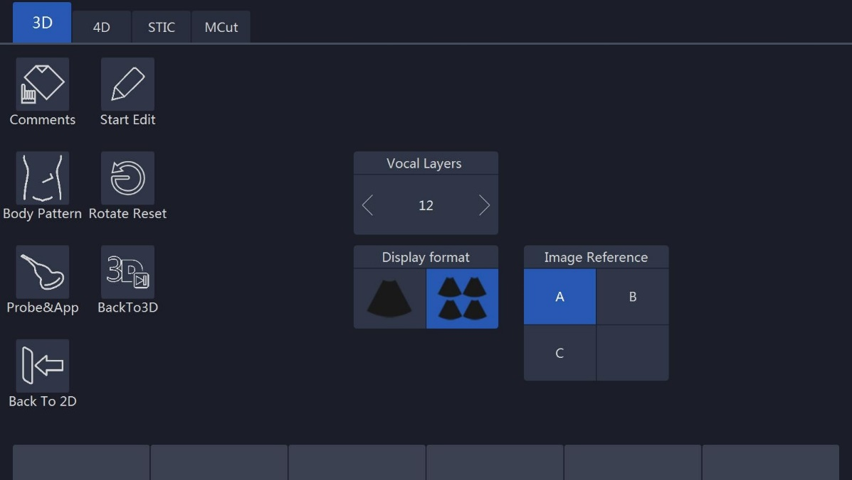

Vocal layers: 8, 12, 16, 20, 24, 28, 32, the number of generated contours.

Touch “Start Edit” to start generating the contours. There is a default contour, and also one contour can be outlined manually. Touch “Clear” to erase the existed contour, then new contour can be outlined. Touch “Next” to display the next layer. Touch “Previous” to back to the last layer, edit the contour.

All contours are outlined, touch “Done” to finish the progress, the result is displayed on the monitor.

Re-Edit: Back to the first layer, the contour is still existed, it can be reviewed and edited.

Redo: Start the progress from the beginning again, all contours are erased.

**Shell:**

1. After finished editing the contours;
2. Touch “Show Thickness” button, the 3D image will show two shell contours;
3. Pull up/down “Thickness” key, the thickness of the shell can be adjusted;
4. If you touch “Redo” button, the image will be restored to its original state;
5. Touch “Thickness” button again to exit the feature.

**Threshold Analysis:**

1. Touch “Show Threshold” button, the volume of the part above the threshold and below the threshold will be shown on the screen;
2. Pull up/down “Threshold” key to adjust it, the higher the value, the more signals are removed;
3. Touch “Threshold” button again to exit the feature.

**Histogram:**

1. Touch “Histogram” button after calculating the volume, the automatically calculated histogram will be displayed on the touch screen;
2. Touch “Histogram” button again to exit.

### 8.1.6 Free3D

Select one LINEAR probe, press “4D” key to enter Free3D page.

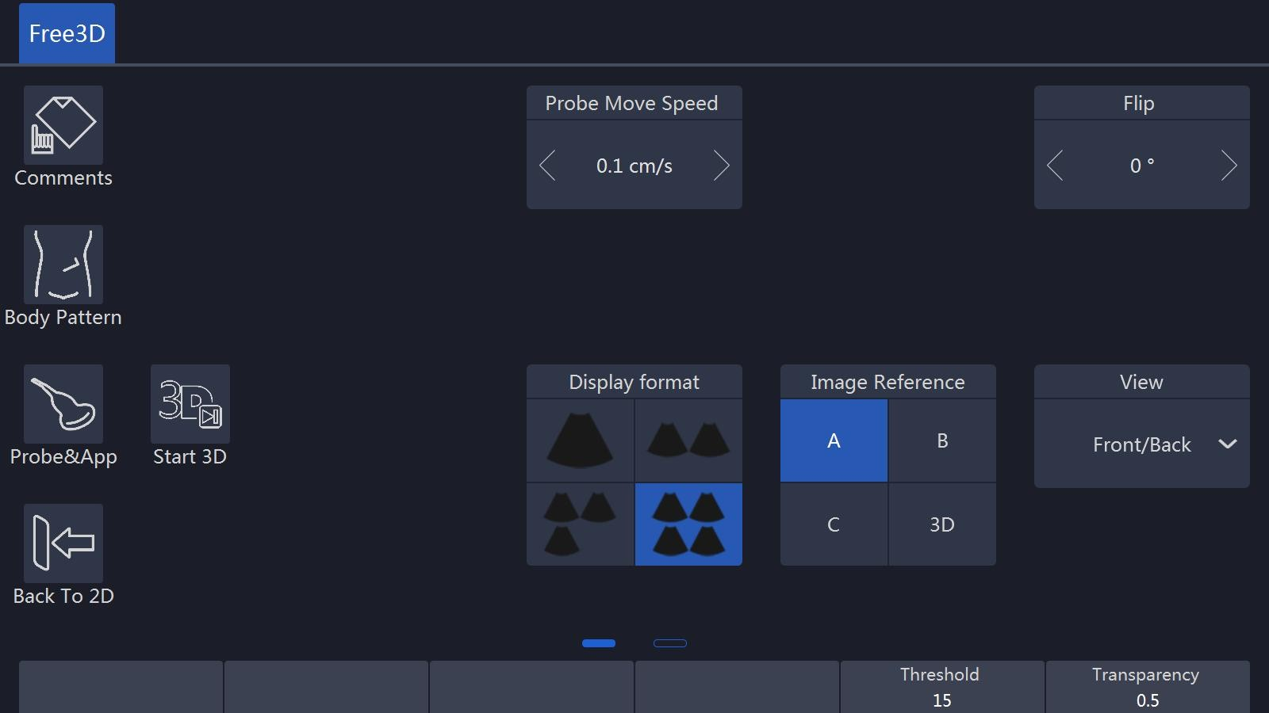

* No “Curve” and “Fix ROI” in pre-Free3D mode.
* There is only render ROI in Free3D.
* “Probe Move Speed”: the speed of moving probe.
* During data acquisition, touch “End Free3D” to end acquisition manually.
* Other operations in Free3D are the same as operations in 3D.

### 8.1.7 Auto Follicle in 3D

1. Touch  after 3D data acquisition to start automatically calculate the volume of follicles.
2. Choose follicle left or right, and click the button 
3. The system will automatically recognize the follicles, and automatically calculate the volume of follicles
4. The result will show on the touch screen

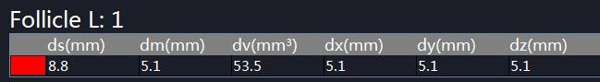

1. Click 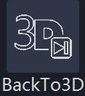 to back 3D mode.
2. Follicle Edit: Pick, Add, Remove, Split, Merge.

### 8.1.7. Niche View

Touch  to enter “Niche View” page as below:

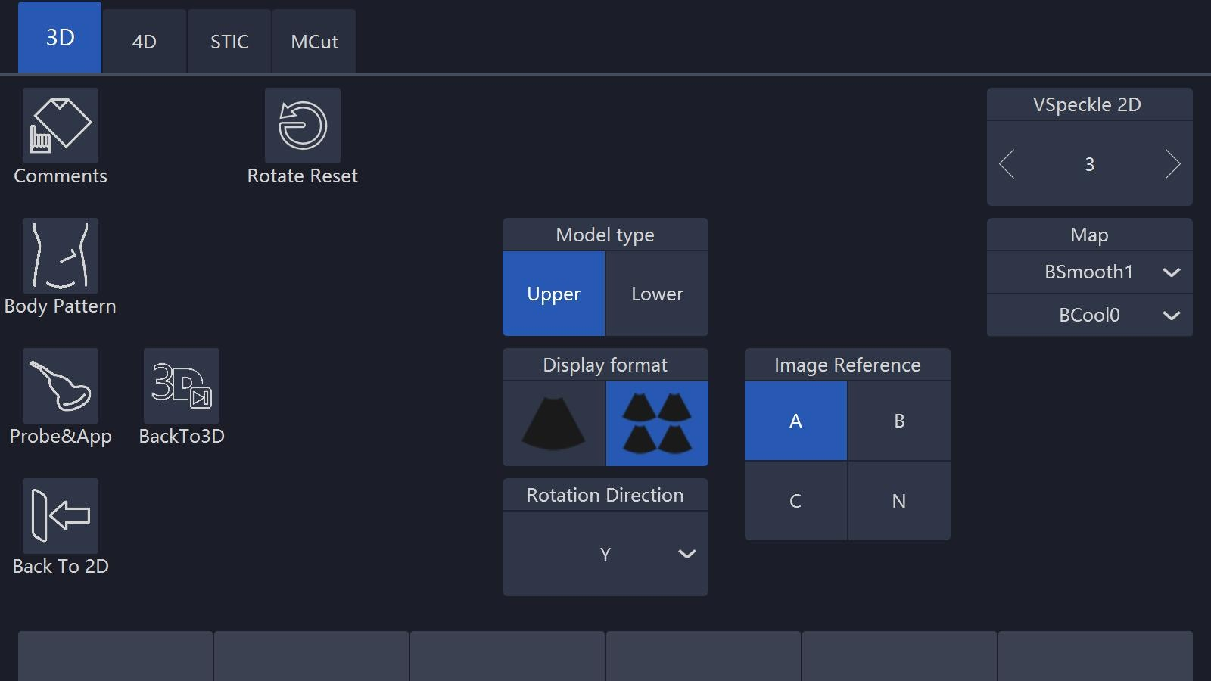

### 8.1.9 VNavIn

Touch “VNavIn” button to enter the function:

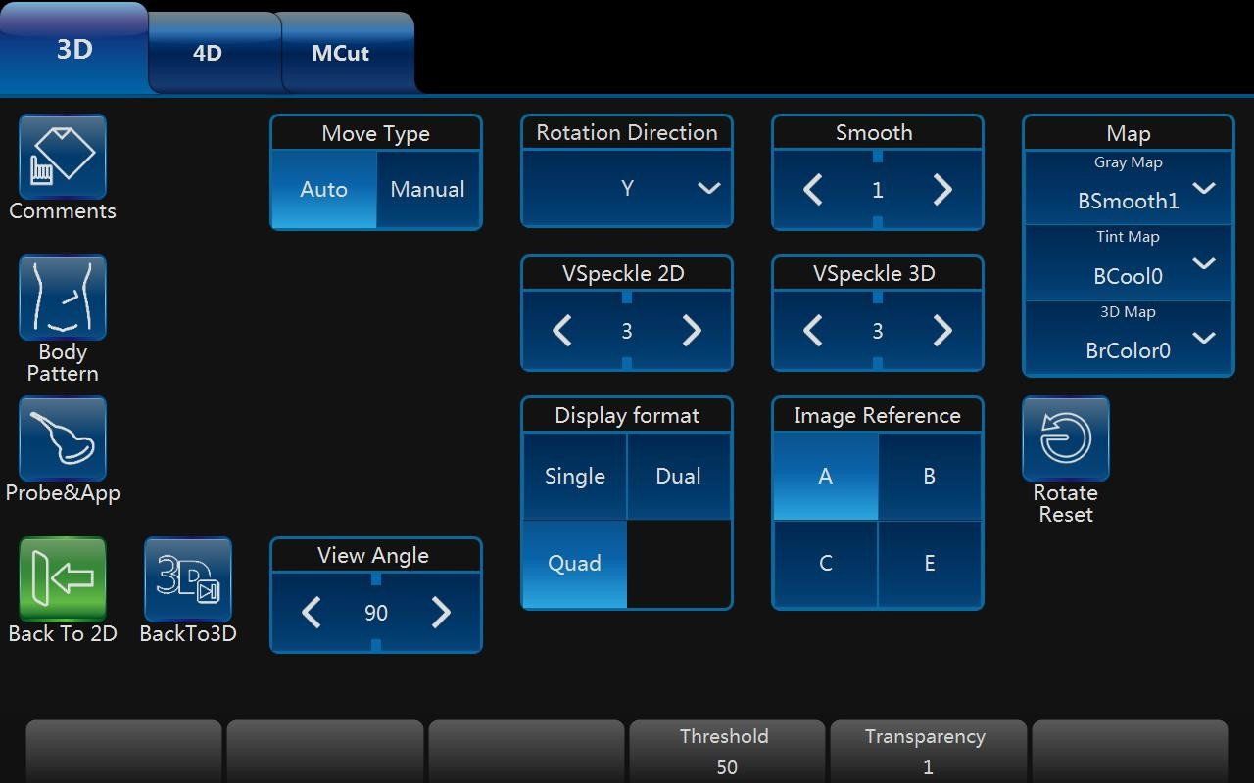

* **“Auto” Move Type**

1. Select one image between “A” “B” “C” image reference, use “Enter” key to write down at least two points on the section and then touch “Start” button, the path will be planned and the camera point will follow the path automatically. The image will be shown in reference “E”;
2. Adjust “Speed” button, the higher the speed value, the faster the camera point moves;
3. Adjust “View Angle” button, the range of view will be greater when the angle is larger.
4. Adjust “Threshold” and “Transparency” key, Threshold can be adjusted to render images and Transparency can change the transparency of the appearance.
5. Touch the “Pause” button, the camera point will pause ahead, the step size can be adjusted right now.
6. Touch “Restart” button, the camera point will follow the path planned before.
7. Selected reference “E”, then rotate 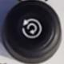 key to change the perspective direction.
8. Touch “Back to 3D” key to exit the function.

* **“Manual” Move Type**

1. Use “Enter” key to write down one point between “A” “B” “C” image reference.
2. Move “Trackball” to adjust working direction of camera point.
3. Adjust the step size, the larger the step size the greater the camera point will move when pushing the move/ back key.
4. Selected reference “E”, then rotate  key to change the perspective direction, the location of camera point also can be moved.
5. Touch “Back to 3D” key to exit the function.

## 8.2 4D (real time)

### 8.2.1 Workflow

After “4D” key on the control panel in B is pressed, the system will enter “3D/4D” mode.

At the same time the image screen will display one image with the active “ROI”. The touch panel menu will display as the “4D” touch panel below (before the scan).

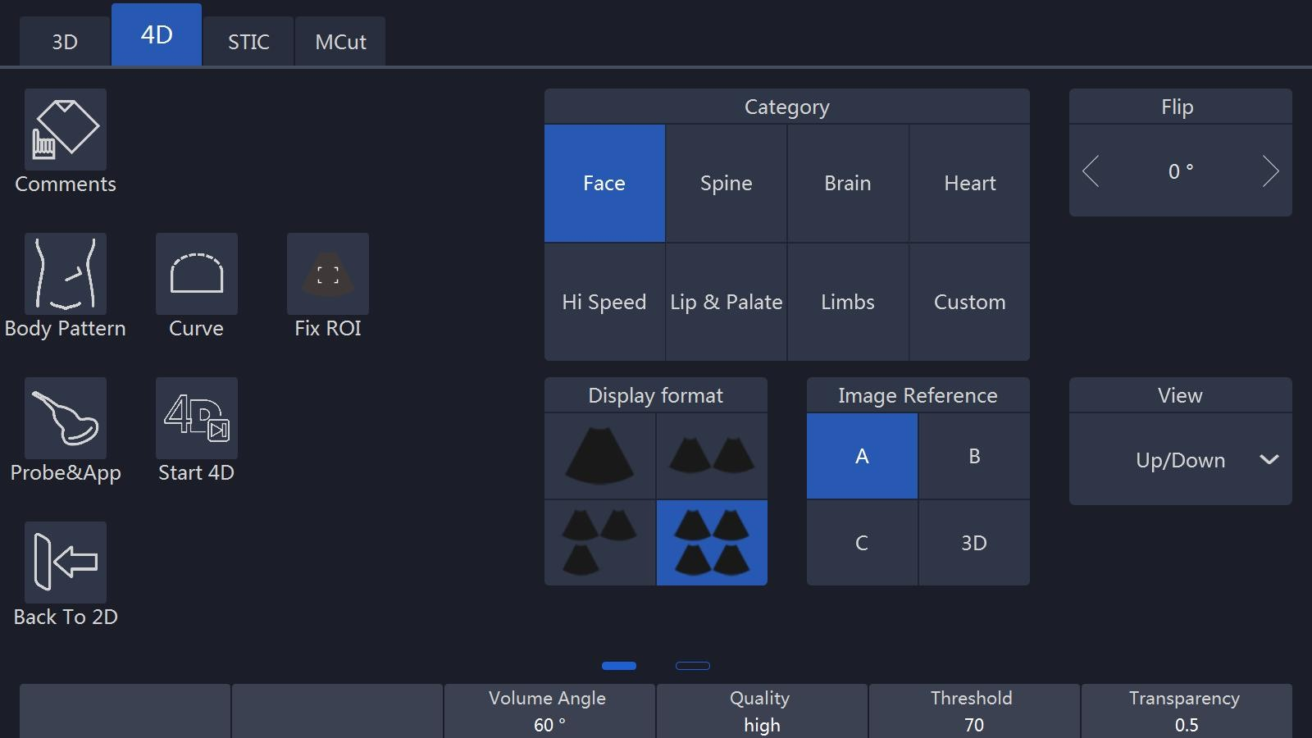

Notes:

1. Select the 4D setting in this UI before starting the 4D real time scan. Select the “Display Format”, “Render”, “View”, “Comments”, “Body Pattern” and other buttons which can refer to the 3D UI description. After selecting finish, the operator can select “Start 4D” on the touch panel or press “4D” on the control panel to start the 4D real time scan.
2. During this time, the image screen displays the normal image similar as the status before selecting the “4D” button. The only difference is that the image will have an ROI appear in order for the operator to change position and size.
3. In dual display format, it will be “A” or “B” or “C” plane + 4D image display.
4. In single image display format, only 4D rendering image displays on the image screen.

* Select all settings and change the ROI size in this time. To change the ROI position the same as other modes by using the “ROI” key on the control panel and trackball.
* The “VSpeckle”, “Quality”, “Threshold”, “Transparency”, “Volume Angle” can be changed, and plane size. Refer to chapter 8.1.1.
* Selecting “Start 4D” button on the touch panel or pressing “4D” on the control panel to start 4D real time scan mode. The UI will be changed to below. The image screen will display the images, depending on what display format is selected.

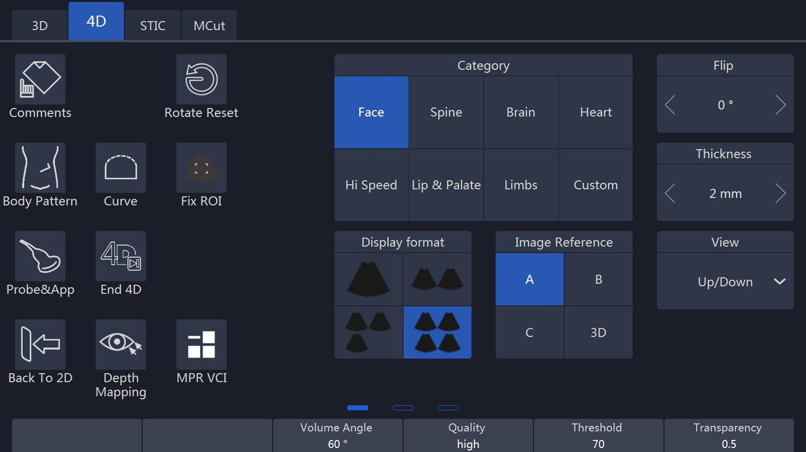

Notes:

1. During the real time scanning, the parameter can also be changed. The 4D rendering image can be rotated by rotating “Rotation/Steer” on the control panel (need to select 4D active image reference and which “X”, “Y”, or “Z” axis). After “A”, “B” or “C” plane is activated and highlighted, the “Rotation/Steer” key can shift “A”, “B”, “C” plane and rotate 3D image
2. Rotate M, PW, CF keys can also rotate the images, M is corresponding X direction, PW is corresponding Y direction, CF is corresponding Z direction.
3. At this time, the “Start/End 4D” button is highlighted. If the operator select this button on the touch panel or press “Freeze” (unfreeze status in this time) on the control panel, 4D real time scanning will end and the 4D cine mode will start.

* Four images and single image formats’ image display are the same as 3D.
* During scanning, all parameters can be changed as same as before scan.
* Also The ROI size and position can be changed by pressing “ROI” on the control panel and moving the trackball. In the meantime, if the 4D reference image position is active, the 4D image can be rotated by rotating “Rotation/Steer” on the control panel on “X”, “Y” or “Z” axis, which depends on which axis is active and highlighted. If other reference image position is active, all images can be rotated.
* In the quad display format, there are rotation axes on image “A”, “B”, “C”.

### 8.2.2 4D Cine Mode

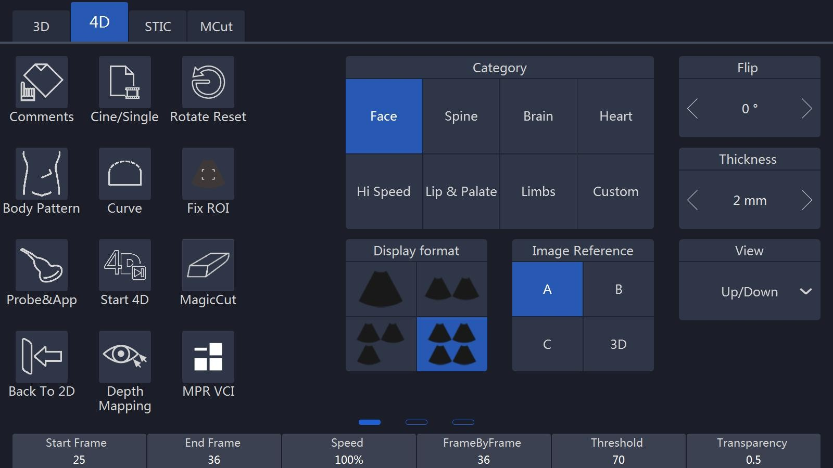After “End 4D” on the touch panel is selected or “Freeze” on the control panel is pressed, the system will switch automatically to freeze mode/4D Cine mode. The Cine mode menu is displayed as shown below. The selected format and last acquired volume will be presented on the image screen.

Notes:

After “Cine/Single” is selected on the touch panel, the image screen will automatically display volume by volume. The “Speed” can be adjusted to play back slowly. The available “Speed” is 100, 75, 50 and25. After “Auto Cine” is selected, this button will be highlighted. Selected again, this will end the auto cine function. Auto cine sequence will be from start volume to end volume, and then it starts from the first volume again.

Pushing the “Vol by Vol” up/down key, can view the volumes one by one.

When pressing “Freeze” on the control panel or selecting “Start 4D” on the touch panel, the UI will go back to the 4D touch panel (during scan).

All images and volumes can be reviewed during this time. This allows the operator to concentrate 4D data acquisition during real time and afterwards review all volume in detail: “Vol by Vol”, slice by slice in cine mode. After “Auto Cine” is selected on the touch panel, the system will play back continuously.

### 8.2.3 3D MCut of Cine Mode

Go to multi-slice cut in Cine mode by selecting “3D MCut” on the touch panel. Then the touch panel will go to UI as shown below in order for the operator to see slices.

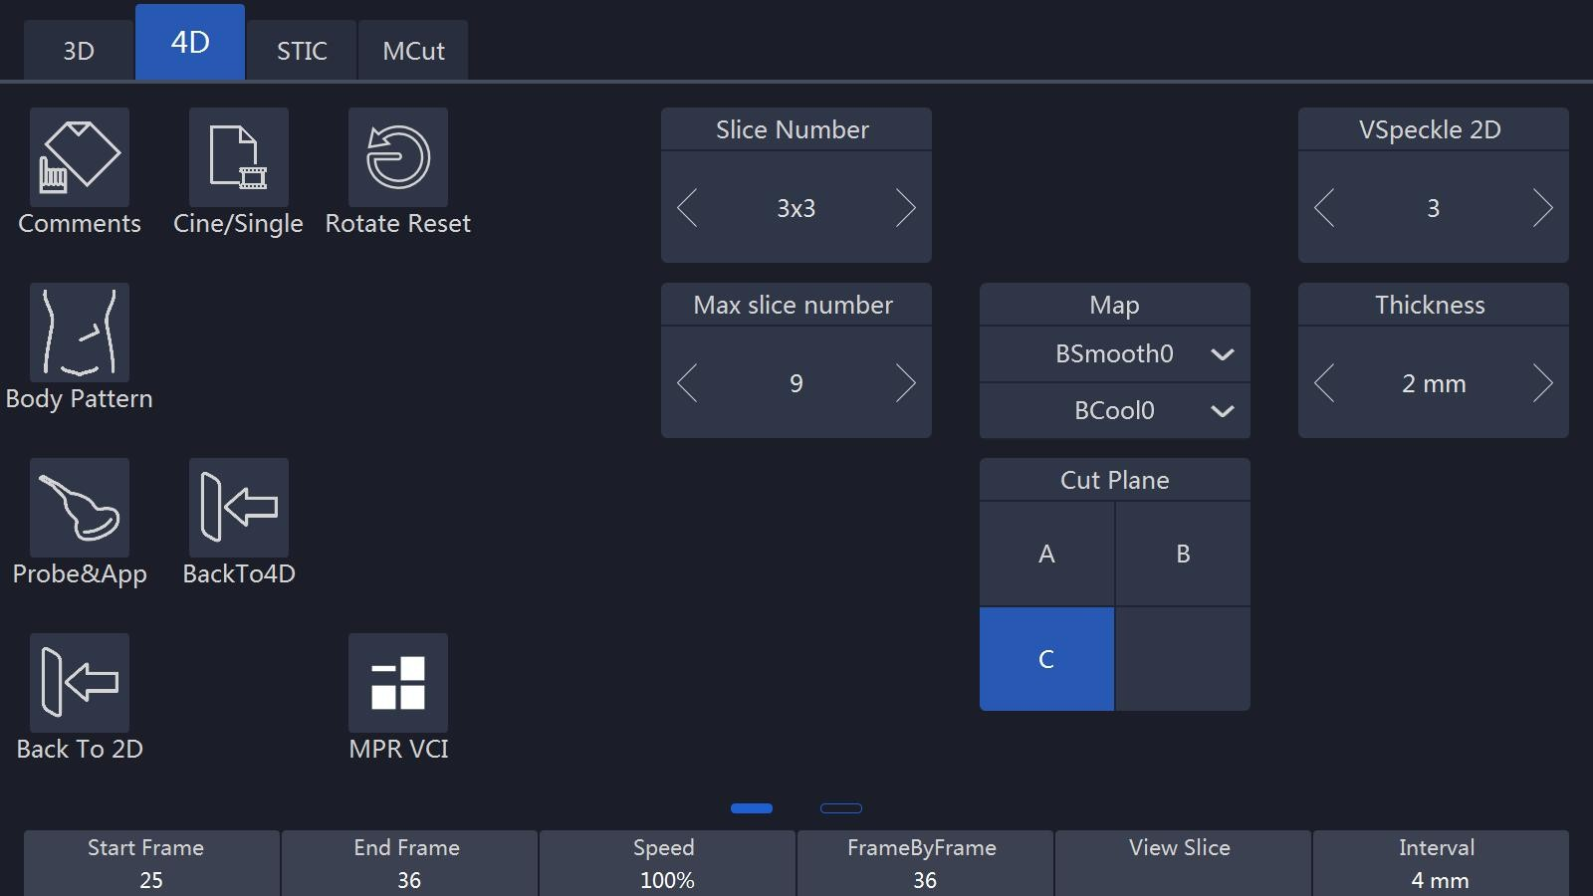

Notes:

1. Vol by Vol: View the volume one by one, the default setting is the last volume.
2. Speed: Defines what speed cine will be. They are 100, 75, 50 and 25. It is only active after the “Auto Cine” key is highlighted.
3. Interval: Adjusts the interval distance between each slice.
4. Slice Number: Different slice number can be selected: 4x4, 3x3, 2x2.
5. Cut Plane: Smaller image size due to display screen limitation. The operator can select which plane (A, B or C) is to be cut by “Cut Plane” group keys. The first displayed image is the selected plane with slice line.
6. Rotation direction: “Rotation/Steer” key will rotate the MCut image by X, Y or Z axis. X, Y and Z can be selected on the touch panel.
7. Rotate M, PW, CF keys can also rotate the images, M is corresponding X direction, PW is corresponding Y direction, CF is corresponding Z direction.
8. Select “Auto Cine” for play back.
9. In all modes, by selecting the top buttons such as “3D”, “4D” or “MCut”, the system will return to the beginning of that mode.

* Select “Back to 2D” on the touch panel or press “B” on the control panel to return to normal 2D mode.

## 8.3 MCut

### 8.3.1 Workflow

* After “4D” on the touch panel is selected, the system goes into “4D” mode. Select “MCut” on the top to enter 4D multi-cut mode.

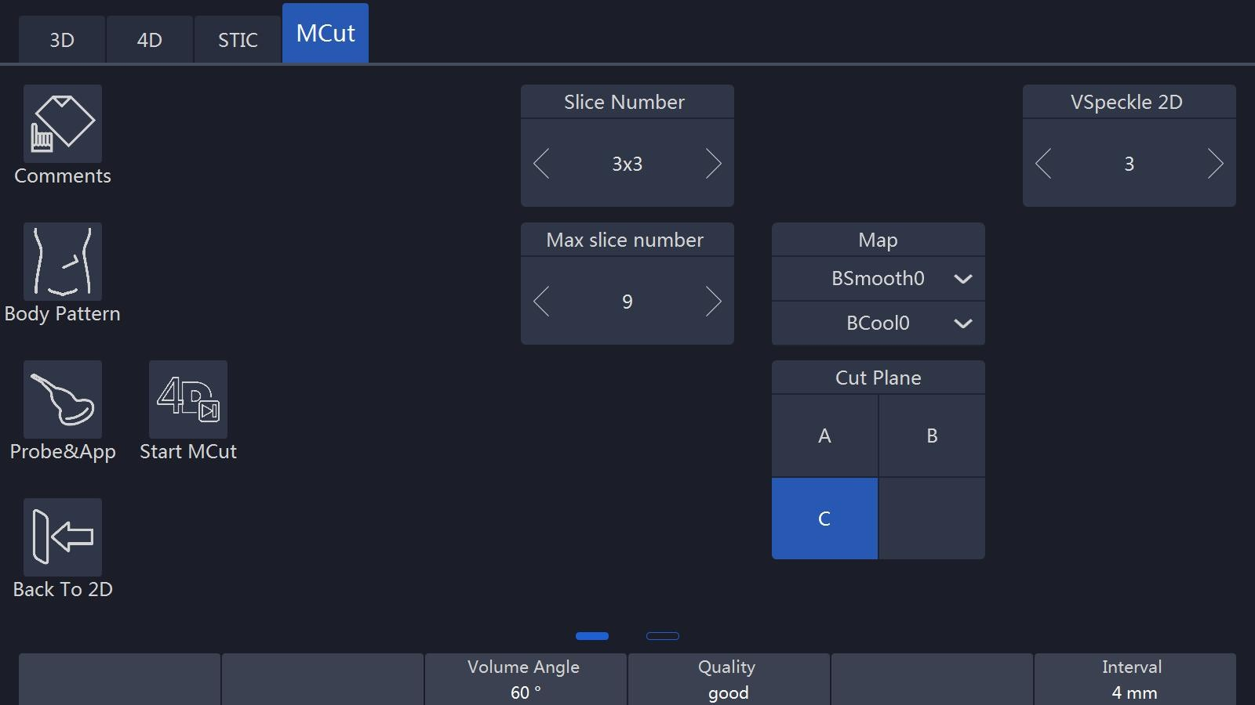

Notes:

1. In the “Cut Plane” group, if the operator selects “A” that means the cut plane is “A” plane. In this time, the initial image and the first image of the multi display is the B plane image in order to show the slice position, and the slice line is vertical. If “B” is selected, the cut plane is B plane. In this time, the initial image and the first image of the multi display is the A plane image in order to show the slice position, and the slice line is vertical. If “C”, is selected, the cut plane is C plane. In this time, the initial image and the first image of the multi display is the A plane image in order to show the slice position, and the slice line is horizontal.

* Before starting 4D data acquisition, the initial image display will only be a 2D image. The “View Slice”, “Slice Number”, Cut Plane” (“A”, “B” or “C”) and other parameter can be adjusted as UI indicated.
* Select “Start MCut” on the touch panel to start real time data acquisition. Real time data acquisition and the display will stop after “End MCut” is selected. The image displays real time slices image. How many slices are displayed depends on how many slice numbers are selected on the touch panel.

Notes:

1. Slice Number: Smaller image size. Different slice numbers can be selected: 4x4, 3x3, 2x2.
2. In real time 4D and play back of “MCut” mode, all slices are live and active. In 3D multi cut, slices are single frame, not live display.

* During real time parameters on the touch panel can be adjusted. Also the “Slice Number” and “Cut Plane” can be changed.
* Touch “End MCut” on the touch panel or press “Freeze” on the control panel to go into frozen mode and the following touch panel UI appears. Image screen displays the last frame before frozen.

Notes:

1. Vol by Vol: To view the volume one by one; the default is the last volume.
2. Speed: To define what speed cine will be. They are 100, 75, 50 and 25. It is only active after the “Auto Cine” button is highlighted.
3. Select “Auto Cine” for play back. The default is “Auto Cine”.

* Pressing “Freeze” on the control panel or selecting “Start MCut” on the touch panel, the system will go to 4D multi-cut real time again to be initial status. If go to “3D”, “4D” “MCut” mode, those buttons on the top of the touch panel can be selected.
* Anytime during “3D” or “4D” mode, press “B” and the system will go back to 2D mode.

## 8.4 STIC

* Press “Start STIC” to enter into STIC mode. If STIC algorithm failed because of incorrect data acquisition or parameter configuration, there will be a warning info on the screen and the system will be automatically back at Pre3D state. If STIC succeeds, system will enter into 4D Cine Mode as a normal rendering.

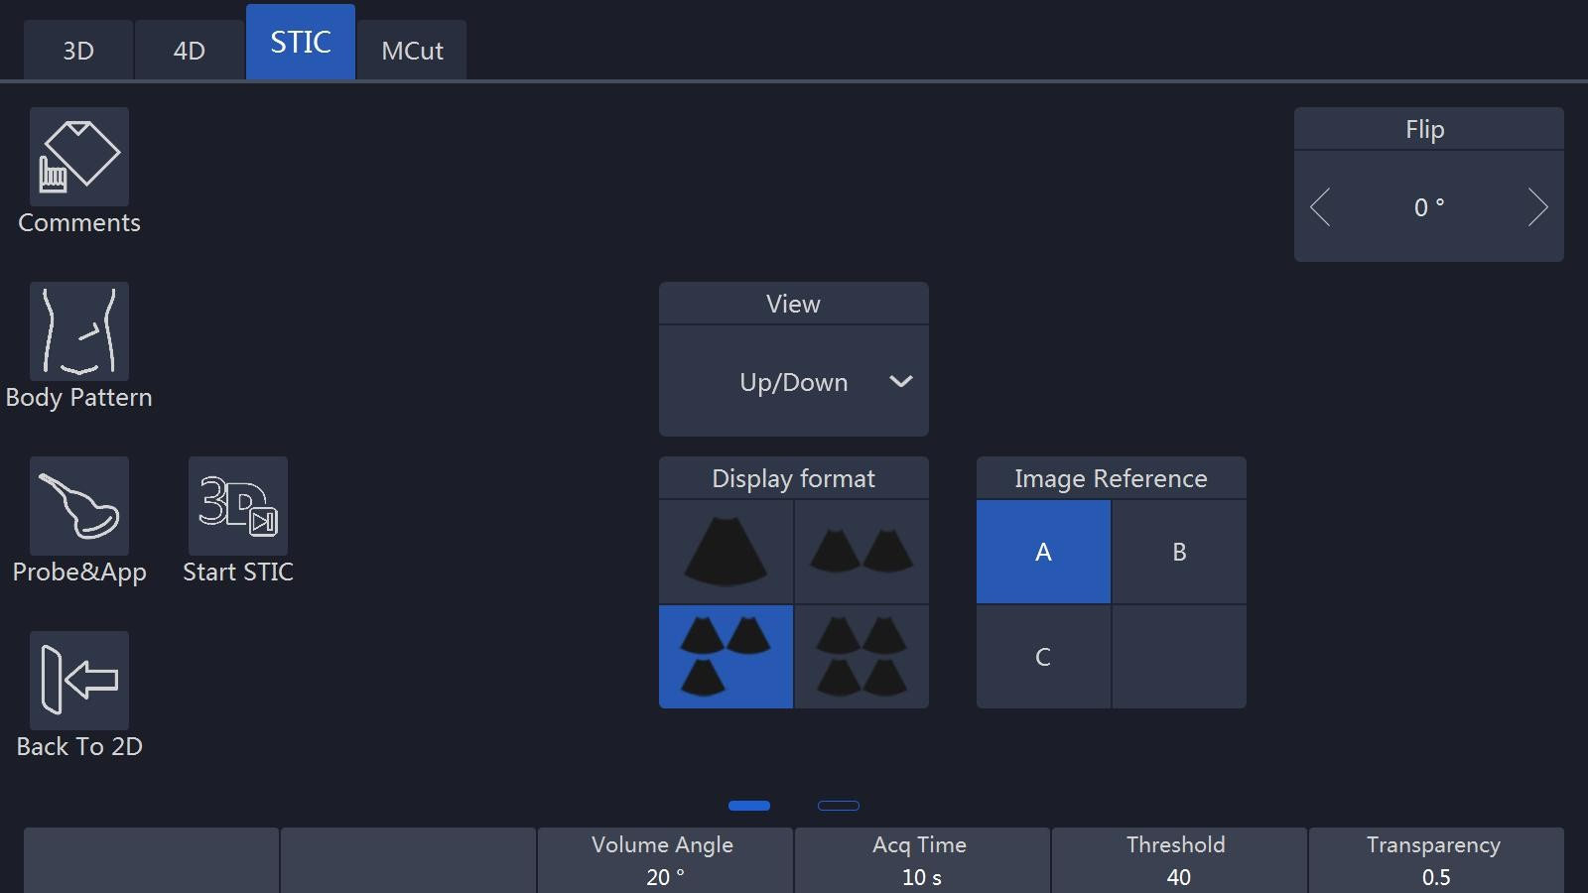

3D Mcut: STIC provides MCut display mode. Refer to MCut section.

Display Format: Render, MCut, MPR( Multi Planar reconstruct: display Axial, Coronal and Sagittal planes).

# 9. Other Modes

## 9.2 Tissue Doppler Imaging (TD)

Tissue Doppler Imaging uses the Doppler principle to provide information about tissue motion direction and velocity. The motion will be shown as a wave profile.

Select the “TD” on the control panel, and the system goes into Tissue Doppler mode. Image display format and the touch panel menu will be similar to “PW/CW”. But the “PW/CW” key changes to “TD” key. The operation workflow is similar to “PW/CW”. Refer to “PW/CW” session for operation please.

## 9.2 Tissue Velocity Imaging (TVI)

### 9.2.1 TVI overview

TVI calculates and color codes velocities in tissue. The velocity information is acquired by the sampling of tissue Doppler velocity values.

### 9.2.2 TVI Workflow

TVI function is only available in cardiac application of the sector probe. If the right application and probe is not selected before entering this mode, the system gives a warning to remind the operator to change accordingly. The ECG needs to be connected before proceeding with the TVI procedure.

1. Select the “TVI” on the control panel and the system will enter “TVI” mode.
2. In the “TVI” mode, new operator menu displays on the touch panel as shown below.
3. TVI’s ROI size and position can be changed by pressing “ROI” on the control panel and moving the trackball combination. The operation is the same as the other ROI adjustment (such as color ROI).
4. Adjust parameters on the touch panel menu.

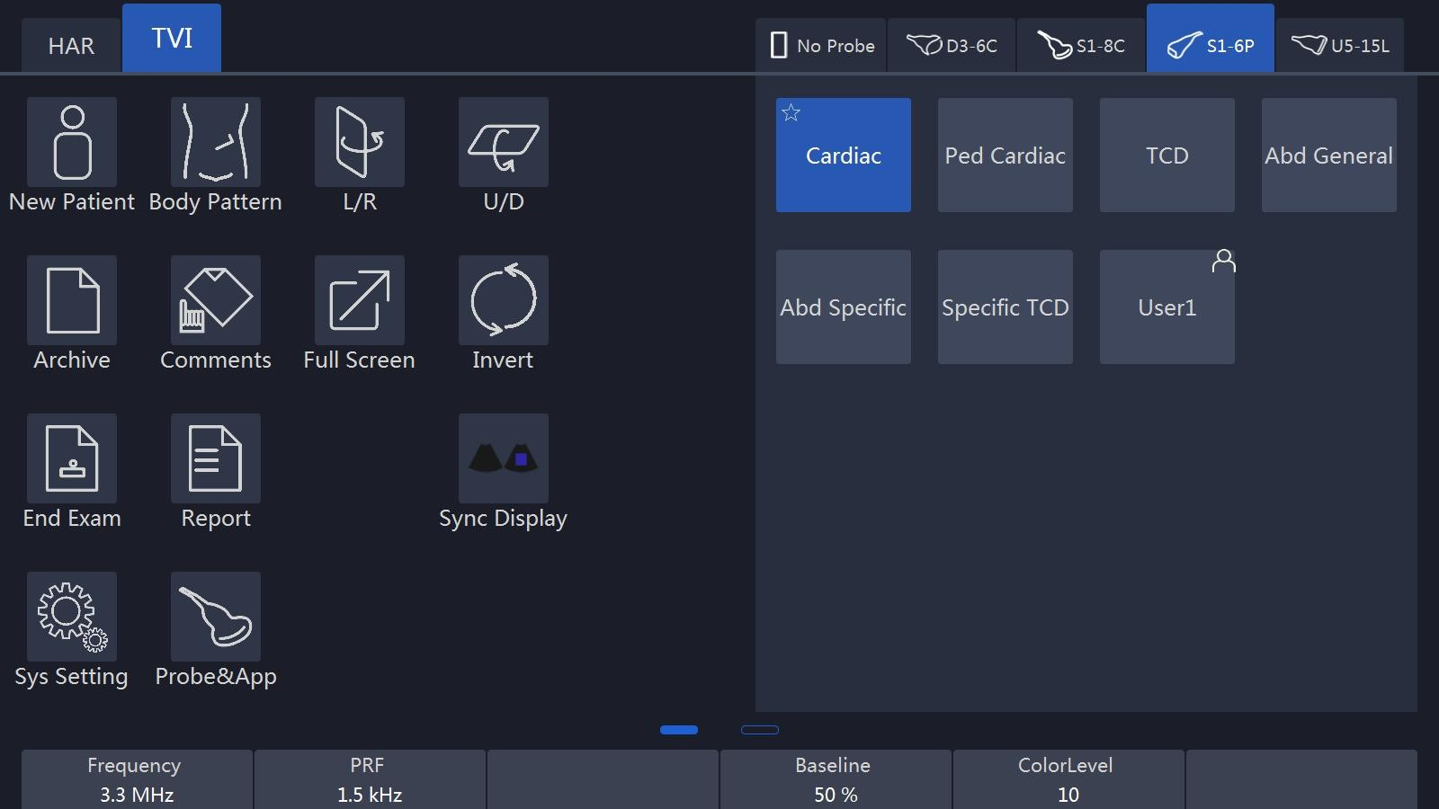

The parameters corresponding to up/down keys are described as follows:

**Frequency:** It enables the adjustment of the transmission frequency to control the sensitivity or the level of penetration.

**Line Density:** Controlling line density will impact the frame rate, and the trade-off between the spatial and the temporal resolution.

**PRF:** It adjusts the repetition rate of Doppler pulses transmitted to acquire the data for color mapping. This adjustment influences the Nyquist limit, which is the ability to detect the maximal velocity without color-aliasing.

**Color Level:** It controls the level of color threshold. Over threshold setting number will not be displayed.

The keys’ functions on the touch panel menu are described as follows:

**Invert:** It is able to invert the color scheme between the positive and negative tissue velocities.

**Baseline**: Adjusts the color map either toward or away from the probe to highlight the tissue motion dynamic range.

**Transparency:** Indicates the visibility of background image.

Image display is as shown below in TVI.

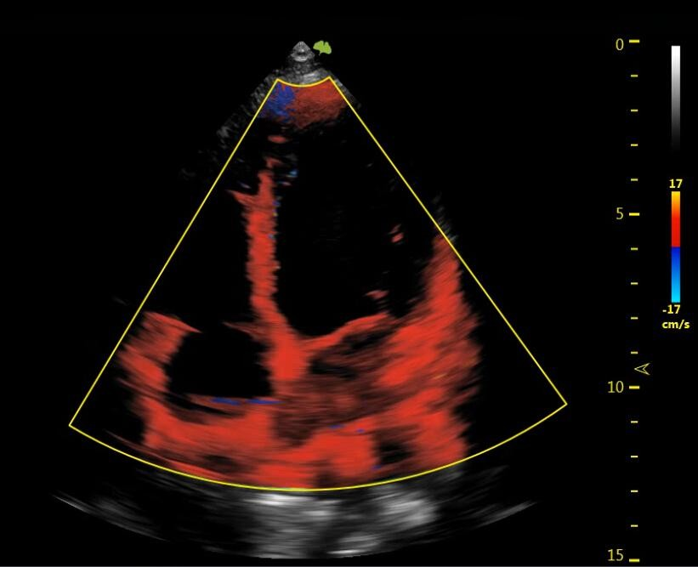

## 9.2 Elastography

**Workflow:**

Select the probe and application and scan in B or Harmonic mode to determine the field of view, then activate the EI mode by touching the El button on the touch panel and determine the region of interest (ROI), the region of interest can be moved and zoomed through the ROI button and track ball on the keyboard. Continuously press the tissue through the probe and there will be a strength bar displayed on the screen, if the pressure is too small or too large, the EI mode will not work. If the pressure is appropriate, the EI mode will work normally and display the strain image together with the gray image of B or Harmonic mode.

For the strain image, different color indicate different stiffness, usually blue indicate hard tissue and red indicate soft tissue. The strain and strain ratio can be measured to diagnose pathologic tissues.

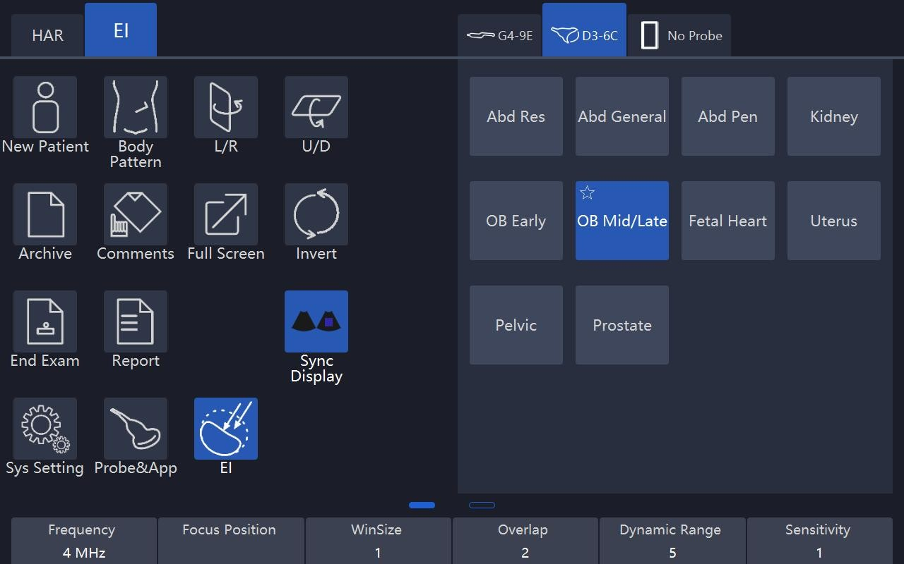

The EI quality can be optimized by adjusting the parameters.

**WinSize and OverLap:** determine the resolution and smooth of the image.

**Sensitivity:** indicates the burst number of the transmit wave.

**Smooth:** indicates the spatial filtering of the image.

**Transparency:** indicates the visibility of background image.

**Persistence:** indicates the frame averaging of the continuous images

**Map:** indicates the mapping of strain value and the display color.

There is one measurement item only working in EI mode: StrainRatio. It is a ratio of two values of strain. Fix these two values of strain in ROI box, then the system will get the ratio.

## 9.4 Contrast Agent Imaging

Contrast Agent Imaging is a new mode to characterize distributions of blood vessel in tissue. By utilizing harmonic component of macro bubble, micro flows can be detected and analyzed quantitatively. Contrast Agent Imaging is an effective technique in clinical diagnosis of cancers and tumors.

### 9.4.1 CBI workflow

1. Pressing “CBI” button on touch panel to enter contrast agent imaging, switch B mode and contrast agent imaging by button “B/HAR”;

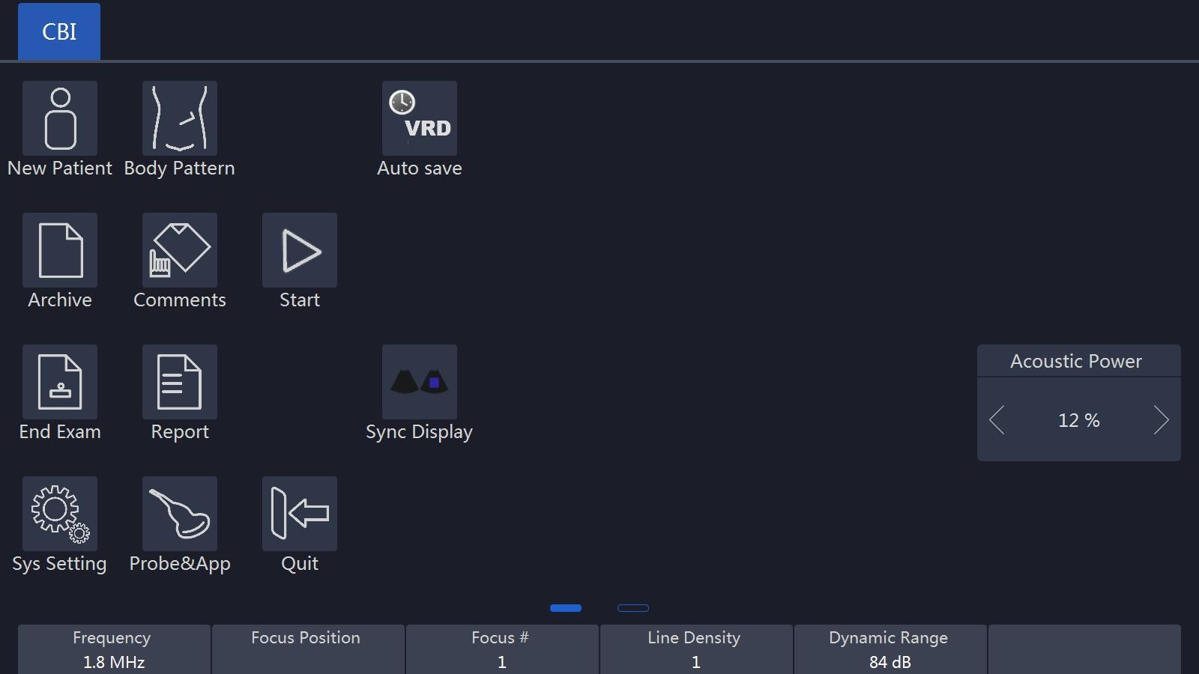

1. Focus position, line density, dynamic range and other parameters can be adjust to acquire a better quality image;
2. Pressing “Start” button to start contrast agent imaging, set “Auto Save” duration to save Contrast Agent Imaging automatically;

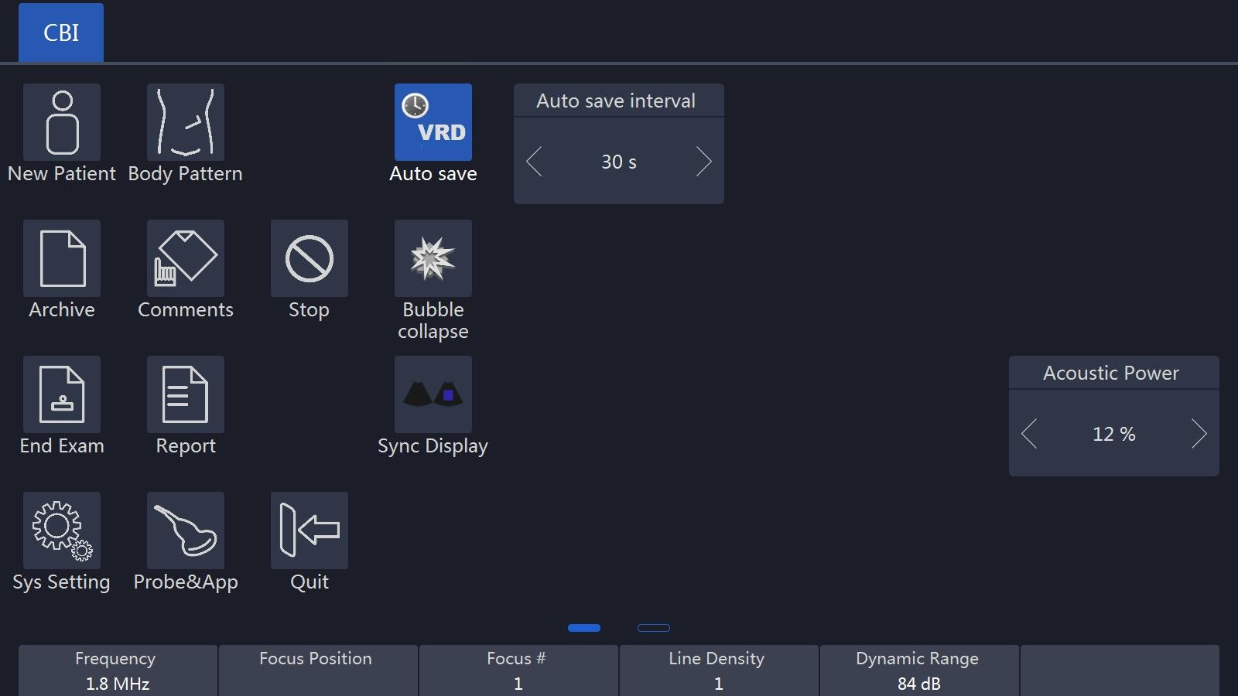

1. Using “Bubble Collapse” button to clean up macro bubble in imaging plane, reperfusion can be detected;
2. Touch “Sync Display” to enabled sync display, the left image is 2D image, and the right image is CBI image.
3. After contrast agent imaging, clinical parameters of TIC curve can be acquired by touching “Analysis” button in replay.

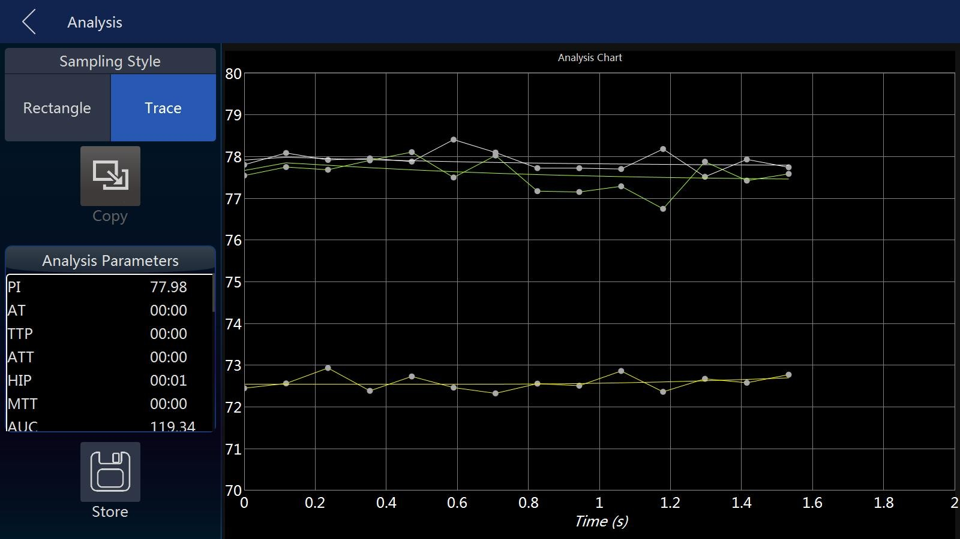

1. Enter PPI page by touching “PPI” when replay one CBI image. After user draw a sample region on image, PPI calculation is started. The calculated results will be displayed on the touch panel.

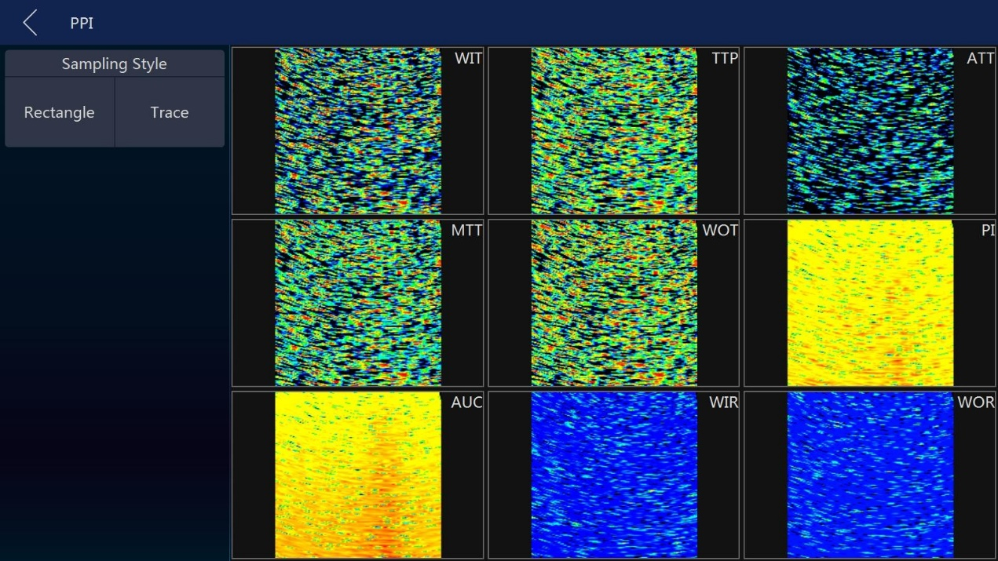

## 9.5 Stress Echo

The load ultrasonic module can perform multi-stage image capture, image viewing, image optimization, wall segment segmentation and generation of load ultrasound reports in multiple protocols for complete and effective load ultrasonic inspection.

A cine refers to the whole heart cycle or systolic motion image display. The cardiac motility cycle can be indicated by ECG R-waveform or QT (timetable). Ultrasound movies are collected in phases according to the selected protocol.

### 9.5.1 Stress Echo Workflow

**Start**

1. Users click  button from touch panel to start Stress Echo.
2. Note: Open Stress Echo function will start ECG mode automatically Recommend to set ECG uses lead II
3. Clipboard is hidden in the main screen, stress echo information is displayed. T1 is total time spent on stress echo, it never stops timing once get into this function; T2 is time spent on current level, it starts from 0 when go to next level.

**Image Capture**

1. **Choose template for current exam**

Template defines capture mode, hart cycles, how many views and levels to capture. Please refer to **step 5** Template Management for details

1. **Start/stop capture**

system starts to capture image by default when stress echo window is open. Click on “Freeze” key to start/stop capture

1. **Save image**

When the ECG signals is stable enough, click “Store to HDD” (make sure this key is configured to store VRD type image to local HDD before start) to save

current capture image to the active cell, system will auto start to capture image for the next cell once the image is saved.

1. **Choose levels or cells**

System displays preview page of all levels by default

Click level name from left side, you can see how many images captured in this level. For example, click on “Baseline” level

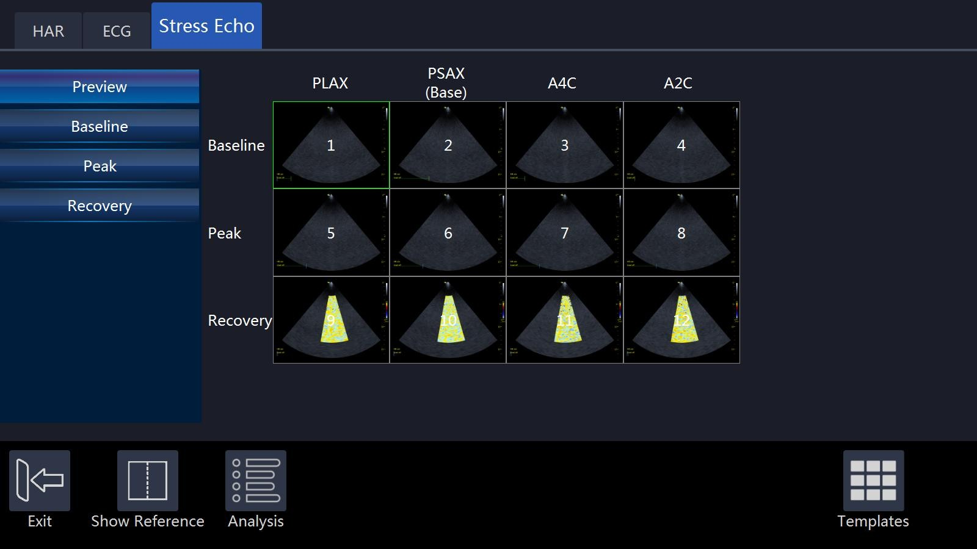

Note: current capturing will be discarded if users choose another level, system starts new capture for the new level

1. **Show reference image**

Click on “Show Reference” when you capture, reference image will show

1. **Continuous Capture**

In normal mode capture, system stores one image no matter how long capture time it is, however, system usually stores more than one image in continuous capture mode.

1. **start continuous capture**

Select the level which is set to continuous capture mode, continuous capture is started

Note: There is timer displayed in the left bottom of main screen when the Continuous capture is started so that users know that.

After save image, system won’t start next capture automatically, because we think one continuous capture would get images for the whole level

1. **Pause during the continuous capture**

Users might want to pause during they capture, they can do this by click on the “Pause” button. visual is still live, but system won’t store the image during the time between users click “Pause” and “Continue”

1. **Allocate image**

Users need allocate images captured in continuous mode by manual touch on image and drag to respective cell

**Analysis**

You can start to analysis when you complete image capture. Click on “Analysis” go to analysis window. System plays the first review group images by default

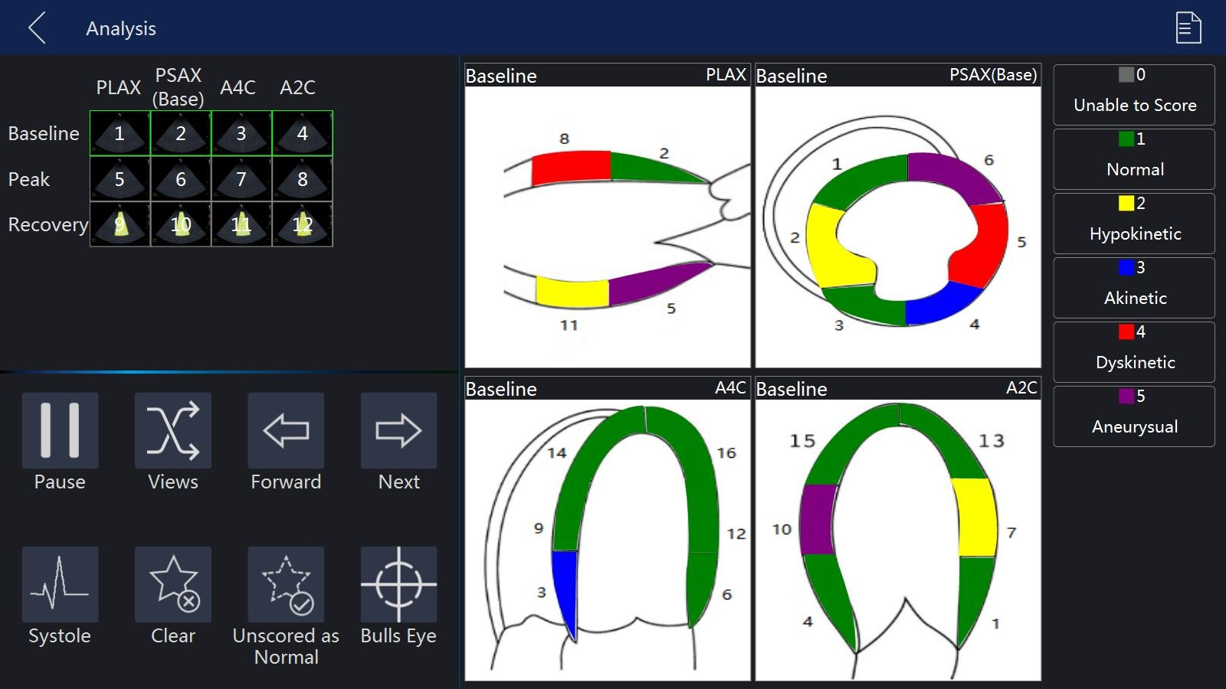

**Score images**

Select one review group or one image to review

Select one segment, and then select a score in the right

**Clear:** clear all the scores of the current review group

**Pause:** pause image

**Not Scored Normal:** score the segments that are not scored to be normal

**Review**

Click on the preview snapshot from clipboard, system goes to analysis window

**Template**

1. Choose template for current exam

System provides a default template, users could start to capture image directly if they are satisfied with default template.

Click on “Template” button, go to Template window. Select one template, click on “Select Current” will do

1. Update template

If users want to update template, click on “Edit” button, select “Capture” tab, update heart cycles, capture mode and reference image in Capture tab

Add new or update review groups in Review tab

Select views from the available area, users can’t add/delete view Select or customize levels in Levels tab

**Report**

Click “Report” on the touch panel to get report for stress echo

Click on Template tab, click on template dropdown, select Stress Echo

Click on Stress Echo tab, report would appear

## 9.6 Strain

Select 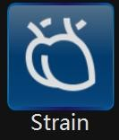 to enter “Strain” page.

1. Select one stored VRD image, and select one view. Touch “Draw ROI” to fix one ROI on the image.

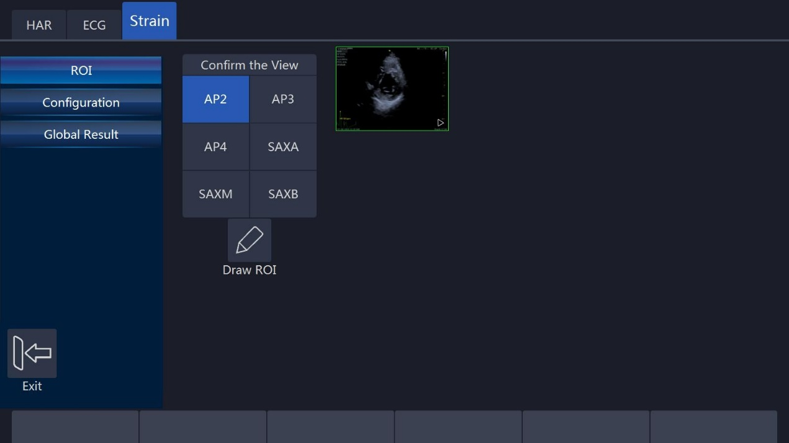

1. Touch “2D Tracking” to start computing.

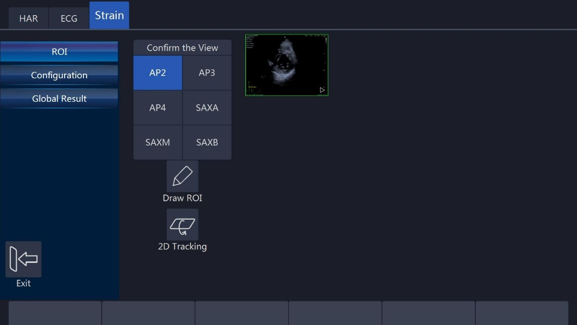

1. After finished compute, accept the result. Select different result types or param types to display different result graph.

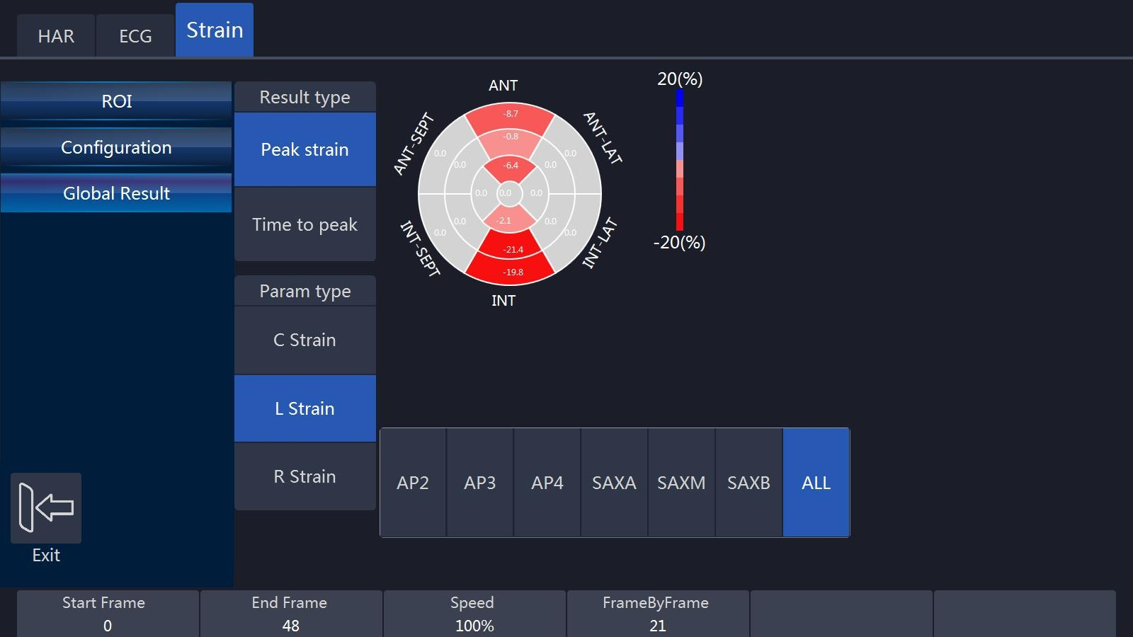

If select “Reject”, back to step 1.

## 

## 9.7 VShear

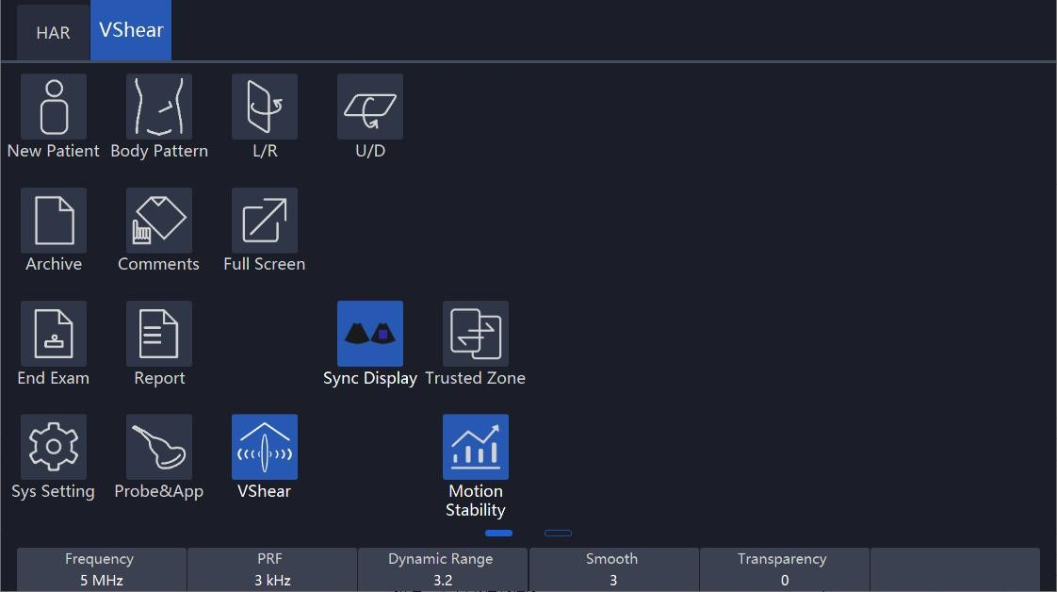

**VShear**: It is similar to elastography, which produces images based on the hardness of the tissue.

**Function and Operation:**

It only works under **B/HAR** mode, and then use these probes: X4-12L/ F4-12L/ U5-15L/ U5-15LE/ X6-16L/ F2-5C/ F2-5CP/ G2-5C/ X2-6C/ S1-8C/ S2-9C/

S2-9CE to enter the function.

**Sync Display:**

After entering VShear mode, the system will display two images. The left is 2D image, and the right is 2D and VShear image.

Both left and right images are live and synchronized. Users can select one of them as the active image for parameter adjustment.

**Trusted Zone & Motion Stability:**

Both of them can assist in judging the reliability of the scanned elastic image results.

* **Trusted Zone:**

Touch the "Trusted Zone" button, part of the elastic image may be hidden, part of the elastic image will be displayed. The hidden parts indicate that the image result is not reliable. On the contrary, the part that shows up, indicates that the result is more reliable.

* **Motion Stability:**

Touch the "Motion Stability" button to enable this function. When turned on it, there will be a progress bar on the right side of the screen indicating movement stability. If the probe or the patient is in a moving state, the progress bar will display below three bars and will show red color.

If the probe and the patient are in a stationary or relatively stationary state, the progress bar will display more than four bars and appear in green, indicating that the image is stable and the results are reliable.

# Measurement and calculation

The measurement and calculation results from the ultrasound image can be used to supplement other clinical approaches. Its measurement accuracy depends not only on the system accuracy, but also on the impact of different medical approaches. If necessary, indicate the medical approach relevant to the measurement and calculation. In the meantime, record the details of the researcher and calculation method and database in the system. Refer to the relevant original article as some clinical operation approaches are recommended by researchers.

Note: Before starting an examination, it is normally necessary to input new patient information. Refer to chapter 4. Any measurement can be repeated as long as the measurement is selected again.

Note: The following measurement methods are normally carried out by using the trackball and “enter” button.

All the calculation formulas are listed in the Advanced Technical Manual.

## 

## 10.1 Introduction

This chapter provides system set-up information relevant with measurement. It also introduces what generic measurements are possible and how to make those measurements in each mode. Topics are as follows:

* Measurement workflow
* Position of the measurement key
* Measurement system settings
* General introduction to measurement
* The list of generic measurements in each mode
* How to configure measurement in each mode.

### 10.1.1 Measurement Workflow

For a patient, the system classifies information according to type of examination, category and measurement. These terms are defined as follows:

1. Examination application types which include:

* Abdominal
* Obstetrics
* Gynecology
* Urology
* Pediatrics
* Cardiac
* Vessel
* Small organs (e.g. breast, testes, thyroid)
* Trans-cranial Doppler

1. Category

After an application is selected, the system allows the operator to select a certain category. For example, the following examination categories can be selected in the OB application.

* Early
* Mid
* Late
* Fetal heart

1. Measurement

This is measurement and calculation for analysis of anatomy, for example, of kidney length. Measurement includes several categories of data. For instance, in order to measure kidney volume, the length, width and height need to be measured.

### 10.1.2 Positions of the measurement keys

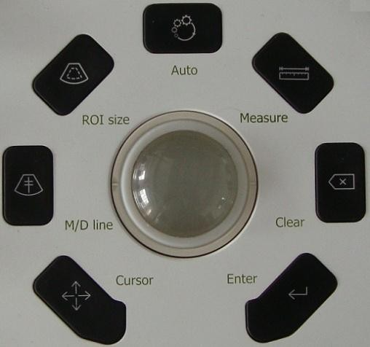

1. Measure: activates measurement caliper and current measurement and calculation setting.
2. Clear: during measurement, press this key to clear measured caliper and relevant results. Holding this key down will clear all annotations, body pattern, measurement results and cursor.
3. Trackball: use this to move the caliper. By pressing “enter”, the caliper will remain fixed. Move the trackball again to fix a new point with the caliper and press “enter”. This enables the operator to measure straight and curved lines and shapes of many kinds.
4. Enter: confirms the measurement.
5. Cursor key: after this key is pressed, the cursor will appear on the screen.
6. Touch panel: all measurement function can be selected on the panel.

### 10.1.3 Measurement system setting

Please refer chapter “Measurement system setting” in “System Setting”.

### 10.1.4 Basic introduction in measurement function

Press “Measure”, and the system will enter measurement mode.

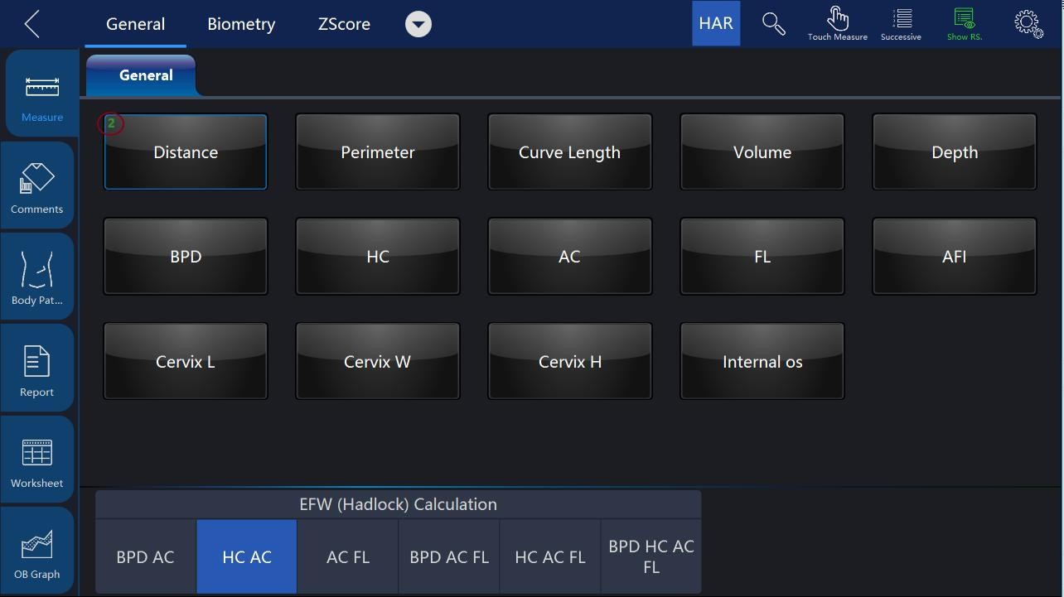

Notes:

* To stop image acquisition before measurement, press “Freeze”.
* To adjust accuracy of caliper, move the trackball or use touch measure slide over the image.
* To delete the caliper and measurement data before complete sequence measurement, press “Clear”.
* To repeat the measurement, select the relevant measurement item on the touch panel.
* Measure count can be marked for measure item in measure window.

Notes: After “Measure” is pressed and it enters the measurement status, the system will go to the default measurement setting in the relevant application. For example, in “B”/ “M” mode, the default measurement is “Distance”. Default measurement is “Velocity” in the PW mode.

**ZScore**: Add ZScore group in OB Early, OB MidLate and Fetal Heart applications.

System calculates cardiac items’ values by measuring specified items and use "Schneider" table to get ZScore calculation.

The ZScore value is hidden by default. When users enabled the setting in system settings, ZScore values will be displayed in Result window, Worksheet, and Report.

**Measurement erasing**

Measurement results can be deleted from system memory as follows:

* After the image is unfreeze, the system will erase all displayed completed measurement results, calculation results and result window. However, measurement and calculation results will be kept in the worksheet.
* After “Clear” is pressed, the system will erase the latest measurement result.
* Holding “Clear” will erase all measurement and calculation results.
* If “New Patient” is selected, the system will erase all measurement results, calculation results, and worksheet.
* To clear the second caliper which is activated and activate the first one, press “Clear”.

**Measurement results worksheet**

After the measurement is completed, all effective measurement results will be entered on the worksheet automatically.

In measure page, touch “Worksheet”, then select different applications, the system will display all measurement results as shown below.

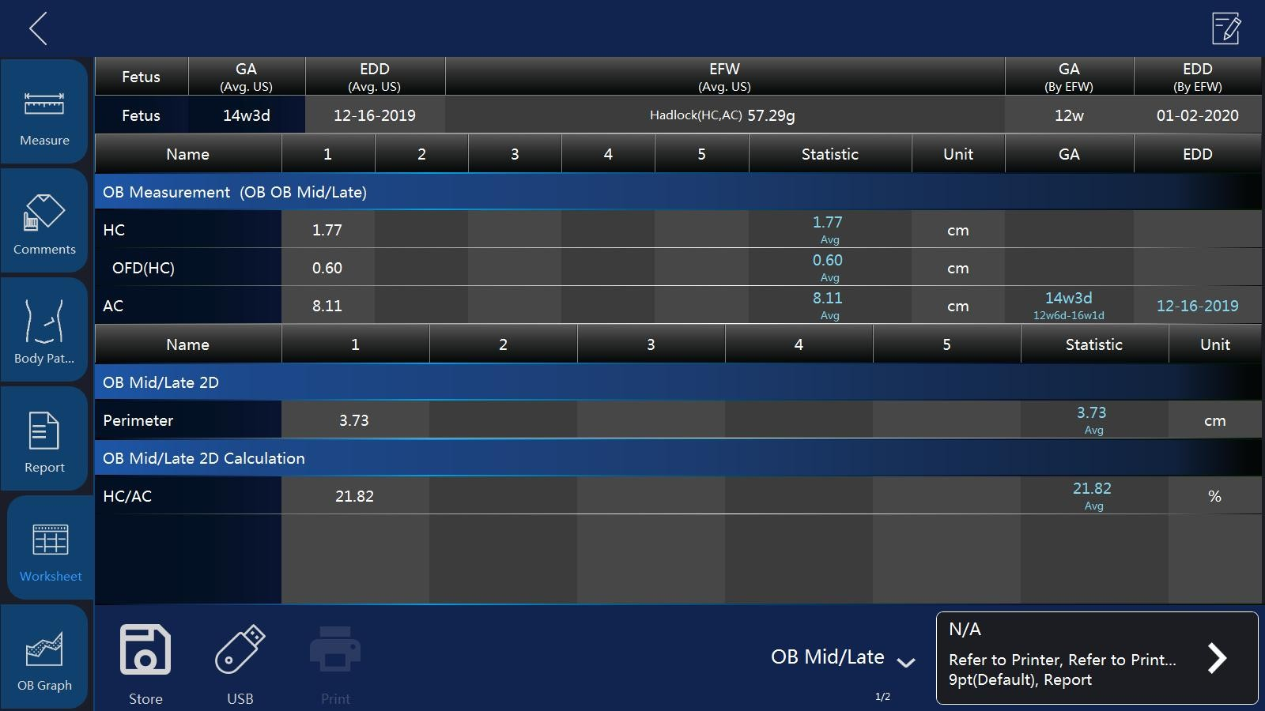

**1/2/3**: This is for repeating measurements of the same item. The maximum is 5 times. If the number of repeated measurements exceeds 5, the worksheet will only save the last 5 measurement results.

**Avg**: This is for post-processing method of measurement results. The options are: Average, Minimum, Maximum and Last. The desired method is selected from the pull-down menu by selecting the relevant position. 1 is for all items, 2 is for the related item.

**Unit**: The unit of measurement value and displayed result. The operator can select different units by touching the uint.

**Print:** Print the worksheet by the selected printer.

If there are more than one printer connected with this device, touch printer button to choose one printer. Touch “>” to configure printer’s setting.

**Edit:** Button “Edit” is selected, the operator can change the unit and statistics, and change the method of EFW. If the data is highlighted, it is selected for calculating Average, Minimum and etc., and it will appear in the report.

The first three items “LMP”, “GA(LMP)” and “EDD(LMP)” are from patient information, and the rest items are calculated by the measurement results. If there is more than one fetus, other fetuses’ information will be listed here too.

**IVF Report template**: Only if when VReport feature is opened, the IVF Report template can be used, which has unique worksheet UI for Follicle(L) and Follicle(R).

### 

### 10.1.5 Generic measurement list in each mode

**B mode generic measurement**

There are 8 generic measurements in 2D mode

* Depth
* Distance
* Perimeter
* Length and width method
* Ellipse method
* Polygon method
* Spline method
* Tracing method
* Area
* Length and width method
* Ellipse method
* Polygon method
* Spline method
* Tracing method
* Volume
* Single line method
* Dual line method
* Triple line method
* Single ellipse method
* Single ellipse and single line method
* Angle
* Stenosis
* Diameter method
* Squaremeter method
* A and B ratio
* Diameter ratio
* Squaremeter ratio

Note: Press “Measure” and the system will enter frozen mode automatically.

**Depth measurement:**

The steps are as follows:

1. Press “Measure”: one caliper will be displayed on the image screen.
2. Move the cursor to measurement menu to select “Depth” category.
3. To move the caliper position, use the trackball.
4. After moving the trackball to the position for measurement, press “Enter” for confirmation.
5. The system will display depth in the measurement results window.

The notes can help operator for depth measurement as follows:

Notes:

* To delete current result and start next measurement, press “Clear” once.
* To activate and edit relevant measurement, select relevant items to display submenu.
* To delete all measurement results, press and hold down “Clear”.

**Distance Measurement:**

The steps are as follows:

1. Press “Measure”.
2. Select the “Distance” measurement category if current measurement is not.
3. Move caliper to the measurement start point with the trackball.
4. Press “Enter” to confirm start point. The system will fix one caliper and a second caliper appears.
5. Move the second caliper to the end point with the trackball.
6. Press “ROI” before fix the second point, the first point is re-activated, then move the caliper if needed.
7. Press “Enter” to complete the distance measurement.

Notes:

* To delete the current result and start the next measurement, press “Clear” once.
* To activate and edit relevant measurement after one measurement is complete, the operator can select relevant items to display submenu.
* To delete all measurement results, press and hold down “Clear”.

**Perimeter: Length and width method**

Perimeter can be measured by two distances (length and width). The steps are the process of the measurement as follows:

1. Press “Measure”.
2. Select “Perimeter” in the measurement menu.
3. Select “L&W” approach in the perimeter menu. Caliper will display on the image screen
4. Measure the two distances separately.
5. After the two distance measurements are complete, the system will display perimeter in the measurement results window.

Notes:

* To delete the current result and start the next measurement, press “Clear” once.
* To exit measurement function, press “Measure” again.

**Perimeter: Ellipse method**

Perimeter can be measured by ellipse. The steps are the process of the measurement as follows:

1. Press “Measure”.
2. Select “Perimeter” in the measurement menu.
3. Select “Ellipse” approach in the perimeter menu. A caliper will display on the image screen
4. Position the first point and press “Enter”. The system will fix the first caliper and display the second caliper.
5. Position the second point and press “Enter” to confirm. The system will display the third caliper and trace the ellipse shape.
6. Finalize the third caliper and ellipse by moving the trackball. Press “Enter”.
7. The system will fix the third caliper and ellipse.
8. Measurement results window will display perimeter result.

Notes:

* Before completing the measurement, press “Clear” and the current measurement data will be deleted. The system will display the previous caliper and start the relevant measurement step again.
* To exit measurement before measurement is complete, press “Measure”.

**Perimeter: Polygon method**

Perimeter can be measured by a polygon. The steps are the process of the measurement as follows:

1. Press “Measure”.
2. Select “Perimeter” in the measurement menu.
3. Select “Polygon” approach in the perimeter menu. Caliper will display on the image screen
4. Position the first point and press “Enter”. The system will fix first caliper and display second caliper.
5. Position the second point and press “Enter” to confirm. The system will fix the second caliper and display the third caliper and trilateral trace.
6. To position third caliper, move trackball and press “Enter” for confirmation.
7. The system will fix the third caliper and display the fourth caliper and quadrilateral.
8. To position the fourth caliper, move the trackball and press “Enter” for confirmation. The system will fix the fourth caliper and display the fifth caliper and pentagon.
9. The rest can be done in the same manner in order to complete measurement in any polygon method. After the measurement is completed by pressing “Enter” twice, the results window will display the result.

Notes:

Before completing the measurement, press “Clear” to delete the current measurement data. The system will display previous caliper and start relevant measurement step again.

To exit measurement before measurement is complete, press “Measure”.

**Perimeter: Spline method**

Perimeter can be measured by spline. The steps are the process of the measurement as follows:

1. Press “Measure”.
2. Select “Perimeter” in measurement menu.
3. Select “Spline” approach in the perimeter menu. Caliper will display on the image screen.
4. To move the first caliper to the start point, move the trackball.
5. Press “Enter” to fix the start point. The first caliper will be fixed and the second caliper appears in the same position as the first caliper position.

Note: Press “Clear” once to delete the second caliper and the first caliper will be activated. If “Clear” is pressed again, the first caliper and spline line will disappear.

1. To fix the second caliper, move the trackball and press “Enter”. The third caliper will appear in the same position.

Note: Same function of “Clear” key as above. At least three points are needed to trace a spline curve. Continuously set the trace point until all required points are set.

1. Fix the final caliper and press “Enter” in order to finalize spline curve.

Note: Press “Enter” twice to complete trace measurement. Before completing the measurement, delete the calipers one by one by pressing “Clear”.

1. After measurement is completed by pressing “Enter” twice, the results window will display the result.

**Perimeter: Tracing method**

Perimeter can be measured by tracing method. The steps are the process of the measurement as follows:

1. Press “Measure”.
2. Select “Perimeter” in the measurement menu.
3. Select “Tracing” approach in the perimeter menu. Caliper will display on the image screen
4. To move the first caliper in the start point, move the trackball
5. To fix the start point, press “Enter”. Tracing caliper will change to an activated caliper.
6. The trackball can be used to trace the anatomical structure of the measurement field. The tracing curve will change to a dotted line.
7. To complete measurement, press “Enter” twice and the results window will display the perimeter result.

Notes:

* Before completing the measurement, press “Clear” once to clear a segment of the trace line.
* To clear the tracing caliper and the current measurement data, press “Clear” for at least 2 seconds.

**Area measurement: Length and width method**

Area can be measured by length and width. The steps are as follows:

1. Press “Measure”.
2. Select “Area” in the measurement menu.
3. Select “L&W” method in the area measurement menu. The active caliper will display on the image screen
4. Measure the two distances in sequence: press “Enter” to fix the start point; then move the trackball and press “Enter” to confirm the second point for distance measurement.
5. After the two distance measurements is completed, the area result will display in the result window.

Note:

Before completing the area measurement

* To clear the current measurement data, press “Clear” once. The system will display the original caliper to restart measurement.
* To exit measurement function before completing measurement, press “Measure” again.

**Area measurement: Ellipse method**

Area can be measured by ellipse. The steps are as follows:

1. Press “Measure”.
2. Select “Area” in the measurement menu.
3. Select “Ellipse” method in the area measurement menu. The active caliper will display on the image screen
4. Press “Enter” to fix the start point; then the second caliper is displayed.
5. Move the trackball to the second position and press “Enter” for confirmation.
6. The system will fix the second point and third caliper and ellipse shape display.
7. To position the third caliper and ellipse, move the trackball and press “Enter” for confirmation.
8. Results will display in the results window.

Notes:

Before completing ellipse measurement

* To clear ellipse and the current measurement data, press “Clear” once. The system will display the original caliper and restart measurement.
* To exit measurement function before completing measurement, press “Measure” again.

**Area measurement: Polygon method**

Area can be measured by polygon. The steps are as follows:

1. Press “Measure”.
2. Select “Area” in the measurement menu.
3. Select “polygon” method in the area measurement menu. The active caliper will display on the image screen
4. Press “Enter” to fix the start point, then the second caliper is displayed.
5. Move the trackball to the second position and press “Enter” for confirmation.
6. The system will fix the second point and third caliper and triangular shape display.
7. To position third caliper, move the trackball and press “Enter”. The system will fix the third point and the fourth caliper and quadrilateral display
8. To position fourth caliper, move the trackball and press “Enter”. The system will fix the fourth point and the fourth caliper and pentagon display.
9. The rest can be done in the same manner, and any polygon can be used to measure area. After measurement is complete, the system will display the results in the results window.

Notes:

Before completing ellipse measurement

* To clear ellipse and the current measurement data, press “Clear” once. The system will display the original caliper and restart measurement.
* To exit measurement function before completing measurement, press “Measure” again.

**Area measurement: Spline method**

Area can be measured by spline. The steps are as follows:

1. Press “Measure”.
2. Select “Area” in the measurement menu.
3. Select “Spline” method in the area the measurement menu. The live caliper will display on the image screen
4. To fix the trackball into the start point after positioned, press “Enter”. After the first caliper is fixed, the second active caliper is displayed in the same position as the first caliper.
5. Notes: Press “Clear” once, the second caliper disappears and the first caliper is activated. If the “Clear” key is pressed again, the first caliper disappears and the spline curve is canceled.
6. To position the second caliper, move the trackball and press “Enter” to confirm. The third active caliper will display in the same position as the second caliper.
7. Notes: The spline curve needs at least 3 points to make it. Continuously set trace points until all needed points are set.
8. To confirm the last caliper, press “Enter” again in order to confirm the final spline curve.

Notes: Press “Enter” twice to complete trace measurement. Before completing the measurement, the points can be erased one by one by pressing “Clear”.

After the measurement is completed, the results window will display the result.

**Area measurement: Tracing method**

Area can be measured by tracing. The steps are as follows:

1. Press “Measure”.
2. Select “Area” in the measurement menu.
3. Select “Tracing” method in the area measurement menu. The active caliper will display on the image screen
4. To move caliper to the start point, move the trackball.
5. Press “Enter” to fix the start point. The active caliper will display in the screen.
6. Trace the measurement dotted line along which the anatomy needs to be measured.
7. After the tracing is completed, and the “Enter” is pressed. Then the result will display in the results window.

Notes:

Before complete the tracing measurement:

Press “Clear” once to clear a segment of the trace line.

To clear caliper and current measurement data, press “Clear” for at least 2 seconds

**Volume measurement**

Volume can be measured by one of the approaches as follows:

* Single line (L), i.e. single distance method
* Dual line (L&W), i.e. dual distance method
* Triple line (L&W&H), i.e. triple distance method
* Single ellipse
* Single ellipse and single line method

Refer to “Distance” measurement to know how to measure distance for details.

Refer to “Perimeter” and “Area” measurement to know how to measure ellipse for details.

To measure volume through single or dual distance method, the steps are as follows:

1. Press “Measure”.
2. Select “Volume” in the measurement menu.
3. Select “L” or “L&W” method in the volume measurement menu. The active caliper will display on the image screen
4. Proceed with single or dual distance measurement.
5. The result will display in the results window.

Notes: Use “Clear” to delete measurement and calculation result.

To measure volume by triple distance method, the steps are as follows:

1. Press “Measure”.
2. Select “Volume” in the measurement menu.
3. Select “L&W&H” method in the volume measurement menu. The active caliper will display on the image screen

Notes: Triple distance can complete in dual image display format. First measurement normally is done in midsagittal plane.

1. Proceed with single distance and dual distance measurement.
2. Volume result is displayed in the results window.

To measure volume by ellipse method, the steps are as follows:

1. Press “Measure”.
2. Select “Volume” in the measurement menu.
3. Select “Ellipse” method in the volume measurement menu. The active caliper will display on the image screen
4. Proceed with ellipse measurement
5. Volume result is displayed in the results window.

To measure volume by ellipse and single distance method, the steps are as follows:

1. Press “Measure”
2. Select “Volume” in the measurement menu.
3. Select “Ellipse&H” method in the volume measurement menu. The active caliper will display on the image screen

Note: Single ellipse and distance can be measured in dual display format. The first measurement normally proceeds in midsagittal plane. The second measurement proceeds in the axial plane normally.

1. Press “Left “or “Right” to activate dual display format.
2. Proceed with single distance and ellipse measurement.
3. Volume result is displayed in the results window.

Notes:

To change parameters during volume measurement, the steps are as follows before restarting measurement.

Check every item’s measurement result in the results window.

If data is not accurate or blank, select editing of relevant measurement or relevant menu in the bottom, then measure and calculate again.

Reminders:

Result is most accurate in midsagittal plane and axial plane measurement.

To display midsagittal plane and axial plane simultaneously, use dual display format.

**Angle Measurement**

The steps are as follows:

1. Press “Measure”.
2. Select “Angle” in the measurement menu. The active caliper will display on the image screen
3. Use the trackball to move the caliper.
4. Press “Enter” to fix the first caliper and the second caliper will display.
5. Use the trackball to move the second caliper to desired position.
6. Press “Enter” to fix the second caliper and third caliper will display.
7. Use the trackball to move the third caliper to the desired position.
8. Press “Enter” to fix the fourth caliper. The result is displayed in results window.

**Stenosis**

Diameter stenosis can be calculated by diameter or area approaches.

**Diameter**

Note: After using diameter approach to calculate stenosis, do not measure distance in vertical angle. It can result in inaccurate estimation of stenosis. It is better to measure vessel diameter in the cross-sectional perspective.

The steps are to calculate stenosis by diameter approach as follows:

1. Press “Measure”.
2. Select “Stenosis” in the measurement menu.
3. In the stenosis measurement menu, after the “Diam” approach is selected, an active tracing caliper will display on the image screen
4. Measure the inter-vascular distance. The system will display another caliper for second distance measurement.
5. Measure the distance of exterior vessels.
6. The results window will display each measured distance and stenosis percentage.
7. Refer to the distance measurement to know how to measure distance.

**Area**

The steps are to calculate stenosis by area approach as follows:

1. Press “Measure”.
2. Select “Stenosis” in measurement menu.
3. In “Stenosis” measurement menu, after “Area” approach is selected, an active tracing caliper will display on the image screen

Notes: Different area measurement approaches can be selected (such as length & width, ellipse, polygon, spline, and tracing method)

1. Measure the area of inter vascular. The system will display another active caliper for second area measurement.
2. Measure the area of the exterior vessel.
3. Results window displays two area results and stenosis percentage.
4. Refer to the area measurement to know how to measure area.

**A and B rate**

In B mode, A and B ratio can be calculated by diameter or area measurement.

**Diameter**

The steps are to calculate A and B ratio by diameter measurement as follows:

1. Press “Measure”.
2. Select “A/B ratio” in the measurement menu.
3. In the “A/B ratio” measurement menu, select the “Diam” approach and an active tracing caliper will display on the image screen
4. Measure the first diameter distance. The system displays another caliper for the second distance measurement.
5. Proceed with the second distance measurement.
6. The system will display two distance measurement results, A and B ratio.
7. First diameter is A and second diameter is B.
8. Refer to the distance measurement for details on the distance measurement approach.

**Area**

The steps are to calculate A and B ratio by area measurement as follows:

1. Press “Measure”.
2. Select “A/B ratio” in the measurement menu.
3. In the “A/B ratio” measurement menu, select the “Area” approach and an active caliper will display on the image screen

Note: Here, different area measurement methods (length & width, ellipse, polygon, spline, and tracing method) can be selected.

1. Proceed with area A measurement. The system will display another active caliper for second area measurement.
2. Proceed with area B measurement.
3. The system will display two area measurement results and the A/B ratio in result window.

Refer to the area measurement section for details on the area measurement approach.

Besides these 8 items there is another measure item “Curve Length”. It has 3 methods: Spline, Trace, Polygon.

M mode measurement

There are 7 generic measurements in “M” mode:

* Depth
* Distance
* Time
* Speed
* Heart rate
* Stenosis
* A and B ratio
* Diameter ratio
* Time ratio
* Speed ratio

Note:

There are the following assumptions before proceeding with measurement:

1. The image screen is displaying anatomy to be measured.
2. System is in M mode. (If not, enter M mode).
3. The system is in “Frozen" state. (If not, press “Freeze”).

**Anatomic depth measurement**

M mode anatomic depth measurement is the same as B mode. It measures the depth between the measured point and the top of image, the steps are as follows:

1. Press “Measure” once: A vertical and horizontal dotted line and an active tracing caliper will display on the image.
2. Use the trackball to position the depth to be measured.
3. Use the “Enter” to finalize the position.
4. The depth result will be displayed in the results window.

**Distance measurement**

The same as 2D mode in distance measurement. It measures the distance between two calipers. The steps are as follows:

1. Press “Measure”.
2. Select “Distance” in the measurement menu. A vertical and horizontal dotted line and an active tracing caliper will display on the image screen.
3. Use the trackball to move the caliper in measurement start point.
4. Press “Enter” to finalize the start point. The system will display the second active caliper.
5. Use the trackball to position the second measurement point.
6. Press “Enter” to complete measurement.
7. The distance result will be displayed in the results window.

**Time interval measurement**

M mode time interval measurement is to measure horizontal interval between two calipers. The steps are as follows:

1. Press “Measure”.
2. Select “Time” in the measurement menu. A vertical and horizontal dotted line and an active caliper will display on the image screen
3. Use the trackball to move caliper in the measurement start point.
4. Press “Enter” to finalize start point. The system will display a second active caliper.
5. Use trackball to position the second measurement point.
6. Press “Enter” to complete measurement. The time interval result will be displayed in the results window.

**Speed measurement**

In “M” mode, use the slope between two points to gain the speed of the two points. The steps are as follows:

1. Press “Measure”.
2. Select “Slope” in the measurement menu. A vertical and horizontal dotted line and an active caliper will display on the image screen
3. Use the trackball to move the caliper in measurement start point.
4. Press “Enter” to finalize the start point. The system will display a second active caliper.
5. Use the trackball to position the second measurement point.
6. Press “Enter” to complete measurement. The system will display the speed between the two points.

**Heart Rate measurement**

Heart rate can be calculated in “M” mode.

The steps are as follows:

1. Press “Measure” in the desired image.
2. Select “HR” in the measurement menu. A vertical and horizontal dotted line and an active caliper will display on the image screen
3. Position one identifiable point in one heart cycle by moving the trackball.
4. Press “Enter” to fix the first point. The system will display the second caliper.
5. Move the trackball to the same position as the first one in the second cycle.

Note:

* The number of measured cycles can be selected in the HR menu, from 1 to 5.
* The number of required measurement cycles is displayed in the information bar at the bottom of the screen.

1. Press “Enter” to complete measurement and transfer the calculation into the worksheet. The system will display heart rate in the results window.

**Stenosis measurement**

The stenosis measurement in “M” mode is the same as diameter measurement method in 2D mode. It measures the percentage between two distances. The steps are as follows:

1. Press “Measure”.
2. Select “Stenosis” in the measurement menu. A vertical and horizontal dotted line and an active caliper will display on the image screen
3. Measure the distance in the inter-vessel area. The system will display another active caliper.
4. Proceed with the distance in the exterior vessel area.
5. The system will display each distance and stenosis percentage in the results window.
6. Refer to the distance measurement for details.

**A and B ratio**

In “M” mode, A and B ratio can be measured through diameter, time and speed measurement.

**Diameter**

Calculate A and B ratio through diameter approach, the steps are as follows:

1. Press “Measure”.
2. Select “A/B ratio” in the measurement menu.
3. Select “Diam” measurement approach in the A/B ratio menu. A vertical and horizontal dotted line and an active caliper will display on the image screen
4. Proceed with the first distance measurement. The system will display another vertical and horizontal dotted line caliper for second measurement.
5. Proceed with the second distance measurement
6. The system will display each distance, and the A/B ratio.

Note: The first distance is A and the second distance is B.

Refer to the distance measurement for details.

**Time**

Calculate A and B ratio through time, the steps are as follows:

1. Press “Measure”.
2. Select “A/B ratio” in the measurement menu.
3. Select “Time” measurement approach in A/B ratio menu. A vertical and horizontal dotted line and an active caliper will display on the image screen
4. Move the trackball to position the caliper in point A.
5. Press “Enter” to fix the measurement point. The system will display the second caliper.
6. Move the trackball to position the point B.
7. Press “Enter” to complete measurement. The system will display two measured time results, A and B ratio.

**Speed**

The steps are as follows:

1. Press “Measure”.
2. Select “A/B ratio” in the measurement menu.
3. Select “Velocity” measurement approach in A/B ratio menu. A vertical and horizontal dotted line and an active caliper will display on the image screen
4. Move the trackball to position the caliper in A point.
5. Press “Enter” to fix measurement point. The system will display the second caliper.
6. Move the trackball to position point B.
7. Press “Enter” to complete measurement. The system will display two measured time results, A and B ratio.

**PW mode measurement**

There are 19 types of measurement in “PW” mode:

* Speed (include PV (Peak Velocity))
* Time (include AT (Accelerate Time))
* Acceleration
* PS (Peak Speed in systole period)
* ED (The speed in the end of diastole period)
* MD (Minimum speed in diastole period)
* TAMAX (maximum speed in time average)
* TAMEAN (mean speed in time average)
* PI (Pulsatility Index)
* RI (Resistance Index)
* PS and ED ratio
* ED and PS ratio
* A and B ratio (A/B ratio)
* Speed ratio
* Time ratio
* Acceleration ratio
* FLOWVOL (Flow Volume)
* MaxPG ( maximum pressure gradient)
* MeanPG (Mean pressure gradient)
* SV ( Stroke Volume)
* Each volume diameter cardiac
* Time mean speed in each stroke volume
* Heart rate

Note:

To carry out this operation:

Scan vessel to be measured in B or B plus CF mode.

Turn to “PW” image.

Press “Freeze” key.

**Speed, Time Interval and Acceleration Measurement**

**Speed (cm/s or m/s)**

In PW mode, the steps of proceeds with speed measurement are as follows:

1. Press “Measure”.
2. Select “Velocity” in the measurement menu. A vertical and horizontal dotted line and a caliper will display on the image screen
3. Move the trackball to position the speed measurement point
4. Once position is fixed, press “Enter”.
5. The result will be displayed in the results window.

**Time interval**

The steps are as follows:

1. Press “Measure”.
2. Select “Time” in the measurement menu. A vertical and horizontal dotted line as and an active tracing caliper will display on the image screen
3. Move trackball to position the first measurement point.
4. After position is fixed, press “Enter”. The system will display the second caliper.
5. Move the trackball to position the second measurement point.
6. Press “Enter” to complete the measurement. The system will display time interval between two calipers in the results window.

**Acceleration (m/s2)**

The steps are as follows:

1. Press “Measure”.
2. Select “Acceleration” in the measurement menu. A vertical and horizontal dotted line and an active caliper will display on the image screen
3. Move the trackball to position the first measurement point.
4. Once position is fixed, press “Enter”. The system will display the second caliper.
5. Move the trackball to position the second measurement point.
6. Press “Enter” to complete the measurement. The system will display the acceleration between two points and the time interval result in the results window.

**PS (Peak speed in systole period), ED (The speed in the end of diastole period) and MD (Minimum speed in diastole period) measurement**

The steps are as follows:

1. Press “Measure”.
2. Select PS, ED or MD in the measurement menu. A vertical and horizontal dotted line as an active tracing caliper will display on the image screen.
3. Move the trackball to position the measurement point
4. Press “Enter” to complete measurement. The system will display peak speed in systole period, the speed in the end of diastole period and the minimum speed in diastole period.

**TAMAX, TAMEAN measurement**

The steps are as follows:

1. Press “Measure”.
2. Select TAMAX, TAMEAN in the measurement menu. A live tracing caliper will display on the image screen.
3. Move the trackball to position the start measurement point.
4. Press “Enter” to fix the start point.
5. Move the trackball to trace spectrum in maximum, mean or minimum.
6. Press “Enter” to complete the measurement. The result will be displayed in the results window.

Note: To remove trace line during tracing, press the “Clear” or “Freeze” key.

**PI (Pulsatility Index) measurement**

The steps are as follows:

1. Press “Measure”.
2. Select “PI” in the measurement menu. A vertical and horizontal dotted line as an active tracing caliper will display on the image screen.
3. Move the trackball to position the start measurement point.
4. Press “Enter” key to fix the start point. The second caliper will display in the system.
5. Move the trackball to trace the whole wave.
6. Press “Enter” to complete the measurement. The system will display results of peak speed in systole period, minimum speed of diastole period, the speed of the end of diastole period, TAMAX and PI in results window.

**Resistance index (RI) measurement**

In “PW” mode, PI can be calculated by ED or MD measurement.

**By ED measurement**

The steps are as follows:

1. Press “Measure”.
2. Select “RI” in the measurement menu.
3. In the “RI” setting menu, select “ED” method. A vertical and horizontal dotted line as an active tracing caliper will display on the image screen
4. Move the trackball to position the start measurement point in peak speed of systole period.
5. Press “Enter” to fix the start point. Second caliper will display in the system.
6. Move the trackball to position the second caliper in the speed of the end of diastole period.
7. Press “Enter” to complete the measurement. The system will display PS, ED and RI in the results window.

**Through MD measurement**

The steps are as follows:

1. Press “Measure”.
2. Select “RI” in the measurement menu.
3. In the “RI” setting menu, select “MD” method. A vertical and horizontal dotted line as an active tracing caliper will display on the image screen.
4. Move the trackball to position the start measurement point in peak speed of systole period.
5. Press “Enter” to fix the start point. Second caliper will display in the system.
6. Move trackball to position the second caliper in the minimum diastole speed.
7. Press “Enter” to complete the measurement. The system will display PS, ED and RI in the results window.

**PS and ED or ED and PS ratio**

To calculate PS and ED or ED and PS ratio, the steps are as follows:

1. Press “Measure”.
2. Select “PS/ED” or “ED/PS” in the measurement menu. A vertical and horizontal dotted line as an active tracing caliper will display on the image screen.
3. Move the trackball to position the caliper in systole peak speed (PS) or diastole end speed (ED).
4. Press “Enter” to fix point. Second caliper will display.
5. Move the trackball to position the second caliper in diastole end speed (ED) or systole peak speed (PS).
6. Press “Enter” to complete the measurement. The system will display PS, ED and PS/ED or ED/PS ratio in results window.

**A and B ratio**

In PW mode, A and B ratio can be measured through speed, time or acceleration.

**Speed**

Calculate A and B ratio through speed, the steps are as follows:

1. Press “Measure”.
2. Select “A/B ratio” in measurement menu.
3. In the “A/B ratio” setting menu, select “Velocity” method. A vertical and horizontal dotted line as an active tracing caliper will display on the image screen.
4. Move trackball to position the caliper in speed A.
5. Press “Enter” to fix the measurement point. Second caliper will display in the system.
6. Move the trackball to position the second caliper in B speed.
7. Press “Enter” to complete the measurement. The system will display two speed results and A/B ratio in the results window.

**Time**

Calculate A and B ratio through time, the steps are as follows:

1. Press “Measure”.
2. Select “A/B ratio” in the measurement menu.
3. In the “A/B ratio” setting menu, select “Time” method. A vertical and horizontal dotted line as an active tracing caliper will display on the image screen.
4. Move the caliper to position A.
5. Press “Enter” to fix the measurement point. Second caliper will display in the system.
6. Move the caliper to position B.
7. Press “Enter” to complete the measurement. The system will display two time results and A/B ratio in the results window.

**Acceleration**

Calculate A and B ratio through acceleration, the steps are as follows

1. Press “Measure”.
2. Select “A/B ratio" in the measurement menu.
3. In the “A/B ratio” setting menu, select “Acceleration" method. A vertical and horizontal dotted line as an active tracing caliper will display on the image screen.
4. Proceed with the position A acceleration measurement:

* Move the trackball to position the caliper in start point.
* Press “Enter” to fix the start point. The second caliper will display.
* Move the trackball to position the caliper in end point.
* Press “Enter” to complete the measurement.

1. The system will display acceleration in the results window and second acceleration caliper will display.
2. Proceed with B acceleration measurement using the same as above steps. The system will display two acceleration results and A/B ratio in the results window.

**FLOW VOL (Flow volume)**

The steps are as follows:

1. Press “Measure”.
2. In the normal Doppler measurement menu, select “FLOWVOL”.

**Max PG (maximum pressure gradient)**

The steps are as follows:

1. Press “Measure”.
2. In the normal Doppler measurement menu, select “Max PG”.

**Mean PG (mean pressure gradient)**

The steps are as follows:

1. Press “Measure”.
2. In the normal Doppler measurement menu, select “Mean PG”.

SV Diam( Stroke volume diameter)

The steps are as follows:

1. Press “Measure”.
2. In the normal Doppler measurement menu, select “SV”.
3. Select “SV Diam” in the SV menu.

SV TAMEAN (stroke volume TAMEAN)

The steps are as follows:

1. Press “Measure”.
2. In the normal Doppler measurement menu, select “SV”.
3. Select “SV TAMEAN” in the SV menu.

**Heart rate measurement**

In PW mode, heart rate can be calculated, the steps are as follows :

1. Press “Measure” after gain image.
2. Select “HR” in the measurement menu. A vertical and horizontal dotted line and an active tracing caliper will display on the image.
3. Move the trackball to position an identifiable point in the first heart cycle.
4. Press “Enter” to fix the first caliper. The system will display the second caliper.
5. Move the second caliper to be the same position as the first one in the second heart cycle.

Note:

* Set required heart cycles for measurement in the “HR” menu. Heart cycle range from 1 to 5.
* In the bottom information bar of the image screen, the system will display the number of heart rate which needs to be measured.

1. Press “Enter” to complete measurement and transfer to worksheet in the meantime. The system will display “HR” in the result window.

**Auto Trace**

To execute “Auto Trace”, the steps are as follows:

1. Press “Measure”.
2. In the normal Doppler measurement menu, select “Auto Trace”.
3. Move the cursor to PW image, press “Enter” key.
4. The system will provide the results automatically. And there are vertical dotted lines to indicate the latest 1-5 cycle(s), the number of cycle is configured in config page. “+” means the peak of the spectrum.

**Semiauto Trace**

To execute “Semiauto Trace”, the steps are as follows:

1. Press “Measure”.
2. Select item “Semiauto Trace”.
3. Fix the start and end point on PW image.
4. The system will provide the results automatically. And there are vertical dotted lines to indicate the valid cycle(s).

Manual Trace

To execute “Manual Trace”, the steps are as follows:

1. Press “Measure”.
2. Select item “Manual Trace”.
3. Fix the start point, move the trackball to trace the spectrum.
4. Move the cursor on PW image back to start point, delete the trace line.
5. Press “Enter” key to fix the end point. The system will provide the results.

**3D/4D mode measurement**

After 3D data acquisition, press Measure key to enter measurement, but only support 3 measurements: Distance, Perimeter and Area. In 4D/MCut mode, after select “Start 4D/MCut”, press Measure key, stop scanning and enter measurement, only support 3 measurements: Distance, Perimeter and Area.

### 

### 10.1.6 Measurement setting in each mode

**B/HAR mode measurement setting**

In B/HAR mode, there are 8 generic and relevant specific measurements. The relevant measurement settings can be made in the setting menu.

Select “Config” on the touch panel to enter setting menu.

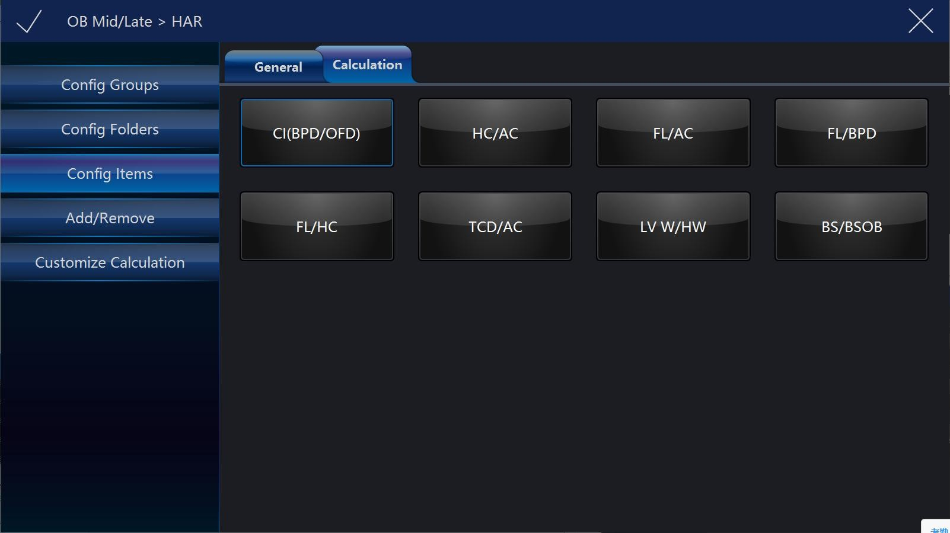

* Config Folders: Display all folders, different applications or modes have different folders. Select one or more folders, select “Save&Exit”, the selected folders will added to measurement menu. Unselect one or more folders, they will be removed from measurement menu. There is only one folder in some applications, it will be “General”.

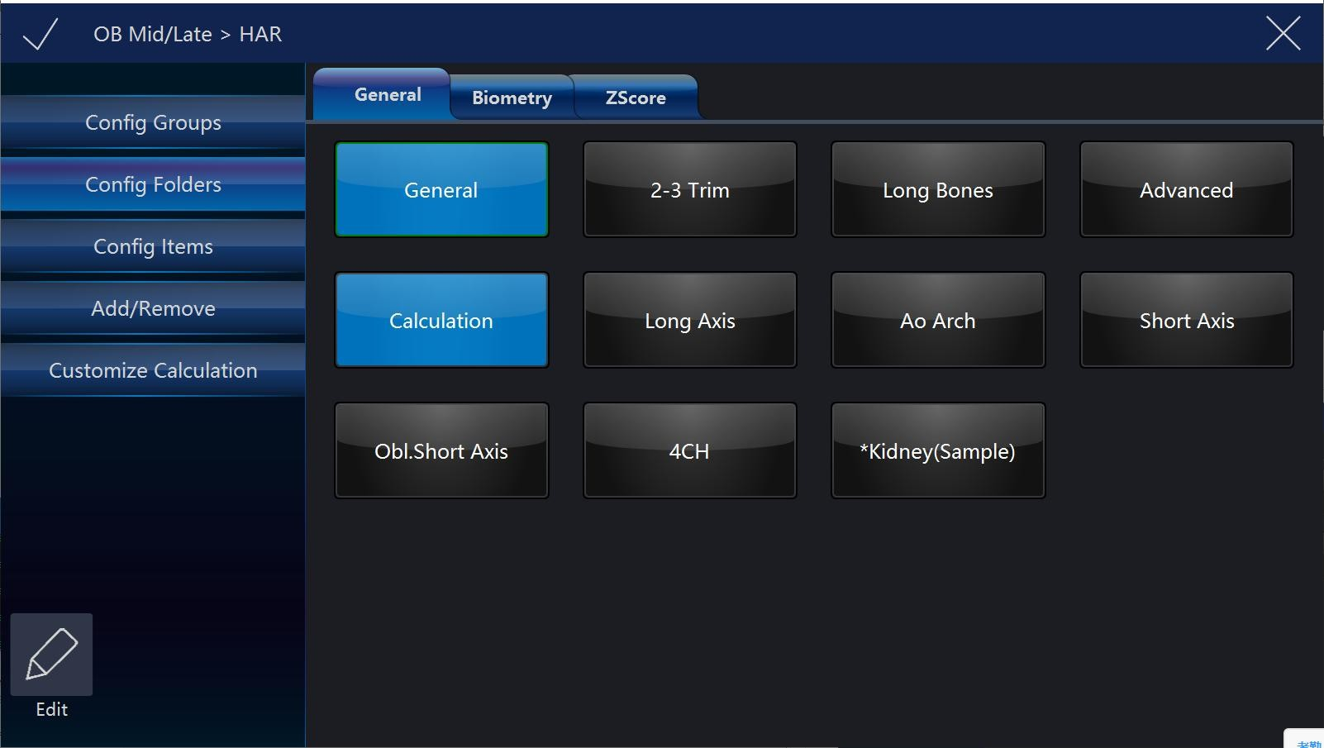

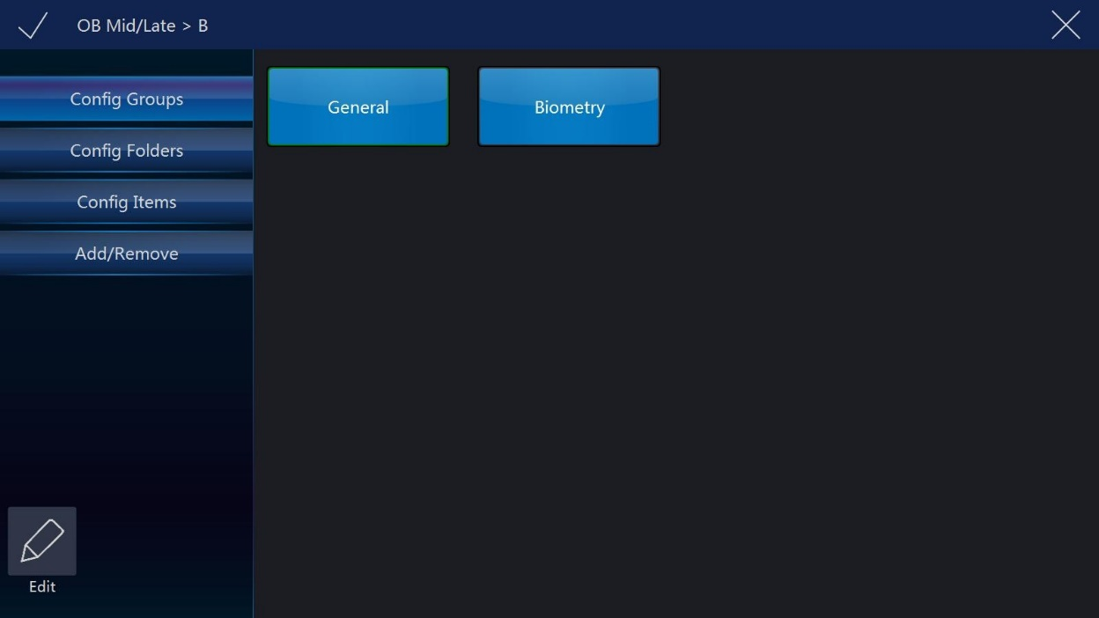

* Config Items: Select one item, if it has more than one method, the system will enter change method page, the operator can select different methods or target items here. Selected methods will be used after back to measurement menu, and selected target items will display in the result window. Select and hold on one item, move it to the first position, then this item is set to be the default one.

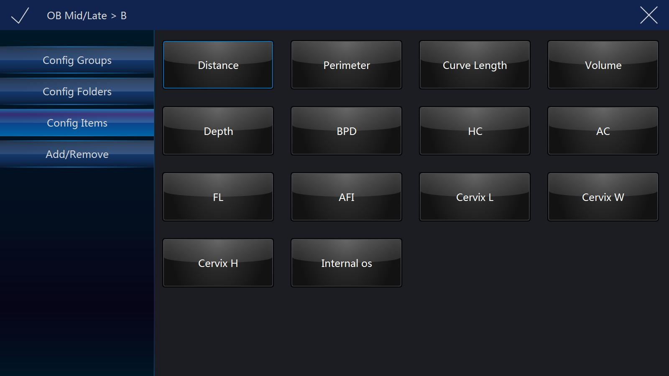

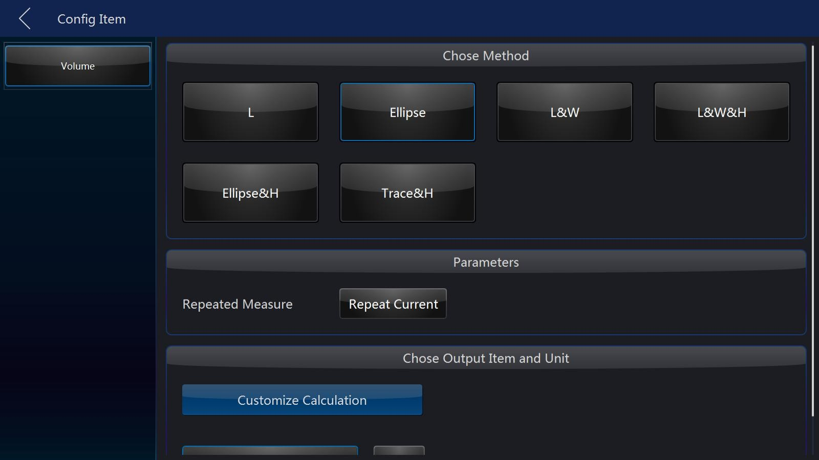

* Add/Remove: Select the desired measurement items, select “Save” or “Save&Exit”, the system returns to the measurement menu and all selected items are displayed. The unselected items will be removed.

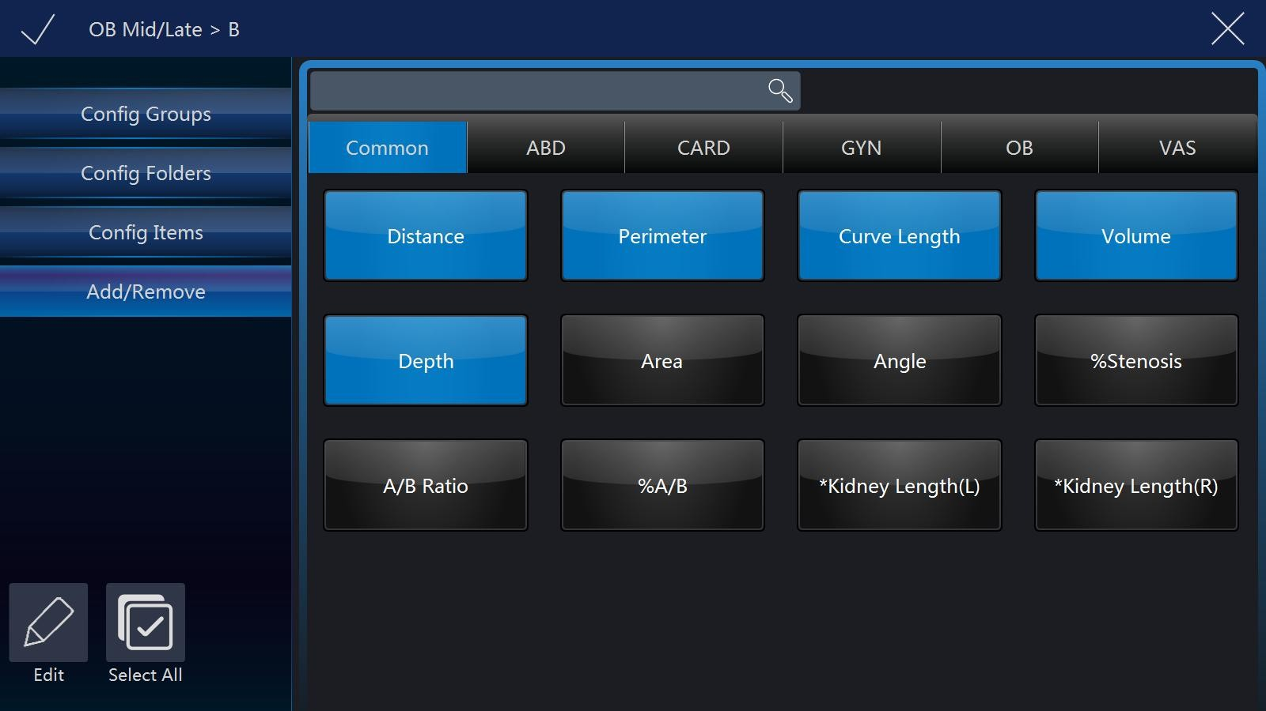

Note:

“Distance” is default setting in 2D mode. Different examination application has factory default setting in 2D mode measurement. The operator can enter the setting menu to change.

**Perimeter setting in B mode**

The steps are as follows:

Select “Perimeter” button in configuration page. The system will display all approaches of perimeter measurement: length and width, ellipse, polygon, spline and trace.

Select the required measurement item. After settings are finished, select “Save” on the touch panel.

Note:

Different applications have factory default settings in 2D mode measurement. The operator can enter the setting menu to change.

**Area setting in B mode**

The steps are as follows:

1. Select “Area” button in configuration page. The system will display all approaches of area measurement: length and width, ellipse, polygon, spline and trace.
2. Select the required measurement item. After settings are finished, select “Save” on the touch panel.

**Volume setting in B mode**

The steps are as follows:

1. Select “Volume” button in configuration page. The system will display all approaches of area measurement: single line, double line, triple line, single ellipse, single ellipse and single line.
2. Select the required measurement item. After settings are finished, select “Save” on the touch panel.

**Stenosis setting in B mode**

The steps are as follows:

1. Select “Stenosis” button in configuration page. The system will display all approaches of area measurement: diameter and area.
2. Select the required measurement item. After settings are finished, select “Save” on the touch panel.

**A and B ratio setting in B mode**

The steps are as follows:

1. Select “A/B ratio” button in configuration page. The system will display all approaches of area measurement: diameter and area approaches.
2. Select the required measurement item. After settings are finished, select “Save” on the touch panel.

**M mode measurement setting**

In “M” mode there are 7 types of generic measurements and specific measurements relevant with application. All measurements can be set in the setting menu.

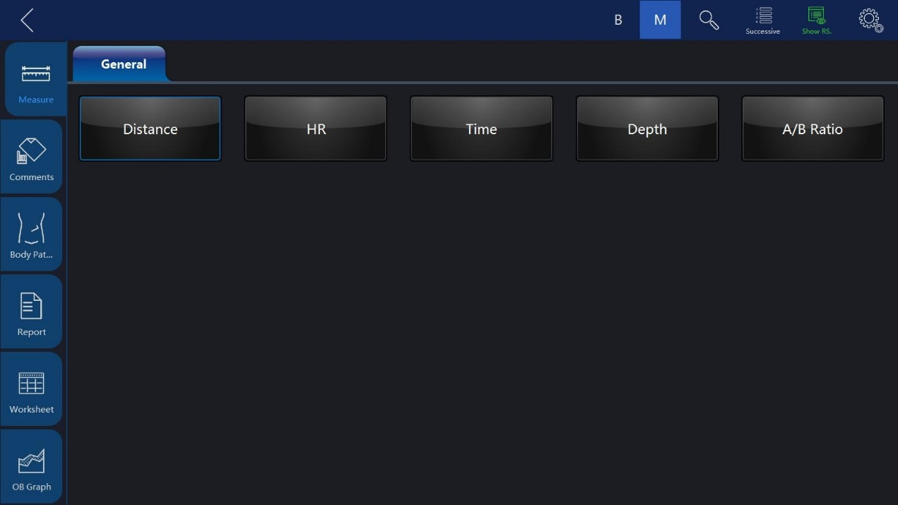

Select “Config” on the touch panel to enter setting menu. Please refer to 11.1.6.1, the configuration operation is the same as it in B mode.

**A and B ratio measurement setting**

The steps are as follows:

1. Select “A/B ratio” button in configuration page. The system will display all measurement methods: Diameter, time and acceleration methods.
2. Select the desired measurement method on the touch panel. After settings are finished, select “Save” on the touch panel.

**PW mode measurement setting**

**General measurement folder setting in PW mode**

In the general measurement folder, there are 19 types of generic measurements and specific measurements with relevant applications.

Please refer to 11.1.6.1, the configuration operation is the same as it in B mode.

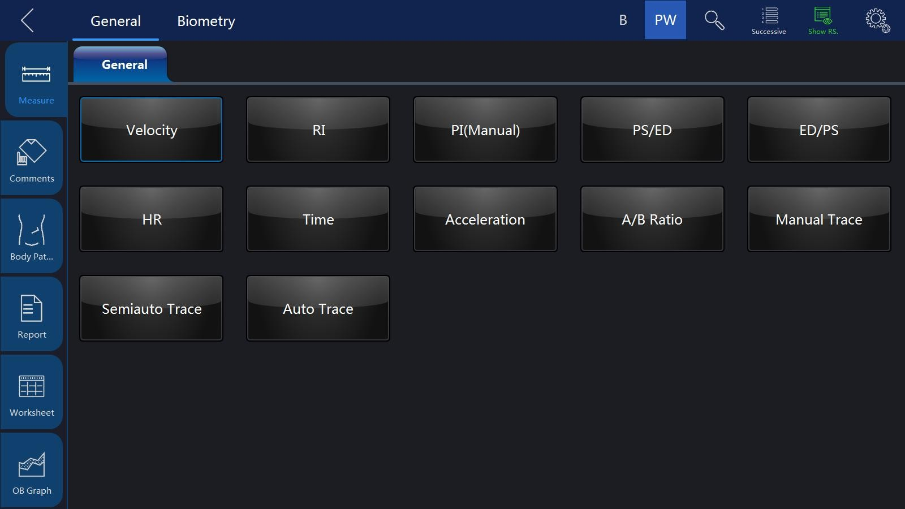

**Resistance index setting in PW mode**

The steps are as follows:

1. Select “RI” button in configuration page. The system displays all measurement methods for “RI” measurement: ED (diastole end speed) and MD (minimum systole speed).
2. Select the desired measurement method on the touch panel. After settings are finished, select “Save” on the touch panel.

**A and B ratio measurement setting in PW mode**

The steps are as follows:

1. Select “A/B ratio” button in configuration page. The system will display all measurement methods for A/B ratio measurement: speed, time and acceleration methods.
2. Select the desired measurement method on the touch panel. After settings are finished, select “Save” on the touch panel.

**Flow volume measurement setting in PW mode**

The steps are as follows:

1. Select “FLOW VOL” button in configuration page. The system will display all measurement methods for FLOW VOL measurement: TAMEAN and TAMAX methods.
2. Select the desired measurement method on the touch panel. After settings are finished, select “Save” on the touch panel.

Note:

If TAMAX measurement method is selected, the final calculation result is considered one compensation factor between 0.5 and 1.0.

**Other measurement setting folder in PW mode**

Other measurement setting folders use the same approach as the “General” measurement setting. Refer to the “General” measurement folder setting.

## 10.2 Abdominal measurements

Brief introduction:

Based on different applications, abdominal measurement provides several different types of measurement options:

* General abdomen
* Difficult abdomen
* Kidney
* Renal vessel
* Abdominal trauma

### 

### 10.2.1 B mode measurements

The measurement menu in the “Abdominal” application includes generic measurement and specific measurement, such as aorta diameter, renal length, and renal volume.

In 2D mode, generic measurement in abdominal application covers the following criteria:

* Depth
* Distance
* Volume
* Angle
* Stenosis
* A and B ratio

Refer to the “General” measurement for more detail on those measurements.

In 2D mode, specific measurements in the abdominal application include the following items:

**Aorta diameter**

Aorta diameter can be measured by single distance measurement. The steps are as follows:

1. Press “Measure”.
2. Select “Aorta Diameter”, then a caliper will display on the image screen
3. Move the trackball to position the caliper in the start point.
4. Press “Enter” to fix the start point. The second active caliper will display.
5. Move the trackball to position the second caliper in the end point.
6. Press “Enter” to complete the measurement. The system will display the aorta diameter result in the results window.

**Renal Length**

Renal length can be measured by single distance measurement. The steps are as follows:

1. Press “Measure”.
2. Select certain direction of Renal Length (left or right), then a caliper will display on the image screen
3. Move the trackball to position the caliper in start point.
4. Press “Enter” to fix the start point. The second active caliper will display.
5. Move the trackball to position the second caliper in the end point.
6. Press “Enter” to complete the measurement. The system will display the renal length result in the results window.

**Renal Volume**

Renal volume is normally measured by the three-distance method. The steps are as follows:

1. Press “Measure”.
2. Select a certain direction of Renal Volume (left or right), and then a caliper will display on the image screen

Note: Three distances can be measured in the dual image display format. The first measurement can be processed in the midsagittal plane, and the second measurement can be processed in the axial plane. To use dual image display format, press “Left” or “Right”.

1. Proceed with the single and dual distance measurement.
2. The system will display three distances and the renal volume result in the results window.

**Spleen volume**

Spleen volume is normally measured by the three distance method. The steps are as follows:

1. Press “Measure”.
2. Three distances can be measured in the dual image display format. The first measurement can be processed in the midsagittal plane, and the second measurement can be processed in the axial plane. To use the dual image display format, press “Left” or “Right”.
3. Proceed with the single and dual distance measurement.
4. The system will display three distances and the spleen volume result in the results window.

**Bladder volume**

There are 2 methods to measure bladder volume: Manual and Auto. The steps are as follows with “Manual”:

1. Press “Measure” key.
2. Select “Bladder Volume”, and then a caliper will display on the image screen Note: Three distances can be measured in the dual image display format. The first measurement can be processed in the midsagittal plane, and the second measurement can be processed in the axial plane. To use the dual image display format, press “Left” or “Right”.
3. Proceed with the single and dual distance measurement.
4. The system will display three distances and the bladder volume result in the results window.

Auto method:

1. Press “Measure” key.
2. Select “Bladder Volume” in “Config” page, touch “Auto”.
3. Save and exit.
4. Move the cursor to the image, press “Enter” key.
5. Unfreeze the system, change scanning section, enter measure again, and press “Enter” key.
6. The system will get the result of bladder volume automatically.

**Prostate volume**

Prostate volume is normally measured by the three distance method. The steps are as follows:

1. Press “Measure”.
2. Select Prostate, and then a caliper will display on the image screen.
3. Note: Three distances can be measured in dual image display format. The first measurement can be processed in the midsagittal plane, and the second measurement can be the processed in axial plane. To use the dual image display format, press “Left” or “Right”.
4. Proceed with the single and dual distance measurement.
5. The system will display three distances and the prostate volume result in the results window.
6. The number of measurement items in 2D mode can be added to or reduced based on each operator’s measurement requirements. Refer to the measurement setting for how to set measurements in detail.

**M mode measurements**

In “M” mode, the measurement menu includes these measurement items:

* Stenosis
* A and B ratio
* Heart Rate

Refer to the Generic measurement in detail for those measurements.

Measurement items in the measurement setting menu can be added to or reduced based the operator’s requirements. Refer to “M” mode measurement setting information in detail.

**PW mode measurements**

In “PW” mode, the measurement menu includes these measurement folders:

* Generic measurement folder
* Aorta measurement folder
* Common hepatic artery measurement folder
* Renal artery measurement folder
* Renal vein measurement folder
* Postcava measurement folder
* Superior mesentery artery measurement folder

Increase or reduce measurement items in the measurement setting menu based on their own requirement. Refer to “PW” mode measurement setting information in detail.

**Generic measurement folder**

In “PW” mode, the generic measurement folder includes items as follows:

* Velocity
* PS (systole peak speed)
* ED (diastole end speed)
* MD (Minimum speed in diastole period)
* TAMAX (maximum speed in time average)
* PI (Pulsatility index)
* RI (resistance index)
* PS/ED
* ED/PS
* A/B ratio
* Velocity
* Time
* Acceleration
* HR

Refer to the Generic measurement in detail for those measurements.

Increase or reduce measurement items in the measurement setting menu based on their own requirement. Refer to “M” mode measurement setting information in detail.

**Measurement folder for other anatomic structure**

In “PW” mode, other measurement folders based on an atomic structure include measurement items as follows:

* Velocity
* PS (systole peak speed)
* ED (Diastole end speed)
* PI (Pulsatility index)
* RI (Resistance index)

Increase or reduce measurement items in the measurement setting menu based on requirements. Refer to “PW” mode measurement setting information in detail.

### 

### 10.3 Small organ measurements

Brief introduction

Based on different applications, small organ measurement provides several different measurement options:

* Thyroid
* Breast
* Testis
* Musculoskeletal
* Upper and lower extremity joint
* Nerve block

### 10.3.1 B mode measurements

The small organ application measurement menu includes generic measurement and specific measurement, such as length of thyroid isthmus, thyroid, volume, testis volume, etc. In 2D mode, generic measurement in small part application includes measurement items as follows:

* Distance
* Volume
* Stenosis

Refer to the generic measurement for more details.

In 2D mode, the specific measurement in small part application includes measurement items as follows:

**Length of thyroid isthmus**

Length of thyroid isthmus can be measured by a single distance. The steps are as follows:

1. Press “Measure”.
2. Select “AP” (Length of thyroid isthmus), and an active tracing caliper will display on the image screen.
3. Move the trackball to position the caliper at the start point.
4. Press “Enter” to fix the start point. The second caliper will display on the image screen.
5. Move the trackball to position the end point. If it has a relevant system measurement preset, a dotted line connects the two measurement points.
6. Press “Enter” to complete the measurement. The system will display length of thyroid isthmus in the results window.

**Thyroid volume**

Thyroid volume is normally measured by the three distances method. The steps are as follows

1. Press “Measure”.
2. Select proper direction (left or right) Thyroid Volume. An active tracing caliper will display on the image screen

Note: The three distances can be measured in the dual image display format. First measurement can be processed in the midsagittal plane, and the second measurement can be processed in axial plane. To use dual image display format, press “Left” or “Right” .

1. Proceed with the single and dual distance measurement.
2. The system will display distance and thyroid volume in the results window.

**Testicle Volume**

Testicle volume is normally measured by the three distances method. The steps are as follows

1. Press “Measure”.
2. Select proper direction (left or right) Testicle Volume. An active tracing caliper will display on the image screen

Note: The three distances can be measured in dual image display format. First measurement can proceed in the midsagittal plane, and the second measurement can proceed in axial plane. To use dual image display format, press “Left” or “Right”

1. Proceed with the single and dual distance measurement.
2. The system will display distance and thyroid volume in the results window.

Increase or reduce measurement items in the measurement setting menu based on their own requirements. Refer to 2D mode measurement setting information in detail.

**VAid**

It only works with breast applications. When this function is enabled, lesion size and aspect ratios can be measured automatically.

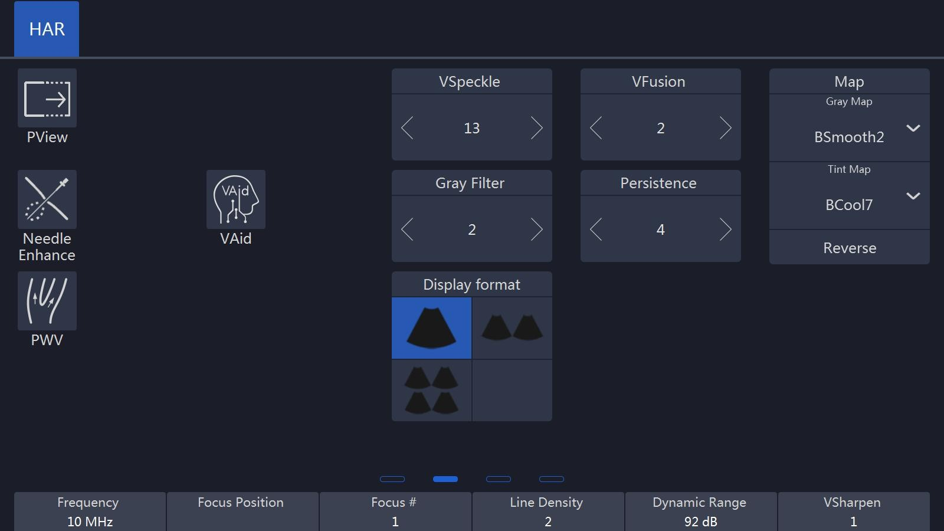

There are three modes provided for VAid: Measure mode, Lite mode and Professional mode.

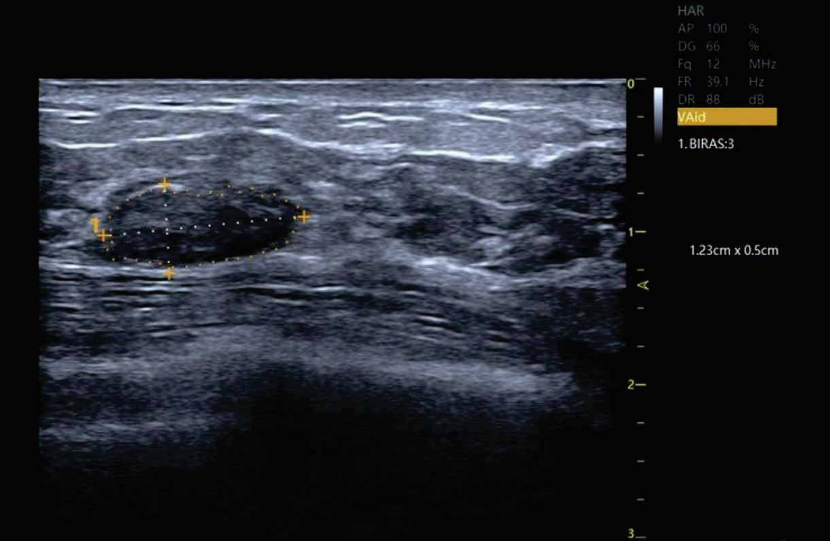

**Lung Auto Analysis**

1. Lung Auto analysis only works with ICU package under the lung application. The steps are as follows:
2. Choose Linear/ Convex/ Phased probes
3. Choose lung application and touch Lung Auto analysis to get into the feature
4. Touch Auto Pleura to start auto pneumothorax measurement.

`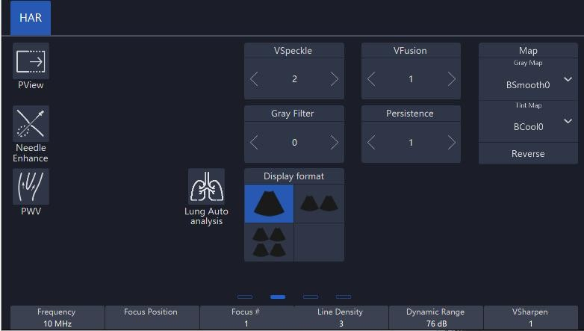

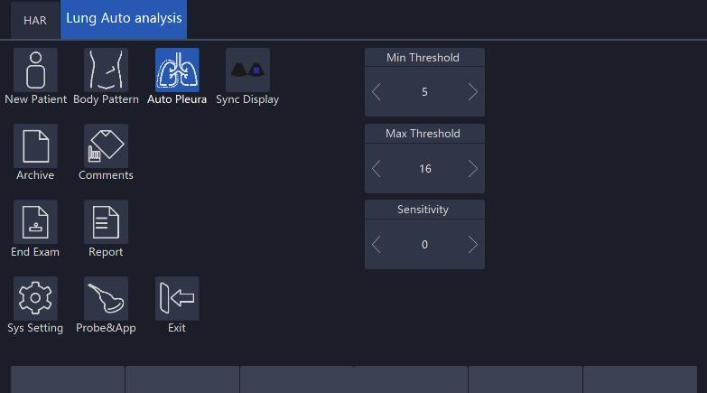

### 10.3.2 M mode measurements

In “M” mode, the measurement menu includes these measurement items:

* Depth
* Distance

Refer to the Generic measurement in detail for those measurements.

Increase or reduce measurement items in the measurement setting menu based on their own requirements. Refer to “M” mode measurement setting information in detail.

### 

### 10.3.3 PW mode measurements

In PW mode, measurements include these measurement folders:

* Generic measurement folder
* Vessel measurement folder

Increase or reduce measurement items in the measurement setting menu based on their own requirement. Refer to “PW” mode measurement setting information in detail.

**Generic measurement folder**

In “PW” mode, the general measurement folder includes these measurement items:

* Velocity
* PS (systole peak speed)
* ED (diastole end speed)
* MD (Minimum speed in diastole period)
* TAMAX (maximum speed in time average)
* PI (Pulsatility index)
* RI (resistance index)
* PS/ED
* ED/PS
* A/B ratio
* Velocity
* Time
* Acceleration
* FLOWVOL (flow volume)
* Max PG (Maximum pressure gradient)
* Mean PG (Mean pressure gradient)
* SV-D (Stroke Volume)
* SV Diam (stroke volume diameter)
* SVTAMAX (stroke volume maximum speed in time average)

Refer to the Generic measurement in detail for “PW” measurements.

**Vessel measurement folder**

In “PW” mode, the vessel measurement folder normally includes these items:

* Velocity
* PS (systole peak speed)
* ED (diastole end speed)
* MD (Minimum speed in diastole period)
* TAMAX (maximum speed in time average)
* PI (Pulsatility index)
* RI (resistance index)
* PS/ED
* ED/PS

Increase or reduce measurement items in the measurement setting menu based on their own requirements. Refer to the “PW” mode measurement setting information in detail.

## 10.4 Vessel measurements

Brief introduction

Based on different applications, vessel measurement provides several different measurement items:

* Carotid artery
* Upper artery
* Upper vein
* Lower artery
* Lower vein
* Vessel puncture
* Trans-cranial Doppler

### 

### 10.4.1 B mode measurements

In the vascular application measurement menu includes generic measurement and specific measurements, such as vessel wall intima-media thickness etc.

In 2D mode, generic measurements in the vessel application include measurements as follows:

* Depth
* Distance
* Stenosis
* A and B ratio

In 2D mode, specific measurements in the vessel application include measurement items as follows:

**IMT (intima-media thickness) measurement**

Intima-media average thickness can be measured to be the index of arteriosclerosis.

Note: Due to the character of the ultrasound image principle, the rear wall IMT measurement is more accurate than antetheca.

**Manual IMT measurement**

The steps are as follows

1. Select “Manual” method for “Ant.CCA IMT” or “Post.CCA IMT” (carotid artery intima-media thickness) in measure config page.
2. Scan the carotid artery to gain relevant good image quality and press “Freeze”.
3. Press “Zoom” once, to amplify the image in order to identify vessel intima, media, and extima.
4. Press “Measure”.
5. Select the proper direction (left or right and rear wall or antetheca) “CCA IMT”.
6. Use the trackball to move caliper and trace extima inter-side of carotid artery.
7. Press “Enter” to fix the first caliper and the system display another operating caliper.
8. Use the trackball to move the caliper and trace intima inter-side of carotid artery.
9. Press “Enter” to complete the measurement. The system will automatically calculate vessel wall intima-media average thickness for tracing part.

**Auto IMT measurement**

Auto IMT measurement means to measure the intima thickness of far field and near field vessel wall. Intima thickness of near field means the distance between extima and intima. Intima thickness of far field means the distance between extima and intima in far field.

The steps are as follows:

1. Select “Auto” method for “Ant.CCA IMT” or “Post.CCA IMT” (carotid artery intima-media thickness) in measure config page.
2. Scan carotid artery to gain relevant good image quality and press “Freeze”.
3. Press “Zoom” once, to amplify the image in order to identify the vessel intima, media, and extima.
4. Press “Measure”.
5. Select the proper direction (left or right and rear wall or antetheca) CCA IMT.
6. Move the trackball to draw one rectangle, make sure that one section of the intima is inside the rectangle.
7. Press “Enter” to complete the measurement. The system will display the measurement result about intima-media thickness as follows:

* Average
* Max
* Min
* Standard Deviation
* Valid Points

**CCA IMT**

The steps are as follows:

1. Scan carotid artery to gain relevant good image quality and press “Freeze”.
2. Press “Zoom” once, to amplify the image in order to identify the vessel intima, media, and extima.
3. Press “Measure”. Select “CCA IMT R” or “CCA IMT L”.
4. Move the trackball to draw one rectangle, make sure that one section of the artery (both rear wall and antetheca are included) is inside the rectangle.
5. Press “Enter” to complete the measurement. The system will display the measurement result about intima-media thickness as follows:

* Average
* Max
* Min
* Standard Deviation
* Valid Points

**Live IMT**

Only works with carotid applications. The measure results include following values: IMT Average, IMT Max, IMT Min, SD, ROI Len, Measure Len and Valid Points.

The ROI size and position can be edited to improve correctness for IMT results. The CCA sides, such as Left CCA, and Right CCA also can be set. Users can set vessel walls. If posterior wall is set, the system will detect posterior vessel wall, and the result only displayed posterior IMT values.

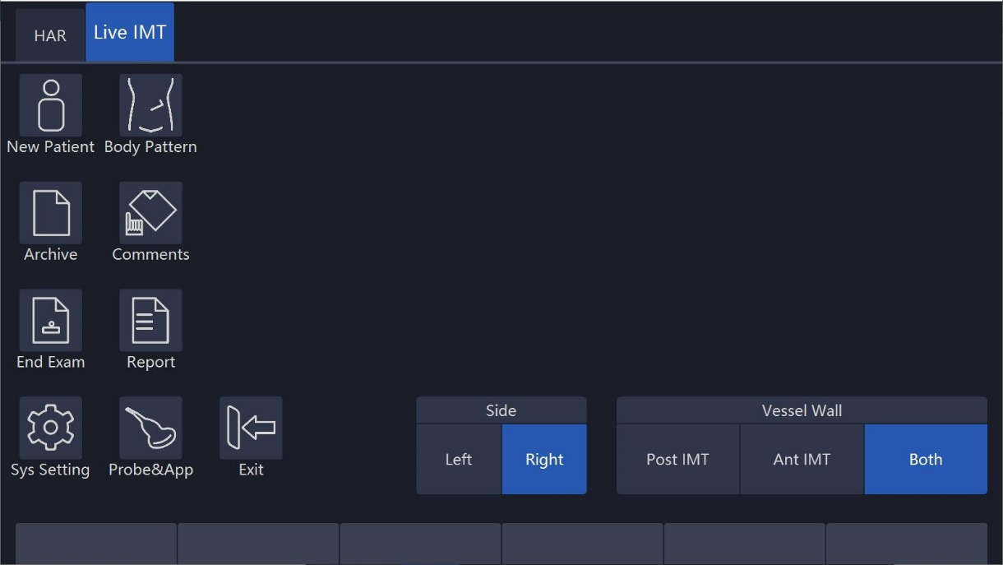

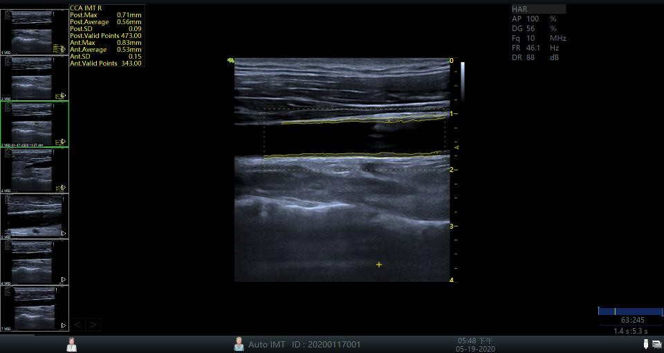

**Vas Plaque (Vascular sclerosis atheromatous plaque grade)**

The steps are as follows:

1. Scan carotid artery to gain a good image quality and then press “Freeze”.
2. Press “Zoom” once, to amplify the image in order to identify vessel intima, media, and extima.
3. Press “Measure”.
4. Select “Vas Plaque”.
5. Input and select Vas Plaque measurement parameter:

* Change the assigned area number and vascular wall limited thickness. Factory default setting is 3 and limited thickness is 1.0 cm
* Select displayed measurement result parameter in configuration page:
* Maximum value in each area
* Average value in each area
* Variance yield in each area
* Maximum value in all measurements
* Average value in all measurements
* Variance yield in all measurements

1. After complete the setting, press “Back” to return to the measurement menu. The system will display a horizontal line and several vertical lines. The number of vertical lines is determined by assigned areas. The interval line divides the whole image area equally.

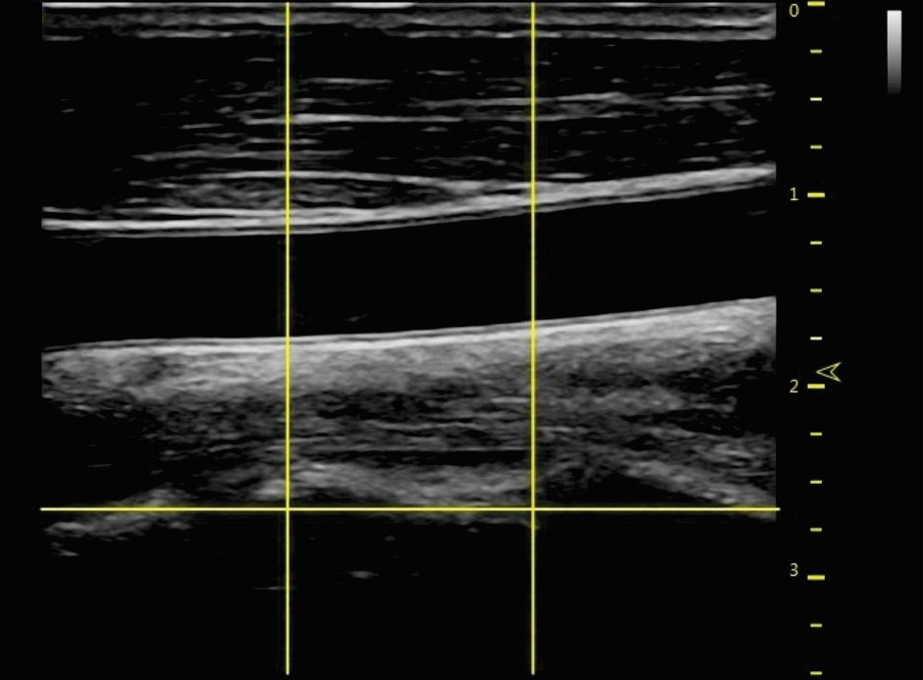

1. Use the trackball and “Rotation/Steer” key to adjust the horizontal line in order to be parallel with vascular wall. Press “Enter” to complete the adjustment. The system will display another caliper.

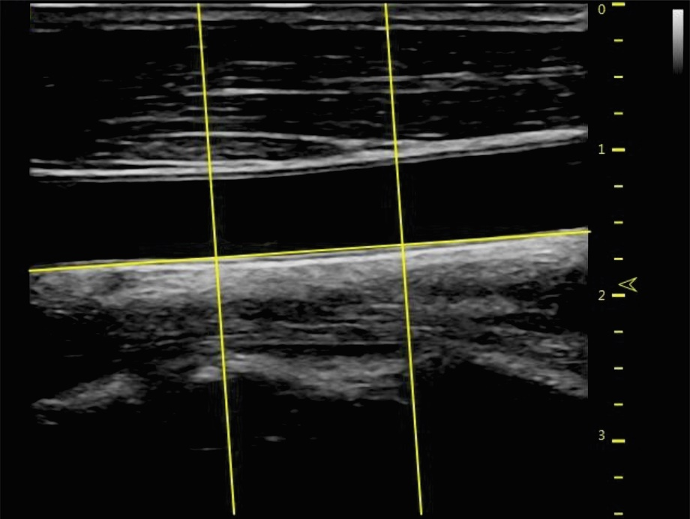

1. Use the trackball to move the caliper and press “Enter” in order to measure the thickness in any place as required.

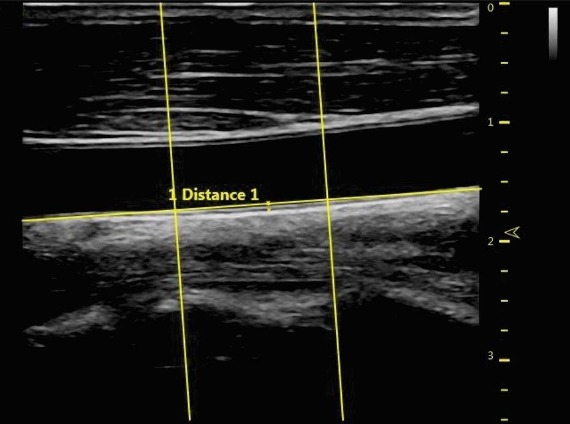

1. The system displays the following measurement and calculation results:

* All measurement results
* Display all parameters which are set in setting menu
* Maximum value in each area
* Average value in each area
* Variance yield in each area
* Maximum value in all measurements
* Average value in all measurements
* Variance yield in all measurements

The number of all measurement points which exceed vascular wall limitation and the number of all areas which exceed vascular wall limitation.

### 10.4.2 M mode measurements

In “M” mode, measurement menu includes measurement items as follows:

* Depth
* Distance
* Stenosis
* A and B ratio
* Heart rate

Refer to the Generic measurement in detail for those measurements.

Increase or reduce measurement items in the measurement setting menu based on their own requirements. Refer to “M” mode measurement setting information in detail.

### 10.4.3 PW mode measurements

In “PW” mode, measurement menu include measurement folders as follows:

* Generic measurement folder
* Arteria carotid communis measurement folder
* Internal carotid measurement folder
* External carotid measurement folder
* VA measurement folder
* BULB measurement folder
* BIF measurement folder
* STA measurement folder
* InnomA measurement folder
* Middle cerebral artery measurement folder
* Posterior cerebral artery measurement folder

Increase or reduce measurement items in the measurement setting menu based on their own requirements. Refer to “PW” mode measurement setting information in detail.

**Generic measurement folder**

In “PW” mode, the general measurement folder includes items as follows:

* Velocity
* Time
* Acceleration
* PS (systole peak speed)
* ED (diastole end speed)
* MD (Minimum speed in diastole period)
* TAMAX (maximum speed in time average)
* TAMEAN (mean speed in time average)
* PI (Pulsatility index)
* RI (resistance index)
* PS/ED
* ED/PS
* A/B ratio
* Velocity
* Time
* Acceleration
* FLOWVOL (flow volume)
* HR

**Other vascular measurement folder:**

In “PW” mode, the vascular measurement folder includes measurement items as follows:

* Velocity
* Time
* Acceleration
* PS (systole peak speed)
* ED (diastole end speed)
* MD (Minimum speed in diastole period)
* TAMAX (maximum speed in time average)
* TAMEAN (mean speed in time average)
* PI (Pulsatility index)
* RI (resistance index)
* PS/ED
* ED/PS
* A/B ratio
* Velocity
* Time
* Acceleration
* FLOWVOL (flow volume)
* HR

Increase or reduce measurement items in the measurement setting menu based on their own requirement. Refer to the “PW” mode measurement setting information in detail.

**Vessel automatically tracing and measurement**

The vessel auto tracing and measurement function can automatically detect and identify the heart cycles. For artery flow, it can automatically identify the “PS” (peak speed in systole period), “MD” (minimum speed in diastole) and “ED” (end speed in diastole), and then automatically calculate the “PI” (pulsatility index) and “RI” (resistance index). For vein flow, it can automatically detect the peak velocity (PV).

Activate vessel auto tracing and measurement

The system supports auto tracing and measurement during live scanning, freeze and cine loop.

To activate auto tracing and measurement function, select the Live option in the “Auto Trace” menu of the touch panel in “PW” mode (automatically display auto tracing and measurement in real scanning image) or the “Frozen” option (automatically display auto tracing and measurement in frozen image). To stop vascular auto tracing and measurement, select “Off”.

**Set vascular auto tracing and measurement parameter**

* Select vascular auto tracing method.
* Select maximum or average speed continuous trace.
* Select Max or Mean in “Trace Method” menu on the touch panel
* Select tracing direction.
* Tracing detection can be used in above baseline, below baseline or combination (above, below) peak velocity data. Select “Above”, “Below” or “Both” in the “Trace Direction” menu in order to set peak velocity data.

**Set vascular auto tracing and measurement result**

After selecting the Dynamic or Static option in the “Auto trace” menu in “PW” mode, the operator can set which measurement and calculation results will be displayed in the vascular auto tracing and measurement result window. The following parameters can be selected: PS, MW, TAMAX, TAMEAN, TAMIN, PI, RI, PS/ED, ED/PS, PV and HR.

Note: PV is to detect peak velocity in vein flow. So it is mutually exclusive from other measurements. In other words, if PV is selected, other measurements will be isolated.

**The following steps are to execute auto tracing and measurement**

1. Reboot system.
2. Proceed with scanning.
3. Activate the auto vascular tracing and measurement function (Dynamic or Static). The system will automatically execute tracing, measurement and calculation.

Note: Select in real time which measurement and calculation will be displayed in the auto vascular tracing and measurement result window through vascular auto tracing and measurement setting menu. Selectable parameters are PS, ED, MD, TAMAX, TAMEAN, TAMIN, PI, RI, PS/ED, ED/PS, PV and HR. PV is

to detect peak velocity of vein flow. It is mutually exclusive of other measurements; that is, once PV is selected, other measurements are automatically isolated.

1. Press “Freeze”, all vascular measurement and calculation results will display in the results window.

## 10.5 Gynecology Measurements

Introduction:

Gynecology measurements provide several types of measurement items:

* Uterus and Pelvis
* Follicle

### 

### 10.5.1 B Mode measurements

For Gynecology measurements, it includes general measurement items and some typical measurement items, such as Uterus Volume (Uterus), Ovary Volume(OV), Follicle Volume and Endometriosis Thickness(En.). For general measurements of 2D mode, it mainly includes “Depth” and “Distance” measurement items. Refer to chapter “General Measurements” in detail.

* Depth
* Distance

The typical measurement items of Gynecology application are as follows:

**UT(Uterus Volume)**

To calculate Uterus Volume, make three distance measurements. The steps are as follows:

1. Press “Measure”.
2. Select UT, and an active tracing caliper displays.
3. Perform a standard distance measurement. The system displays the distance value in the results window.
4. Repeat Step 3 to make the second and third distance measurement.

Note: Make three distance measurements in the dual display format by pressing the “Left”/ “Right” on the control panel.

1. After the third distance measurement is completed, the system displays the uterus volume in the results window.

**OV(Ovary Volume)**

To calculate Ovary Volume, make three distance measurements as normal. The steps are as follows:

1. Press “Measure”.
2. Select OV(L) or OV(R), and an active tracing caliper displays.
3. Perform a standard distance measurement. The system displays the distance value in the results window.
4. Repeat Step 3 to make the second and third distance measurement.

Note: Three distance measurements can be made in the dual display format by pressing “Left”/ “Right” on the control panel.

1. After the third distance measurement is completed, the system displays the ovary volume in the results window.

**Follicle (Follicle Volume)**

To measure Follicle Volume, the steps are as follows:

1. Press “Measure”.
2. Select “Follicle (L)” or “Follicle(R)”.
3. Select the measurement method as shown below menu or use the default one and an active tracing caliper displays.
4. Perform a standard distance measurement. The system displays the distance value in the results window.
5. Repeat Step 3 to make the second and third distance measurement.

**Auto Follicle**

Automatically measure follicular volume, the steps are as follows:

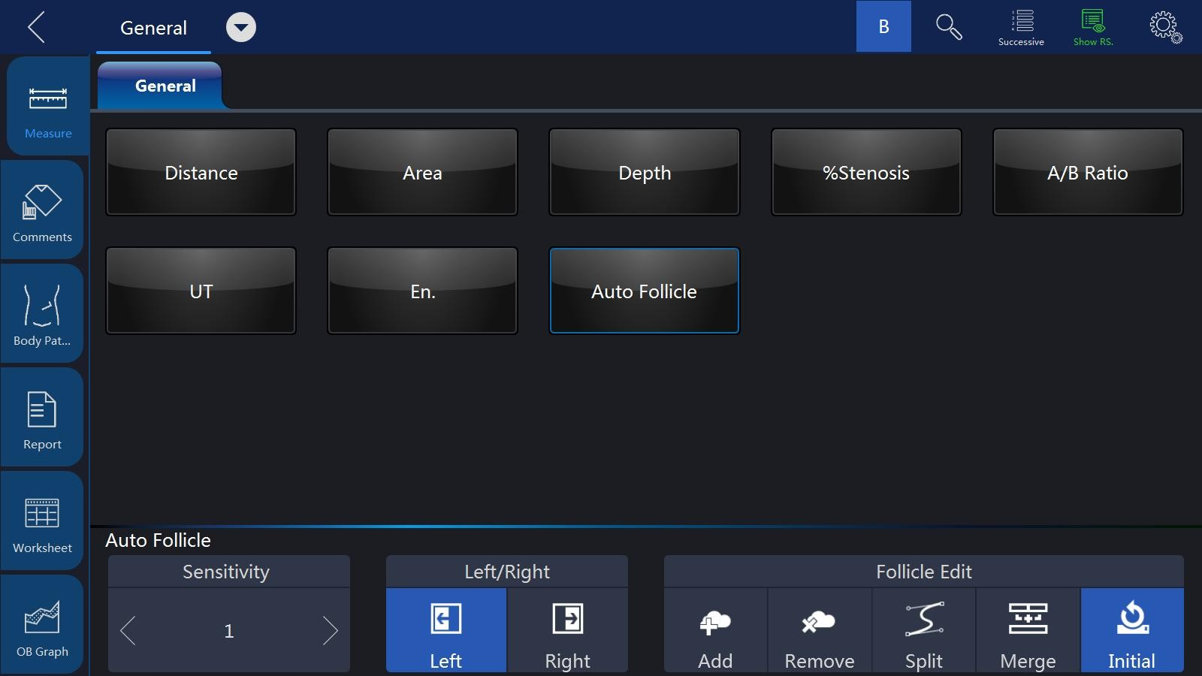

1. Press “Measure”.
2. Choose “Auto Follicle”.
3. Choose left or right.
4. The system will automatically recognize the follicles, and automatically calculate the volume of follicles

Notes:

Refer to chapter “General Measurements” for the single distance, dual distance and three distance measurement methods. As for “Mean” measurement method, three distance measurements are needed to calculate the follicle volume. Three distance measurements can be made in the dual display format by pressing “Left”/ “Right” on the control panel.

1. After the third distance measurement is completed, the system displays the follicle volume in the results window.

**Vaim (Follicle/ Uterus/ Pelvic)**

“Vaim” means intelligent measurement. The feature only can be used under these items: OB, Pelvic, Uterus, Follicle and Ped Hip.

To execute the Vaim measurements, the steps are as follows:

1. Choose the Follicle/ Uterus/ Pelvic application.
2. Touch “Vaim” press.
3. The results can be calculated automatically and shown in the screen.

**En.(Endometriosis Thickness)**

To measure Endometriosis Thickness, the steps are as follows:

Press “Measure”.

Select “En.", and an active tracing caliper displays on the image screen

Perform a standard distance measurement. The system displays the endometriosis thickness in the results window.

**Tumor Uterus**

To measure Tumor Uterus there are 6 methods: L, Ellipse, L&W, L&W&H, Ellipse&H, Trace&H.

**Tumor Cervix**

To measure Tumor Cervix there are 6 methods: L, Ellipse, L&W, L&W&H, Ellipse&H, Trace&H

**Cervix L, Cervix W, Cervix H**

To measure Cervix L/W/H there are 4 methods: Distance, Polygon, Spline, Trace.

The measurement menu of Gynecology application can be configured by adding or removing the measurement items in 2D mode. Refer to “Measurement Menu Configuration” in the chapter “General Measurements” for how to configure of the measurement menu.

**Ant. Pelvic(Rest) and Ant. Pelvic(Valsalva)**

To measure Ant. Pelvic(Rest) and Ant. Pelvic(Valsalva), the steps are as follows:

1. Press “Measure”.
2. Select “Ant. Pelvic(Rest)” or “Ant. Pelvic(Valsalva)”.
3. Determine the baseline.
4. Define the place of bladder neck (point U), the system will automatically calculate BSD.
5. Define the place of proximal urethra (point E), the system will automatically calculate UGA.
6. Define the place of retrovesical wall (point R), the system will automatically calculate RVA.
7. Define the place of bladder descend (point V), the system will automatically calculate BND.

After finished the above steps, the results of URA and BND will be calculated automatically.

**Auto Levator Ani in 3D/ 4D mode**

To measure Auto Levator Ani, the steps are as follows:

1. Touch “Auto Levator Ani” press after click Measure button in 3D/ 4D mode.
2. Choose levator left or right, and then click the enter button.
3. The system will automatically recognize the levator, and automatically calculate the area, perimeter, LHLR, LHAP, Left LUG and Right LUG of levators.
4. The result will show on the screen.

**PW mode measurements**

In “PW” mode of Gynecology application, it includes measurement folders as follows:

* General Measurement Folder
* Ao (Aorta) Measurement Folder
* Desc. Aorta Measurement Folder
* Umbilical Measurement Folder
* Placenta Measurement Folder
* Uterus Measurement Folder
* Follicle Measurement Folder
* MCA Measurement Folder

Configure the measurement menu of Gynecology application by adding or removing the measurement folders in “PW” mode. Refer to the “Measurement Menu Configuration” in the chapter “General Measurements” for how to make the configuration of the measurement menu.

General Measurement Folder

In the General Measurement Folder, it includes measurement items as follows:

* Velocity
* PS
* ED
* MD
* TAMAX
* PI
* RI
* PS/ED
* ED/PS
* A/B Ratio
* Velocity
* Time
* Acceleration
* HR

Other Measurement Folders

In the other Measurement Folders, they include the measurement items as

follows. It might have minor differences depending on the different factory settings.

* Velocity
* PS
* ED
* MD
* TAMAX
* PI
* RI
* PS/ED
* ED/PS
* A/B Ratio
* Velocity
* Time
* Acceleration
* HR

Configure the measurement menu of all measurement folders by adding or removing the measurement items in the measurement folders. Refer to the “Measurement Menu Configuration” in the chapter “General Measurements” for how to make the configuration of the measurement menu.

### 10.6.1 Urology Measurements

Introduction

Urology measurements provide several types of measurement items:

* Bladder
* Prostate
* Renal
* Kidney and ureter
* Pelvic Floor dysfunction

### 10.6.1 B Mode measurements

Urology measurements include general measurement items and some typical measurement items, such as Bladder Volume, Renal Length, Renal Volume and Prostate Volume. General measurements in 2D mode include measurement items as follows. Refer to the chapter “General Measurements” in detail.

* Depth
* Distance
* Volume
* Angle
* Stenosis
* A/B Ratio

The typical measurement items of Urology application are as follows:

**Bladder volume**

There are 2 methods to measure bladder volume: Manual and Auto. The steps are as follows with “Manual”:

1. Press “Measure” key.
2. Select “Bladder Volume”, and then a caliper will display on the image screen Note: Three distances can be measured in the dual image display format. The first measurement can be processed in the midsagittal plane, and the second measurement can be processed in the axial plane. To use the dual image display format, press “Left” or “Right”.
3. Proceed with the single and dual distance measurement.
4. The system will display three distances and the bladder volume result in the results window.

**Auto method:**

1. Press “Measure” key.
2. Select “Bladder Volume” in “Config” page, touch “Auto”.
3. Save and exit.
4. Move the cursor to the image, press “Enter” key.
5. Unfreeze the system, change scanning section, enter measure again, and press “Enter” key.
6. The system will get the result of bladder volume automatically.

**Renal Length**

To measure Renal Length, the steps are as follows:

1. Press “Measure”.
2. Select “Renal Len.(L)” or “Renal Len.(R)”, and an active tracing caliper displays.
3. Perform a standard distance measurement. The system displays the renal length in the results window.
4. Renal Volume
5. To calculate Renal Volume, make three distance measurements. The steps are as follows:
6. Press “Measure”.
7. Select “Renal Vol.(L)” or “Renal Vol.(R)”, and an active tracing caliper displays.
8. Perform a standard distance measurement. The system displays the distance value in the results window.
9. Repeat Step 3 to make the second and third distance measurement.

Note: Three distance measurements can be made in the dual display format by pressing “Left”/ “Right”.

1. After the third distance measurement is completed, the system displays the renal volume in the results window.

**Prostate Volume**

To calculate Prostate Volume, make three distance measurements. The steps are as follows:

1. Press “Measure”.
2. Select “Prostate Vol.”, and an active tracing caliper displays on the image screen
3. Perform a standard distance measurement. The system displays the distance value in the results window.
4. Repeat Step 3 to make the second and third distance measurement.

Note: Three distance measurements can be made in the dual display format by pressing “Left” / “Right”.

1. After the third distance measurement is completed, the system displays the prostate volume in the results window.

**PSAD and PPSA Measurement**

“PSAD” and “PPSA” measurements can be made after Prostate Volume measurement. The definition of PSAD and PPSA is as follows.

PSAD: Prostatic Specific Antigen (PSA) Density – defined as: PSAD = PSA/Volume

PPSA: Predicted Prostate Specific Antigen – defined as: PPSA= Volume x PPSA Coefficient

To measure PSAD and PPSA, the steps are as follows:

1. Press “Measure”.
2. Measure “Prostate Volume”.
3. Select “PSA” and “PPSA Coefficient”, edit the coefficients:
4. 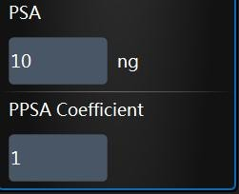
5. Enter the value of “PSA” and “PPSA Coefficient” in the above coefficient window.

Note: The value of “PSA” and “PPSA Coefficient” can be entered at the urology patient screen also.

1. PSAD and PPSA are automatically calculated, and the system displays the value in the results window.

**Pelvic Floor Dysfunction Measurement**

**BNR (Bladder Neck Rest) Measurement**

To take the Bladder Neck Rest Measurement, the steps are as follows:

1. Acquire the bladder image when the patient is in the rest status and press “Freeze”.
2. Press “Measure”.
3. Select “BNR”, and a horizontal baseline displays on the image screen
4. Move the trackball to adjust the position of the baseline at the trailing edge of the symphysisosslum pubis, and press “Enter”.

Note: It shows positive values below the baseline and negative values above the baseline.

1. When the baseline is fixed, an active tracing caliper displays on the image screen. Move the trackball to position the caliper at the leading edge of the bladder neck.
2. Perform a standard distance measurement, and the system displays the value in the results window.

**BNS (Bladder Neck Stress) Measurement**

To take the Bladder Neck Stress Measurement, the steps are as follows:

1. Acquire the bladder image after the patient finishes the “Valsalva” and press “Freeze”.
2. Press “Measure”.
3. Select “BNS”, and a horizontal baseline displays on the image screen
4. Move the trackball to adjust the position of the baseline at the trailing edge of the symphysisosslum pubis, and press “Enter”.

Note: It shows positive values below the baseline and negative values above the baseline.

1. When the baseline is fixed, an active tracing caliper displays. Move the trackball to put the caliper at the leading edge of the bladder neck.
2. Perform standard distance measurement, and the system displays the value in the results window.

**BND (Bladder Neck Down) Measurement**

To take the Bladder Neck Down Measurement. The steps are as follows:

1. Measure “BNR” and “BNS”.
2. Select “BND”, and the system displays the BND value in the results window.
3. Note: BND = BNR – BNS

**DWT (Detrusor Wall Thickness) Measurement**

To measure Detrusor Wall Thickness, make three distance measurements on the wall of the bladder. The steps are as follows:

1. Press “Measure”.
2. Select “DWT”, and an active tracing caliper displays on the image screen
3. Perform a standard distance measurement. The system displays the distance value in the results window.
4. Repeat Step 3 to make the second and third distance measurement.
5. After the third distance measurement is completed, the system displays the average detrusor wall thickness in the results window.

**RUV (Residual Urine) Measurement**

To calculate Residual Urine, make two distance measurements. The steps are as follows:

1. Press “Measure”.
2. Select “RUV”, and an active tracing caliper displays on the image screen
3. Perform a standard distance measurement. The system displays the distance value in the results window.
4. Repeat Step 3 to make the second distance measurement.
5. When the second distance measurement is completed, the system calculates the residual urine automatically and displays the value in the Results Window.

Note: RUV(ml) = D1(cm) x D2(cm) x 5.9 – 14.9.

**UTDMAX (Maximum Uterine Down Position) Measurement**

To measure the maximum position of uterine down. The steps are as follows:

1. Acquire the uterine image when the patient is on the stress status and click the Freeze button.
2. Press “Measure”.
3. Select “UTDMAX”, and a horizontal baseline displays on the image screen
4. Move the trackball to adjust the position of the baseline at the trailing edge of the symphysisosslum pubis, and press “Enter”.

Note: Positive values are shown below the baseline and negative values above the baseline.

1. When the baseline is fixed, an active tracing caliper displays. Move the trackball to put the caliper at the bottom position of the uterus.
2. Perform a standard distance measurement, and the system displays the value in the results window.

**RADMAX (Maximum Ampulla Recti Down Position) Measurement** To measure the maximum position of ampulla recti down, the steps are as follows:

1. Acquire the image of ampulla recti when the patient is in the stress status and press “Freeze”.
2. Press “Measure”.
3. Select “RADMAX”, and a horizontal baseline displays on the image screen.
4. Move the trackball to adjust the position of the baseline at the trailing edge of the symphysisosslum pubis, and press “Enter”.

Note: Positive values are shown below the baseline and negative values above the baseline.

1. When the baseline is fixed, an active tracing caliper displays. Move the trackball to position the caliper at the bottom of the ampulla recti.
2. Perform a standard distance measurement, and the system displays the value in the results window.

**Rectocele Depth and Width Measurement**

To measure Rectocele Depth and Width, make two distance measurements. The steps are as follows:

1. Press “Measure”.
2. Select “Rectocele”, and an active tracing caliper displays on the image screen
3. Perform one standard distance measurement, and the system displays the rectocele depth in the results window.
4. Perform another standard distance measurement, and the system displays the rectocele width in the results window.

**Levator Hiatus Stress Measurement**

To measure Lavator Hiatus Stress, make two distance measurements and the system calculates the area automatically. The steps are as follows

1. Press “Measure”.
2. Select “Levator Hiatus Stress”, and an active tracing caliper displays on the image screen
3. Perform the first standard distance measurement.
4. Perform the second standard distance measurement.
5. Calculate the area of levator hiatus automatically, and the system displays the values in the results window.
6. The measurement menu of Urology application can be configured by adding or removing the measurement items in 2D mode. Refer to the “Measurement Menu Configuration” in the chapter “General Measurements” for how to make the configuration of the measurement menu.

### 10.6.2 PW Mode measurements

The “PW” mode of Gynecology application includes the following measurement folder:

* General Measurement Folder
* General Measurement Folder

The General Measurement Folder includes the following measurement items:

1. Velocity
2. PS
3. ED
4. MD
5. TAMAX
6. PI
7. RI
8. PS/ED
9. ED/PS
10. FLOW VOL

The measurement menu of Urology application can be configured by adding or removing the measurement items in “PW” mode. Refer to “Measurement Menu Configuration” in the chapter “General Measurements” for how to make the configuration of the measurement menu.

## 10.7 Pediatric Measurements

Introduction

Pediatric measurements provide several types of measurement items:

* Neonatal Head
* Neonatal Abdomen
* Pediatric Abdomen
* Pediatric Hip
* FAST

### 10.7.1 B Mode measurements

Pediatric measurements include general measurement items and some typical measurement items, such as HIP(α), HIP(αβ), and acetabular cartilage thickness. General measurements of 2D mode mainly consist of the following measurement items. Refer to the chapter “General Measurements” for more detailed information.

* Distance
* Area
* Volume
* Angle
* Stenosis
* A/B Ratio

The typical measurement items of Pediatric application are as follows:

**Pediatric Hip Dysplasia Measurement**

It is helpful to evaluate children’s hip dysplasia by calculating the HIP(α) and HIP(αβ). To calculate HIP(α) and HIP(αβ), three lines are defined as follows:

Baseline, a line connected acetabular convexity and the cross point among the joint capsule, perichondrium and ilium.

Acetabular roof line (Lineα), a line connected acetabular convexity and inferior to hip.

Inclination line (Lineβ), a line connected acetabular convexity and acetabular labrum.

Angle α is the angle between baseline and line α, and angle β is the angle between baseline and line β.

a / b: IIlium

c: Acetabular labrum

d: Many strands of top

e: Acetabular roof

f: Caput Femoris

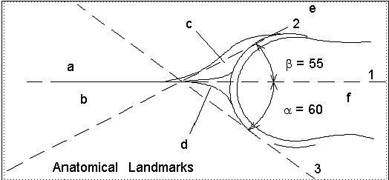

β**line**

**Baseline**

α **line**

**HIP(α)**

To measure HIP(α). The steps are as follows:

1. Press “Measure”.
2. Select “HIP(α)(L)” or “HIP(α)(R)”, and a horizontal line displays on the image screen.
3. Adjust the baseline to align with the acetabular convexity using the trackball.
4. Adjust the inclination of the baseline by the “Rotation/Steer” key.
5. Fix the baseline with the Enter key, and the system displays the line.
6. Adjust the inclination of the lineα by the “Rotation/Steer” key.
7. Fix the lineα with the “Enter” key, and the system displays the angleα in the results window.

**HIP(αβ)**

To measure HIP(αβ). The steps are as follows:

1. Press “Measure”.
2. Select “HIP(αβ)(L)” or “HIP(αβ)(R)”, and a horizontal line displays on the image screen
3. Adjust the baseline to align with the acetabular convexity by the trackball.
4. Adjust the inclination of the baseline by the “Rotation/Steer” key.
5. Fix the baseline with the “Enter” key, and the system displays the lineα.
6. Adjust the inclination of the lineα by the “Rotation/Steer” key.
7. Fix the lineα with the “Enter” key, and the system displays the lineβ.
8. Adjust the inclination of the lineβ by the “Rotation/Steer” key.
9. Fix the lineβ with the “Enter” key, and the system displays the angleα and angleβ in the results window.

**Measurement configuration of HIP(αβ)**

The steps are as follows:

1. Select the configuration menu of “HIP(αβ)” measurement, and the system shows its measurement method as shown below:
2. Select the measurement method “Group” or “Ungroup” to complete the measurement setting.

Note: Baseline, lineα and lineβ always intersect at the acetabular convexity. Therefore, the operator should keep the three lines intersect at one point when using either the Group method or Ungroup method.

**Pediatric Hip Dysplasia Classification on the HIP(αβ) measurements**

The steps are as follows:

1. Select “Hip Growth Type Definition” after the “HIP(αβ)” measurements, and the system shows the pediatric hip dysplasia classification as shown below:

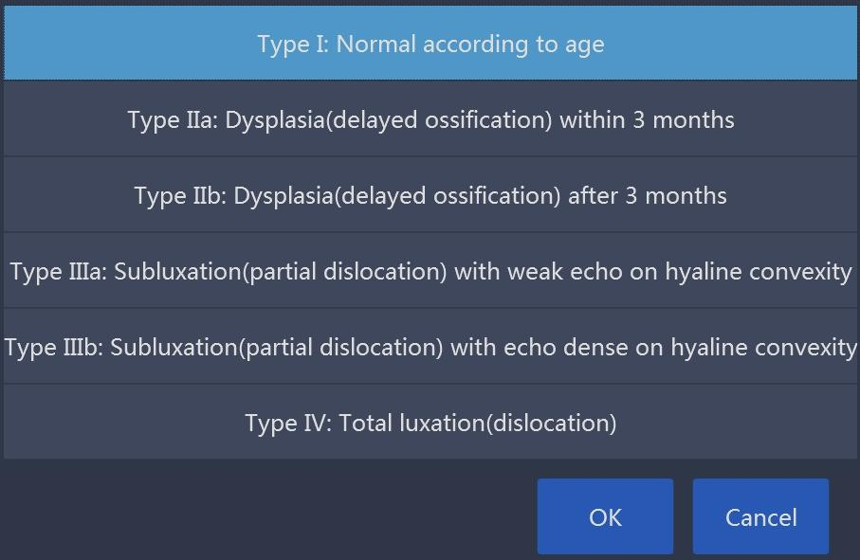

1. The pediatric hip dysplasia type can be rated based on the result of the HIP(αβ) measurements.

**Acetabular Cartilage Thickness**

To measure Acetabular Cartilage Thickness, make a single distance measurement.

1. The steps are as follows:
2. Press “Measure”.
3. Select “ACT”, and an active tracing caliper displays on the image screen
4. Perform one standard distance measurement, and the system displays the acetabular cartilage thickness in the results window.

**Vaim (Ped Hip)**

“Vaim” means intelligent measurement. The feature only can be used under these items: OB, Pelvic, Uterus, Follicle and Ped Hip.

To execute the Vaim measurements, the steps are as follows:

1. Choose the Ped Hip application.
2. Touch “Vaim” press.
3. The results can be calculated automatically and shown in the screen.

**PW mode measurements**

The “PW” mode of Pediatric application includes the following measurement folder:

* General Measurement Folder
* Anterior cerebral artery measurement folder
* Middle cerebral artery measurement folder
* Posterior cerebral artery measurement folder

Configure the measurement menu of Pediatric application by adding or removing the measurement folders in “PW” mode. Refer to the “Measurement Menu Configuration” in the chapter “General Measurements” for how to make the configuration of the measurement menu.

**General Measurement Folder**

In the General Measurement Folder, it includes measurement items as follows:

* Velocity
* PS
* ED
* MD
* TAMAX
* PI
* RI
* PS/ED
* ED/PS
* Flow VOL

The measurement menu of Urology application can be configured by adding or removing the measurement items in “PW” mode. Refer to “Measurement Menu Configuration” in the chapter “General Measurements” for how to make the configuration of the measurement menu.

## 10.8 Obstetrics Measurements

**Examination Preparation:**

Prior to an ultrasound examination, the patient should be informed of the clinical indication, specific benefits, potential risks, and alternatives, if any. In addition, if the patient requests information about the exposure time and intensity, it should be provided. Patient access to educational materials regarding ultrasound is strongly encouraged to supplement the information communicated directly to the patient. Furthermore, these examinations should be conducted in a manner and take place in a setting which assures patient dignity and privacy.

* Prior material knowledge and approval of the presence of nonessential personnel with the number of such personnel kept to a minimum.
* An intent to share the information obtained with the parents per the physician’s judgment, either during the examination or shortly thereafter.
* An offer of choice about viewing the fetus.
* An offer of choice about learning the sex of the fetus, if such information becomes available. However, an ultrasound examination should not be carried out for the sole purpose of identifying the sex of the fetus.
* Ultrasound examination performed solely to satisfy the family's desire to know the sex of the fetus, to view the fetus, or to obtain a picture of the fetus should be discouraged.

**Acoustic Output Considerations**

**General warning**

This device is a multi-use device which is capable of exceeding FDA pre-enactment acoustic output (spatial peak temporal average) intensity limits for fetal applications.

**CAUTION**

It is prudent to conduct an examination with the minimum amount and duration of acoustic output necessary to optimize the image's diagnostic value.

**Concerns surrounding fetal exposure**

Always be aware of the acoustic output level by observing the Acoustic Output Display. In addition, become thoroughly familiar with the Acoustic Output Display and equipment controls affecting output.

**Training**

It is recommended that all operators receive proper training in fetal Doppler applications before performing them in a clinical setting. Contact a local sales representative for training assistance please.

Introduction

Obstetrics measurements provide several types of measurement items:

* OB Early
* OB Mid
* OB Late
* Fetal Heart

### 10.8.1 B Mode measurements

Obstetrics measurements include general measurement items and some typical measurement items, such as GS, CRL, NT, OB Ratio, Estimated Fetal Weight, OB Curve and OB Table. General measurements of 2D mode mainly consist of the measurement items below. Refer to the chapter “General Measurements” for more detailed information.

* Depth
* Distance
* A/B Ratio

The typical measurement items of Obstetrics application are as shown below:

**Gestational Sac (GS)**

To measure the size of gestational sac, the method of measurement can be configured:

1. Press “Measure”.
2. Select “GS” with the measurement method “Max”, and an active tracing caliper displays.
3. Perform a standard distance measurement, and the system displays the maximum diameter of the gestational sac in the results window.

To calculate the size of gestational sac with the “Mean” measurement method, make three distance measurements. The steps are as follows:

1. Press “Measure”.
2. Select “GS” with the measurement method “Mean”, and an active tracing caliper displays on the image screen.
3. Perform a standard distance measurement. The system displays the distance value in the results window.
4. Repeat Step 3 to make the second and third distance measurement.

Note: Three distance measurements can be made in the dual display format by pressing “Left” / “Right”.

1. After the third distance measurement is completed, the system displays the average diameter of the gestational sac in the results window.

**Yolk Sac (YS)**

To measure the size of Yolk Sac, the steps are as follows:

1. Press “Measure”.
2. Select “YS”, and an active tracing caliper displays on the image screen.
3. Perform a standard distance measurement. The system displays the size of yolk sac in the results window.

**Crown-rump Length (CRL)**

To measure the Crown-rump Length, the steps are as follows:

1. Press “Measure”.
2. Select “CRL”, and an active tracing caliper displays on the image screen.
3. Perform a standard distance measurement. The system displays the crown-rump length in the results window.

**Nuchal Translucency Thickness**

To measure the Nuchal Translucency Thickness, if select the method “Manual”, the steps are as follows:

1. Press “Measure”.
2. Select “NT”, and an active tracing caliper displays on the image screen.
3. Perform a standard distance measurement. The system displays the nuchal translucency thickness in the results window.

If select the method “Auto”, the steps are as follows:

1. Press “Measure”.
2. Select “NT”, and an active tracing caliper displays on the image screen.
3. Fix one dotted box in the interest area, the system will provide the measurement value automatically.

**Intracranial Translucency Thickness**

To measure the Intracranial Translucency Thickness, if select the method “Manual”, the steps are as follows:

1. Press “Measure”.
2. Select “IT”, and an active tracing caliper displays on the image screen.
3. Perform a standard distance measurement. The system displays the Intracranial translucency thickness in the results window.

If select the method “Auto”, the steps are as follows:

1. Press “Measure”.
2. Select “IT”, and an active tracing caliper displays on the image screen.
3. Fix one dotted box in the interest area, the system will provide the measurement value automatically.

**Uterus Volume (UT)**

To calculate Uterus Volume, make three distance measurements. The steps are as follows:

1. Press “Measure”.
2. Select “UT”, and an active tracing caliper displays on the image screen.
3. Perform a standard distance measurement. The system displays the distance value in the results window.
4. Repeat Step 3 to make the second and third distance measurement.

Note: Three distance measurements can be made in the dual display format by pressing “Left” / “Right”.

1. After the third distance measurement is completed, the system displays the uterus volume in the results window.

**Endometriosis Thickness (En.)**

To measure Endometriosis Thickness, the steps are as follows:

1. Press “Measure”.
2. Select “En.”, and an active tracing caliper displays on the image screen
3. Perform a standard distance measurement. The system displays the endometriosis thickness in the results window.

**Ovary Volume (OV)**

To calculate Ovary Volume, make three distance measurements normally. The steps are as follows:

1. Press “Measure”.
2. Select “OV (L)” or “OV(R)”, and an active tracing caliper displays on the image screen
3. Perform a standard distance measurement. The system displays the distance value in the results window.
4. Repeat Step 3 to make the second and third distance measurement.

Note: Three distance measurements can be made in the dual display format by pressing “Left” / “Right”.

1. After the third distance measurement is completed, the system displays the ovary volume in the results window.

**Biparietal Diameter (BPD)**

There are 2 methods: Manual and Auto.

To measure Biparietal Diameter with “Manual”, the steps are as follows:

1. Press “Measure”.
2. Select “BPD”, and an active tracing caliper displays on the image screen
3. Perform a standard distance measurement. The system displays the biparietal diameter in the results window.

To measure Biparietal Diameter with “Auto”, the steps are as follows:

1. Press “Measure”.
2. Select “BPD” in “Config” page, touch “Auto”.
3. Save and exit.
4. Move the cursor to the image, press “Enter” key.
5. The system will get the result of BPD automatically.

**Occipito-frontal Diameter (OFD)**

There are 2 methods: Manual and Auto.

To measure Occipito-frontal Diameter, the steps are as follows:

1. Press “Measure”.
2. Select “OFD”, and an active tracing caliper displays on the image screen
3. Perform a standard distance measurement. The system displays the occipito-frontal diameter in the results window.

To measure **Occipito-frontal Diameter** with “Auto”, the steps are as follows:

1. Press “Measure”.
2. Select “OFD” in “Config” page, touch “Auto”.
3. Save and exit.
4. Move the cursor to the image, press “Enter” key.
5. The system will get the result of BPD automatically.

**Head Circumference (HC)**

To calculate Head Circumference, there are six measurement methods: BPD&OFD, Ellipse, Polygon, Spine and Trace. Ellipse and BPD&OFD method are the most common settings.

To measure Head Circumference with the “BPD&OFD” method, make two distance measurements. The steps are as follows:

1. Press “Measure”.
2. Select “HC”.
3. Select the measurement method “BPD&OFD” as the default setting from the configuration menu, and an active tracing caliper displays on the image screen
4. Perform a standard distance measurement. The system displays the distance value in the results window.
5. Repeat Step 3 to make the second distance measurement.
6. After the second distance measurement is completed, the system displays the head circumference in the results window.

To measure Head Circumference with the “Ellipse” method, make an ellipse measurement. The steps are as follows:

1. Press “Measure”.
2. Select “HC”.
3. Select the measurement method “Ellipse” as the default setting from the configuration menu, and an active ellipse displays on the image screen
4. To position the active caliper of the ellipse, move the trackball.
5. To fix the start point, press “Enter”. The system fixes the first caliper and displays a second active caliper.
6. To position the second caliper, move the trackball.
7. Adjust the “Ellipse” control and an ellipse with an initial circle shape displays.

Note: To position the ellipse and to size the measured axes (move the calipers), move trackball.

1. To complete the measurement, press “Enter”. The system displays the head circumference in the results window.

To measure Head Circumference with the “Polygon” method, make a polygon trace measurement. The steps are as follows:

1. Press “Measure”.
2. Select “HC”.
3. Select the measurement method “Polygon” as the default setting from the configuration menu, and an active tracing caliper displays on the image screen
4. To position the active caliper of the polygon, move the trackball.
5. To fix the start point, press “Enter”. The system fixes the first caliper and displays a second active caliper.
6. To position the second caliper, move the trackball.
7. To fix the second point, press “Enter”. The system fixes the second caliper and displays a third active caliper.
8. To position the third caliper, move the trackball.
9. To fix the third point, press “Enter”. The system fixes the third caliper and displays a next active caliper.

Note: At least three calipers are needed to form a polygon.

1. Repeat Steps 8-9 to add more caliper of the polygon.
2. To complete the measurement, press “Enter”. The system displays the head circumference in the results window.

Note:

Before completing the polygon measurement,

* To erase the line (little by little) back from its current point, press “Clear” once;
* To clear the trace caliper and the current data measured, press “Clear” for at least 2 seconds.

To measure Head Circumference with the “Spline” method, make a spline trace measurement. The steps are as follows:

1. Press “Measure”.
2. Select “HC”.
3. Select the measurement method “Spline” as the default setting from the configuration menu, and an active tracing caliper displays on the image screen
4. To position the active caliper of the spline, move the trackball.
5. To fix the start point, press “Enter”. The system fixes the first caliper and displays a second active caliper.
6. To position the second caliper, move the trackball.
7. To fix the second point, press “Enter”. The system fixes the second caliper and displays a third active caliper.
8. To position the third caliper, move the trackball.
9. To fix the third point, press “Enter”. The system fixes the third caliper and displays a next active caliper.
10. Note: At least three calipers are needed to form a spline.
11. Repeat Steps 8-9 to add more calipers to the spline.
12. To complete the measurement, press “Enter”. The system displays the head circumference in the results window.

Note:

Before completing the spline measurement,

* To erase the line (little by little) back from its current point, press “Clear” once;
* To clear the trace caliper and the current data measured, press “Clear” for at least 2 seconds.

To measure Head Circumference with the “Trace” method, the steps are as follows:

Press “Measure”.

Select “HC”.

Select the measurement method “Trace” as the default setting from the configuration menu, and an active tracing caliper displays on the image screen

To position the trace caliper, move the trackball.

To fix the trace start point, press “Enter”. The system fixes the first caliper and the trace caliper changes to an active tracing caliper.

To trace the measurement area, move the trackball around the anatomy.

To complete the measurement, press “Enter”. The system displays the head circumference in the results window.

Note:

Before completing the spline measurement,

* To erase the line (Before completing little by little) back from its current point, press “Clear” k once;

To clear the trace caliper and the current data measured, press “Clear” for at least 2 seconds.

Measure “HC” with “Auto” method:

1. Press “Measure”.
2. Select “HC” in “Config” page, touch “Auto”.
3. Save and exit.
4. Move the cursor to the image, press “Enter” key.
5. The system will get the result of “HC” automatically.

**Cerebellar Diameter (CD)**

To measure Cerebellar Diameter, the steps are as follows:

1. Press “Measure”.
2. Select “CD”, and an active tracing caliper displays on the image screen
3. Perform a standard distance measurement. The system displays the cerebellar diameter in the results window.

**Transverse Cerebellar Diameter (TCD)**

To measure Transverse Cerebellar Diameter, the steps are as follows:

1. Press “Measure”.
2. Select “TCD”, and an active tracing caliper displays on the image screen
3. Perform a standard distance measurement. The system displays the transverse cerebellar diameter in the results window.

**Binocular Diameter (BD)**

To measure Binocular Diameter, the steps are as follows:

1. Press “Measure”.
2. Select “BD”, and an active tracing caliper displays on the image screen
3. Perform a standard distance measurement. The system displays the binocular diameter in the results window.

**Outer Orbital Diameter (OOD)**

To measure Outer Orbital Diameter, the steps are as follows:

1. Press “Measure”.
2. Select “OOD”, and an active tracing caliper displays on the image screen
3. Perform a standard distance measurement. The system displays the outer orbital diameter in the results window.

**Inter Orbital Diameter (IOD)**

To measure Inter Orbital Diameter, the steps are as follows:

1. Press “Measure”.
2. Select “IOD”, and an active tracing caliper displays on the image screen
3. Perform a standard distance measurement. The system displays the inter-orbital diameter in the results window.

**Humerus Length (HL)**

To measure Humerus Length, the steps are as follows:

1. Press “Measure”.
2. Select “HL”, and an active tracing caliper displays on the image screen
3. Perform a standard distance measurement. The system displays the humerus length in the results window.

**Anter-posterior Abdominal Diameter (APAD)**

To measure Anter-posterior Abdominal Diameter, the steps are as follows:

1. Press “Measure”.
2. Select “APAD”, and an active tracing caliper displays on the image screen
3. Perform a standard distance measurement. The system displays the anter-posterior abdominal diameter in the results window.

**Transverse Abdominal Diameter (TAD)**

To measure Transverse Abdominal Diameter, the steps are as follows:

1. Press “Measure”.
2. Select “TAD”, and an active tracing caliper displays on the image screen
3. Perform a standard distance measurement. The system displays the transverse abdominal diameter in the results window.

**Abdominal Circumference (AC)**

To calculate Abdominal Circumference, there are six measurement methods: APAD&TAD, Ellipse, Polygon, Spine and Trace. Ellipse and APAD&TAD method are the default settings.

To measure Abdominal Circumference with the “APAD&TAD” method, make two distance measurements. The steps are as follows:

1. Press “Measure”.
2. Select “AC”.
3. Select the measurement method “APAD&TAD” as the default setting from the configuration menu, and an active tracing caliper displays on the image screen
4. Perform a standard distance measurement. The system displays the distance value in the results window.
5. Repeat Step 3 to make the second distance measurement.
6. After the second distance measurement is completed, the system displays the abdominal circumference in the results window.

To measure Abdominal Circumference with the “Ellipse” method, make an ellipse measurement. The steps are as follows:

1. Press “Measure”.
2. Select “AC”.
3. Select the measurement method “Ellipse” as the default setting from the configuration menu, and an active ellipse displays on the image screen
4. To position the active caliper of the ellipse, move the trackball.
5. To fix the start point, press “Enter”. The system fixes the first caliper and displays a second active caliper.
6. To position the second caliper, move the trackball.
7. Adjust the “Ellipse” control and an ellipse with an initial circle shape displays.

Note: To position the ellipse and to size the measured axes (move the calipers), move the trackball.

1. To complete the measurement, press “Enter”. The system displays the abdominal circumference in the results window.

To measure Abdominal Circumference with the “Polygon” method, make a polygon trace measurement. The steps are as follows:

1. Press “Measure”.
2. Select “AC”.
3. Select the measurement method “Polygon” as the default setting from the configuration menu, and an active tracing caliper displays on the image screen
4. To position the active caliper of the polygon, move the trackball.
5. To fix the start point, press “Enter”. The system fixes the first caliper and
6. displays a second active caliper.
7. To position the second caliper, move the trackball.
8. To fix the second point, press “Enter”. The system fixes the second caliper and displays a third active caliper.
9. To position the third caliper, move the trackball.
10. To fix the third point, press “Enter”. The system fixes the third caliper and displays a next active caliper.

Note: At least three calipers are needed to form a polygon.

1. Repeat Steps 8-9 to add more calipers to the polygon.
2. To complete the measurement, press “Enter”. The system displays the abdominal circumference in the results window.

Note:

Before completing the polygon measurement,

* To erase the line (little by little) back from its current point, press “Clear” once;
* To clear the trace caliper and the current data measured, press “Clear” for at least 2 seconds.

To measure Abdominal Circumference with the “Spline” method, make a spline trace measurement. The steps are as follows:

1. Press “Measure”.
2. Select “AC”.
3. Select the measurement method “Spline” as the default setting from the configuration menu, and an active tracing caliper displays on the image screen
4. To position the active caliper of the spline, move the trackball.
5. To fix the start point, press “Enter”. The system fixes the first caliper and displays a second active caliper.
6. To position the second caliper, move the trackball.
7. To fix the second point, press “Enter”. The system fixes the second caliper and displays a third active caliper.
8. To position the third caliper, move the trackball.
9. To fix the third point, press “Enter”. The system fixes the third caliper and displays a next active caliper.

Note: At least three calipers are needed to form a spline.

1. Repeat Steps 8-9 to add more caliper of the spline.
2. To complete the measurement, press “Enter”. The system displays the abdominal circumference in the results window.

Note:

Before completing the spline measurement,

* To erase the line (little by little) back from its current point, press “Clear” key once;
* To clear the trace caliper and the current data measured, press “Clear” for at least 2 seconds.

To measure Abdominal Circumference with the “Trace” method, the steps are as follows:

1. Press “Measure”.
2. Select “AC”.
3. Select the measurement method “Trace” as the default setting from the configuration menu, and an active tracing caliper displays on the image screen
4. To position the trace caliper, move the trackball.
5. To fix the trace start point, press “Enter”. The system fixes the first caliper and the trace caliper changes to an active tracing caliper.
6. To trace the measurement area, move the trackball around the anatomy.
7. To complete the measurement, press “Enter”. The system displays the abdominal circumference in the results window.

Note: Before completing the spline measurement,

* To erase the line (little by little) back from its current point, press “Clear” key once;
* To clear the trace caliper and the current data measured, press “Clear” for at least 2 seconds.

Measure “AC” with “Auto” method:

1. Press “Measure”.
2. Select “AC” in “Config” page, touch “Auto”.
3. Save and exit.
4. Move the cursor to the image, press “Enter” key.
5. The system will get the result of “AC” automatically.
6. Anter-posterior Trunk Diameter (APTD)

To measure Anter-posterior Trunk Diameter, the steps are as follows:

1. Press “Measure”.
2. Select APTD, and an active tracing caliper displays on the image screen
3. Perform a standard distance measurement. The system displays the anter-posterior trunk diameter in the results window.

**Transverse Trunk Diameter (TTD)**

To measure Transverse Trunk Diameter:

1. Press “Measure”.
2. Select “TTD”, and an active tracing caliper displays on the image screen
3. Perform a standard distance measurement. The system displays the transverse trunk diameter in the results window.

**Trunk Cross-sectional Area (AxT)**

To calculate Trunk Cross-sectional Area, there are five measurement methods: APAD&TAD, Ellipse, Polygon, Spine and Trace. Ellipse and APTD&TTD method are the most common settings.

To measure Trunk Cross-sectional Area with the “APTD&TTD” method, make two distance measurements.

1. Press “Measure”.
2. Select “AxT”.
3. Select the measurement method “APTD&TTD” as the default setting from the configuration menu, and an active tracing caliper displays on the image screen
4. Perform a standard distance measurement. The system displays the distance value in the results window.
5. Repeat Step 3 to make the second distance measurement.
6. After the second distance measurement is completed, the system displays the trunk cross-sectional area in the results window.

To measure Trunk Cross-sectional Area with the Ellipse method, make an ellipse measurement. The steps are as follows:

1. Press “Measure”.
2. Select “AxT”.
3. Select the measurement method “Ellipse” as the default setting from the configuration menu, and an active ellipse displays on the image screen
4. To position the active caliper of the ellipse, move the trackball.
5. To fix the start point, press “Enter”. The system fixes the first caliper and displays a second active caliper.
6. To position the second caliper, move the trackball.
7. Adjust the “Ellipse” control and an ellipse with an initial circle shape displays.

Note:

* To position the ellipse and to size the measured axes (move the calipers), move the trackball.
* To complete the measurement, press “Enter”. The system displays the trunk cross-sectional area in the results window.

To measure Trunk Cross-sectional Area with the “Polygon” method, make a polygon trace measurement. The steps are as follows:

1. Press “Measure”.
2. Select “AxT”.
3. Select the measurement method “Polygon” as the default setting from the configuration menu, and an active tracing caliper displays on the image screen
4. To position the active caliper of the polygon, move the trackball.
5. To fix the start point, press “Enter”. The system fixes the first caliper and displays a second active caliper.
6. To position the second caliper, move the trackball.
7. To fix the second point, press “Enter”. The system fixes the second caliper and displays a third active caliper.
8. To position the third caliper, move the trackball.
9. To fix the third point, press “Enter”. The system fixes the third caliper and displays a next active caliper.

Note: At least three calipers are needed to form a polygon.

1. Repeat Steps 8-9 to add more calipers to the polygon.
2. To complete the measurement, press “Enter”. The system displays the trunk cross-sectional area in the results window.

Note:

* Before completing the polygon measurement,
* To erase the line (little by little) back from its current point, press “Clear” key once;
* To clear the trace caliper and the current data measured, press “Clear” for at least 2 seconds.

To measure Trunk Cross-sectional Area with the “Spline” method, make a spline trace measurement. The steps are as follows:

1. Press “Measure”.
2. Select “AxT”.
3. Select the measurement method “Spline” as the default setting from the configuration menu, and an active tracing caliper displays on the image screen
4. To position the active caliper of the spline, move the trackball.
5. To fix the start point, press “Enter”. The system fixes the first caliper and displays a second active caliper.
6. To position the second caliper, move the trackball.
7. To fix the second point, press “Enter”. The system fixes the second caliper and displays a third active caliper.
8. To position the third caliper, move the trackball.
9. To fix the third point, press “Enter”. The system fixes the third caliper and displays a next active caliper.

Note: At least three calipers are needed to form a spline.

1. Repeat Steps 8-9 to add more caliper of the spline.
2. To complete the measurement, press “Enter”. The system displays the trunk cross-sectional area in the results window.

Note:

Before completing the spline measurement,

* To erase the line (little by little) back from its current point, press “Clear” once;
* To clear the trace caliper and the current data measured, press “Clear” for at least 2 seconds.

To measure Trunk Cross-sectional Area with the “Trace” method, the steps are as follows:

1. Press “Measure”.
2. Select “AxT”.
3. Select the measurement method Trace as the default setting from the configuration menu, and an active tracing caliper displays on the image screen
4. To position the trace caliper, move the trackball.
5. To fix the trace start point, press “Enter”. The system fixes the first caliper and the trace caliper changes to an active tracing caliper.
6. To trace the measurement area, move the trackball around the anatomy.
7. To complete the measurement, press “Enter”. The system displays the trunk cross-sectional area in the results window.

Note:

Before completing the spline measurement,

1. To erase the line (little by little) back from its current point, press “Clear” key once.
2. To clear the trace caliper and the current data measured, press “Clear” for at least 2 seconds.
3. Fetal Trunk Area (FTA)
4. To calculate Fetal Trunk Area, there are five measurement methods: LTD&TTD, Ellipse, Polygon, Spine and Trace. Ellipse and LTD&TTD method are the most default settings.

To measure Fetal Trunk Area with the LTD&TTD method, make two distance measurements. The steps are as follows:

1. Press “Measure”.
2. Select “FTA”.
3. Select the measurement method “LTD&TTD” as the default setting from the configuration menu and an active tracing caliper displays on the image screen
4. Perform a standard distance measurement. The system displays the distance value in the results window.
5. Repeat Step 3 to make the second distance measurement.
6. After the second distance measurement is completed, the system displays the fetal trunk area in the results window.

To measure Fetal Trunk Area with the Ellipse method, make an ellipse measurement. The steps are as follows:

1. Press “Measure”.
2. Select “FTA”.
3. Select the measurement method “Ellipse” as the default setting from the configuration menu, and an active ellipse displays.
4. To position the active caliper of the ellipse, move the trackball.
5. To fix the start point, press “Enter”. The system fixes the first caliper and displays a second active caliper.
6. To position the second caliper, move the trackball.
7. Adjust the “Ellipse” control and an ellipse with an initial circle shape displays.

Note:

* To position the ellipse and to size the measured axes (move the calipers), move the trackball.
* To complete the measurement, press “Enter”. The system displays the fetal trunk area in the results window.

To measure Fetal Trunk Area with the “Polygon” method, make a polygon trace measurement. The steps are as follows:

1. .Press “Measure”
2. Select “FTA”.
3. Select the measurement method “Polygon” as the default setting from the configuration menu, and an active tracing caliper displays on the image screen
4. To position the active caliper of the polygon, move the trackball.
5. To fix the start point, press “Enter”. The system fixes the first caliper and displays a second active caliper.
6. To position the second caliper, move the trackball.
7. To fix the second point, press “Enter”. The system fixes the second caliper and displays a third active caliper.
8. To position the third caliper, move the trackball.
9. To fix the third point, press “Enter”. The system fixes the third caliper and displays a next active caliper.

Note: At least three calipers are needed to form a polygon.

Repeat Steps 8-9 to add more caliper of the polygon.

To complete the measurement, press “Enter”. The system displays the fetal trunk area in the results window.

Note:

Before completing the polygon measurement,

* To erase the line (little by little) back from its current point, press “Clear” once;
* To clear the trace caliper and the current data measured, press “Clear” for at least 2 seconds.

To measure Fetal Trunk Area with the “Spline” method, make a spline trace measurement. The steps are as follows:

1. Press “Measure”.
2. Select “FTA”.
3. Select the measurement method “Spline” as the default setting from the configuration menu, and an active tracing caliper displays on the image screen
4. To position the active caliper of the spline, move the trackball.
5. To fix the start point, press “Enter”. The system fixes the first caliper and displays a second active caliper.
6. To position the second caliper, move the trackball.
7. To fix the second point, press “Enter”. The system fixes the second caliper and displays a third active caliper.
8. To position the third caliper, move the trackball.
9. To fix the third point, press the Enter key. The system fixes the third caliper and displays a next active caliper.

Note: At least three calipers are needed to form a spline.

1. Repeat Steps 8-9 to add more caliper of the spline.
2. To complete the measurement, press “Enter”. The system displays the fetal trunk area in the results window.

Note:

Before completing the spline measurement,

* To erase the line (little by little) back from its current point, press “Clear” key once;
* To clear the trace caliper and the current data measured, press “Clear” for at least 2 seconds.

To measure Fetal Trunk Area with the “Trace” method, the steps are as follows:

1. Press “Measure”.
2. Select “FTA”.
3. Select the measurement method “Trace” as the default setting from the configuration menu, and an active tracing caliper displays on the image screen
4. To position the trace caliper, move the trackball.
5. To fix the trace start point, press “Enter”. The system fixes the first caliper and the trace caliper changes to an active tracing caliper.
6. To trace the measurement area, move the trackball around the anatomy.
7. To complete the measurement, press “Enter”. The system displays the fetal trunk area in the results window.
8. Note:
9. Before completing the spline measurement,
10. To erase the line (little by little) back from its current point, press “Clear” key once;
11. To clear the trace caliper and the current data measured, press “Clear” for at least 2 seconds

**Transverse Thorax Diameter (THD)**

To measure Transverse Thorax Diameter, the steps are as follows:

1. Press “Measure”.
2. Select “THD”, and an active tracing caliper displays on the image screen
3. Perform a standard distance measurement. The system displays the transverse thorax diameter in the results window.

**Thorax Circumference (ThC)**

To calculate Thorax Circumference, there are five measurement methods: L&W, Ellipse, Polygon, Spine and Trace. Ellipse and L&W method are the most default settings.

To measure Thorax Circumference with the L&W method, make two distance measurements. The steps are as follows:

1. Press “Measure”.
2. Select “THC”.
3. Select the measurement method “L&W” as the default setting from the configuration menu, and an active tracing caliper displays on the image screen
4. Perform a standard distance measurement. The system displays the distance value in the results window.
5. Repeat Step 3 to make the second distance measurement.
6. After the second distance measurement is completed, the system displays the thorax circumference in the results window.

To measure Thorax Circumference with the Ellipse method, make an ellipse measurement. The steps are as follows:

1. Press “Measure”.
2. Select “THC”.
3. Select the measurement method “Ellipse” as the default setting from the configuration menu, and an active ellipse displays on the image screen
4. To position the active caliper of the ellipse, move the trackball.
5. To fix the start point, press “Enter”. The system fixes the first caliper and displays a second active caliper.
6. To position the second caliper, move the trackball.
7. Adjust the “Ellipse” control and an ellipse with an initial circle shape displays.

Note:

* To position the ellipse and to size the measured axes(move the calipers), move the trackball.
* To complete the measurement, press “Enter”. The system displays the thorax circumference in the results window.

To measure Thorax Circumference with the Polygon method, make a polygon trace measurement. The steps are as follows:

1. Press “Measure”.
2. Select “THC”.
3. Select the measurement method Polygon as the default setting from the configuration menu, and an active tracing caliper displays.
4. To position the active caliper of the polygon, move the trackball.
5. To fix the start point, press “Enter”. The system fixes the first caliper and displays a second active caliper.
6. To position the second caliper, move the trackball.
7. To fix the second point, press “Enter”. The system fixes the second caliper and displays a third active caliper.
8. To position the third caliper, move the trackball.
9. To fix the third point, press “Enter”. The system fixes the third caliper and displays a next active caliper.

Note: At least three calipers are needed to form a polygon.

1. Repeat Steps 8-9 to add more calipers to the polygon.
2. To complete the measurement, press “Enter”. The system displays the thorax circumference in the Results Window.

Note:

Before completing the polygon measurement,

* To erase the line (little by little) back from its current point, press “Clear” key once;
* To clear the trace caliper and the current data measured, press “Clear” for at least 2 seconds.

To measure Thorax Circumference with the Spline method, make a spline trace measurement. The steps are as follows:

1. Press “Measure”.
2. Select “THC”.
3. Select the measurement method Spline as the default setting from the configuration menu, and an active tracing caliper displays.
4. To position the active caliper of the spline, move the trackball.
5. To fix the start point, press “Enter”. The system fixes the first caliper and displays a second active caliper.
6. To position the second caliper, move the trackball.
7. To fix the second point, press “Enter”. The system fixes the second caliper and displays a third active caliper.
8. To position the third caliper, move the trackball.
9. To fix the third point, press “Enter”. The system fixes the third caliper and displays a next active caliper.

Note: At least three calipers are needed to form a spline.

1. Repeat Steps 8-9 to add more caliper of the spline.
2. To complete the measurement, press “Enter”. The system displays the thorax circumference in the results window.

Note:

Before completing the spline measurement,

* To erase the line (little by little) back from its current point, press “Clear” key once;
* To clear the trace caliper and the current data measured, press “Clear” for at least 2 seconds.

To measure Thorax Circumference with the Trace method, the steps are as follows:

1. Press “Measure”.
2. Select “THC”.
3. Select the measurement method Trace as the default setting from the configuration menu, and an active tracing caliper displays.
4. To position the trace caliper, move the trackball.
5. To fix the trace start point, press “Enter”. The system fixes the first caliper and the trace caliper changes to an active tracing caliper.
6. To trace the measurement area, move the Trackball around the anatomy.
7. To complete the measurement, press “Enter”. The system displays the thorax circumference in the results window.

Note:

Before completing the spline measurement,

* To erase the line (little by little) back from its current point, press “Clear” key once;
* To clear the trace caliper and the current data measured, press “Clear” for at least 2 seconds.

**Fetal Cardiac Thorax Diameter Ratio (CTDR)**

To measure Fetal Cardiac Thorax Diameter Ratio, make two distance measurements. The steps are as follows:

1. Press “Measure”.
2. Select “CTDR”, and an active tracing caliper display.
3. Perform a standard distance measurement. The system displays the distance value in the results window.
4. Repeat Step 3 to make the second distance measurement.
5. After the second distance measurement is completed, the system displays the cardiac thorax diameter ratio in the results window.

**Fetal Cardiac Thorax Area Ratio (CTAR)**

To measure Fetal Cardiac Thorax Area Ratio, make two area measurements. The steps are as follows:

1. Press “Measure”.
2. Select “CTAR”, and an active tracing caliper displays.
3. Perform a standard area measurement with the default measurement method.
4. The system displays the area value in the results window.
5. Repeat Step 3 to make the second area measurement.
6. After the second area measurement is completed, the system displays the cardiac thorax area ratio in the results window.

**Spinal Length (SL)**

To measure Spinal Length, the steps are as follows:

1. Press “Measure”.
2. Select “SL”, and an active tracing caliper displays.
3. Perform a standard distance measurement. The system displays the spinal length in the results window.

**Femur Length (FL)**

To measure Femur Length, the steps are as follows:

1. Press “Measure”.
2. Select “FL”, and an active tracing caliper displays.
3. Perform a standard distance measurement. The system displays the femur length in the results window.
4. Measure “FL” with “Auto” method:
5. Press “Measure”.
6. Select “FL” in “Config” page, touch “Auto”.
7. Save and exit.
8. Move the cursor to the image, press “Enter” key.
9. The system will get the result of “FL” automatically.

**Ulnar Length (ULNA)**

To measure Ulnar Length, the steps are as follows:

1. Press “Measure”.
2. Select “ULNA”, and an active tracing caliper displays.
3. Perform a standard distance measurement. The system displays the ulnar length in the results window.

**Radius Length (RAD)**

To measure Radius Length, the steps are as follows:

1. Press “Measure”.
2. Select “RAD”, and an active tracing caliper displays.
3. Perform a standard distance measurement. The system displays the radius length in the results window.

**Tibial Length (TIB)**

1. To measure Tibial Length, the steps are as follows:
2. Press “Measure”.
3. Select “TIB”, and an active tracing caliper displays.
4. Perform a standard distance measurement. The system displays the tibial length in the results window.

**Fibular Length (FIB)**

To measure Fibular Length, the steps are as follows:

1. Press “Measure”.
2. Select “FIB”, and an active tracing caliper displays.
3. Perform a standard distance measurement. The system displays the fibular length in the results window.

**Foot Length (Ft)**

To measure Foot Length, the steps are as follows:

1. Press “Measure”.
2. Select “Ft”, and an active tracing caliper displays.
3. Perform a standard distance measurement. The system displays the foot length in the results window.

**Placenta Thickness (PT)**

To measure Placenta Thickness, the steps are as follows:

1. Press “Measure”.
2. Select “PT”, and an active tracing caliper displays.
3. Perform a standard distance measurement. The system displays the placenta thickness in the results window.

**Amniotic Fluid Index (AFI)**

To calculate the Amniotic Fluid Index, make measurements of the four quadrants of the uterine cavity. The system adds these four measurements together to calculate the Amniotic Fluid Index. The steps are as follows:

1. Press “Measure”.
2. Select “AFI”. The first distance measurement, AFI-Q1, is already selected.
3. Make a standard distance measurement for the first quadrant:
4. To position the active caliper at the start point, move the trackball.
5. To fix the start point, press “Enter”. The system fixes the first caliper and displays a second active caliper.
6. To position the second active caliper at the end point, move the trackball. A dotted line connects the measurement points.
7. To complete the measurement, press “Enter”. The system displays the distance value in the results window.
8. When the measurement of the first quadrant is completed, unfreeze the image and move to the second quadrant.
9. After the image is obtained, then “Freeze” and “Measure” are pressed. The system prompts to continue with the AFI measurements. Make sure that the next quadrant has been selected.
10. Perform a standard distance measurement for the second, third and fourth Quadrants, repeat step 2.
11. When all four quadrants have been measured, the system calculates the AFI total and displays it in the results window.

**Cervix L, Cervix W, Cervix H**

To measure Cervix L/W/H there are 4 methods: Distance, Polygon, Spline, Trace.

**Nasal Bone**

To measure Nasal Bone, the steps are as follows:

1. Press “Measure”.
2. Select “Nasal Bone”, and an active tracing caliper displays.
3. Perform a standard distance measurement. The system displays the length of nasal bone in the results window.

**Lat Ventricle**

To measure Lat Ventricle, the steps are as follows:

1. Press “Measure”.
2. Select “Lat Ventricle”, and an active tracing caliper displays.
3. Perform a standard distance measurement. The system displays the length of lat ventricle in the results window.

**Internal os**

To measure Internal os, the steps are as follows:

1. Press “Measure”.
2. Select “Internal os”, and an active tracing caliper displays.
3. Perform a standard distance measurement. The system displays the length of internal os in the results window.

**Cardiac Axis**

To measure Cardiac Axis, the steps are as follows:

1. Press “Measure”.
2. Select “Cardiac Axis”, and an active tracing caliper displays.
3. Perform a standard distance measurement. The system displays the length of cardiac axis in the results window.

**Vaim (OB)**

“Vaim” means intelligent measurement. The feature only can be used under these items: OB, Pelvic, Uterus, Follicle and Ped Hip.

To execute the Vaim measurements, the steps are as follows:

1. Choose the OB application.
2. Touch “Vaim” press.
3. The results can be calculated automatically and shown in the screen.

**OB Ratio:**

* HC/AC
* FL/AC
* FL/BPD
* CI (BPD/OFD)
* FL/HC
* TCD/AC

To get the ratio result need to finish the two sub-items.

**GA(LMP)**

GA(LMP): Gestational age that is calculated based on the date of Last Menstrual Period.

**GA(GA)**

GA(GA):Gestational age(GA) is to show from the zona-binding count that day to birth. The normal maturity is 38 weeks (266 days) for the fetus. Because of zona-binding the time cannot be precisely calculated. It can only be estimated, and the average time could be reduced by 2 weeks according to the menstrual age calculation. When in the patient information, input the date of the last menstruation, and the system will automatically calculate the gestational age GA. Another method is to measure the results calculated according to some gestational age.

**EDD by LMP**

EDD by LMP: Estimated delivery date that is calculated from the time of Last Menstrual Period. When in the patient information, input the end time period of time, the system will automatically calculate the estimated delivery date by LMP (EDD by LMP).

**EDD by GA**

EDD by GA: When the system obtains the gestational age(GA), the system will automatically calculate the delivery date gestational age estimates (EDD by GA).

**Multiple Fetus Measurement**

The system allows to measure and report multiple fetus development. If more than one fetus is imaged during the examination, enter the number of fetuses in the patient information window, and there will be “ABCD” in measurement menu (take 4 fetuses for example):

A, B, C, D is the specific fetus, and 4 is the fetal quantity.

Switch among A/4, B/4, C/4 and D/4 to take the measurement on the specific fetus.

**Estimated Fetal Weight (EFW)**

Estimated Fetal Weight measurement is applied for OB Mid and OB Late application only.

If “Auto Select EFW Method” is enabled in system setting, after do one or more OB related measurements, like BPD, FL, HC, AC, the system will select one method to calculate EFW automatically.

If it is disabled, select one method, the do the related measurements, the system will calculate EFW.

EFW methods are depended on the selected EFW table in the system setting.

**OB Curve Graph**

OB Graphs allow to assess fetal growth compared to a normal growth curve. When a patient has completed two or more ultrasound examinations, the graphs can be used to look at fetal trending. For multi-gestational patients can plot all fetuses and compare the growth on the graphs.

The system provides the following two basic types of graphs:

* **Fetal Growth Curve Graph** – show one measurement per graph. These graphs show the normal growth curve, positive and negative standard deviations or applicable percentiles, and ultrasound age of the fetus using the current measurement. For multi-gestational pregnancies can view all fetuses. If previous examination data is available, the graph can show fetal trending.
* **Fetal Growth Bar Graph** – shows the ultrasound age and the gestational age based on patient data. Plot all measurements on one graph.

To view OB graphs. The steps are as follows:

1. Press “Measure”.
2. Select “OB Graph” (only for OB application), select “Graph Type”.
3. The system provides 5 types of display format on Fetal Growth Curve Graph: Single, Dual, Quad, Multi-fetal Compare and Multi-fetal Parallel (these 2 types only work when there are 2 or more fetuses).

3.1 Single display format displays a fetal growth curve graph of any a maternity measuring parameter.Dual display format displays two fetal growth curve graphs of any two maternity measuring parameters parallel. Quad display format displays four fetal growth curve graphs of any four maternity measuring parameters together.

3.2 Multi-fetal Compare and Multi-fetal Parallel are for the fetal growth curve graph of multiple fetuses. Multi-fetal Compare displays the fetal growth curve graph of the comparison among all fetuses. Multi-fetal Parallel displays the fetal growth curve graphs of all fetuses parallel in the separate graph.

4. The system provides two types of display format on Fetal Growth Bar Graph: Single and Multi-fetal Parallel (only work when there are 2 or more fetuses).

4.1 Single display format displays a fetal growth bar graph.

4.2 Multi-fetal Parallel displays the fetal growth curve graphs of all fetuses parallel in the separate graph.

**Fetal Growth Curve Graph**

* The horizontal axis shows the fetal age in weeks. The system determines this age from the data on the patient information window.
* The vertical axis shows one of the following:
* For measurements, mm or cm
* For ratios, percent
* For fetal weight, grams
* The Fetal Growth Curve Graph shows the information for the selected measurement as follows:
* The normal growth curve
* The standard deviations or relevant percentiles
* The gestational age of the fetus, using patient data (vertical dotted line)
* Using the current ultrasound measurement data, where the fetus is on the growth curve
* The legend at the bottom of the graph shows the symbols and colors that indicate data for fetal trending (Past and Present), and multiple gestation (Fetus) in the Multi-fetal Compare Display format.
* To select which measurement want to display on the Fetal Growth Curve Graph:

1. On the graph display, the system displays a list of measurements.
2. Select the desired measurement. The system displays the Fetal Growth Curve Graph for the selected measurement.

**Fetal Growth Bar Graph**

* The fetal growth bar graph shows current examination measurements and the normal growth range based on the gestational age. It shows all measurements on one graph.
* The horizontal axis shows the gestational weeks.
* The red vertical shows GA by LMP or EDD.
* The white “X” shows the ultrasound average age using the current measurement.
* The green rectangle shows the normal age range for the measurement.
* To add a new measurement to be displayed on the Fetal Growth Bar Graph, do one of the following:

1. On the graph display, the system displays a list of measurements.
2. Select the desired measurement. The system displays the new selected measurement on the Fetal Growth Bar Graph.

**To Edit Patient Data on the Fetal Growth Graph**

When working with graphs can change or enter the patient data as follows. Note: Select the field to be changed or entered. The system allows to input the patient data.

* LMP: the time of last menstrual period of the patient.
* BBT: the time of basal body temperature of the patient.
* GA: this field is computed using the LMP/BBT/Avg.US date on the Patient information Window. Or show the data inputted.
* EDD: this field is computed using GA.

To change GA:

1. Select the field.
2. Type the correct weeks or days.

The system makes the following changes:

-GA (LMP/BBT) is now GA (GA) and shows the age entered.

-In the Patient Data section, the GA changes.

-In the Patient Data section, the EDD shows an updated date, using the GA entered.

* Fetus Position: type information about the fetus position.
* Placenta: type information about the placenta.

If there are more than one printer connected with this device, touch printer button to choose one printer. Touch “>” to configure printer’s setting. Touch button “Print” to print the OB graph.

### 

### 10.8.2 M Mode measurements

In “M” mode of Obstetrics application, it includes measurement items as follows:

* Depth
* Distance
* LVEF
* HR
* A/B Ratio

### 10.8.3 PW mode measurements

In “PW” mode of Obstetrics application, it includes measurement folders as follows:

* General
* Aorta
* Desc.Aorta
* Umbilical
* Placenta
* Uterus
* Follicle
* MCA

General Measurement Folder:

* Velocity
* PS
* ED
* MD
* TAMAX
* PI
* RI
* HR

Other Measurement Folders:

* Velocity
* PS
* ED
* PI
* RI
* HR

Note:

Configure the measurement menu of all Measurement Folders by adding or removing the measurement items in the Measurement Folders. Refer to the “Measurement Menu Configuration” in the chapter “General Measurements” for how to make the configuration of the measurement menu.

## 10.9 Cardiac Measurements

Introduction

Based on the application of different subjects, age and weight, Cardiac measurement provides the different measurement options of each chamber and the corresponding valve in diastolic and systolic period:

* General
* LV
* MV
* Ao
* AV
* LA
* RV
* TV
* PV
* RA
* System

Overview

Cardiac measurements provides the main measurement folders: General, LV, MV, Ao, AV, LA, RV, TV, PV, RA, and System, on the B/M, CF, PW/CW/TD mode of this device.

**Measurement Configuration of Measuring Option Folders**

To configure the measurement folder options:

1. Press “Measure”.
2. Select the configuration menu of the measurement folder options.

Note: Measurement folder option may not be same in the different mode.

1. Choose the measurement folder option which to have, or uncheck the measurement folder option which does not need but has been chosen.
2. After finishing the configuration, press “Back” to return to the previous menu, and the system shows the measurement folder list which has chosen.

In 2D mode of Cardiac examination, the General Measurement Folder includes measurements as follows:

* Depth
* Distance
* Circumference or Perimeter
* Area
* Volume
* Volume d
* Volume s
* %Stenosis
* Diam
* Area
* A/B Ratio
* Diam
* Area

In “M” mode of Cardiac examination, the General Measurement Folder includes measurements as follows:

* Distance
* Time
* Slope or Velocity
* A/B Ratio
* HR

In the PW mode of Cardiac examination, the General Measurement Folder includes measurements as follows:

* Velocity
* Time
* Acceleration
* TAMAX
* TAMEAN
* A/B Ratio
* Velocity
* Time
* Acceleration
* FLOW VOL
* Max PG
* Mean PG
* SV
* SV Diam
* VTI
* HR

Note: Refer to the chapter “General Measurements” for how to execute and configure the above measurements.

Cardiac Left Ventricular(LV) Measurement Folder

In 2D mode of Cardiac examination, the LV Measurement Folder includes measurements as follows:

Single distance measurement:

* LVIDd
* LVPWd
* LVIDs
* LVPWs
* LVd Major
* LVd Minor
* LVs Major
* LVs Minor
* LVOT Diam

To execute the single distance measurement, the steps are as follows:

1. Press “Measure”.
2. Select the distance measurement to be executed, and an active tracing caliper displays.
3. To position the active caliper at the start point, move the trackball.
4. To fix the start point, press “Enter”. The system fixes the first caliper and displays a second active caliper.
5. To position the second active caliper at the end point, move the trackball. A dotted line connects the measurement points, if preset accordingly.
6. To complete the measurement, press “Enter”. The system displays the distance value in the results window.

Multiple distance measurement:

* LV Study
* IVSd
* LVIDd
* LVPWd
* IVSs
* LVIDs
* LVPWs
* LV Study (Simple)
* LVIDd
* LVIDs
* %FS
* LVd
* LVs

To complete the LV Study or LV Study (Simple) measurement, perform six or two standard distance measurements continuously.

To configure the measurement setting of LV Study, the steps are as follows:

1. Press “Measure”.
2. Select “Config” then selects “LV Study” button, and a menu displays.
3. Select Cube or Teichholz as the calculation formula.
4. Choose the parameters that need to be calculated and displayed in the results window: LVEDV, LVESV, SV, EF, CO, SI, CI, LVIDd Index, LVd Mass, LVd Mass Index, LVd Mass(ASE), LVd Mass Index(ASE), LVIDs Index, LVs Mass, LVs Mass Index, LVs Mass(ASE), LVs Mass Index(ASE), %FS, %IVS, and %LVPW.

Note: The calculation of some parameters need to use HR and BSA, where HR can be gotten from ECG device, and BSA can be calculated through the patient’s height and weight.

Area Measurement, and the measurement method option can be Polygon, Spline and Trace, where Trace method is the default setting.

* 2C LVAd
* 2C LVAs
* 4C LVAd
* 4C LVAs
* S LVAd
* S LVAs
* Endo LVAd
* Endo LVAs
* EpiLVAd
* Epi LVAs
* LVOT Area

To execute the area measurement by Trace method, the steps are as follows:

1. Press “Measure”.
2. Select the area measurement to be executed.
3. Select the measurement method Trace as the default setting from the configuration menu, and an active tracing caliper displays.
4. To position the trace caliper, move the trackball.
5. To fix the trace start point, press “Enter”. The system fixes the first caliper and the trace caliper changes to an active tracing caliper.
6. To trace the measurement area, move the Trackball around the anatomy.
7. To complete the measurement, press “Enter”. The system displays the measured area value in the results window.

Note:

Before completing the spline measurement,

* To erase the line (little by little) back from its current point, press “Clear” key once;
* To clear the trace caliper and the current data measured, press “Clear” for at least 2 seconds.

Single Trace combined with Single Distance Measurement:

* Diastolic Period: A2C LVEDV, A4C LVEDV
* Systolic Period: A2C LVESV, A4C LVESV

When the single plane area-length method is applied, area of cross-section of the left ventricle (A), and length of the long axis of the left ventricle (L) are measured, and length of the short axis of the left ventricle (D) is calculated from these data using the following formula on the assumption that the left ventricle is a spheroid:

* A2C A-L
* LVAd
* LVLd
* LVAs
* LVLs
* A4C A-L
* LVAd
* LVLd
* LVAs
* LVLs
* Bi-plane A2C&A4C A-L
* A2C LVAd
* LVLd
* A2C LVAs
* LVLs
* A4C LVAd
* A4C LVAs

To execute the multiple area and multiple distance measurements, the steps are as below:

1. Enter “Measure”, select the measurement item.
2. Press Enter key to start the measurement.
3. Fix the area with the relevant method.
4. Fix the distance.
5. Repeat step 3-4 for twice or three times to complete the measurement.

When the Single-plane/Enter Simpson Disc method is used, the long axes (L) of apical two-chamber or four-chamber views is divided equally into 20, and the inside diameters of the short axes (ai and bi) of 20 disks in directions perpendicular to the long axes are obtained. Left ventricular volume is calculated from the total sum of the cross-sectional areas of the 20 discs. The areas of the left ventricular cavity are obtained on the assumption that each disc is oval:

* A2C-Enter Simpson Disc Method
* LVEDV
* LVESV
* A4C-Enter Simpson Disc Method
* LVEDV
* LVESV
* Modified Simpson Disc Method
* A2C LVEdV
* A2C LVESV
* A4C LVEdV
* A4C LVESV

To execute the multiple area and multiple distance measurements, the steps are as below:

1. Enter “Measure”, select the measurement item.
2. Press Enter key to start the measurement.
3. Fix the trace.
4. Fix the vertex.
5. Repeat step 3-4 for twice or more times to complete the measurement.

**Auto EF**

Configure “Auto” method for “LVEDV”, “LVESV” in “A2C-Enter Simpson Disc Method”.

To execute this measurement item, the steps are as below:

1. Enter “Measure”, select the measurement item.
2. Press Enter key to fix 2 point, the system finishes the trace automatically.
3. Move the cursor to the green point, press Enter key and move the cursor at the same time to modify the trace line.
4. Press Enter key twice to fix the trace line.
5. Repeat step 2-4 for twice or more to complete the measurement.

The same steps can be executed for “A4C-Enter Simpson Disc Method” and “Modified Simpson Disc Method”.

In “M” mode of Cardiac examination, the “LV” measurement folder includes measurements as follows:

Single Distance Measurement:

* LVIDd
* LVPWd
* LVIDs
* LVPWs

To execute the single distance measurement, the steps are as follows:

1. Press “Measure”.
2. Select the distance measurement to be executed, a vertical and horizontal dotted line and an active tracing caliper will display on the image screen.
3. To position the active caliper at the most anterior point to be measured, move the trackball.
4. To fix the start point, press “Enter”. The system fixes the first caliper and displays a second active caliper.
5. To position the second caliper at the most posterior point to be measured, move the trackball.
6. To complete the measurement, press “Enter”. The system displays the vertical distance between the two points in the results window.

Multiple Distance Measurements:

* LV Study
* IVSd
* LVIDd
* LVPWd
* IVSs
* LVIDs
* LVPWs
* LV Study (Simple)
* LVIDd
* LVIDs
* %FS
* LVd
* LVs

To complete the LV Study or LV Study (Simple) measurement, perform six or two standard distance measurements continuously.

To configure the measurement setting of LV Study, the steps are as follows:

1. Press “Measure”.
2. Select “Config” then selects “LV Study” button, and a menu displays.
3. Select “Cube” or “Teichholz” as the calculation formula.
4. Choose the parameters that need to be calculated and displayed in the results window:

LVEDV, LVESV, SV, EF, CO, SI, CI, LVIDd Index, LVd Mass, LVd Mass

Index, LVd Mass(ASE), LVd Mass Index(ASE), LVIDs Index, LVs Mass, LVs Mass Index, LVs Mass(ASE), LVs Mass Index(ASE), %FS, %IVS,

and %LVPW.

Note: The calculation of some parameters need to use HR and BSA, where HR can be gotten from ECG device, and BSA can be calculated through the patient’s height and weight.

Single Time Interval Measurement:

* LVPEP
* LVET
* MVcf
* HR(R-R)
* Q-to-PV open
* Q-to-TV open

To execute the time interval measurement, the steps are as follows:

1. Press “Measure”.
2. Select the time measurement to be executed, a vertical and horizontal dotted line and an active tracing caliper will display on the image screen.
3. To position the caliper at the start point, move the trackball.
4. To fix the first caliper, press “Enter”. The system fixes the first caliper and displays a second active caliper.
5. To position the second caliper at the end point, move the trackball.
6. To complete the measurement, press “Enter”. The system displays the horizontal time interval between the two calipers in the results window.

In “PW” mode of Cardiac examination, the LV Measurement Folder includes the following measurements:

Single Velocity Measurement:

* LVOT Vmax
* Med Vel S
* Med Vel E'
* Med Vel A'
* Lat Vel S
* Lat Vel E'
* Lat Vel A'
* TV Vel E
* TV Vel A

To execute the velocity measurement, the steps are as follows:

1. Press “Measure”.
2. Select the velocity measurement to be executed, a vertical and horizontal dotted line and an active tracing caliper will display on the image screen..
3. To position the caliper at the desired measurement point, move the Trackball.
4. To complete the measurement, press “Enter”. The system displays the velocity measurement in the results window.

Double Velocity Measurement:

* LVOT Max PG
* Vmax1
* Vmax2
* E/Med E'
* MV E
* MV Med E’
* Med E'/E
* MV Med E’
* MV E
* E/Lat E'
* MV E
* MV Lat E’
* Lat E'/E
* MV Lat E’
* MV E

To execute the two velocity measurements, the steps are as follows:

1. Press “Measure”.
2. Select the double velocity measurement which to be execute, a vertical and horizontal dotted line and an active tracing caliper will display on the image screen.
3. To position the caliper at the desired measurement point, move the Trackball.
4. To complete the first velocity measurement, press “Enter”. The system displays the first velocity measurement in the Results Window, and a second active caliper with a vertical and horizontal dotted line displays.
5. To position the caliper at the desired measurement point, move the Trackball.
6. To complete the second velocity measurement, press “Enter”. The system displays the second velocity measurement and Max PG in the results window.

Single Time Interval Measurement:

* LVET
* LVHR
* Q-to-PV open
* Q-to-TV open

To execute the time interval measurement, the steps are as follows:

1. Press “Measure”.
2. Select the time measurement to be executed, a vertical and horizontal dotted line and an active tracing caliper will display on the image screen..
3. To position the caliper at the start point, move the trackball.
4. To fix the first caliper, press “Enter”. The system fixes the first caliper and displays a second active caliper.
5. To position the second caliper at the end point, move the trackball.
6. To complete the measurement, press “Enter”. The system displays the horizontal time interval between the two calipers in the results window.

Single Trace Measurement:

* LVOT Trace

To execute the trace measurement, the steps are as follows:

1. Press “Measure”.
2. Select the trace measurement to be executed, an active trace caliper displays.
3. To fix the start point, press “Enter”.
4. To trace the velocities of the desired portion of the spectrum, move the trackball.

Note: To re-edit the existing trace line, press “Clear” once and move the trackball again.

To complete the measurement, press “Enter”. The system displays the measurement values in the results window.

To configure the trace measurement:

1. Configure the single trace measurement to define the parameter that needs to be calculated and displayed in the Results Window.
2. Press “Measure”.
3. Select “Config”, then select "LVOT Trace”, and a menu displays.
4. Choose the measurement to be executed.

Single Trace combined with Single Distance Measurement:

* SV (Stroke Volume)
  + SV Diam
  + SV TAMEAN
* PISA MR
  + Radius
  + VTI

To measure SV, the steps are as follows:

1. Press “Measure”.
2. Select “SV”.
3. Select “SV Diam”, and perform the single distance measurement.
4. Select “SV TAMEAN”, and perform the single trace measurement.
5. The system displays measurement values in the results window.
6. If there is HR measurement result or get HR from ECG, the system will calculate CO and CI.

Cardiac Mitral Valve(MV) Measurement Folder

In 2D mode of Cardiac examination, the MV Measurement Folder includes measurements as follows:

Single Distance Measurement:

* MV Ann Diam
* EPSS
* MR Radius(only available in the CFI mode)

To execute the single distance measurement, the steps are as follows:

1. Press “Measure”.
2. Select the distance measurement to be executed, and an active tracing caliper displays.
3. To position the active caliper at the start point, move the trackball.
4. To fix the start point, press “Enter”. The system fixes the first caliper and displays a second active caliper.
5. To position the second active caliper at the end point, move the trackball. A dotted line connects the measurement points, if preset accordingly.
6. To complete the measurement, press “Enter”. The system displays the distance value in the results window.

Area Measurement, and the measurement method option can be Polygon, Spline and Trace, where Trace method is the default setting.

* MVA by PHT

To execute the area measurement by “Trace” method, the steps are as follows:

1. Press “Measure”.
2. Select the area measurement to be executed.
3. Select the measurement method “Trace” as the default setting from the configuration menu, and an active tracing caliper displays.
4. To position the trace caliper, move the trackball.
5. To fix the trace start point, press “Enter”. The system fixes the first caliper and the trace caliper changes to an active tracing caliper.
6. To trace the measurement area, move the Trackball around the anatomy.
7. To complete the measurement, press “Enter”. The system displays the measured area value in the results window.

Note:

Before completing the spline measurement:

* To erase the line (little by little) back from its current point, press “Clear” once;
* To clear the trace caliper and the current data measured, press “Clear” for at least 2 seconds.

In “M” mode of Cardiac examination, the MV Measurement Folder includes measurements as follows:

Single Distance Measurement:

EPSS

To execute the single distance measurement, the steps are as follows:

1. Press “Measure”.
2. Select the distance measurement to be executed, a vertical and horizontal dotted line and an active tracing caliper will display on the image screen.
3. To position the active caliper at the most anterior point to be measured, move the trackball.
4. To fix the start point, press “Enter”. The system fixes the first caliper and displays a second active caliper.
5. To position the second caliper at the most posterior point to be measured, move the trackball.
6. To complete the measurement, press “Enter”. The system displays the vertical distance between the two points in the results window.

Single Slope Measurement:

* D-E Excursion
* D-E Slope
* E-F Slope

To execute the slope measurement, the steps are as follows:

1. Press “Measure”.
2. Select the slope measurement to be executed, a vertical and horizontal dotted line and an active tracing caliper will display on the image screen.
3. To position the active caliper at the start point to be measured, move the trackball.
4. To fix the start point, press “Enter”. The system fixes the first caliper and displays a second active caliper.
5. To position the second caliper at the end point to be measured, move the trackball.
6. To complete the measurement, press “Enter”. The system displays the slope, vertical distance and horizontal time interval between the two points in the results window.

* A/B Ratio(Slope)
* MVE/A Ratio
  + MV Vel A
  + MV Vel E

To measure A/B Ratio(Slope), the steps are as follows:

1. Press “Measure”.
2. Select MV E/A Ratio, a vertical and horizontal dotted line and an active tracing caliper will display on the image screen.
3. To position the velocity A, move the trackball.
4. To fix the velocity A, press “Enter”. The system fixes the first caliper and displays a second active caliper.
5. To position the velocity A, move the trackball.
6. To complete the measurement, press “Enter” to fix the velocity B. The system displays the velocity A, velocity B and velocity A/velocity B ratio in the results window.

In the “PW” mode of Cardiac examination, the MV Measurement Folder includes the following measurements:

Single Velocity Measurement:

* MR Vmax
* MV Vmax
* MV Vel E
* MV Vel A

To execute the velocity measurement, the steps are as follows:

1. Press “Measure”.
2. Select the velocity measurement to be executed, a vertical and horizontal dotted line and an active tracing caliper will display on the image screen.
3. To position the caliper at the desired measurement point, move the trackball.
4. To complete the measurement, press “Enter”. The system displays the velocity measurement in the results window.

Double Velocity Measurement:

* MR Max PG
  + Vmax1
  + Vmax2
* MV Max PG
  + Vmax1
  + Vmax2
* MV E/A Ratio
  + MV Vel A
* MV Vel E

To execute the two velocity measurements, the steps are as follows:

1. Press “Measure”.
2. Select the double velocity measurement to be executed, a vertical and horizontal dotted line and an active tracing caliper will display on the image screen.
3. To position the caliper at the desired measurement point, move the trackball.
4. To complete the first velocity measurement, press “Enter”. The system displays the first velocity measurement in the results window, and a second active caliper with a vertical and horizontal dotted line displays.
5. To position the caliper at the desired measurement point, move the trackball.
6. To complete the second velocity measurement, press “Enter” . The system displays the second velocity measurement and Max PG or velocity ratio in the results window.

Single Time Interval Measurement:

* MV Acc Time
* MV Dec Time
* MVET
* MV A Dur
* MV TTP
* MV E Dur

To execute the time interval measurement, the steps are as follows:

1. Press “Measure”.
2. Select the time measurement to be executed, a vertical and horizontal dotted line and an active tracing caliper will display on the image screen.
3. To position the caliper at the start point, move the trackball.
4. To fix the first caliper, press “Enter”. The system fixes the first caliper and displays a second active caliper.
5. To position the second caliper at the end point, move the trackball.
6. To complete the measurement, press “Enter”. The system displays the horizontal time interval between the two calipers in the results window.

Single Slope Measurement:

* MR Acc
* MV Acc
* MV Dec
* MV PHT
* MPA by PHT

To execute the slope measurement, the steps are as follows:

1. Press “Measure”.
2. Select the slope measurement to be executed, a vertical and horizontal dotted line and an active tracing caliper will display on the image screen.
3. To position the active caliper at the start point to be measured, move the trackball.
4. To fix the start point, press “Enter”. The system fixes the first caliper and displays a second active caliper.
5. To position the second caliper at the end point to be measured, move the trackball.
6. To complete the measurement, press “Enter”. The system displays the slope, two velocities and horizontal time interval between the two points in the results window.

Single Trace Measurement:

* MR Trace
* MV Trace

To execute the trace measurement, the steps are as follows:

1. Press “Measure”.
2. Select the trace measurement to be executed, an active trace caliper displays.
3. To fix the start point, press “Enter”.
4. To trace the velocities of the desired portion of the spectrum, move the Trackball.
5. Note: To re-edit the existing trace line, press “Clear” once and move the trackball again.
6. To complete the measurement, press “Enter”. The system displays the measurement values in the results window.

To configure the trace measurement:

Configure the single trace measurement to define the parameter that needs to be calculated and displayed in the Results Window.

1. Press “Measure”.
2. Select “Config” then select “MR Trace or MV Trace” button, and a menu displays.
3. Choose the measurement to be executed.

Multiple Time Interval Measurement:

LV TEI Index

* MV C-O dur
* LVET

To execute the time interval measurement, the steps are as follows:

1. Press “Measure”.
2. Select “LV TEI Index” to be executed, a vertical and horizontal dotted line and an active tracing caliper will display on the image screen.
3. To position the caliper at the start point, move the trackball.
4. To fix the first caliper, press “Enter”. The system fixes the first caliper and displays a second active caliper.
5. To position the second caliper at the end point, move the trackball.
6. To complete the measurement, press “Enter”. The system displays the horizontal time interval between the two calipers in the results window.

Cardiac Aortic Measurement Folder

In 2D mode of Cardiac examination, the “Ao” Measurement Folder includes measurements as follows:

Single Distance Measurement:

* AoDiam
* Ao Arch Diam
* AoAscDiam
* AoDescDiam
* Ao Isthmus
* Ao ST Junct

To execute the single distance measurement, the steps are as follows:

1. Press “Measure”.
2. Select the distance measurement to be executed, and an active tracing caliper displays on the image screen
3. To position the active caliper at the start point, move the trackball.
4. To fix the start point, press “Enter”. The system fixes the first caliper and displays a second active caliper.
5. To position the second active caliper at the end point, move the Trackball. A dotted line connects the measurement points, if preset accordingly.
6. To complete the measurement, press “Enter”. The system displays the distance value in the results window.

In “M” mode of Cardiac examination, the “Ao” Measurement Folder includes the following measurements:

Single Distance Measurement:

* AoDiam

To execute the single distance measurement, the steps are as follows:

1. Press “Measure”.
2. Select the distance measurement to be executed, a vertical and horizontal dotted line and an active tracing caliper will display on the image screen.
3. To position the active caliper at the most anterior point to be measured, move the trackball.
4. To fix the start point, press “Enter”. The system fixes the first caliper and displays a second active caliper.
5. To position the second caliper at the most posterior point to be measured, move the Trackball.
6. To complete the measurement, press “Enter”. The system displays the vertical distance between the two points in the results window.

In “PW” mode of Cardiac examination, the “Ao” Measurement Folder includes measurements as follows:

Single Velocity Measurement:

* AR Vmax
* AREndVmax
* Coarc Pre-Dust
* Coarc Post-Dust

To execute the velocity measurement, the steps are as follows:

1. Press “Measure”.
2. Select the velocity measurement to be executed, a vertical and horizontal dotted line and an active tracing caliper will display on the image screen.
3. To position the caliper at the desired measurement point, move the trackball.
4. To complete the measurement, press “Enter”. The system displays the velocity measurement in the results window.

Double Velocity Measurement:

* AR Max PG
* Vmax1
* Vmax2

To execute the two velocity measurements, the steps are as follows:

1. Press “Measure”.
2. Select the double velocity measurement to be executed, a vertical and horizontal dotted line and an active tracing caliper will display on the image screen.
3. To position the caliper at the desired measurement point, move the Trackball.
4. To complete the first velocity measurement, press “Enter”. The system displays the first velocity measurement in the results window, and a second active caliper with a vertical and horizontal dotted line displays.
5. To position the caliper at the desired measurement point, move the trackball.
6. To complete the second velocity measurement, press “Enter”. The system displays the second velocity measurement and Max PG in the results window.

Single Slope Measurement:

* AR PHT

To execute the slope measurement, the steps are as follows:

1. Press “Measure”.
2. Select the slope measurement to be executed, a vertical and horizontal dotted line and an active tracing caliper will display on the image screen.
3. To position the active caliper at the start point to be measured, move the trackball.
4. To fix the start point, press “Enter”. The system fixes the first caliper and displays a second active caliper.
5. To position the second caliper at the end point to be measured, move the trackball.
6. To complete the measurement, press “Enter”. The system displays the slope, two velocities and horizontal time interval between the two points in the results window.

Single Trace Measurement:

* AR Trace

To execute the trace measurement, the steps are as follows:

1. Press “Measure”.
2. Select the trace measurement to be executed, a vertical and horizontal dotted line and an active tracing caliper will display on the image screen.
3. To fix the start point, press “Enter”.
4. To trace the velocities of the desired portion of the spectrum, move the trackball.
5. Note: To re-edit the existing trace line, press Clear once and move the trackball again.
6. To complete the measurement, press “Enter”. The system displays the measurement values in the results window.

To configure the trace measurement:

Configure the single trace measurement to define the parameter that needs to be calculated and displayed in the Results Window.

1. Press “Measure”.
2. Select “Config” then select “AR Trace” button, and a menu displays.
3. Choose the measurement to be executed.

Cardiac Aortic Valve(AV) Measurement Folder

In the B mode of Cardiac examination, the AV Measurement Folder includes the following measurements:

Single Distance Measurement:

* AV Diam
* AV Cusp
* AR Radius(only available in the CFI mode)

To execute the single distance measurement, the steps are as follows:

1. Press “Measure”.
2. Select the distance measurement to be executed, a vertical and horizontal dotted line and an active tracing caliper will display on the image screen.
3. To position the active caliper at the start point, move the trackball.
4. To fix the start point, press “Enter”. The system fixes the first caliper and displays a second active caliper.
5. To position the second active caliper at the end point, move the Trackball. A dotted line connects the measurement points, if preset accordingly.
6. To complete the measurement, press “Enter”. The system displays the distance value in the results window.

Area Measurement, and the measurement method option can be Polygon, Spline and Trace, where Trace method is the default setting.

* AVA
* AV–A
* Trans AVAd
* Trans AVAs

To execute the area measurement by Trace method, the steps are as follows:

1. Press “Measure”.
2. Select the area measurement to be executed.
3. Select the measurement method Trace as the default setting from the configuration menu, and an active tracing caliper displays.
4. To position the trace caliper, move the trackball.
5. To fix the trace start point, press “Enter”. The system fixes the first caliper and the trace caliper changes to an active tracing caliper.
6. To trace the measurement area, move the trackball around the anatomy.
7. To complete the measurement, press “Enter”. The system displays the measured area value in the results window.

Note:

Before completing the spline measurement:

* To erase the line (little by little) back from its current point, press “Clear” once;
* To clear the trace caliper and the current data measured, press “Clear” for at least 2 seconds.

In the M mode of Cardiac examination, the AV Measurement Folder includes the following measurements:

Single Distance Measurement:

* AV Cusp

To execute the single distance measurement, the steps are as follows:

1. Press “Measure”.
2. Select the distance measurement to be executed, a vertical and horizontal dotted line and an active tracing caliper will display on the image screen.
3. To position the active caliper at the most anterior point to be measured, move the trackball.
4. To fix the start point, press “Enter”. The system fixes the first caliper and displays a second active caliper.
5. To position the second caliper at the most posterior point to be measured, move the trackball.
6. To complete the measurement, press “Enter”. The system displays the vertical distance between the two points in the results window.

In “PW” mode of Cardiac examination, the AV Measurement Folder includes measurements as follows:

Single Velocity Measurement:

* AV Vmax

To execute the velocity measurement, the steps are as follows:

1. Press “Measure”.
2. Select the velocity measurement to be executed, a vertical and horizontal dotted line and an active tracing caliper will display on the image screen.
3. To position the caliper at the desired measurement point, move the trackball.
4. To complete the measurement, press “Enter”. The system displays the velocity measurement in the results window.

Double Velocity Measurement:

* AV Max PG
  + Vmax1
  + Vmax2

To execute the two velocity measurements, the steps are as follows:

1. Press “Measure”.
2. Select the double velocity measurement to be executed, a vertical and horizontal dotted line and an active tracing caliper will display on the image screen.
3. To position the caliper at the desired measurement point, move the trackball.
4. To complete the first velocity measurement, press “Enter”. The system displays the first velocity measurement in the Results Window, and a second active caliper with a vertical and horizontal dotted line displays.
5. To position the caliper at the desired measurement point, move the trackball.
6. To complete the second velocity measurement, press “Enter”. The system displays the second velocity measurement and Max PG in the results window.

Single Time Interval Measurement:

* AV Acc Time
* AV Dec Time
* AVET
* AVHR

To execute the time interval measurement, the steps are as follows:

1. Press “Measure”.
2. Select the time measurement to be executed, a vertical and horizontal dotted line and an active tracing caliper will display on the image screen.
3. To position the caliper at the start point, move the Trackball.
4. To fix the first caliper, press “Enter”. The system fixes the first caliper and displays a second active caliper.
5. To position the second caliper at the end point, move the trackball.
6. To complete the measurement, press “Enter”. The system displays the horizontal time interval between the two calipers in the Results Window.

A/B Ratio（Time）Measurement:

* AV Ratio
* AV Acc Time
* AVET

To measure AV Ratio, the steps are as follows:

1. Press “Measure”.
2. Select “AV Ratio”, a vertical and horizontal dotted line and an active tracing caliper will display on the image screen.
3. Perform two standard time interval measurements on AV Acc Time and AVET.
4. The system displays AV Acc Time, AVET and AV Acc Time/AVET Ratio in the results window.

Single Slope Measurement:

* AV Acc
* AV Dec
* AVA by PHT

To execute the slope measurement, the steps are as follows:

1. Press “Measure”.
2. Select the slope measurement to be executed, a vertical and horizontal dotted line and an active tracing caliper will display on the image screen.
3. To position the active caliper at the start point to be measured, move the trackball.
4. To fix the start point, press “Enter”. The system fixes the first caliper and displays a second active caliper.
5. To position the second caliper at the end point to be measured, move the trackball.
6. To complete the measurement, press “Enter”. The system displays the slope, two velocities and horizontal time interval between the two points in the results window.

Single Trace Measurement:

* AV Trace

To execute the trace measurement, the steps are as follows:

1. Press “Measure”.
2. Select the trace measurement to be executed, an active trace caliper displays.
3. To fix the start point, press “Enter”.
4. To trace the velocities of the desired portion of the spectrum, move the trackball.
5. Note: To re-edit the existing trace line, press Clear once and move the trackball again.
6. To complete the measurement, press “Enter”. The system displays the measurement values in the results window.

To configure the trace measurement:

Configure the single trace measurement to define the parameter that needs to be calculated and displayed in the results window.

1. Press “Measure”.
2. Select “Config” then select “AV Trace” button, and a menu displays.
3. Choose the measurement to be executed.
4. Cardiac Left Atrium(LA) Measurement Folder

In the B mode of Cardiac examination, the LA Measurement Folder includes the following measurements:

Single Distance Measurement:

* LA Diam
* LAd Major
* LAd Minor
* LAs Major
* LAs Minor

To execute the single distance measurement, the steps are as follows:

Press “Measure”.

Select the distance measurement to be executed, and an active tracing caliper displays.

To position the active caliper at the start point, move the trackball.

To fix the start point, press “Enter”. The system fixes the first caliper and displays a second active caliper.

To position the second active caliper at the end point, move the Trackball. A dotted line connects the measurement points, if preset accordingly.

To complete the measurement, press “Enter”. The system displays the distance value in the results window.

Area Measurement, and the measurement method option can be Polygon, Spline and Trace, where Trace method is the default setting.

* LAAd
* LAAs

To execute the area measurement by Trace method, the steps are as follows:

1. Press “Measure”.
2. Select the area measurement to be executed.
3. Select the measurement method Trace as the default setting from the configuration menu, and an active tracing caliper displays.
4. To position the trace caliper, move the trackball.
5. To fix the trace start point, press “Enter”. The system fixes the first caliper and the trace caliper changes to an active tracing caliper.
6. To trace the measurement area, move the trackball around the anatomy.
7. To complete the measurement, press “Enter”. The system displays the measured area value in the results window.

Note:

Before completing the spline measurement:

* To erase the line (little by little) back from its current point, press “Clear” once;
* To clear the trace caliper and the current data measured, press “Clear” for at least 2 seconds.

Single Trace combined with Single Distance Measurement:

* Diastolic Period: A2C LAEDV, A4C LAEDV
* Systolic Period: A2C LAESV, A4C LAESV

In the M mode of Cardiac examination, the LA Measurement Folder includes the following measurements:

Single Distance Measurement:

* LA Diam

To execute the single distance measurement, the steps are as follows:

1. Press “Measure”.
2. Select the distance measurement to be executed, a vertical and horizontal dotted line and an active tracing caliper will display on the image screen.
3. To position the active caliper at the most anterior point to be measured, move the trackball.
4. To fix the start point, press “Enter”. The system fixes the first caliper and displays a second active caliper.
5. To position the second caliper at the most posterior point to be measured, move the trackball.
6. To complete the measurement, press “Enter”. The system displays the vertical distance between the two points in the results window.

A/B Ratio(Diam) Measurement:

* LA/Ao
* LA Diam
* AoDiam

To measure LA/Ao, the steps are as follows:

1. Press “Measure”.
2. Select “LA/Ao”, a vertical and horizontal dotted line and an active tracing caliper will display on the image screen.
3. Perform two standard distance measurements on LA Diam and Ao Diam.
4. The system displays LA Diam, AoDiam and LA Diam/AoDiam Ration in the results window.

Cardiac Right Ventricular(RV) Measurement Folder

In the B mode of Cardiac examination, the RV Measurement Folder includes the following measurements:

Single Distance Measurement:

* RVAWd
* RVIDd
* RVAWs
* RVIDs
* RVd Major
* RVd Minor
* RVs Major
* RVs Minor
* RVOT Diam
* LPA Diam
* RPA Diam
* MPA Diam

To execute the single distance measurement, the steps are as follows:

Press “Measure”.

1. Select the distance measurement to be executed, and an active tracing caliper displays.
2. To position the active caliper at the start point, move the trackball.
3. To fix the start point, press “Enter”. The system fixes the first caliper and displays a second active caliper.
4. To position the second active caliper at the end point, move the trackball. A dotted line connects the measurement points, if preset accordingly.
5. To complete the measurement, press “Enter”. The system displays the distance value in the results window.

Area Measurement, and the measurement method option can be Polygon, Spline and Trace, where Trace method is the default setting.

* RVAd
* RVAs
* LPAA
* RPAA

To execute the area measurement by Trace method, the steps are as follows:

1. Press “Measure”.
2. Select the area measurement to be executed.
3. Select the measurement method “Trace” as the default setting from the configuration menu, and an active tracing caliper displays.
4. To position the trace caliper, move the trackball.
5. To fix the trace start point, press “Enter”. The system fixes the first caliper and the trace caliper changes to an active tracing caliper.
6. To trace the measurement area, move the Trackball around the anatomy.
7. To complete the measurement, press “Enter”. The system displays the measured area value in the results window.

Note:

Before completing the spline measurement:

* To erase the line (little by little) back from its current point, press “Clear” once;
* To clear the trace caliper and the current data measured, press “Clear” for at least 2 seconds.

In the M mode of Cardiac examination, the RV Measurement Folder includes the following measurements:

Single Distance Measurement:

* RVAWd
* RVIDd
* RVAWs
* RVIDs

To execute the single distance measurement, the steps are as follows:

1. Press “Measure”.
2. Select the distance measurement to be executed, a vertical and horizontal dotted line and an active tracing caliper will display on the image screen.
3. To position the active caliper at the most anterior point to be measured, move the trackball.
4. To fix the start point, press “Enter”. The system fixes the first caliper and displays a second active caliper.
5. To position the second caliper at the most posterior point to be measured, move the trackball.
6. To complete the measurement, press “Enter”. The system displays the vertical distance between the two points in the results window.

Double Distance Measurement:

* RV Study
* RVIDd
* RVIDs

To complete the RV Study measurement, perform the two standard distance measurements continuously.

Single Time Interval Measurement:

RVPEP

RVET

To execute the time interval measurement, the steps are as follows:

1. Press “Measure”.
2. Select the time measurement to be executed, a vertical and horizontal dotted line and an active tracing caliper will display on the image screen.
3. To position the caliper at the start point, move the trackball.
4. To fix the first caliper, press “Enter”. The system fixes the first caliper and displays a second active caliper.
5. To position the second caliper at the end point, move the trackball.
6. To complete the measurement, press “Enter”. The system displays the horizontal time interval between the two calipers in the results window.

In the “PW” mode of Cardiac examination, the RV Measurement Folder includes the following measurements:

Single Velocity Measurement:

* RVOT Vmax

To execute the velocity measurement, the steps are as follows:

1. Press “Measure”.
2. Select the velocity measurement to be executed, a vertical and horizontal dotted line and an active tracing caliper will display on the image screen.
3. To position the caliper at the desired measurement point, move the trackball.
4. To complete the measurement, press “Enter”. The system displays the velocity measurement in the results window.

Double Velocity Measurement:

* RVOT Max PG
  + Vmax1
  + Vmax2

To execute the two velocity measurements, the steps are as follows:

1. Press “Measure”.
2. Select the double velocity measurement to be executed, a vertical and horizontal dotted line and an active tracing caliper will display on the image screen.
3. To position the caliper at the desired measurement point, move the trackball.
4. To complete the first velocity measurement, press “Enter”. The system displays the first velocity measurement in the results window, and a second active caliper with a vertical and horizontal dotted line displays.
5. To position the caliper at the desired measurement point, move the trackball.
6. To complete the second velocity measurement, press “Enter”. The system displays the second velocity measurement and Max PG in the results window.

Single Time Interval Measurement:

* RVET

To execute the time interval measurement, the steps are as follows:

1. Press “Measure”.
2. Select the time measurement to be executed, a vertical and horizontal dotted line and an active tracing caliper will display on the image screen.
3. To position the caliper at the start point, move the Trackball.
4. To fix the first caliper, press “Enter”. The system fixes the first caliper and displays a second active caliper.
5. To position the second caliper at the end point, move the trackball.
6. To complete the measurement, press “Enter”. The system displays the horizontal time interval between the two calipers in the results window.

Single Trace Measurement:

* RVOT Trace

To execute the trace measurement, the steps are as follows:

1. Press “Measure”.
2. Select the trace measurement to be executed, an active trace caliper displays.
3. To fix the start point, press “Enter”.
4. To trace the velocities of the desired portion of the spectrum, move the trackball.

Note:

* To re-edit the existing trace line, press “Clear” once and move the trackball again.
* To complete the measurement, press “Enter”. The system displays the measurement values in the results window.

To configure the trace measurement:

Configure the single trace measurement to define the parameter that needs to be calculated and displayed in the Results Window.

1. Press “Measure”.
2. Select “Config” then select “RVOT Trace” button, and a menu displays.
3. Choose the measurement to be executed.
4. Single Trace combined with Single Distance Measurement:
5. SV (Stroke Volume)
6. SV Diam
7. SV TAMEAN
8. To measure SV, the steps are as follows:
9. Press “Measure”.
10. Select “SV”.
11. Select “SV Diam”, and perform the single distance measurement.
12. Select “SV TAMEAN”, and perform the single trace measurement.
13. The system displays measurement values in the results window.
14. If there is HR measurement result or get HR from ECG, the system will calculate CO and CI.

Cardiac Tricuspid Valve(TV) Measurement Folder

In the B mode of Cardiac examination, the TV Measurement Folder includes the following measurements:

* Single Distance Measurement: TV Ann Diam
* TR Radius（only available in CFI mode）

To execute the single distance measurement, the steps are as follows:

1. Press “Measure”.
2. Select the distance measurement to be executed, and an active tracing caliper displays.
3. To position the active caliper at the start point, move the trackball.
4. To fix the start point, press “Enter”. The system fixes the first caliper and displays a second active caliper.
5. To position the second active caliper at the end point, move the Trackball. A dotted line connects the measurement points, if preset accordingly.
6. To complete the measurement, press “Enter”. The system displays the distance value in the results window.

Area Measurement

The measurement method options are Polygon, Spline and Trace. Trace method is the default setting.

TVA

To execute the area measurement by Trace method, the steps are as follows:

1. Press “Measure”.
2. Select the area measurement to be executed.
3. Select the measurement method Trace as the default setting from the configuration menu, and an active tracing caliper displays.
4. To position the trace caliper, move the trackball.
5. To fix the trace start point, press “Enter”. The system fixes the first caliper and the trace caliper changes to an active tracing caliper.
6. To trace the measurement area, move the trackball around the anatomy.
7. To complete the measurement, press “Enter”. The system displays the measured area value in the results window.

Note:

Before completing the spline measurement,

* To erase the line (little by little) back from its current point, press “Clear” once;
* To clear the trace caliper and the current data measured, press “Clear” for at least 2 seconds.

In the M mode of Cardiac examination, the TV Measurement Folder includes the following measurements:

Single Time Interval Measurement:

* Q-to-TV close

To execute the time interval measurement, the steps are as follows:

1. Press “Measure”.
2. Select the time measurement to be executed, a vertical and horizontal dotted line and an active tracing caliper will display on the image screen.
3. To position the caliper at the start point, move the trackball.
4. To fix the first caliper, press “Enter”. The system fixes the first caliper and displays a second active caliper.
5. To position the second caliper at the end point, move the trackball.
6. To complete the measurement, press “Enter”. The system displays the horizontal time interval between the two calipers in the results window.

In the PW mode of Cardiac examination, the TV Measurement Folder includes the following measurements:

Single Velocity Measurement:

* TR Vmax
* TV Vmax

To execute the velocity measurement, the steps are as follows:

1. Press “Measure”.
2. Select the velocity measurement to be executed, a vertical and horizontal dotted line and an active tracing caliper will display on the image screen.
3. To position the caliper at the desired measurement point, move the trackball.
4. To complete the measurement, press “Enter”. The system displays the velocity measurement in the results window.

Double Velocity Measurement:

* TR Max PG
  + Vmax1
  + Vmax2
* TV Max PG
  + Vmax1
  + Vmax2
* TV E/A Ratio
  + MV Vel A
  + MV Vel E

To execute the two velocity measurements, the steps are as follows:

1. Press “Measure”.
2. Select the double velocity measurement to be executed, a vertical and horizontal dotted line and an active tracing caliper will display on the image screen.
3. To position the caliper at the desired measurement point, move the trackball.
4. To complete the first velocity measurement, press “Enter”. The system displays the first velocity measurement in the results window, and a second active caliper with a vertical and horizontal dotted line displays.
5. To position the caliper at the desired measurement point, move the trackball.
6. To complete the second velocity measurement, press “Enter”. The system displays the second velocity measurement and Max PG or TV E/A Ratio in the results window.

Single Time Interval Measurement:

* TCO
* TV TTP
* TV A Dur
* Q-to-TV close

To execute the time interval measurement, the steps are as follows:

1. Press “Measure”.
2. Select the time measurement to be executed, a vertical and horizontal dotted line and an active tracing caliper will display on the image screen.
3. To position the caliper at the start point, move the trackball.
4. To fix the first caliper, press “Enter”. The system fixes the first caliper and displays a second active caliper.
5. To position the second caliper at the end point, move the trackball.
6. To complete the measurement, press “Enter”. The system displays the horizontal time interval between the two calipers in the results window.

Multiple Time Interval Measurement:

* RV TEI Index
* TV C-O dur
* RVET

To execute the time interval measurement, the steps are as follows:

1. Press “Measure”.
2. Select “RV TEI Index” to be executed, a vertical and horizontal dotted line and an active tracing caliper will display on the image screen.
3. To position the caliper at the start point, move the trackball.
4. To fix the first caliper, press “Enter”. The system fixes the first caliper and displays a second active caliper.
5. To position the second caliper at the end point, move the trackball.
6. To complete the measurement, press “Enter”. The system displays the horizontal time interval between the two calipers in the results window.

Single Slope Measurement:

* TR Acc
* TV PHT

To execute the slope measurement, the steps are as follows:

1. Press “Measure”.
2. Select the slope measurement to be executed, a vertical and horizontal dotted line and an active tracing caliper will display on the image screen.
3. To position the active caliper at the start point to be measured, move the trackball.
4. To fix the start point, press “Enter”. The system fixes the first caliper and displays a second active caliper.
5. To position the second caliper at the end point to be measured, move the trackball.
6. To complete the measurement, press “Enter”. The system displays the slope, two velocities and horizontal time interval between the two points in the results window.

Single Trace Measurement:

* TR Trace
* TV Trace

To execute the trace measurement, the steps are as follows:

1. Press “Measure”.
2. Select the trace measurement to be executed, an active trace caliper displays.
3. To fix the start point, press “Enter”.
4. To trace the velocities of the desired portion of the spectrum, move the trackball.
5. Note: To re-edit the existing trace line, press Clear once and move the trackball again.
6. To complete the measurement, press “Enter”. The system displays the measurement values in the results window.

To configure the trace measurement:

Configure the single trace measurement to define the parameter that needs to be calculated and displayed in the results window.

1. Press “Measure”.
2. Select “Config” then select “TR Trace” or “TV Trace” button, and a menu displays.
3. Choose the measurement to be executed.

Single Trace combined with Single Distance Measurement:

* SV (Stroke Volume)
* SV Diam
* SV TAMEAN

To measure SV, the steps are as follows:

1. Press “Measure”.
2. Select “SV”.
3. Select “SV Diam”, and perform the single distance measurement.
4. Select “SV TAMEAN”, and perform the single trace measurement.
5. The system displays measurement values in the results window.
6. If there is HR measurement result or get HR from ECG, the system will calculate CO and CI.

Cardiac Pulmonary Valve(PV) Measurement Folder

In the B mode of Cardiac examination, the PV Measurement Folder includes the following measurements:

Single Distance Measurement:

* Pulmonic Diam
* PV Ann Diam
* PR Radius (only available in the CF mode)

To execute the single distance measurement, the steps are as follows:

1. Press “Measure”.
2. Select the distance measurement to be executed, and an active tracing caliper displays.
3. To position the active caliper at the start point, move the trackball.
4. To fix the start point, press “Enter”. The system fixes the first caliper and displays a second active caliper.
5. To position the second active caliper at the end point, move the trackball. A dotted line connects the measurement points, if preset accordingly.
6. To complete the measurement, press “Enter”. The system displays the distance value in the results window.

Area Measurement

The measurement method options are Polygon, Spline and Trace, where Trace method is the default setting.

* PVA
* PV-A

To execute the area measurement by Trace method, the steps are as follows:

1. Press “Measure”.
2. Select the area measurement to be executed.
3. Select the measurement method Trace as the default setting from the configuration menu, and an active tracing caliper displays.
4. To position the trace caliper, move the trackball.
5. To fix the trace start point, press “Enter”. The system fixes the first caliper and the trace caliper changes to an active tracing caliper.
6. To trace the measurement area, move the trackball around the anatomy.
7. To complete the measurement, press “Enter”. The system displays the measured area value in the results window.

Note:

Before completing the spline measurement:

* To erase the line (little by little) back from its current point, press “Clear” once;
* To clear the trace caliper and the current data measured, press “Clear” for at least 2 seconds.

In the M mode of Cardiac examination, the PV Measurement Folder includes the following measurements:

Single Time Interval Measurement:

* Q-to-PV close

To execute the time interval measurement, the steps are as follows:

1. Press “Measure”.
2. Select the time measurement to be executed, a vertical and horizontal dotted line and an active tracing caliper will display on the image screen.
3. To position the caliper at the start point, move the trackball.
4. To fix the first caliper, press “Enter”. The system fixes the first caliper and displays a second active caliper.
5. To position the second caliper at the end point, move the trackball.
6. To complete the measurement, press “Enter”. The system displays the horizontal time interval between the two calipers in the results window.

In the PW mode of Cardiac examination, the PV Measurement Folder includes the following measurements:

Single Velocity Measurement:

* PR Vmax
* PREnd Vmax
* PV Vmax

To execute the velocity measurement, the steps are as follows:

1. Press “Measure”.
2. Select the velocity measurement to be executed, a vertical and horizontal dotted line and an active tracing caliper will display on the image screen.
3. To position the caliper at the desired measurement point, move the trackball.
4. To complete the measurement, press “Enter”. The system displays the velocity measurement in the results window.

Double Velocity Measurement:

* PR Max PG
  + Vmax1
  + Vmax2
* PREnd Max PG
  + Vmax1
  + Vmax2
* PV Max PG
  + Vmax1
  + Vmax2

To execute the two velocity measurements, the steps are as follows:

1. Press “Measure”.
2. Select the double velocity measurement to be executed, a vertical and horizontal dotted line and an active tracing caliper will display on the image screen.
3. To position the caliper at the desired measurement point, move the trackball.
4. To complete the first velocity measurement, press “Enter”. The system displays the first velocity measurement in the results window, and a second active caliper with a vertical and horizontal dotted line displays.
5. To position the caliper at the desired measurement point, move the trackball.
6. To complete the second velocity measurement, press “Enter”. The system displays the second velocity measurement and Max PG in the results window.

Single Time Interval Measurement:

* PV Acc Time
* PV Dec Time
* PVET
* Q-to-PV close

To execute the time interval measurement, the steps are as follows:

1. Press “Measure”.
2. Select the time measurement to be executed, a vertical and horizontal dotted line and an active tracing caliper will display on the image screen.
3. To position the caliper at the start point, move the trackball.
4. To fix the first caliper, press “Enter”. The system fixes the first caliper and displays a second active caliper.
5. To position the second caliper at the end point, move the trackball.
6. To complete the measurement, press “Enter”. The system displays the horizontal time interval between the two calipers in the results window.

A/B Ratio（Time）Measurement:

* PV Ratio
* PV Acc Time
* PVET

To measure PV Ratio, the steps are as follows:

1. Press “Measure”.
2. Select “PV Ratio”, a vertical and horizontal dotted line and an active tracing caliper will display on the image screen.
3. Perform two standard time interval measurements on PV Acc Time and PVET.
4. The system displays PV Acc Time, PVET and PV Acc Time/PVET Ratio in the results window.

Single Slope Measurement:

* PR Acc
* PR PHT
* PV Acc

To execute the slope measurement, the steps are as follows:

1. Press “Measure”.
2. Select the slope measurement to be executed, a vertical and horizontal dotted line and an active tracing caliper will display on the image screen.
3. To position the active caliper at the start point to be measured, move the trackball.
4. To fix the start point, press “Enter”. The system fixes the first caliper and displays a second active caliper.
5. To position the second caliper at the end point to be measured, move the trackball.
6. To complete the measurement, press “Enter”. The system displays the slope, two velocities and horizontal time interval between the two points in the results window.

Single Trace Measurement:

* PAEDP
* PR Trace
* PV Trace

To execute the trace measurement, the steps are as follows:

1. Press “Measure”.
2. Select the trace measurement to be executed, an active trace caliper displays.
3. To fix the start point, press “Enter”.
4. To trace the velocities of the desired portion of the spectrum, move the trackball.
5. Note: To re-edit the existing trace line, press Clear once and move the trackball again.
6. To complete the measurement, press “Enter”. The system displays the measurement values in the results window.

To configure the trace measurement:

Configure the single trace measurement to define the parameter that needs to be calculated and displayed in the results window.

1. Press “Measure”.
2. Select “Config” then select “PR Trace” or “PV Trace” button, and a menu displays.
3. Choose the measurement to be executed.

Cardiac Right Atrium(RA) Measurement Folder

In the B mode of Cardiac examination, the RA Measurement Folder includes the following measurements:

Single Distance Measurement:

* RAd Major
* RAd Minor
* RAs Major
* RAs Minor

To execute the single distance measurement, the steps are as follows:

1. Press “Measure”.
2. Select the distance measurement to be executed, and an active tracing caliper displays.
3. To position the active caliper at the start point, move the trackball.
4. To fix the start point, press “Enter”. The system fixes the first caliper and displays a second active caliper.
5. To position the second active caliper at the end point, move the trackball. A dotted line connects the measurement points, if preset accordingly.
6. To complete the measurement, press “Enter”. The system displays the distance value in the results window.

Area Measurement, and the measurement method option can be Polygon, Spline and Trace, where Trace method is the default setting.

* RAAd
* RAAs

To execute the area measurement by Trace method, the steps are as follows:

1. Press “Measure”.
2. Select the area measurement to be executed.
3. Select the measurement method Trace as the default setting from the configuration menu, and an active tracing caliper displays.
4. To position the trace caliper, move the trackball.
5. To fix the trace start point, press “Enter”. The system fixes the first caliper and the trace caliper changes to an active tracing caliper.
6. To trace the measurement area, move the trackball around the anatomy.
7. To complete the measurement, press “Enter”. The system displays the measured area value in the results window.

Note:

Before completing the spline measurement:

* To erase the line (little by little) back from its current point, press “Clear” once;
* To clear the trace caliper and the current data measured, press “Clear” for at least 2 seconds.

Cardiac System Measurement Folder

In the B mode of Cardiac examination, the System Measurement Folder includes the following measurements:

Single Distance Measurement:

* IVC Diam
* Systemic Vein Diam
* PDA Diam
* PFO Diam
* VSD Diam
* ASD Diam
* PEd

To execute the single distance measurement, the steps are as follows:

1. Press “Measure”.
2. Select the distance measurement to be executed, and an active tracing caliper displays.
3. To position the active caliper at the start point, move the trackball.
4. To fix the start point, press “Enter”. The system fixes the first caliper and displays a second active caliper.
5. To position the second active caliper at the end point, move the trackball. A dotted line connects the measurement points, if preset accordingly.
6. To complete the measurement, press “Enter”. The system displays the distance value in the results window.

Multiple Distance Measurement:

* %IVS
* IVSd
* IVSs
* RV/LV
* RVIDd
* LVIDd
* RVIDs
* LVIDs

To complete the %IVS and RV/LV measurement, perform the multiple standard distance measurements continuously.

In the M mode of Cardiac examination, the System Measurement Folder includes the following measurements:

Single Distance Measurement:

* PEd

To execute the single distance measurement, the steps are as follows:

1. Press “Measure”.
2. Select the distance measurement to be executed, a vertical and horizontal dotted line and an active tracing caliper will display on the image screen.
3. To position the active caliper at the most anterior point to be measured, move the trackball.
4. To fix the start point, press “Enter”. The system fixes the first caliper and displays a second active caliper.
5. To position the second caliper at the most posterior point to be measured, move the trackball.
6. To complete the measurement, press “Enter”. The system displays the vertical distance between the two points in the results window.

Multiple Distance Measurement:

* %IVS
* IVSd
* IVSs
* RV/LV
* RVIDd
* LVIDd
* RVIDs
* LVIDs

To complete the %IVS and RV/LV measurement, perform the multiple standard distance measurements continuously.

In the PW mode of Cardiac examination, the System Measurement Folder includes the following measurements:

Single Velocity Measurement:

* PVeinVel A
* PVeinVel S
* PVeinVel D
* PVeinVd
* PVeinVs
* Systemic Vein Vd
* Systemic Vein Vs
* VSD Vmax
* ASD Vmax

To execute the velocity measurement, the steps are as follows:

1. Press “Measure”.
2. Select the velocity measurement to be executed, a vertical and horizontal dotted line and an active tracing caliper will display on the image screen.
3. To position the caliper at the desired measurement point, move the trackball.
4. To complete the measurement, press “Enter”. The system displays the velocity measurement in the results window.

Double Velocity Measurement:

* VSD Max PG
  + Vmax1
  + Vmax2
* PVein S/D Ratio
  + PVeinVel S
  + PVeinVel D

To execute the two velocity measurements, the steps are as follows:

1. Press “Measure”.
2. Select the double velocity measurement to be executed, a vertical and horizontal dotted line and an active tracing caliper will display on the image screen.
3. To position the caliper at the desired measurement point, move the trackball.
4. To complete the first velocity measurement, press the Enter key. The system displays the first velocity measurement in the results window, and a second active caliper with a vertical and horizontal dotted line displays.
5. To position the caliper at the desired measurement point, move the trackball.
6. To complete the second velocity measurement, press “Enter”. The system displays the second velocity measurement and VSD Max PG or PVein S/D Ratio in the results window.

Single Time Interval Measurement:

PVein A Dur

IVCT

IVRT

To execute the time interval measurement, the steps are as follows:

1. Press “Measure”.
2. Select the time measurement to be executed, a vertical and horizontal dotted line and an active tracing caliper will display on the image screen.
3. To position the caliper at the start point, move the trackball.
4. To fix the first caliper, press “Enter”. The system fixes the first caliper and displays a second active caliper.
5. To position the second caliper at the end point, move the trackball.
6. To complete the measurement, press “Enter”. The system displays the horizontal time interval between the two calipers in the results window.

Single Trace Measurement:

* PA VTI
* Systemic Vein VTI

To execute the trace measurement, the steps are as follows:

1. Press “Measure”.
2. Select the trace measurement to be executed, an active trace caliper displays.
3. To fix the start point, press “Enter”.
4. To trace the velocities of the desired portion of the spectrum, move the trackball.

Note: To re-edit the existing trace line, press “Clear” once and move the trackball again.

1. To complete the measurement, press “Enter”. The system displays the measurement values in the results window.

Double Trace Measurement:

* Qp/Qs

To complete the Qp/Qs measurement, perform the two standard single trace measurements.

# 11. Probes

## 11.1 Probe overview

This device supports following types of probes

* Curved array (Convex)
* Linear array
* Phase array
* 4D probe
* Endocavity
* Intra-operative

## 11.2 Probes

|  |  |  |  |
| --- | --- | --- | --- |
| Probe | Type | Illustration | Clinical Applicable Parts |
| G2-5C | Convex |  | Obstetrics/Fetal, gynecology,  urology, abdomen, Pediatric |
| S2-9C | Convex |  | Obstetrics/Fetal, gynecology, urology, abdomen, Pediatric |
| X2-6C | Convex |  | Obstetrics/Fetal, gynecology,  urology, abdomen, Pediatric |
| B2-6C | Convex |  | Obstetrics/Fetal, gynecology, urology, abdomen, Pediatric |
| F2-5C | Convex |  | Obstetrics/Fetal, gynecology,  urology, abdomen, Pediatric |
| D3-6C | Volume  Convex |  | Obstetrics/Fetal, gynecology,  urology, abdomen |
| G4-9E | Endocavity |  | Obstetrics/Fetal, gynecology,  urology |
| D4-9E | Volume  Convex |  | Obstetrics/Fetal, gynecology,  urology |
| F4-9E | Endocavity |  | Obstetrics/Fetal, gynecology,  urology |
| X4-9E | Endocavity |  | Obstetrics/Fetal, gynecology,  urology |
| G3-9M | Endocavity |  | Pediatric, cardiac |
| G4-9M | Micro  Convex |  | Pediatric, cardiac |
| I7-18L | Linear |  | Vascular, nerve, small parts, musculoskeletal, pediatric,  vas. Access |
| U5-15LE | Linear |  | Vascular, nerve, small parts, musculoskeletal, pediatric,  vas. Access |
| F4-12L | Linear |  | Vascular, nerve, small parts,  musculoskeletal, pediatric, vas. Access |
| X3-10L | Linear |  | Vascular, nerve, small parts,  musculoskeletal, pediatric, vas. Access |
| X4-12L | Linear |  | Vascular, nerve, small parts,  musculoskeletal, pediatric, vas. Access |
| X6-16L | Linear |  | Vascular, nerve, small parts, musculoskeletal, pediatric,  vas. Access |
| X9-22L | Linear |  | Vascular, nerve, small parts,  musculoskeletal, pediatric, vas. Access |
| X10-23L | Linear |  | Vascular, nerve, small parts,  musculoskeletal, pediatric, vas. Access |
| S1-6P | Phased |  | Adult cardiac, pediatric  cardiac, coronary, abdomen, TCD |
| G1-4P | Phased |  | Adult cardiac, pediatric cardiac, coronary, abdomen,  TCD |
| G3-10P | Phased |  | Adult cardiac, pediatric  cardiac, coronary, abdomen, TCD |
| G3-10PX | Phased |  | Adult cardiac, pediatric  cardiac, coronary, abdomen, TCD |
| G4-12P | Phased |  | Adult cardiac, pediatric  cardiac, coronary, abdomen, TCD |
| BP4-9 | Endocavity |  | Obstetrics/Fetal, gynecology,  urology |
| G1-3R | Phased |  | Cardiac, TCD |
| D2-6C | Volume  Convex |  | Obstetrics/Fetal, gynecology,  urology, abdomen |
| D2-7C | Volume  Convex |  | Obstetrics/Fetal, gynecology,  urology, abdomen |
| I4-11T | Linear |  | Peripheral Vascular, Small organs/parts, Pediatrics, Interventional Guidance,  Intra-operative |
| D3-6CX | Volume  Convex |  | Obstetrics/Fetal, gynecology,  urology, abdomen |
| S1-8CM | Phased |  | Obstetrics/Fetal, gynecology,  urology, abdomen, Pediatric |

**Probe orientation:**

Each probe has one mark in one side of the probe head. This mark indicates the start point of scanning.

**Probe Labeling:**

Each probe is labeled with the following information:

* Name of manufacture
* Model name
* Probe serial number
* Year of manufacture
* Regulatory marks

## 11.3 Probe connection and disconnection

Only approved probes can be connected with this device. The probe can be connected or disconnected from the probe port at any time. When the probe is connected to this device, it is automatically detected.

After inserting the probe connector into this device, the operator needs to lock the probe by pressing the locker into the probe connector.

To disconnect the probe, the operator can push the locker and let the locker pop up for un-locking. Then pull the probe connector straight out of the probe port. The operator can switch active probe by “Probe & App” button on the touch panel.

## 11.4 Probe Surface Temperature Measurements

|  |  |  |
| --- | --- | --- |
| Transducer | Surface Temperature Rise,  Simulated use (°C) | Surface Temperature  Rise Still Air (°C) |
| X2-6C | 7.4 | 12 |
| F2-5C | 4.6 | 8.3 |
| D3-6C | 6.2 | 10.3 |
| G2-5C | 8.9 | 19 |
| S2-9C | 7.9 | 12.6 |
| B2-6C | 8.9 | 18.6 |
| G4-9E | 4.6 | 10.7 |
| F4-9E | 5.8 | 15.7 |
| X4-9E | 2.9 | 5.5 |
| D4-9E | 4.9 | 10.7 |
| G3-9M | 6.3 | 10.4 |
| G4-9M | 6.8 | 15.8 |
| G1-4P | 5.4 | 7.9 |
| G3-10P | 3.2 | 7.7 |
| G3-10PX | 8.5 | 16.5 |
| G4-12P | 3.9 | 6.2 |
| S1-6P | 8.6 | 16.7 |
| G1-3R | 0.8 | 1.7 |
| X10-23L | 0.7 | 2.3 |
| I7-18L | 1.9 | 4.8 |
| X6-16L | 2.6 | 4.5 |
| X3-10L | 5.6 | 9.3 |
| F4-12L | 4.6 | 8.8 |
| X4-12L | 3.8 | 8.5 |
| U5-15LE | 2.9 | 5.3 |
| X9-22L | 4.8 | 12.7 |
| D2-6C | 4.1 | 6.3 |
| D2-7C | 3.4 | 6.1 |
| BP4-9C | 4.4 | 10.2 |
| BP4-9L | 2.1 | 6.6 |
| I4-11T | 1.7 | 3.9 |
| D3-6CX | 6.9 | 14.2 |
| Supplementary information:  External use probe:  G1-4P,G3-10P,G3-10PX,G4-12P,G1-3R,F2-5C,X2-6C,I7-18L,X10-23L, X6-16L,D3-6C,S1-6P,G3-9M,G4-9M,X3-10L,X4-12L,F4-12L,U5-15LE, X9-22L,G2-5C,S2-9C,B2-6C,D2-6C,D2-7C, S1-8CM, I4-11T, D3-6CX  Non-external use probe:  G4-9E,BP4-9,F4-9E,D4-9E,X4-9E, E3-8T.  Test condition: operating continuously for 30 minutes. | | |

Some probes can exceed 41°C in some modes and require special attention. Details are in the table below.

|  |  |
| --- | --- |
| Transducer Model | Temp.(°C) |
| G2-5C | 41.9 |
| B2-6C | 41.9 |
| G3-10PX | 41.5 |
| S1-6P | 41.6 |
| G4-9E | 41.6 |
| D4-9E | 41.9 |
| BP4-9C | 41.4 |

## 11.5 Biopsy

The data in the following list is the depth which is the distance between the surfaces with the cross point. The cross point is between the biopsy angle line and the center line for probes in this device. Cross point depth H can be referred the diagram as an example as shown below.

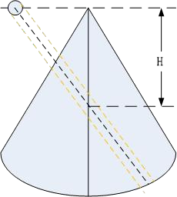

Unit: cm

|  |  |  |  |  |
| --- | --- | --- | --- | --- |
| Probes for Biopsies | Fixed Angle | Depth | | |
| G2-5C | - | 4.0 | 6.0 | 8.0 |
| S1-8C | - | 4.0 | 6.0 | 8.0 |
| G4-9E(Steel, reusable) | 0 | - | - | - |
| G4-9E Steel 21G | 0 | - | - | - |
| G4-9E Steel 14G | 0 | - | - | - |
| X4-12L | - | 2.0 | 4.0 | 6.0 |
| X6-16L | - | 1.5 | 2.5 | 3.5 |
| G1-4P | - | 4.0 | 5.5 | 8.0 |
| S1-6P | - | 4.0 | 5.5 | 8.0 |
| F2-5C | - | 4.0 | 6.0 | 8.0 |
| F4-9E | 0 | - | - | - |
| BP4-9 | 0 | - | - | - |
| F4-12L |  | 2.0 | 4.0 | 6.0 |

# 12. System Setting

## 12.1 General

After “Sys Setting” in “B” mode main menu is selected, the system will enter the system settings menu. The default first entrance is “General”. In the display menu, the following items can be changed.

1. **General**

**Hospital Information**

* Edit hospital name, department and address.

**Time & language**

* Select time format by 12 hours or 24 hours, date format by Month-Day-Year, Year-Month-Day or Day-Month-Year.
* Select Date, Time Zone and Time. But the selected Time Zone is only effective after rebooting.
* Select which language will be used in the general. But the selected language is only effective after rebooting.

**Patient/Exam**

* Default New Patient UI: Local Data, Worklist.
* Patient ID prefix: Add prefix for patient ID.
* Patient Weight and Height Units: Metric Units, Imperial Units.
* Patient name format: First (Middle) Family, Family (Middle) First.
* Accession number Format: None, PatientID and IncrementNumber, ExamDate and IncrementNumber, Patient Name and IncrementNumber.
* Show patient birthday on image: Disabled, Enabled, Age (display age not birthday).

**Store**

Auto Cine time span: 1-1500 seconds can be selected. The default value is 5 seconds, freeze the system during scanning, enable “Cine/Single” button, the latest 5 seconds will be replayed.

Report printing ink saving: The stored image has no background after enabled this function.

**Comments**

* Comments fontsize: Set different fontsize for comments.
* Comments Retain After Unfreeze: Comments will not be cleared after unfreeze the system if it is enabled.
* Auto open soft keyboard when edit a comment.
* Use “Common” comments as default: “Common” tab is selected when enter “Comments” if it is enabled.

**Report Format Setting**

Report Format Options: Default、PDF、Doc、Csv.

1. **Image Setting Image Setting**

**Image Setting**

* Automatically refresh tissue image when Doppler MDLine is moved: In PW/CW/TD mode, move MDLine, tissue image will be activated automatically for a while.
* 3D/4D Quick scan workflow: Switch to 4D after 3D data acquisition, start 4D scan automatically if this function is enabled. It also works when switch from 4D to 3D.
* Auto Duplex/Triplex: Duplex or triplex is enabled automatically when enter PW mode if this function is enabled.
* Flow/Doppler Max Steer Angle: 20°, 25°, 30°, change the max angle to steer linear image.
* Scan Image Rotation: Image can be rotated 90°/180°/270° if this item is enabled.
* 3D/4D use Depth Mapping: There is “Depth Mapping” in 3D/4D menu after enable this function. And the operator can enable/disable “Depth Mapping”.
* Zoom guide display: Display zoom guide on every reference image if this function is enabled.
* Enable Quick Steer function on B/HAR mode: Rotate “Rotation/Steer” key to steer linear image when this function is enabled.

**CBI**

* The Contrast Bubble type: default, typeA, typeB, typeC.

**Biopsy**

* Biopsy line type: Guide line, Parallel Region, Guideline And Tolerance Line.
* If select “Parallel Region”, user can select Biopsy Parallel Line Distance: 0.2, 0.3, 0.5, 0.8, 1, 1.5.
* Show Biopsy on first page: Enable it to display “Biopsy” button on the first page

**More Settings**

* Auto Optimization Mode:
* Optimize Image: Only optimize image quality, parameters will not be adjusted.
* Optimize parameters: Reset the value of TGC, Dynamic Range and Gain in B/HAR mode.
* Optimize parameters and ROI: Reset the value of TGC, Dynamic Range and Gain in B/HAR mode or CF/PDI/TVI mode, and reset the size and position of ROI in CF/PDI/TVI mode.
* Image Auto Level: The level is low, medium, high.
* Auto Frequency: Change the frequency of modes automatically.
* Auto Invert when steering on flow or Doppler.
* Default state of SyncDisplay: If selecting “Enable”, when enter CF mode, it has two images on main screen, the left one is 2D image, the right one is 2D+CF image. If selecting “Disable”, when enter CF mode, it only has 2D+CF image.
* Enable Pre Doppler Mode: “By pressing MDLine key”, “By pressing mode key”.
* Select “By pressing MDLine key”: Pressing MDLine key, enter pre PW mode, “Sample Volume” can be adjusted. Press PW key, enter PW mode.
* Select “By pressing mode key”: Pressing PW key, enter pre PW mode, “Sample Volume” can be adjusted. Pressing PW key again, enter PW mode. Pressing CW key, enter pre CW mode. Pressing CW key again, enter CW mode. Pressing TD key, enter pre TD mode, “Sample Volume” can be adjusted. Pressing TD key again, enter TD mode.
* Full Screen: Enable it, set “Full Screen” as default.
* Auto Sync ROI: When enable it, the system will automatically turn on Sync ROI mode.
* Image Size Level: Large, Middle, Small.
* Display auto trace line only within heart cycle: Display green auto trace line along the valid spectrum within cycles configured by “Heart Cycle”, if this item is enabled.

1. **Input Setting**

**Input Setting**

* Counterclockwise rotate to increase depth: Enable it, the depth will be increased when rotate “Depth” key counterclockwise.
* Caps Lock as default: Set “Caps” as default for Alphanumeric keyboard.
* Hide softkeyboard while using external keyboard: When plug in one external keyboard, the soft keyboard will not come out if it is enabled.
* Switch ‘Cursor’ and ‘Enter’ key: Enable it to switch the functions of ‘Cursor’ and ‘Enter’ key.
* Rotate factor of Gain knob: 1, 2, 5.
* Window open after freeze: Enter Measure when freeze the system, if select “Measure”. Enter Comments when freeze the system, if select “Comments”. Enter Body Pattern when freeze the system, if select “Body Pattern”. Just freeze the system if select “Do nothing”.
* Default Mouse Move Speed: 1-20
* Measure Mouse Move Speed: 1-20

1. **Function Setting**

**ECG Setting**

* Turn on ECG when start Stress Echo scan: ECG will be enabled automatically when enter Stress Echo after it is enabled.
* Auto enable ECG for Cardiac App: ECG will be enabled automatically when select cardiac application after it is enabled.
* ECG filter frequency: 50Hz, 60Hz.
* After “Show Manual” is selected, the operator manual will appear.

**Stress Echo Setting**

* Maximum Continuous Capture Time Span: 100-600.
* Score Model: Four Scores, Five Scores, Seven Scores.
* Segment Model: ASE16, ASE17.

**Optional functions**

* Play doppler audio for replayed doppler images: Play audio if it is enabled.
* Show tutorial control panel: Display “Tutorials” tab after enable it.
* PView Advanced Features: enable this item to activate zoom in/out and move functions in PView.
* Show TGC panel: enable this to show TGC on touch panel.
* Hints: When show TGC panel is enabled, the TGC slider (on keyboard) will be not available.
* Segments & Applications configuration: General, MSK.
* Hints: Set the probe applications, scan parameters, measurement and comment settings, ect.to apply to a specific segment. Select “General” to return to the factory default settings.

**Power Saving**

* Auto Freeze after a period of idle time (minutes): Never, 5, 10, 15, 30, 45, 60. 15 is the factory setting, if the system run 15 minutes with no operation, it will be frozen.
* Turn off the display while freezing automatically: Turn off the main screen and touch panel while the system freezing automatically. Press any key or touch the touch panel to activate the main screen and touch panel again.

1. **UI Style**

* UI Theme: there are two options, Ocean blue, Simple Dark. After reboot the system, the selected theme will be effective.
* Show Login Window: Enable it, the login window will appear when boot the system. Disable it, the system starts to scan at once when boot it.
* TGC bar Shown Temporally on Live Visual When TGC Adjust: Display one green line on the left of the image area to indicate TGC sliders’ position.
* Display Frequency range: Display every mode’s frequency range if this item is enabled.
* Show indicator on Application: After enabled “Simple UI”, display indicator icon for applications if this item is enabled.
* Image quick preview: Display preview window when the cursor is on the stored image on clipboard after enabled it.
* Info window on Non-Main Monitor: Normal, Simple, Hide.
* Show VAid Hint: The hints will appear during VAid Measure.
* Customize user interface: Users can perform the following operations after enabled the feature:

Define a workflow, unit or steps, and then the machine will automatically run according to predefined steps.

* Run/Ignore/Redo specific steps
* Clone the factory sample and modify the unit/steps, or create new steps from stretch.

After changing settings, select “√” to save the information and exit from system setting menu. If selecting “Save”, it will save current page information only without changing menu page. Select “X” to exit from the system setting menu without saving any information.

## 12.2 Monitor Tests

Select “Monitor Tests” on the top left side of the system setting menu to enter monitor testing menu. In this monitor tests menu, select the test pattern on the screen in order to test monitor quality, such as “Gradient-H”, “Color Bands”, “Response Time Ref”, “Sub Pixel Font”, “White”, “Inversion All”, “Response”, “Sharpness D”, “Black”. Select “Exit Test” to exit monitor test, or 10 seconds later, it exits automatically.

## 12.3 Measurement

Enter “Sys Setting” menu, and select “Measure”, then display setting items as follows:

1. **Cursor**

**Cursor**

* Cursor Type: “+” is the default factory setting for cursor type. Other cursor types can also be selected to replace the factory setting.
* Cursor and arrow cursor size: “16x16” is the factory setting. Other size can also be selected for cursor size.
* Cursor size when measure: “10x10” is factory setting. Other size can also be selected for shape cursor size.

**More Settings**

* Use Arrow Cursor for indication on image: Enable it and enable “Cursor”, there is an arrow on the image.
* Cursor color (M/D mode): Yellow, Lime. The color of the big cursor on PW/M image.
* Cursor line weight (M/D mode): Normal, Thin. The line weight of cursor can be changed by the setting.
* M mode distance caliper: HorilBeam, Cross.

1. **Result Window Setting**

**Result Window Setting**

* Show Result Window: During measurement, results are displayed in the results window with measurement number, and are updated simultaneously until complete. All results are displayed in the measurement results window. If necessary, this window can be hidden. Disable “Show RS.” button to hide the result window.
* Show Result Window Title: Enable this, the result’s title is displayed in front of the measurement results window. If necessary, this title also can be hidden.
* Result Window Position: The position of the measurement result window can be changed. To move the window, select the option from the list below:
* Top Left
* Bottom Left
* Top Right
* Bottom Right
* Font Size: To change the font size in the results window, select the size from the “Font Size” pull-down menu.
* Measure result position when not on main screen: Bottom right, Same as main screen.
* Measure result margin when not on main screen: 0, 1, 2, 3, 4.

**More Settings**

* Font color in normal state: Yellow, White, Lime. Yellow is the factory setting.
* Font color in focus state: Lime is the factory setting, other color can also be selected from the pull-down menu.
* Keep unfinished protocol item result after unfreeze: Retain, Clear. If select “Retain”, all measurement results of unfinished items are retained, if select “Clear”, all measurement results are cleared.
* Keep EFW dependent items’ results on result window after unfreeze: Clear, Retain. If select “Retain”, all results of EFW dependent items are retained, if select “Clear”, all results are cleared.
* Only clear the measurements on the active display segment unfreeze: The measure results will not be cleared on the visual that is not active after unfreeze the system.

1. **Display**

**Display**

* Show Cursor line: During measurement, the system will display one dotted line to indicate measurement. After the position is selected when using touch panel measurement, the system will display measurement line “Enable” is selected for “Show cursor line”. If “Disable” is selected, the system will erase the dotted line and only display the caliper with a number.
* Show depth guideline: Display a dotted line when do the measurement of “Depth”. If the probe is linear and “TView” is disabled, the dotted is not needed.
* Show brief annotation: Enable it, display brief annotations when do the measurements.
* Annotation and Index font size for measurement line: To change the font size of the annotation, select the size from the “Annotation font size” pull-down menu.
* Show comment of measure items: Explain the measurement item in local language.
* Worksheet Statistic Method: Avg, Min, Max, Last.

**Unit**

* Unit for normal distance related measurement: cm, mm. Select different unit for normal distance measurement.
* Length measurement unit for high resolution probe: mm, cm, inch, ft. Select different unit for length measurement unit of high resolution probe.
* Length measurement unit for common linear probe: mm, cm, inch, ft. Select different unit for length measurement unit of common linear probe.
* Unit for area related measurement: m2,cm2, mm2.
* Unit for velocity related measurement: m/s,cm/s, mm/s.
* Unit for time related measurement: s, ms.

**More Settings**

* Show result of protocol items in worksheet: If the current measurement is multi-step (like “Volume-L&W&H”), before finish the measurement, enter “Worksheet”, this measurement item will be displayed. This function is disabled if select “off”.
* Display measurement line when reviewing stored image: If this function is disabled, the system will erase the dotted line of all measurement when replay one image which contains measurements.
* Measure across multiple images: In dual or quad display format, the measure lines can across the image A and B or image C and D if this function is enabled. But the lines can not across the image A and C or image B and D.
* Show absolute value for velocity in doppler mode: No minus value of velocity if this function is enabled.
* Synchronous Measurement For Sync Display: When enabled, cross-graph measurements can be made.
* Auto select default measure item when enter measure: When enabled, click the measure key and the default measure item will be selected automatically. Hints: When "Successive" feature is enabled, this setting will not take effect, and the last selected item will be auto selected when enter measure.
* Measurement line color: Yellow, White, Lime. Yellow is the factory setting, other color can also be selected from the pull-down menu.
* Auto adjust cursor size for tiny distance (px): If the distance is shorter than 10, 20, 30 or 50 pixels, the cursor size will become very small. This function is disabled if select “off”.
* Auto snap range for closed curve line(px): If the measurement method is “Trace”, “Polygon” or “Spline”, when the distance between the end point and the start point is shorter than 10, 20, 30 or 50 pixels, the measurement will finish automatically, and the last cursor back to the start point. This function is disabled if select “off”.
* Auto calculation mode: Not support, Support, Support(Only display latest calculation results).
* Whether protocol measurements are repeated: Repeat Current, Not Repeat.

1. **OB**

**OB Measure Global Config**

* Show GA(LMP/BBT) on status bar: If there is GA(LMP/BBT) for the current patient, display it on the status bar.
* Show GA after Measure: During measurement, select whether or not to display the estimated fetal age automatically. If the fetal age is selected to be displayed in system set-up, the measurement results window will display estimated age after a measurement. If not, the estimated age will not be displayed in the results window.
* Show EDD after Measure: During measurement, select whether or not the estimated delivery time is displayed automatically after measurement. If estimated delivery time display is selected in the system setting, the estimated delivery time will appear in the results window after measurement. If not, estimated delivery time will not appear in the results window.
* Add 1 week to EDD Calac: If this item is selected, delivery time will be increased by 1 additional week.
* Show Percentile after Measure: Enable it, after finish the OB related measurement, show the percentile according to the OB table. LMP, BBT or GA need to be input when create the current patient before do the measurement.
* Show EFW after Measure
* EFW Method: According to different areas select different methods.
* Unit for EFW: auto, g, kg, lb/oz. The unit of EFW is depended on the EFW method if “auto” is selected.
* GA Display Format: To change the display format for “GA” after enable “Show GA after measure”.

**More Setting**

* Auto Select EFW Method: Enable it, the system will select EFW method automatically when do EFW related measurements.
* Auto Generate Fetal Growth Curve Graph When Enter Report: Fetal growth curve graph will be generated automatically when enter report if this function is enabled.
* The processing method of FL and HL during VAim measurement: Always ask, Treat as FL and Treat as HL.

1. **OB Tables**

* User Defined OB Tables: User defined OB tables can be imported, deleted.
* Plug in one USB device, there is one file folder named “OBTables” in USB device, in the folder the file named “FG Table Template.csv” or “GA Table Template.csv” can be imported.
* OB Table Type: According to different area select different types.
* **OB Measure Item GA Table Config:** To configurate GA table for every measurement item.

Folder name and file name should be the same as the described above. Table example:

|  |  |  |  |  |  |  |
| --- | --- | --- | --- | --- | --- | --- |
| Table Category | Measured Item | Author Name | Table Range | Measured Value  Unit | GA  Unit | SD  Unit |
| GA | CRL | bbb | 2 | mm | day | day |
|  |  |  |  |  |  |  |
| Index | Measured  Value | GA Min | GA  Mean | GA Max | GA  SD |  |
| 1 | 50 |  | 79 |  | 22 |  |
| 2 | 55 |  | 82 |  | 22 |  |
| 3 | 60 |  | 85 |  | 22 |  |
| 4 | 65 |  | 89 |  | 22 |  |
| 5 | 70 |  | 92 |  | 22 |  |
| …. | …. | …. | …. | …. | …. | …. |

## 12.4 Extended key

**Printing and Save Keys in Control panel:**

There are three keys on the right side of the control panel to start printing and saving functions. They are “Print”, “Store to HDD” and “Store to USB” which are marked on the control panel. Here the HDD means the system’s HDD which stores OS, application software, system setting and patient data. This section can configure those keys for following usage.

And “Foot Switch” can be configured too.

The operator must make sure that USB memory stick is virus-free before connecting it with this device. Run a virus scan for USB memory stick in your computer before using.

The following functions can be configured into those three keys, 2 external foot switches.

If it is connected to double key foot switch, the foot switch on the left is configured with “External Foot Switch 1”, and the foot switch on the right is configured with “External Foot Switch 2” by default.

If it is connected to single key foot switch, the foot switch is configured with “External Foot Switch 1” by default.

The functions can be configured are as follows:

* Print

Select “Details” to choose one printer if there is more than one printer connected.

* Printer connected by USB (thermal printer or normal printer)
* Printer connected by network: connect the network first, then add one network printer.
* DICOM printer: connect the network first, then connect one DICOM printer.

Also “Display format” can be changed in “Details”. Select the different display formats in pull-down menu.

If “Draw background” is enabled, draw black background when print images.

And “Paper size” and “Orientation” can be changed.

* Store

Select “Details” to select different destinations and file formats.

* Destination:

HDD

USB

File Server (need to connect to one file server first)

DICOM Storage Server (need to connect to one DICOM storage server first)

FTP Server (need to connect to one FTP server first)

* File Format:

VRD

DICOM

AVI or Image

* Time span: for storing live scan image

VRD: 1-1500 seconds

DICOM/AVI: 1-30 seconds

* Freeze/Unfreeze
* Save Screen Shot to USB: Press the corresponding key to save the snapshots of touch panel, main screen and the extended screen.
* Perform Function
* Measure
* BodyPattern
* Comment

Enter “Measure”, “Body Pattern” or “Comment” after press the related key.

* Do nothing

Note:

1. If store file format is VRD or DICOM, there is an option “Store single frame image”, after it is enabled one single frame image is stored even when the system is in live scan mode.
2. If “Including patient information on snapshot” is enabled, preview the stored image in Report, there are patient ID and name on the image.
3. If store destination is USB, DICOM Storage Server, File Server or FTP Server, there is an option “Backup stored file in Local Machine”, after it is enabled, the image will be stored to the server and HDD.
4. If store destination is DICOM Storage Server or FTP Server, there is an option “Auto image data transfer after end exam”. If it is enabled, the image will be stored to the server after the exam is ended. If it is disabled, the image will be stored to the server immediately.

**Factory default configuration as below:**

“Print” key: SONY UP-X898MD

“Store to HDD” key: Save VRD to HDD.

“Store to USB” key: Save image to USB.

“External Foot Switch”: Do nothing.

“External Foot Switch 1”: Do nothing.

“External Foot Switch 2”: Do nothing.

**Config Network Printer**

Select “Search” to find network printers, display all available printers. If the printer is installed, it can be used directly. Otherwise, “Install” should be selected to install the printer’s driver. Also, installed printers can be uninstalled.

## 

## 12.5 Network

Please ONLY use the hospital’s LAN. Note:

-Connection of the ultrasound diagnostic apparatus to an IT-NETWORK that includes other equipment could result in previously unidentified RISKS to PATIENTS, OPERATORS or third parties;

-The RESPONSIBLE ORGANIZATION should identify, analyze, evaluate and control these RISKS;

-Subsequent changes to the IT-NETWORK could introduce new RISKS and require additional analysis; and

- changes to the IT-NETWORK include:

* changes in the IT-network configuration;
* connection of additional items to the IT-NETWORK
* disconnecting items from the IT-NETWORK;
* update of equipment connected to the IT-NETWORK; and
* upgrade of equipment connected to the IT-NETWORK.

### 12.5.1 General

This configuration category enables the operator to set the network for the system and connected remote archive.

If one network cable is plugged in, the operator can do the following settings to connect the network:

* If enable “Auto config IP address”, the system will connect to the network automatically.
* If disable “Auto config IP address”, the operator needs to input IPv4, Subnet mask and Default gateway.

If one wireless network adaptor is plugged in, the operator can do the following settings to connect the network:

* Reboot the system after plug in the adaptor,
* Select one network, input the password, then touch “Enter”;
* Or select “Other”, input the network name and password, then touch “Enter”.
* Touch “Refresh” to update wireless network list.
* Touch “Unsave” to disconnect the current connected network.

### 

### 12.5.2 File Server

If the operator wants to connect one server:

* Input the server address in “Server Path”, and touch “Confirm”.
* If the server needs authentication, enable “User Authentication” then input username and password.

After all settings are ready, select the “Save” or “Save & Exit” key to save all setting in the system.

### 

### 12.5.3 Email Setting

* Email Account: Input the email account here for sending emails.
* Email Password: Email account’s password.
* SMTP Server: Input SMTP server here.
* SMTP Port: Input SMTP port here.
* Secure Mode: There are 2 secure modes, “Normal” and “SSL”.
* Email Subject and Email Body: There is default template of email subject and email body, the operator can edit them.
* Addressee: Input one addressee here and select “Test” to test the email account setting.

### 12.5.4 FTP

* FTP server address: Input FTP server address.
* FTP server port: Input FTP server port.
* FPT sub folder: Input the store path on the server.
* FTP account: Input FTP account.
* FTP password: Input FTP password.
* Enable FTP storage: Enable it to connect FTP server.

During uploading, there is an icon showing the number of the uploading images. If the file upload to server failed, there will be an error icon on the right bottom corner of the main screen. Click the icon, popup the file list of fail uploaded. Select “Retry” to upload again, or select “Delete” to delete the file.

Images of all formats can be uploaded to FTP server, but only DICOM images can be downloaded and viewed.

## 12.6 DICOM

### 12.6.1 General

**DICOM file format:**

Lossless bitmap

Lossless compressed jpeg

Lossy compressed jpeg.

**DICOM Compress mode**

Full compatibility

Suitable for Elitech: Store one DICOM video, play it on PC with DICOM player, it is not a video but one frame image.

Suitable for third party: Store one DICOM video, play it on ELITECH machine, it is not a video but one frame image.

**DICOM default encoding:** Different encoding methods.

**Patient Name Format:** Family Name^First Name, First Name^Family Name, Family Name^First Name^Middle Name, First Name^Family Name^Middle Name.

**Local setting:**

* Local AET: input service class user’s application entity title
* Local Address: input service class user’s address
* Local port: input service class user’s port

### 12.6.2 Storage

* SCP List: Support multiple DICOM storage servers without number limitation.
* Storage SCP AET: input service class provider’s application entity title
* Storage SCP address: input service class provider’s IP address
* Storage SCP port: input service class provider’s port
* Enable storage: enable it, save DICOM image to PACS server. Please select “Save DICOM to HDD and DICOM server” in “Extended key”.

Only DICOM image can be uploaded to DICOM Storage Server. During uploading, there is an icon showing the number of the uploading images.

If the file upload to server failed, there will be an error icon on the right bottom corner of the main screen. Click the icon, popup the file list of fail uploaded. Select “Retry” to upload again, or select “Delete” to delete the file.

### 12.6.3 Worklist

* Worklist SCP AET: input service class provider’s application entity title
* Worklist SCP address: input service class provider’s IP address
* Worklist SCP port: input service class provider’s port
* Enable Worklist: enable it to get patient list from server.

**Worklist Special Config:**

* Specify Local AET: Only list the patient(s) whose AET is the same with the local AET set in General if it is enabled.
* Force Date Format: Only start date can be selected when filter the patients if it is enabled, the end data is the current data.
* Auto Load Worklist: Get the patient list from worklist server automatically if it is enabled.
* Convert patient name to Double-byte for querying.
* End query when end of sequence.
* Patient Name Format: Family name at the first, or first name at the first.

### 12.6.4 Print

* Print SCP AET: input service class provider’s application entity title
* Print SCP Address: input service class provider’s IP address
* Print SCP port: input service class provider’s port
* Enable print: Enable it to connect the DICOM printer.
* Enable print: Enable it connect to multiple DICOM printers. (But one key can only link to one printer).

## 12.7 Service Tool

This menu includes auto diagnostic functions for each electrical part and catches software log files in order for engineers to identify the root cause.

### 12.7.1 Demo mode

Enable this function, loop playback the images in the clipboard.

### 12.7.2 Electrical parts auto diagnostic tools

There are several following automatic diagnostic tools for different electrical parts

* Keyboard
* Select “Diagnostic” to detect if there are some keys stuck.
* Press the keys on the keyboard, the related button on the touch panel will be highlighted.
* Touch panel
* Monitor
* Probe Board
* Transport

Save the information of PCIE status to one log file, and it can be downloaded. Please refer “Software log file download”.

* Acceptor
* Mainboard
* DCDC board

Press and hold “Auto” key about 10 seconds, main monitor and touch panel can be re-configured.

Click “Touch Panel Diagnostic”:

* Test: Touch every point on the touch panel to check if all points work well.
* Calibration: Do calibration for the touch panel.
* Reset: Reset calibration data to default.

### 12.7.3 Display Backlight Config

The display backlight of Main Screen can be adjusted and reset.

### 12.7.4 S-Video Output

* Main Screen Output Mode: Basic, All, Image Only.
* Resolution: different resolutions can be selected for video output.
* Show Touch Screen Content: enable this function to display the content of touch screen on the extended monitor.
* Measure Font Size Scale: configurate the font size of measure result on the extended monitor.
* Video Scale Value: change the size of output video.
* Video Horizontal Offset: Move the output video leftward or rightward.
* Video Vertical Offset: Move the output video upward or downward.
* Video Location Reset: Reset the position and size of output video.
* Color Enhance: adjust brightness, contrast and gamma.

### 12.7.5 Software log file download

There is one “Report” button to send this issue to service engineer.

* Report Current Issue: input some words to descript the issue.
* Report: Copy the description words to the log
* Download log file: Download all log files to one connected USB device.

### 12.7.6 Export/Import UserDefine Configuration

Export to USB: Export all user defined data to one USB device, include data of “Application&Parameters”, “Measurements”, “Comments” and “System Setting”. Select “Export” to start.

Import from USB

* Select “Import”, come out one dialog for the operator to select which item is needed to import.
* If there is no user defined data, “Empty User Define config” will be displayed.
* If there is user defined preset, please select probe and application which is needed to be imported.
* If enable “Reset to factory default”, all user defined presets will be cleared before import user defined presets from USB disk.
* Delete User Defined Preset: After select “Delete”, the system need to restart. Then all user defined preset will be cleared.
* Delete All User Defined Configuration: After select “Delete”, the system needs to restart. Then all user defined configurations are cleared, all settings are reset as factory default.

### 12.7.7 System Upgrade

There is one “Check” button to check the system upgrade.

* Plug in USB memory stick
* Select “Check” button
* The system will check the available new version software from the USB memory stick. If the USB memory stick has valid upgrade, select “OK”, the system start upgrade.

## 

## 12.8 Features

* Installed Features: List all features can be used at the current moment, including standard features and optional features that already got license.
* Available Features: List all features those are optional but no license.

## 12.9 User Management

This section defines the operator’s ID, the operator’s authority and login procedure setting.

Start the system with “Show Login window” enabled, the operator can select “User Management” in “System Settings”.

**Authority levels:**

Administrator: can add, modify and delete a user.

No authority (selecting “Cancel” to login): cannot add, modify or delete a user.

The following steps show how to manage users.

Add New User:

Input “User Name”, “Password”.

Select “Admin” (administration) or “User” authority.

Select “Enter” button to confirm adding action

The factory default Administrator account is as below:

Name: admin

Password: admin

**Modify User:**

Select the edit button of one user.

Edit its name and password, then select “Enter”.

**Remove operator:**

Select the user to be removed in user list.

Press “X” button to delete this user.

## 12.10 About

This section displays “Software Version”, “Hardware Version”, “DongleId”, “License”, “CopyRight”.

# 13. Accessories and Peripherals

## 13.1 Introduction

The following devices are peripherals.

* B&W thermal printer
* Color thermal printer

The following devices are accessories.

ECG lead wire

HDMI port Adapter

DVI to HDMI cable

Bluetooth adapter

Wireless adapter

Single-Key Foot Switch

Dual-Key Foot Switch

Only use ELITECH approved equipment as internal peripherals.

When using the peripheral devices, observe all warnings and cautions given in the peripheral operator manuals please.

## 13.2 Printing

Do not connect printer power cable to other devices except the approved printer.

This device can support a color and a black & white thermal printer. The printer devices are controlled from “Print” key on the control panel. “Store to HDD” or “Store to USB” keys can be also configured as printing key. Alternatively, the “Print” key can be also configured as storage function. Refer to system set-up chapter.

When pressing “Print” key on the control panel, the image displayed on the screen is printed on B&W or Color Printer, which depends on the key assignment configuration.

## 13.3 Approved Peripherals

The following devices are approved peripherals.

* B&W thermal video printer: Sony UP-X898MD
* Color thermal video printer: Sony UP-D25MD The following devices are approved accessories.
* ECG lead wire: LAUNCH 98ME01EA312
* HDMI port Adapter: UGREEN 20124
* DVI to HDMI cable: Best Match DVI to HDMI cable - 0.5m
* Bluetooth adapter: ORICO BTA-403
* Wireless adapter: COMFAST CF-812AC
* Single-Key Foot Switch: KACON HRF-M5-U IP 68

Dual-Key Foot Switch: KACON HRF-M52-U IP 68

The product external interface includes VCR audio output interface, USB (universal serial bus) ,analog video output interface S - VIDEO, digital video output interface DVI, and network interface RJ45.

Refer to the document accompanying those peripherals to be familiar with specification.

If the operator wants to install the driver of the third party printer, please contact ELITECH.

# 14 Operator maintenance and technical data

## 14.1 System maintenance

As there are no components with short working lives, periodic maintenance inspection is not mandatory. However, some customer quality assurance programs may require the additional inspections at periods of frequency different from those listed in this manual.

The manufacture will make available on request circuit diagrams, component part lists, descriptions, calibration instructions, or other information that will assist service personnel to repair those parts of the equipment that are designated by the manufacture as repairable by service personnel.

 The operator must ensure that safety inspections are performed

at least every 12 months according to the requirements of the patient safety standard IEC 60601-1. Only trained person are allowed to perform the safety inspections mentioned above.

To ensure maintaining good operating conditions of this device, we recommend the customer internal maintenance plan includes the following procedures.

### 14.1.1 Inspecting this device

If any defect is observed, DO NOT operate this device and inform a qualified service person.

Inspect the following parts on a monthly basis:

* Connectors on cables, for any mechanical defects
* Entire length of electrical and power cables, for cuts or abrasions
* Equipment, for loose or missing hardware
* Control panel and touch panel defects
* Caster brakes

To avoid electric shock hazard, DO NOT remove panels or covers from this device.

### 14.1.2 Virus protection

To minimize virus vulnerability this device is configured with a minimal set of open ports and all network services not active used. This significantly reduces the risk of a virus attack. ELITECH Company is continuously assessing the need for additional actions to reduce vulnerability of equipment; this includes vulnerability scanning of our products and evaluation of new security patches for the third party technology used.

This device should only be used with an internal Local Area Network (LAN).

### 14.1.3 Cleaning this device

Frequent and diligent cleaning of this device will reduce the risk of spreading infection from person to person, and also help maintain a clean working environment.

When performing cleaning procedures, to prevent the risk of system damage, always observe following precautions:

* Use only recommended cleaning materials and solutions
* Do not spray any liquid directly onto this device’s covers, monitor, touch panel and control panel
* Do not allow any liquid to drip or seep into this device.
* Prior to cleaning, turn OFF power of this device

**System surface cleaning:**

1. On a weekly basis, moisten a soft, non-abrasive folded cloth or sponge with a mild, general purpose, non-abrasive soap and water solution. DO NOT use any solution containing abrasive powder or strong chemicals such as acid or alkaline. Squeeze excess liquid from the cloth/sponge, and then wipe down the top, front, back and both sides of this device.
2. Rinse the cloth/sponge with clean running water and wipe this device surfaces again.
3. Use a dry, soft, line-free cloth to dry this device surfaces.
4. Wait for this device surfaces to dry completely before turn on the system.

Note: If disinfection is required, wipe with a soft, dust‐free cloth and a small quantity of isopropyl alcohol.

**Monitor cleaning:**

1. On a weekly basis, gently wipe the monitor with a dry, soft, lint-free non-abrasive folded cloth.
2. Wipe or dust the stain gently with a soft, dry cloth.
3. If the stain remains, moisten a soft, lint-free cloth with water or a 50/50 mixture of isopropyl alcohol and water.
4. Wring the cloth to remove as much liquid as possible then wipe the monitor again.

**Control panel cleaning:**

DO NOT spray any liquid directly onto the control panel!

1. On a weekly basis, moisten a soft, non-abrasive folded cloth or sponge with a mild, general purpose, non-abrasive soap and water solution or general purpose disinfectant. DO NOT use any solution containing abrasive powder or strong chemicals such as acid or alkaline.
2. Squeeze excess liquid from the cloth/sponge, and then wipe down the control panel.
3. Rinse the cloth/sponge with clean running water and wipe this device surfaces again.
4. Use a dry, soft, line-free cloth to dry this device’s surfaces.
5. Wait for this device surfaces to dry completely before turning on the system.

**Trackball cleaning**

1. Unscrew the fixing ring around the trackball anticlockwise.
2. Remove the fixing ring.
3. Take out the trackball.
4. Use a soft cloth or sponge to clean the dirt on the fixing ring, trackball and positioning rod.
5. The trackballs of some products are light sensitive trackballs. After taking out the ball, clean the dust and paper scraps inside the transparent ball holder with a brush.

**Notes**: For cleaning light sensitive trackballs, it should be noted that a soft bristle brush or dry soft cloth should be used, and the bottom of the transparent ball holder must not be scratched, otherwise the effect of laser transmission will be affected, leading to abnormal use of trackballs.

1. After cleaning, put the trackball back gently, buckle the fixing ring and turn the lock fixing ring clockwise.

**DVDRW drive cleaning:**

Clean the drive head and media with the vendor-supplied cleaning kit. DVD or CD must be stored away from dust and cigarette smoke. Do not use alcohol or benzene to clean the DVDRW drive.

**Peripherals:**

Clean the printers in accordance with SONY’s manual.

**ECG lead wire cleaning and disinfecting**

Cleaning procedure:

|  |  |  |
| --- | --- | --- |
| **Cleaning and disinfectants name** | **Intended Use** | **Manufacturer** |
| Medizyme Enzymatic Detergent | Cleaning | Medicom |

1. Disconnect the ECG lead wire from the unit.
2. Wipe the ECG lead wire with a soft cloth lightly moistened (damp; not dripping) with soap and potable water or Medizyme Enzymatic Detergent.
3. Wipe the ECG lead wire with a soft cloth or paper towel moisten in clean water until all cleaner is removed.
4. Wipe dry with a soft cloth or paper towel.

Below is the list of germicides:

|  |  |  |
| --- | --- | --- |
| **Cleaning and disinfectants name** | **Intended Use** | **Manufacturer** |
| OxivirR Tb | Disinfection | Diversey |

Disinfecting procedure:

1. Apply OxivirR Tb undiluted to surfaces by spray, cloth or disposable wipe.
2. All surfaces must remain visibly wet for 1 minute for viruses and bacteria. For fungi, surfaces must remain visibly wet for 10 minutes.
3. Allow to air dry.

### 14.1.4 Battery

**Battery**

The lithium ion battery provides power when an AC power source is not available. Lithium ion batteries last longer than conventional batteries and do not require replacement as often. You can expect one hour of battery life with a single fully charged battery. Used batteries should not be placed with common household waste products. Contact local authorities for the location of a chemical waste collection program nearest you.

NOTE: The battery is designed to work with this device only. Only use the batteries authorized by ELITECH.



* The battery has a safety device. Do not disassemble or alter the battery.
* Charge the batteries only when the ambient temperature is between 0° and 50°and discharge the batteries between 0°C and 60°C.
* Do not short-circuit the battery by directly connecting the negative terminals with metal objects.
* Do not heat the battery or discard it in a fire.
* Do not expose the battery to temperature over 60°C. Keep it away from fire and other heat sources.
* Do not charge the battery near a heat source, such as a fire or heater.
* Do not leave the battery in direct sunlight.
* Do not pierce the battery with a sharp object, hit it, or step on it.
* Do not use a damaged battery.
* Do not solder a battery.
* Do not connect the battery to an electrical power outlet.

If this device is not being used on a monthly basis, the battery needs to be removed during the lengthy non-use period.

 To avoid the battery bursting, igniting, or fumes from the battery

causing equipment damage, observe the following precautions:

* Do not immerse the battery in water or allow it to get wet.
* Do not put the battery into a microwave oven or pressurized container.
* If the battery leaks or emits an odor, remove it from all possible flammable sources.
* If the battery emits an odor or heat, is deformed or discolored, or in a way appears abnormal during use, recharging or storage, immediately remove it and stop using it. If you have any questions about the battery, consult ELITECH or your local representative.
* Short term (less than one month) storage of battery pack:
* Store the battery in a temperature range between 0°C and 50°C.



* Long term (3 months or more) storage of battery pack:
* Store the battery in a temperature range between -20°C and 45°C.
* Upon receipt of this device and before first time usage, it is highly recommended that the operator performs one full discharge/charge cycle. If the battery has not been used for >2 months, the operator is recommended to perform one full discharge/charge cycle. It is also recommended to store the battery in a shady and cool area with FCC (full current capacity).
* One Full Discharge/Charge Cycle Process:

1. Full discharge of battery to let this device automatically shut down.
2. Charge this device to 100% FCC (full current capacity).
3. Discharge of this device for complete shut down (takes one hour for discharge).

* When storing packs for more than 6 months, charge the pack at least once during the 6 month timeframe to prevent leakage and deterioration in performance.
* Use only ELITECH recognized batteries.

**Battery Replacement and Disposition:**

Battery replacement every three years is recommended.

Contact a local Service Representative for the replacement of the battery. Used batteries will be discarded appropriately by ELITECH.

NOTE: Disposing of the battery should meet local law and regulatory requirements.

NOTE: Dispose of the system according to local law and regulatory requirements.

## 14.2 Technical Data

### 14.2.1 General

Model: USG PREMIERE-02

Serial number: marked in identification plate on the rear side of this device

Identification Risk:

**Electro-magnetic influence**: In the working frequency range of the ultrasound system from 1 to 18MHz can be visible in the range from 200 to 500mV/m influence depending on the probe connected.

Safety classification:

1. Type: Class I
2. Type BF applied part: Ultrasound probe, Type CF applied part: ECG electrode
3. No defibrillation-proof applied part
4. Waterproof level: IPX0, except transducer lens is IPX7, probe housing to cable is IPX4 but intra operative probe housing to cable is IPX7.
5. NOT category AP equipment or category APG equipment
6. Ordinary Equipment/Continuous Operation
7. not intended for use in an OXYGEN RICH ENVIRONMENT

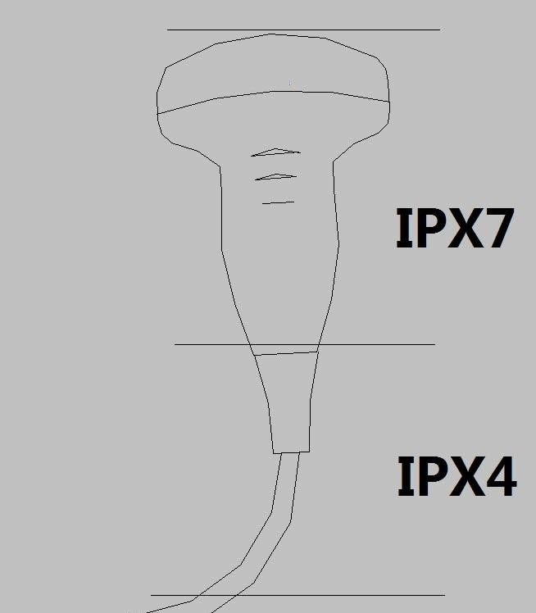 (The grade of waterproof for all convex probes, linear probes and phased array probes can refer this picture.)

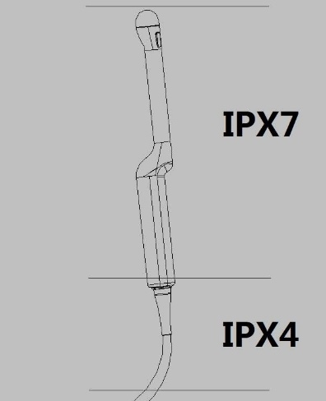 (The grade of waterproof for all endocavity probes can refer this picture.)

**Barometric Pressure**: 700 to 1060 hPa

**Dimension**:

Width: 605mm.

Depth: 940mm

Height: 1420mm

**Weight**: Basic unit without accessories approx: 60kg

### 

### 14.2.2 Power supply

Power requirement: 100V – 240VAC. 50Hz or 60Hz

Power consumption: Nominal <= 700VA.

Main outlets: It is the sockets for accessories. All outlets are co-switched by the system switch via built-in isolation transformer.

Output voltage is 220V. Max power of all connected accessories must not exceed 160 VA

**Battery**

Model Type: V9BAT Voltage: DC 14.4V Capacity: 96.48Wh

Maximum continuous discharge current: 10A

### 14.2.3 Operator panel

Control panel: Ergonomic designed control panel with interactive back-lighting.

+45°to - 45°horizontal swivel together with touch panel and monitor.

Touch panel: 13.3” projected capacitive touch panel in high resolution and color. And it is the operator-defined and configurable layout UI.

Monitor: 21.5” high resolution monitor with wide view angle.

### 

### 14.2.4 Console Design

4 probe ports

On-board Black/White printer storage

Bottom probe cable hook for cable management

5 probe holders, removable for cleaning and washing

125mm diameter and flexible rotating wheels with front locking mechanism

### 

### 14.2.5 Transmitter

Frequency range: Broadband system 1 to 18MHz, automated adaptation to the probe used.

Control of acoustic output: 10% -100%

Focusing: selectable transmit focal width and focal depth

### 14.2.6 Receiver

Frequency range: Broadband system 1 to 18MHz, automated adaptation to the probe used.

Focusing: Digital dynamic focusing system, accuracy of focus: +/- 5ns. Sample-rate: 50MHz.

### 

### 14.2.7 Scan Converter

Image resolution: 1080 x 1920

Image Lines: max 1024

Scan angle: max 360

### 

### 14.2.8 Cine Loop Memory

Call back sequence: manually frame by frame. Call back automatically from 20% to 100% of real time rate with selectable start and end point.

### 

### 14.2.9 Basic Measurement Accuracy

The table below lists the basic measurement accuracy of this device, in order to guide the operator to use this instrument for clinical diagnosis when the number of changes or measurement error may arise. The error may be due to the limitations of the instrument itself or inappropriate operation of the operator. If an operator regulates the operation according to the operational guidelines, can make the potential measurement error reduced to a minimum.

|  |  |  |  |  |  |  |  |  |  |
| --- | --- | --- | --- | --- | --- | --- | --- | --- | --- |
| **Measurement** | | | | **Unit** | | **Accuracy** | | **Conditions** | |
|  | | Lateral | | mm | | ±5% | |  | |
| Distance | | Axial | | mm | | ±5% | |  | |
|  | | Depth | | mm | | ±5% | |  | |
|  | | L&W | |  | |  | |  | |
|  | | Ellipse | |  | |  | |  | |
| Perimeter | | Polygon | | mm | | ±10% | |  | |
|  | | Spline | |  | |  | |  | |
|  | |  | |  | |  | | B | |
|  | | Trace | |  | |  | |  | |
|  | |  | |  | |  | | Harmonic | |
|  | |  | |  | |  | |
|  | | L&W | |  | |  | |  | |
|  | | Ellipse | |  | |  | |  | |
| Area | | Polygon | | mm^2 | | ±10% | |  | |
|  | | Spline | |  | |  | |  | |
|  | | Trace | |  | |  | |  | |
| Volume | | L&W&H | | mm^3 | | ±10% | |  | |
| Angle | |  | | deg | | ±5% | |  | |
| Time | |  | | s | | ±5% | | M, PW,TD | |
| Slope | | Velocity | | mm/s | | ±10% | | M | |
| Acceleration | | mm/s^2 | | ±10% | | PW | |
| SV Depth | |  | | mm | | ±2mm | | PW, TD | |
| Velocity | |  | | cm/s | | 0-100cm/s: ±10% | | PW, CW | |
|  | |  | | 100-130cm/s: ±5% | |
|  | |  | | 50% (only for reference) | | CFI | |
| Angle Correction | |  | | cm/s | | 0-60deg: ±5% | | PW | |
|  | |  | |  | | 60-80deg: ±12% | |  | |

**System Model: PREMIERE-02**

**Transducer Model and Operating Mode: F2-5C,B,HAR,B/HAR+M**

|  |  |  |  |  |  |  |  |  |
| --- | --- | --- | --- | --- | --- | --- | --- | --- |
| **Index Label** | | | ***MI*** | ***TIS*** | | ***TIB*** | | ***TIC*** |
| **At Surface** | **Below Surface** | **At Surface** | **Below Surface** |
| Maximum index value | | | 0.7935 | 0.1918 | | 0.771 | | (b) |
| Index component value | | | --- | 0.1918 | 0.1473 | 0.771 | 0.08999 |  |
| Acoustic Parameters | *p*r,α at zMI | (MPa) | 1.244 | --- | --- | --- | --- |  |
| *P* | (mW) | --- | 46.1 | | 49.7 | | (b) |
| *P*1x1 | (mW) | --- | 13.1 | | 7.6 | |  |
| *z*s | (cm) | --- | --- | 4.65 | --- | --- |  |
| *z*b | (cm) | --- | --- | --- | --- | n/a |  |
| *zMI* | (cm) | 4.85 | --- | --- | --- | --- |  |
| *z*pii,α | (cm) | 4.85 | --- | --- | --- | --- |  |
| *f*awf | (MHz) | 2.46 | B:3.115  M:3.064 | | 2.487 | | (b) |
| Other Information | *prr* | (Hz) | 4047 |  |  |  |  |  |
| *srr* | (Hz) | 51.22 |  |  |  |  |  |
| *n*pps | | 1 |  |  |  |  |  |
| *I*pa*,α at z*pii,α | (W/cm²) | 99.36 |  |  |  |  |  |
| *Is*pta*,α* at *z*pii,α or *z*sii,α | (mW/cm²) | 10.08 |  |  |  |  |  |
| *Is*pta at *z*pii or *z*sii | (mW/cm²) | 21.55 |  |  |  |  |  |
| *pr* at *z*pii | (MPa) | 1.75 |  |  |  |  |  |
| --- | --- | |  |  |  |  |  |  |
| Operating control conditions | Control 1 | | MI |  |  |  |  |  |
| Control 2 | |  | TISas | TISbs |  |  |  |
| Control 3 | |  |  |  | TISas | TISbs |  |
| Control 4 | |  |  |  |  |  |  |
| Control 5 | |  |  |  |  |  |  |
| Control 6 | |  |  |  |  |  |  |

Notes:

This index is not required for this operating mode.

This probe is not intended for adult transcranial or neonatal cephalic uses. (c)This formulation for TIS is less than that for an alternate formulation in this mode. (d)The maximum index value is less than 1.0.

# No data is provided for this operation condition since the maximum index value is not reported for the reason listed.

Control 1:B Mode,Frequency 2MHz,Depth 16cm,Focus Position 7.4cm,Line Density 0,Image Angle 59deg,Frame Rate 51.2Hz,AP 100%.

Control 2:B+M Mode,B:Frequency 3MHz,Depth 18cm,Focus Position 9.2cm,Line Density 2,Image Angle 59deg,Frame Rate 20.8Hz,AP 100%.M:Frame Rate 20.8Hz,AP 100%.

Control 3:B Mode,Frequency 2MHz,Depth 18cm,Focus Position 5.6cm,Line Density 2,Image Angle 59deg,Frame Rate 33Hz,AP 100%.

**System Model: PREMIERE-02**

**Transducer Model and Operating Mode: F2-5C,CF,B/HAR+CM+M,B/HAR+CF+PW**

|  |  |  |  |  |  |  |  |  |
| --- | --- | --- | --- | --- | --- | --- | --- | --- |
| **Index Label** | | | ***MI*** | ***TIS*** | | ***TIB*** | | ***TIC*** |
| **At Surface** | **Below Surface** | **At Surface** | **Below Surface** |
| Maximum index value | | | 0.9118 | 0.2114 | | 2.043 | | (b) |
| Index component value | | | --- | 0.2114 | 0.2114 | 2.043 | 0.1732 |  |
| Acoustic Parameters | *p*r,α at zMI | (MPa) | 1.443 | --- | --- | --- | --- |  |
| *P* | (mW) | --- | 75 | | 135.5 | | (b) |
| *P*1x1 | (mW) | --- | 17.6 | | 17.8 | |  |
| *z*s | (cm) | --- | --- | n/a | --- | --- |  |
| *z*b | (cm) | --- | --- | --- | --- | n/a |  |
| *zMI* | (cm) | 5.5 | --- | --- | --- | --- |  |
| *z*pii,α | (cm) | 5.5 | --- | --- | --- | --- |  |
| *f*awf | (MHz) | 2.505 | 2.523 | | 2.044 | | (b) |
| Other Information | *prr* | (Hz) | 207.7 |  |  |  |  |  |
| *srr* | (Hz) | 1.562 |  |  |  |  |  |
| *n*pps | | 16 |  |  |  |  |  |
| *I*pa*,α at z*pii,α | (W/cm²) | 213.6 |  |  |  |  |  |
| *Is*pta*,α* at *z*pii,α or *z*sii,α | (mW/cm²) | 1.124 |  |  |  |  |  |
| *Is*pta at *z*pii or *z*sii | (mW/cm²) | 2.5 |  |  |  |  |  |
| *pr* at *z*pii | (MPa) | 2.205 |  |  |  |  |  |
| --- | --- | |  |  |  |  |  |  |
| Operating control conditions | Control 1 | | MI |  |  |  |  |  |
| Control 2 | |  | TISas | TISbs |  |  |  |
| Control 3 | |  |  |  | TISas | TISbs |  |
| Control 4 | |  |  |  |  |  |  |
| Control 5 | |  |  |  |  |  |  |
| Control 6 | |  |  |  |  |  |  |

Notes:

This index is not required for this operating mode.

This probe is not intended for adult transcranial or neonatal cephalic uses. (c)This formulation for TIS is less than that for an alternate formulation in this mode. (d)The maximum index value is less than 1.0.

# No data is provided for this operation condition since the maximum index value is not reported for the reason liste

Control 1:CF Mode,Frequency 2.5MHz,PRF 3.8KHz,Depth 18cm,Focus Position 6.2cm,Package Size 16,Sensitivity 0,Line Density 5,Image Angle 59deg,ROI center 6.5cm, ROI Depth 1.43cm,Frame Rate 1.6Hz.AP 100%.

Control 2:CF Mode,Frequency 2.5MHz,PRF 9.0KHz,Depth 16cm,Focus Position 5.2cm,Package Size 12,Sensitivity 4,Line Density 3,Image Angle 30deg,ROI center 5cm, ROI Depth 1.69cm,Frame Rate 10.6Hz.AP 100%.

Control 3:CF Mode,Frequency 2MHz,PRF 5.1KHz,Depth 18cm,Focus Position 5.3cm,Package Size 12,Sensitivity 4,Line Density 3,Image Angle 59deg,ROI center 5.1cm, ROI Depth 2.19cm,Frame Rate 3.5Hz.AP 100%.

**System Model: PREMIERE-02**

**Transducer Model and Operating Mode:F2-5C,PW,B/HAR+PW**

|  |  |  |  |  |  |  |  |  |
| --- | --- | --- | --- | --- | --- | --- | --- | --- |
| **Index Label** | | | ***MI*** | ***TIS*** | | ***TIB*** | | ***TIC*** |
| **At Surface** | **Below Surface** | **At Surface** | **Below Surface** |
| Maximum index value | | | 0.8424 | 0.5961 | | 1.555 | | (b) |
| Index component value | | | --- | 0.2651 | 0.5961 | 1.28 | 1.555 |  |
| Acoustic Parameters | *p*r,α at zMI | (MPa) | 1.504 | --- | --- | --- | --- |  |
| *P* | (mW) | --- | 90.2 | | 90.2 | | (b) |
| *P*1x1 | (mW) | --- | 21.7 | | 21.7 | |  |
| *z*s | (cm) | --- | --- | 3.25 | --- | --- |  |
| *z*b | (cm) | --- | --- | --- | --- | 6.35 |  |
| *zMI* | (cm) | 4.8 | --- | --- | --- | --- |  |
| *z*pii,α | (cm) | 4.8 | --- | --- | --- | --- |  |
| *f*awf | (MHz) | 3.187 | B:3.079 PW:2.52 | | B:3.079 PW:2.52 | | (b) |
| Other Information | *prr* | (Hz) | 1357 |  |  |  |  |  |
| *srr* | (Hz) | n/a |  |  |  |  |  |
| *n*pps | | n/a |  |  |  |  |  |
| *I*pa*,α at z*pii,α | (W/cm²) | 203.1 |  |  |  |  |  |
| *Is*pta*,α* at *z*pii,α or *z*sii,α | (mW/cm²) | 164.3 |  |  |  |  |  |
| *Is*pta at *z*pii or *z*sii | (mW/cm²) | 465.5 |  |  |  |  |  |
| *pr* at *z*pii | (MPa) | 2.47 |  |  |  |  |  |
| --- | --- | |  |  |  |  |  |  |
| Operating control conditions | Control 1 | | MI |  |  |  |  |  |
| Control 2 | |  | TISas | TISbs | TIBas | TIBbs |  |
| Control 3 | |  |  |  |  |  |  |
| Control 4 | |  |  |  |  |  |  |
| Control 5 | |  |  |  |  |  |  |
| Control 6 | |  |  |  |  |  |  |

Notes:

This index is not required for this operating mode.

This probe is not intended for adult transcranial or neonatal cephalic uses. (c)This formulation for TIS is less than that for an alternate formulation in this mode. (d)The maximum index value is less than 1.0.

# No data is provided for this operation condition since the maximum index value is not reported for the reason listed.

Control 1:PW Mode:Frequency 3.3MHz,PRF 1.4KHz,Depth 17cm,Focus Position 5.9cm,Image Angle 59deg,Sample Volume 1mm,Sample Volume Depth 5.6cm,Frame Rate 27.1Hz,AP 100%.

Control 2:B+PW Mode,B:Frequency 3MHz,Depth 18cm,Focus Position 7.9cm,Line Density 2,Image Angle 59deg, Frame Rate 4.5Hz,AP 100%.PW:Frequency 2.5MHz,PRF 2.4KHz,,Depth 18cm,Focus Position 7.9cm,Image Angle 59deg, Sample Volume 2mm,Sample Volume Depth 7.5cm,Frame Rate 4.5Hz,AP 100%.

**System Model: PREMIERE-02**

**Transducer Model and Operating Mode:F2-5C,CBI**

|  |  |  |  |  |  |  |  |  |
| --- | --- | --- | --- | --- | --- | --- | --- | --- |
| **Index Label** | | | ***MI*** | ***TIS*** | | ***TIB*** | | ***TIC*** |
| **At Surface** | **Below Surface** | **At Surface** | **Below Surface** |
| Maximum index value | | | 0.5296 | 0.03617 | | 0.2186 | | (b) |
| Index component value | | | --- | 0.03617 | 0.03617 | 0.2186 | 0.03617 |  |
|  | *p*r,α at zMI | (MPa) | 0.8607 | --- | --- | --- | --- |  |
|  | *P* | (mW) | --- | 14.5 | | 14.5 | | (b) |
|  | *P*1x1 | (mW) | --- | 2.8 | | 2.8 | |  |
| Acoustic | *z*s | (cm) | --- | --- | n/a | --- | --- |  |
| *z*b | (cm) | --- | --- | --- | --- | n/a |  |
| Parameters |
|  | *zMI* | (cm) | 6.35 | --- | --- | --- | --- |  |
|  | *z*pii,α | (cm) | 6.35 | --- | --- | --- | --- |  |
|  | *f*awf | (MHz) | 2.642 | 2.713 | | 2.713 | | (b) |
|  | *prr* | (Hz) | 1924 |  |  |  |  |  |
|  | *srr* | (Hz) | 6.088 |  |  |  |  |  |
| Other | *n*pps | | 2 |  |  |  |  |  |
| *I*pa*,α at z*pii,α | (W/cm²) | 68.23 |  |  |  |  |  |
| Information |
| *Is*pta*,α* at *z*pii,α or *z*sii,α | (mW/cm²) | 2.227 |  |  |  |  |  |
|  | *Is*pta at *z*pii or *z*sii | (mW/cm²) | 5.391 |  |  |  |  |  |
|  | *pr* at *z*pii | (MPa) | 1.471 |  |  |  |  |  |
| --- | --- | |  |  |  |  |  |  |
| Operating control conditions | Control 1 | | MI |  |  |  |  |  |
| Control 2 | |  | TISas | TISbs | TIBas | TIBbs |  |
| Control 3 | |  |  |  |  |  |  |
| Control 4 | |  |  |  |  |  |  |
| Control 5 | |  |  |  |  |  |  |
| Control 6 | |  |  |  |  |  |  |

Notes:

This index is not required for this operating mode.

This probe is not intended for adult transcranial or neonatal cephalic uses. (c)This formulation for TIS is less than that for an alternate formulation in this mode. (d)The maximum index value is less than 1.0.

# No data is provided for this operation condition since the maximum index value is not reported for the reason listed.

Control 1:CBI Mode,Frequency 2.5MHz,Depth 17cm,Focus Position 8.7cm,Line Density 4,Image Angle 59deg,Frame Rate 6.1Hz,AP 100%.

Control 2:CBI Mode,Frequency 2.5MHz,Depth 18cm,Focus Position 6.5cm,Line Density 4,Image Angle 30deg,Frame Rate 11.7Hz,AP 100%.

**System Model: PREMIERE-02**

**Transducer Model and Operating Mode: X4-12L,B,HAR,B/HAR+M**

|  |  |  |  |  |  |  |  |  |
| --- | --- | --- | --- | --- | --- | --- | --- | --- |
| **Index Label** | | | ***MI*** | ***TIS*** | | ***TIB*** | | ***TIC*** |
| **At Surface** | **Below Surface** | **At Surface** | **Below Surface** |
| Maximum index value | | | 1.08 | 0.2232 | | 1.984 | | (b) |
| Index component value | | | --- | 0.2232 | 0.2232 | 1.984 | 0.2232 |  |
| Acoustic Parameters | *p*r,α at zMI | (MPa) | 2.554 | --- | --- | --- | --- |  |
| *P* | (mW) | --- | 46.7 | | 46.7 | | (b) |
| *P*1x1 | (mW) | --- | 8.4 | | 8.4 | |  |
| *z*s | (cm) | --- | --- | n/a | --- | --- |  |
| *z*b | (cm) | --- | --- | --- | --- | n/a |  |
| *zMI* | (cm) | 1.35 | --- | --- | --- | --- |  |
| *z*pii,α | (cm) | 1.35 | --- | --- | --- | --- |  |
| *f*awf | (MHz) | 5.596 | 5.58 | | 5.58 | | (b) |
| Other Information | *prr* | (Hz) | 12430 |  |  |  |  |  |
| *srr* | (Hz) | 38.83 |  |  |  |  |  |
| *n*pps | | 1 |  |  |  |  |  |
| *I*pa*,α at z*pii,α | (W/cm²) | 351.2 |  |  |  |  |  |
| *Is*pta*,α* at *z*pii,α or *z*sii,α | (mW/cm²) | 23.4 |  |  |  |  |  |
| *Is*pta at *z*pii or *z*sii | (mW/cm²) | 38.38 |  |  |  |  |  |
| *pr* at *z*pii | (MPa) | 3.235 |  |  |  |  |  |
| --- | --- | |  |  |  |  |  |  |
| Operating control conditions | Control 1 | | MI |  |  |  |  |  |
| Control 2 | |  | TISas | TISbs | TIBas | TIBbs |  |
| Control 3 | |  |  |  |  |  |  |
| Control 4 | |  |  |  |  |  |  |
| Control 5 | |  |  |  |  |  |  |
| Control 6 | |  |  |  |  |  |  |

Notes:

This index is not required for this operating mode.

This probe is not intended for adult transcranial or neonatal cephalic uses. (c)This formulation for TIS is less than that for an alternate formulation in this mode. (d)The maximum index value is less than 1.0.

# No data is provided for this operation condition since the maximum index value is not reported for the reason listed.

Control 1:B Mode,Frequency 6MHz,Depth 4cm,Focus Position 1.9cm,Line Density 2, Frame Rate 38.8Hz,AP 100%.

Control 2:B Mode,Frequency 6MHz,Depth 4cm,Focus Position 2.3cm,Line Density 2, Frame Rate 39Hz,AP 100%.

**System Model: PREMIERE-02**

**Transducer Model and Operating Mode: X4-12L,B/HAR+CF,B/HAR+CM+M,B/HAR+CF+PW**

|  |  |  |  |  |  |  |  |  |
| --- | --- | --- | --- | --- | --- | --- | --- | --- |
| **Index Label** | | | ***MI*** | ***TIS*** | | ***TIB*** | | ***TIC*** |
| **At Surface** | **Below Surface** | **At Surface** | **Below Surface** |
| Maximum index value | | | 1.545 | 0.3214 | | 1.057 | | (b) |
| Index component value | | | --- | 0.3214 | 0.3214 | 1.057 | 0.3214 |  |
|  | *p*r,α at zMI | (MPa) | 3.445 | --- | --- | --- | --- |  |
|  | *P* | (mW) | --- | 20.9 | | 20.9 | | (b) |
|  | *P*1x1 | (mW) | --- | 16.7 | | 16.7 | |  |
| Acoustic | *z*s | (cm) | --- | --- | n/a | --- | --- |  |
| *z*b | (cm) | --- | --- | --- | --- | n/a |  |
| Parameters |
|  | *zMI* | (cm) | 1.3 | --- | --- | --- | --- |  |
|  | *z*pii,α | (cm) | 1.3 | --- | --- | --- | --- |  |
|  | *f*awf | (MHz) | 4.973 | 4.041 | | 4.041 | | (b) |
|  | *prr* | (Hz) | 66.18 |  |  |  |  |  |
|  | *srr* | (Hz) | 11.03 |  |  |  |  |  |
| Other | *n*pps | | 12 |  |  |  |  |  |
| *I*pa*,α at z*pii,α | (W/cm²) | 562 |  |  |  |  |  |
| Information |
| *Is*pta*,α* at *z*pii,α or *z*sii,α | (mW/cm²) | 11.29 |  |  |  |  |  |
|  | *Is*pta at *z*pii or *z*sii | (mW/cm²) | 17.24 |  |  |  |  |  |
|  | *pr* at *z*pii | (MPa) | 4.093 |  |  |  |  |  |
| --- | --- | |  |  |  |  |  |  |
| Operating control conditions | Control 1 | | MI |  |  |  |  |  |
| Control 2 | |  | TISas | TISbs | TIBas | TIBbs |  |
| Control 3 | |  |  |  |  |  |  |
| Control 4 | |  |  |  |  |  |  |
| Control 5 | |  |  |  |  |  |  |
| Control 6 | |  |  |  |  |  |  |

Notes:

This index is not required for this operating mode.

This probe is not intended for adult transcranial or neonatal cephalic uses. (c)This formulation for TIS is less than that for an alternate formulation in this mode. (d)The maximum index value is less than 1.0.

# No data is provided for this operation condition since the maximum index value is not reported for the reason listed.

Control 1:CF Mode,Frequency 5MHz,PRF 0.2KHz,Depth 4cm,Focus Position 1.8cm,Package Size 12,Sensitivity 3,Line Density 1, ROI center 1.7cm,ROI Depth 0.99cm,Frame Rate 11Hz,AP 100%.

Control 2:CF Mode,Frequency 4MHz,PRF 15.4KHz,Depth 4cm,Focus Position 1.6cm,Package Size 12,Sensitivity 3, Line Density 1, ROI center 1.5cm,ROI Depth 1.01cm,Frame Rate 32.6Hz,AP 100%.

**System Model: PREMIERE-02**

**Transducer Model and Operating Mode: X4-12L,PW,B/HAR+PW**

|  |  |  |  |  |  |  |  |  |
| --- | --- | --- | --- | --- | --- | --- | --- | --- |
| **Index Label** | | | ***MI*** | ***TIS*** | | ***TIB*** | | ***TIC*** |
| **At Surface** | **Below Surface** | **At Surface** | **Below Surface** |
| Maximum index value | | | 1.366 | 0.3418 | | 1.627 | | (b) |
| Index component value | | | --- | 0.3418 | 0.2979 | 1.002 | 1.627 |  |
|  | *p*r,α at zMI | (MPa) | 2.501 | --- | --- | --- | --- |  |
|  | *P* | (mW) | --- | 20.2 | | 20.2 | | (b) |
|  | *P*1x1 | (mW) | --- | 17.4 | | 17.4 | |  |
| Acoustic | *z*s | (cm) | --- | --- | 0.75 | --- | --- |  |
| *z*b | (cm) | --- | --- | --- | --- | 1.25 |  |
| Parameters |
| *zMI* | (cm) | 1.3 | --- | --- | --- | --- |  |
|  | *z*pii,α | (cm) | 1.3 | --- | --- | --- | --- |  |
|  | *f*awf | (MHz) | 3.35 | B:5.741 | | B:5.741 | | (b) |
|  | PW:4.058 | | PW:4.058 | |
|  | *prr* | (Hz) | 580.9 |  |  |  |  |  |
|  | *srr* | (Hz) | n/a |  |  |  |  |  |
| Other | *n*pps | | n/a |  |  |  |  |  |
| *I*pa*,α at z*pii,α | (W/cm²) | 202.6 |  |  |  |  |  |
| Information |
| *Is*pta*,α* at *z*pii,α or *z*sii,α | (mW/cm²) | 83.3 |  |  |  |  |  |
|  | *Is*pta at *z*pii or *z*sii | (mW/cm²) | 115.7 |  |  |  |  |  |
|  | *pr* at *z*pii | (MPa) | 3.005 |  |  |  |  |  |
| --- | --- | |  |  |  |  |  |  |
| Operating control conditions | Control 1 | | MI |  |  |  |  |  |
| Control 2 | |  | TISas | TISbs | TIBas | TIBbs |  |
| Control 3 | |  |  |  |  |  |  |
| Control 4 | |  |  |  |  |  |  |
| Control 5 | |  |  |  |  |  |  |
| Control 6 | |  |  |  |  |  |  |

Notes:

This index is not required for this operating mode.

This probe is not intended for adult transcranial or neonatal cephalic uses. (c)This formulation for TIS is less than that for an alternate formulation in this mode. (d)The maximum index value is less than 1.0.

# No data is provided for this operation condition since the maximum index value is not reported for the reason listed.

Control 1:PW Mode,Frequency 3MHz,PRF 0.6KHz,Depth 4cm,Focus Position 1.9cm,Sample Volume 1mm, Sample Volume Depth 1.8cm,Frame Rate 27.8Hz,AP 100%.

Control 2:B+PW Mode,B:Frequency 6MHz,Depth 4cm,Focus Position 1.7cm,Line Density 2, Frame Rate 8.4Hz,AP 100%.

PW:Frequency 4MHz,PRF 13.2KHz,Depth 4cm,Focus Position 1.7cm,Sample Volume 1mm, Sample Volume Depth 1.5cm,Frame Rate 8.4Hz,AP 100%.

**System Model: PREMIERE-02**

**Transducer Model and Operating Mode: X4-12L,B/HAR+EI**

|  |  |  |  |  |  |  |  |  |
| --- | --- | --- | --- | --- | --- | --- | --- | --- |
| **Index Label** | | | ***MI*** | ***TIS*** | | ***TIB*** | | ***TIC*** |
| **At Surface** | **Below Surface** | **At Surface** | **Below Surface** |
| Maximum index value | | | 1.231 | 1.555 | | 4.954 | | (b) |
| Index component value | | | --- | 1.555 | 1.555 | 4.954 | 1.555 |  |
| Acoustic Parameters | *p*r,α at zMI | (MPa) | 3.153 | --- | --- | --- | --- |  |
| *P* | (mW) | --- | 100 | | 100 | | (b) |
| *P*1x1 | (mW) | --- | 50 | | 50 | |  |
| *z*s | (cm) | --- | --- | n/a | --- | --- |  |
| *z*b | (cm) | --- | --- | --- | --- | n/a |  |
| *zMI* | (cm) | 1.5 | --- | --- | --- | --- |  |
| *z*pii,α | (cm) | 1.5 | --- | --- | --- | --- |  |
| *f*awf | (MHz) | 6.158 | B:5.845 EI:6.531 | | B:5.845 EI:6.531 | | (b) |
| Other Information | *prr* | (Hz) | 327.7 |  |  |  |  |  |
| *srr* | (Hz) | 27.31 |  |  |  |  |  |
| *n*pps | | 1 |  |  |  |  |  |
| *I*pa*,α at z*pii,α | (W/cm²) | 380.7 |  |  |  |  |  |
| *Is*pta*,α* at *z*pii,α or *z*sii,α | (mW/cm²) | 8.567 |  |  |  |  |  |
| *Is*pta at *z*pii or *z*sii | (mW/cm²) | 16.51 |  |  |  |  |  |
| *pr* at *z*pii | (MPa) | 4.229 |  |  |  |  |  |
| --- | --- | |  |  |  |  |  |  |
| Operating control conditions | Control 1 | | MI |  |  |  |  |  |
| Control 2 | |  | TISas | TISbs | TIBas | TIBbs |  |
| Control 3 | |  |  |  |  |  |  |
| Control 4 | |  |  |  |  |  |  |
| Control 5 | |  |  |  |  |  |  |
| Control 6 | |  |  |  |  |  |  |

Notes:

This index is not required for this operating mode.

This probe is not intended for adult transcranial or neonatal cephalic uses. (c)This formulation for TIS is less than that for an alternate formulation in this mode. (d)The maximum index value is less than 1.0.

# No data is provided for this operation condition since the maximum index value is not reported for the reason listed.

Control 1:B+EI mode,B:Frequency 6MHz,Depth 4cm,Focus Position 1.8cm,Line Density 4, Frame Rate 27.3Hz， AP:100%;EI: Frequency 7.3MHz,Focus Position 4cm,Focus Position 1.8cm,Sensitivity 1,Line density 1,ROI center 1.5cm,ROI Depth 1.39cm,Frame Rate 27.3Hz,AP:100%.

Control 2:B+EI mode,B:Frequency 6MHz,Depth 4cm,Focus Position 1.7cm,Line Density 2,Frame Rate 30.8 Hz. AP:100%;EI: Frequency 7.3MHz,Focus Position 4cm,Focus Position 1.7cm,Sensitivity 1,Line density 1,ROI center 1.5cm,ROI Depth 0.5cm,Frame Rate 30.8Hz,AP:100%.

**System Model: PREMIERE-02**

**Transducer Model and Operating Mode: X4-12L,CBI**

|  |  |  |  |  |  |  |  |  |
| --- | --- | --- | --- | --- | --- | --- | --- | --- |
| **Index Label** | | | ***MI*** | ***TIS*** | | ***TIB*** | | ***TIC*** |
| **At Surface** | **Below Surface** | **At Surface** | **Below Surface** |
| Maximum index value | | | 0.5782 | 0.03374 | | 0.4607 | | (b) |
| Index component value | | | --- | 0.03374 | 0.03374 | 0.4607 | 0.03374 |  |
|  | *p*r,α at zMI | (MPa) | 1.358 | --- | --- | --- | --- |  |
|  | *P* | (mW) | --- | 9.3 | | 9.3 | | (b) |
|  | *P*1x1 | (mW) | --- | 1.5 | | 1.5 | |  |
| Acoustic | *z*s | (cm) | --- | --- | n/a | --- | --- |  |
| *z*b | (cm) | --- | --- | --- | --- | n/a |  |
| Parameters |
|  | *zMI* | (cm) | 1.2 | --- | --- | --- | --- |  |
|  | *z*pii,α | (cm) | 1.2 | --- | --- | --- | --- |  |
|  | *f*awf | (MHz) | 5.12 | 4.723 | | 4.723 | | (b) |
|  | *prr* | (Hz) | 4167 |  |  |  |  |  |
|  | *srr* | (Hz) | 13.35 |  |  |  |  |  |
| Other | *n*pps | | 1 |  |  |  |  |  |
| *I*pa*,α at z*pii,α | (W/cm²) | 70.43 |  |  |  |  |  |
| Information |
| *Is*pta*,α* at *z*pii,α or *z*sii,α | (mW/cm²) | 2.09 |  |  |  |  |  |
|  | *Is*pta at *z*pii or *z*sii | (mW/cm²) | 3.661 |  |  |  |  |  |
|  | *pr* at *z*pii | (MPa) | 1.629 |  |  |  |  |  |
| --- | --- | |  |  |  |  |  |  |
| Operating control conditions | Control 1 | | MI |  |  |  |  |  |
| Control 2 | |  | TISas | TISbs | TIBas | TIBbs |  |
| Control 3 | |  |  |  |  |  |  |
| Control 4 | |  |  |  |  |  |  |
| Control 5 | |  |  |  |  |  |  |
| Control 6 | |  |  |  |  |  |  |

Notes:

This index is not required for this operating mode.

This probe is not intended for adult transcranial or neonatal cephalic uses. (c)This formulation for TIS is less than that for an alternate formulation in this mode. (d)The maximum index value is less than 1.0.

# No data is provided for this operation condition since the maximum index value is not reported for the reason listed.

Control 1:CBI Mode,Frequency 5MHz,Depth 3.8cm,Focus Position 1.8cm,Line Density 2,Frame Rate 13.4Hz,AP 100%.

Control 2:CBI Mode,Frequency 5MHz,Depth 4cm,Focus Position 1.7cm,Line Density 2,Frame Rate 13.2Hz,AP 100%.

**System Model: PREMIERE-02**

**Transducer Model and Operating Mode:G3-10P,B,HAR,B/HAR+M**

|  |  |  |  |  |  |  |  |  |
| --- | --- | --- | --- | --- | --- | --- | --- | --- |
| **Index Label** | | | ***MI*** | ***TIS*** | | ***TIB*** | | ***TIC*** |
| **At Surface** | **Below Surface** | **At Surface** | **Below Surface** |
| Maximum index value | | | 0.7955 | 0.4459 | | 0.82 | | 0.82 |
| Index component value | | | --- | 0.4459 | 0.4459 | 0.82 | 0.4459 | --- |
|  | *p*r,α at zMI | (MPa) | 1.425 | --- | --- | --- | --- | --- |
|  | *P* | (mW) | --- | 33.5 | | 33.5 | | 33.5 |
|  | *P*1x1 | (mW) | --- | 22.7 | | 22.7 | | --- |
| Acoustic | *z*s | (cm) | --- | --- | n/a | --- | --- | --- |
| *z*b | (cm) | --- | --- | --- | --- | n/a | --- |
| Parameters |
|  | *zMI* | (cm) | 3.3 | --- | --- | --- | --- | --- |
|  | *z*pii,α | (cm) | 3.3 | --- | --- | --- | --- | --- |
|  | *f*awf | (MHz) | 3.209 | 4.125 | | 4.125 | | 4.125 |
|  | *prr* | (Hz) | 4210 |  |  |  |  |  |
|  | *srr* | (Hz) | 26.65 |  |  |  |  |  |
| Other | *n*pps | | 1 |  |  |  |  |  |
| *I*pa*,α at z*pii,α | (W/cm²) | 105.8 |  |  |  |  |  |
| Information |
| *Is*pta*,α* at *z*pii,α or *z*sii,α | (mW/cm²) | 16.18 |  |  |  |  |  |
|  | *Is*pta at *z*pii or *z*sii | (mW/cm²) | 25.69 |  |  |  |  |  |
|  | *pr* at *z*pii | (MPa) | 2.072 |  |  |  |  |  |
| --- | --- | |  |  |  |  |  |  |
| Operating control conditions | Control 1 | | MI |  |  |  |  |  |
| Control 2 | |  | TISas | TISbs | TIBas | TIBbs | TIC |
| Control 3 | |  |  |  |  |  |  |
| Control 4 | |  |  |  |  |  |  |
| Control 5 | |  |  |  |  |  |  |
| Control 6 | |  |  |  |  |  |  |

Notes:

This index is not required for this operating mode.

This probe is not intended for adult transcranial or neonatal cephalic uses. (c)This formulation for TIS is less than that for an alternate formulation in this mode. (d)The maximum index value is less than 1.0.

# No data is provided for this operation condition since the maximum index value is not reported for the reason listed.

Control 1:B Mode,Frequency 3MHz,Depth 16cm,Focus Position 4.9cm,Line Density 4,Image Angle 89deg, Frame Rate 26.6Hz,AP 100%.

Control 2:B Mode,Frequency 4MHz,Depth 10cm,Focus Position 5.1cm,Line Density 4,Image Angle 10deg, Frame Rate 356.5Hz,AP 100%.

**System Model: PREMIERE-02**

**Transducer Model and Operating Mode:G3-10P,CF,B/HAR+CM+M,B/HAR+CF+PW**

|  |  |  |  |  |  |  |  |  |
| --- | --- | --- | --- | --- | --- | --- | --- | --- |
| **Index Label** | | | ***MI*** | ***TIS*** | | ***TIB*** | | ***TIC*** |
| **At Surface** | **Below Surface** | **At Surface** | **Below Surface** |
| Maximum index value | | | 0.8124 | 0.4301 | | 0.7784 | | 0.7784 |
| Index component value | | | --- | 0.4301 | 0.4301 | 0.7784 | 0.4301 | --- |
| Acoustic Parameters | *p*r,α at zMI | (MPa) | 1.471 | --- | --- | --- | --- | --- |
| *P* | (mW) | --- | 31.8 | | 31.8 | | 31.8 |
| *P*1x1 | (mW) | --- | 22.2 | | 22.2 | | --- |
| *z*s | (cm) | --- | --- | n/a | --- | --- | --- |
| *z*b | (cm) | --- | --- | --- | --- | n/a | --- |
| *zMI* | (cm) | 3.25 | --- | --- | --- | --- | --- |
| *z*pii,α | (cm) | 3.25 | --- | --- | --- | --- | --- |
| *f*awf | (MHz) | 3.28 | 4.069 | | 4.069 | | 4.069 |
| Other Information | *prr* | (Hz) | 103 |  |  |  |  |  |
| *srr* | (Hz) | 51.48 |  |  |  |  |  |
| *n*pps | | 10 |  |  |  |  |  |
| *I*pa*,α at z*pii,α | (W/cm²) | 172.6 |  |  |  |  |  |
| *Is*pta*,α* at *z*pii,α or *z*sii,α | (mW/cm²) | 15.06 |  |  |  |  |  |
| *Is*pta at *z*pii or *z*sii | (mW/cm²) | 30.04 |  |  |  |  |  |
| *pr* at *z*pii | (MPa) | 2.024 |  |  |  |  |  |
| --- | --- | |  |  |  |  |  |  |
| Operating control conditions | Control 1 | | MI |  |  |  |  |  |
| Control 2 | |  | TISas | TISbs | TIBas | TIBbs | TIC |
| Control 3 | |  |  |  |  |  |  |
| Control 4 | |  |  |  |  |  |  |
| Control 5 | |  |  |  |  |  |  |
| Control 6 | |  |  |  |  |  |  |
| Control 7 | |  |  |  |  |  |  |

Notes:

This index is not required for this operating mode.

This probe is not intended for adult transcranial or neonatal cephalic uses. (c)This formulation for TIS is less than that for an alternate formulation in this mode. (d)The maximum index value is less than 1.0.

# No data is provided for this operation condition since the maximum index value is not reported for the reason list

Control 1:CF Mode,Frequency 3.3MHz,PRF 1.4KHz,Depth 16cm,Focus Position 4.7cm,Package Size 10,Sensitivity 3,Line Density 0,Image Angle 89deg,ROI center 6.1cm, ROI Depth 4.2cm,Frame Rate 51.5Hz.AP 100%.

Control 2:CF Mode,Frequency 4MHz,PRF 10.4KHz,Depth 7cm,Focus Position 5cm,Package Size 10,Sensitivity 4,Line Density 2,Image Angle 10deg,ROI center 4.9cm, ROI Depth 1cm,Frame Rate 170.1Hz.AP 100%.

**System Model: PREMIERE-02**

**Transducer Model and Operating Mode:G3-10P,PW,B/HAR+PW**

|  |  |  |  |  |  |  |  |  |
| --- | --- | --- | --- | --- | --- | --- | --- | --- |
| **Index Label** | | | ***MI*** | ***TIS*** | | ***TIB*** | | ***TIC*** |
| **At Surface** | **Below Surface** | **At Surface** | **Below Surface** |
| Maximum index value | | | 0.783 | 0.6146 | | 0.8176 | | 0.8176 |
| Index component value | | | --- | 0.6146 | 0.291 | 0.8176 | 0.3062 | --- |
| Acoustic Parameters | *p*r,α at zMI | (MPa) | 1.545 | --- | --- | --- | --- | --- |
| *P* | (mW) | --- | 33.4 | | 33.4 | | 33.4 |
| *P*1x1 | (mW) | --- | 23.8 | | 23.8 | | --- |
| *z*s | (cm) | --- | --- | 2.9 | --- | --- | --- |
| *z*b | (cm) | --- | --- | --- | --- | 3.8 | --- |
| *zMI* | (cm) | 3.4 | --- | --- | --- | --- | --- |
| *z*pii,α | (cm) | 3.4 | --- | --- | --- | --- | --- |
| *f*awf | (MHz) | 3.895 | 5.423 | | 5.423 | | 5.423 |
| Other Information | *prr* | (Hz) | 495.7 |  |  |  |  |  |
| *srr* | (Hz) | 10.33 |  |  |  |  |  |
| *n*pps | | 1 |  |  |  |  |  |
| *I*pa*,α at z*pii,α | (W/cm²) | 111 |  |  |  |  |  |
| *Is*pta*,α* at *z*pii,α or *z*sii,α | (mW/cm²) | 1.676 |  |  |  |  |  |
| *Is*pta at *z*pii or *z*sii | (mW/cm²) | 3.057 |  |  |  |  |  |
| *pr* at *z*pii | (MPa) | 2.311 |  |  |  |  |  |
| --- | --- | |  |  |  |  |  |  |
| Operating control conditions | Control 1 | | MI |  |  |  |  |  |
| Control 2 | |  | TISas | TISbs | TIBas | TIBbs | TIC |
| Control 3 | |  |  |  |  |  |  |
| Control 4 | |  |  |  |  |  |  |
| Control 5 | |  |  |  |  |  |  |
| Control 6 | |  |  |  |  |  |  |

Notes:

This index is not required for this operating mode.

This probe is not intended for adult transcranial or neonatal cephalic uses. (c)This formulation for TIS is less than that for an alternate formulation in this mode. (d)The maximum index value is less than 1.0.

# No data is provided for this operation condition since the maximum index value is not reported for the reason listed.

Control 1:B+PW Mode,B:Frequency 4MHz,Depth 16cm,Focus Position 6.5cm,Line Density 4,Image Angle 89deg,Frame Rate 10.3Hz,AP 100%.PW:Frequency 4MHz,PRF 3.6KHz,Depth 16cm,Focus Position 6.5cm,,Image Angle 89deg,Sample Volume 3mm,Sample Volume Depth 6.3cm,Frame Rate 10.3Hz.AP 100%.

Control 2:PW Mode,Frequency 5.7MHz,PRF 9.5KHz,Depth 7cm,Focus Position 4.9cm,,Image Angle 10deg, Sample Volume 0.5mm,Sample Volume Depth 4.8cm,Frame Rate 476Hz.AP 100%.

**System Model: PREMIERE-02**

**Transducer Model and Operating Mode:G3-10P,CBI**

|  |  |  |  |  |  |  |  |  |
| --- | --- | --- | --- | --- | --- | --- | --- | --- |
| **Index Label** | | | ***MI*** | ***TIS*** | | ***TIB*** | | ***TIC*** |
| **At Surface** | **Below Surface** | **At Surface** | **Below Surface** |
| Maximum index value | | | 0.4295 | 0.1553 | | 0.4529 | | 0.4529 |
| Index component value | | | --- | 0.1553 | 0.1553 | 0.4529 | 0.1553 | --- |
|  | *p*r,α at zMI | (MPa) | 0.8891 | --- | --- | --- | --- | --- |
|  | *P* | (mW) | --- | 18.5 | | 18.5 | | 18.5 |
|  | *P*1x1 | (mW) | --- | 10.7 | | 10.7 | | --- |
| Acoustic | *z*s | (cm) | --- | --- | n/a | --- | --- | --- |
| *z*b | (cm) | --- | --- | --- | --- | n/a | --- |
| Parameters |
|  | *zMI* | (cm) | 3.85 | --- | --- | --- | --- | --- |
|  | *z*pii,α | (cm) | 3.85 | --- | --- | --- | --- | --- |
|  | *f*awf | (MHz) | 4.286 | 3.049 | | 3.049 | | 3.049 |
|  | *prr* | (Hz) | 2103 |  |  |  |  |  |
|  | *srr* | (Hz) | 33.38 |  |  |  |  |  |
| Other | *n*pps | | 2 |  |  |  |  |  |
| *I*pa*,α at z*pii,α | (W/cm²) | 23.63 |  |  |  |  |  |
| Information |
| *Is*pta*,α* at *z*pii,α or *z*sii,α | (mW/cm²) | 2.089 |  |  |  |  |  |
|  | *Is*pta at *z*pii or *z*sii | (mW/cm²) | 4.311 |  |  |  |  |  |
|  | *pr* at *z*pii | (MPa) | 1.53 |  |  |  |  |  |
| --- | --- | |  |  |  |  |  |  |
| Operating control conditions | Control 1 | | MI |  |  |  |  |  |
| Control 2 | |  | TISas | TISbs | TIBas | TIBbs | TIC |
| Control 3 | |  |  |  |  |  |  |
| Control 4 | |  |  |  |  |  |  |
| Control 5 | |  |  |  |  |  |  |
| Control 6 | |  |  |  |  |  |  |

Notes:

This index is not required for this operating mode.

This probe is not intended for adult transcranial or neonatal cephalic uses. (c)This formulation for TIS is less than that for an alternate formulation in this mode. (d)The maximum index value is less than 1.0.

# No data is provided for this operation condition since the maximum index value is not reported for the reason listed.

Control 1:CBI Mode,Frequency 5MHz,Depth 16cm,Focus Position 4.9cm,Line Density 1,Image Angle 89deg,Frame Rate 33.4Hz,AP 100%.

Control 2:CBI Mode,Frequency 2.8MHz,Depth 7cm,Focus Position 4.3cm,Line Density 2,Image Angle 90deg,Frame Rate 43.2Hz,AP 100%.

**System Model: PREMIERE-02**

**Transducer Model and Operating Mode:G3-10P,CW**

|  |  |  |  |  |  |  |  |  |
| --- | --- | --- | --- | --- | --- | --- | --- | --- |
| **Index Label** | | | ***MI*** | ***TIS*** | | ***TIB*** | | ***TIC*** |
| **At Surface** | **Below Surface** | **At Surface** | **Below Surface** |
| Maximum index value | | | 0.04171 | 0.4267 | | 1.377 | | 1.375 |
| Index component value | | | --- | 0.4267 | 0.3771 | 1.375 | 1.377 | --- |
| Acoustic Parameters | *p*r,α at zMI | (MPa) | 0.08342 | --- | --- | --- | --- | --- |
| *P* | (mW) | --- | 34.4 | | 34.4 | | 34.4 |
| *P*1x1 | (mW) | --- | 22.4 | | 22.4 | | --- |
| *z*s | (cm) | --- | --- | 2 | --- | --- | --- |
| *z*b | (cm) | --- | --- | --- | --- | 2.5 | --- |
| *zMI* | (cm) | 3.15 | --- | --- | --- | --- | --- |
| *z*pii,α | (cm) | 3.15 | --- | --- | --- | --- | --- |
| *f*awf | (MHz) | 4 | 4 | | 4 | | 4 |
| Other Information | *prr* | (Hz) | - |  |  |  |  |  |
| *srr* | (Hz) | n/a |  |  |  |  |  |
| *n*pps | | n/a |  |  |  |  |  |
| *I*pa*,α at z*pii,α | (W/cm²) | 0.2429 |  |  |  |  |  |
| *Is*pta*,α* at *z*pii,α or *z*sii,α | (mW/cm²) | 242.9 |  |  |  |  |  |
| *Is*pta at *z*pii or *z*sii | (mW/cm²) | 504 |  |  |  |  |  |
| *pr* at *z*pii | (MPa) | 0.1202 |  |  |  |  |  |
| --- | --- | |  |  |  |  |  |  |
| Operating control conditions | Control 1 | | MI |  |  |  |  |  |
| Control 2 | |  | TISas | TISbs | TIBas | TIBbs | TIC |
| Control 3 | |  |  |  |  |  |  |
| Control 4 | |  |  |  |  |  |  |
| Control 5 | |  |  |  |  |  |  |
| Control 6 | |  |  |  |  |  |  |

Notes:

This index is not required for this operating mode.

This probe is not intended for adult transcranial or neonatal cephalic uses. (c)This formulation for TIS is less than that for an alternate formulation in this mode. (d)The maximum index value is less than 1.0.

# No data is provided for this operation condition since the maximum index value is not reported for the reason listed.

Control 1:CW Mode,Frequency 4MHz,PR F 12.5KHz,Depth 16cm,Focus Position 20.6cm,Image Angle 89deg,Sample Volume Depth 6.3cm,Frame Rate 33.4Hz,AP 100%.

Control 2:CW Mode,Frequency 4MHz,PR F 12.5KHz,Depth 7cm,Focus Position 20.6cm,Image Angle 10deg, Sample Volume Depth 5cm,Frame Rate 476Hz,AP 100%.

# 15. Probe Maintenance

Improper handling can lead to early probe failure and electric

shock hazards. Only follow the specific cleaning and disinfection procedures provided in this chapter and the germicide manufacturer's instructions.

Improper cleaning and disinfection procedures will result in probe failure which will void probe warranty.

## 15.1 Inspecting the probe

After each use, needs to inspect the probe, clean the probe and disinfect the probe if required. Inspect the transducer cable, case, and lens before each use.

 If any damages are found, DO NOT uses the probe until it has been inspected and released for further use by ELITECH qualified person.

After each use, inspect the lens, the probe housing and the cable as shown below figure. Check whether there is damage area that might allow the liquid into the probe.

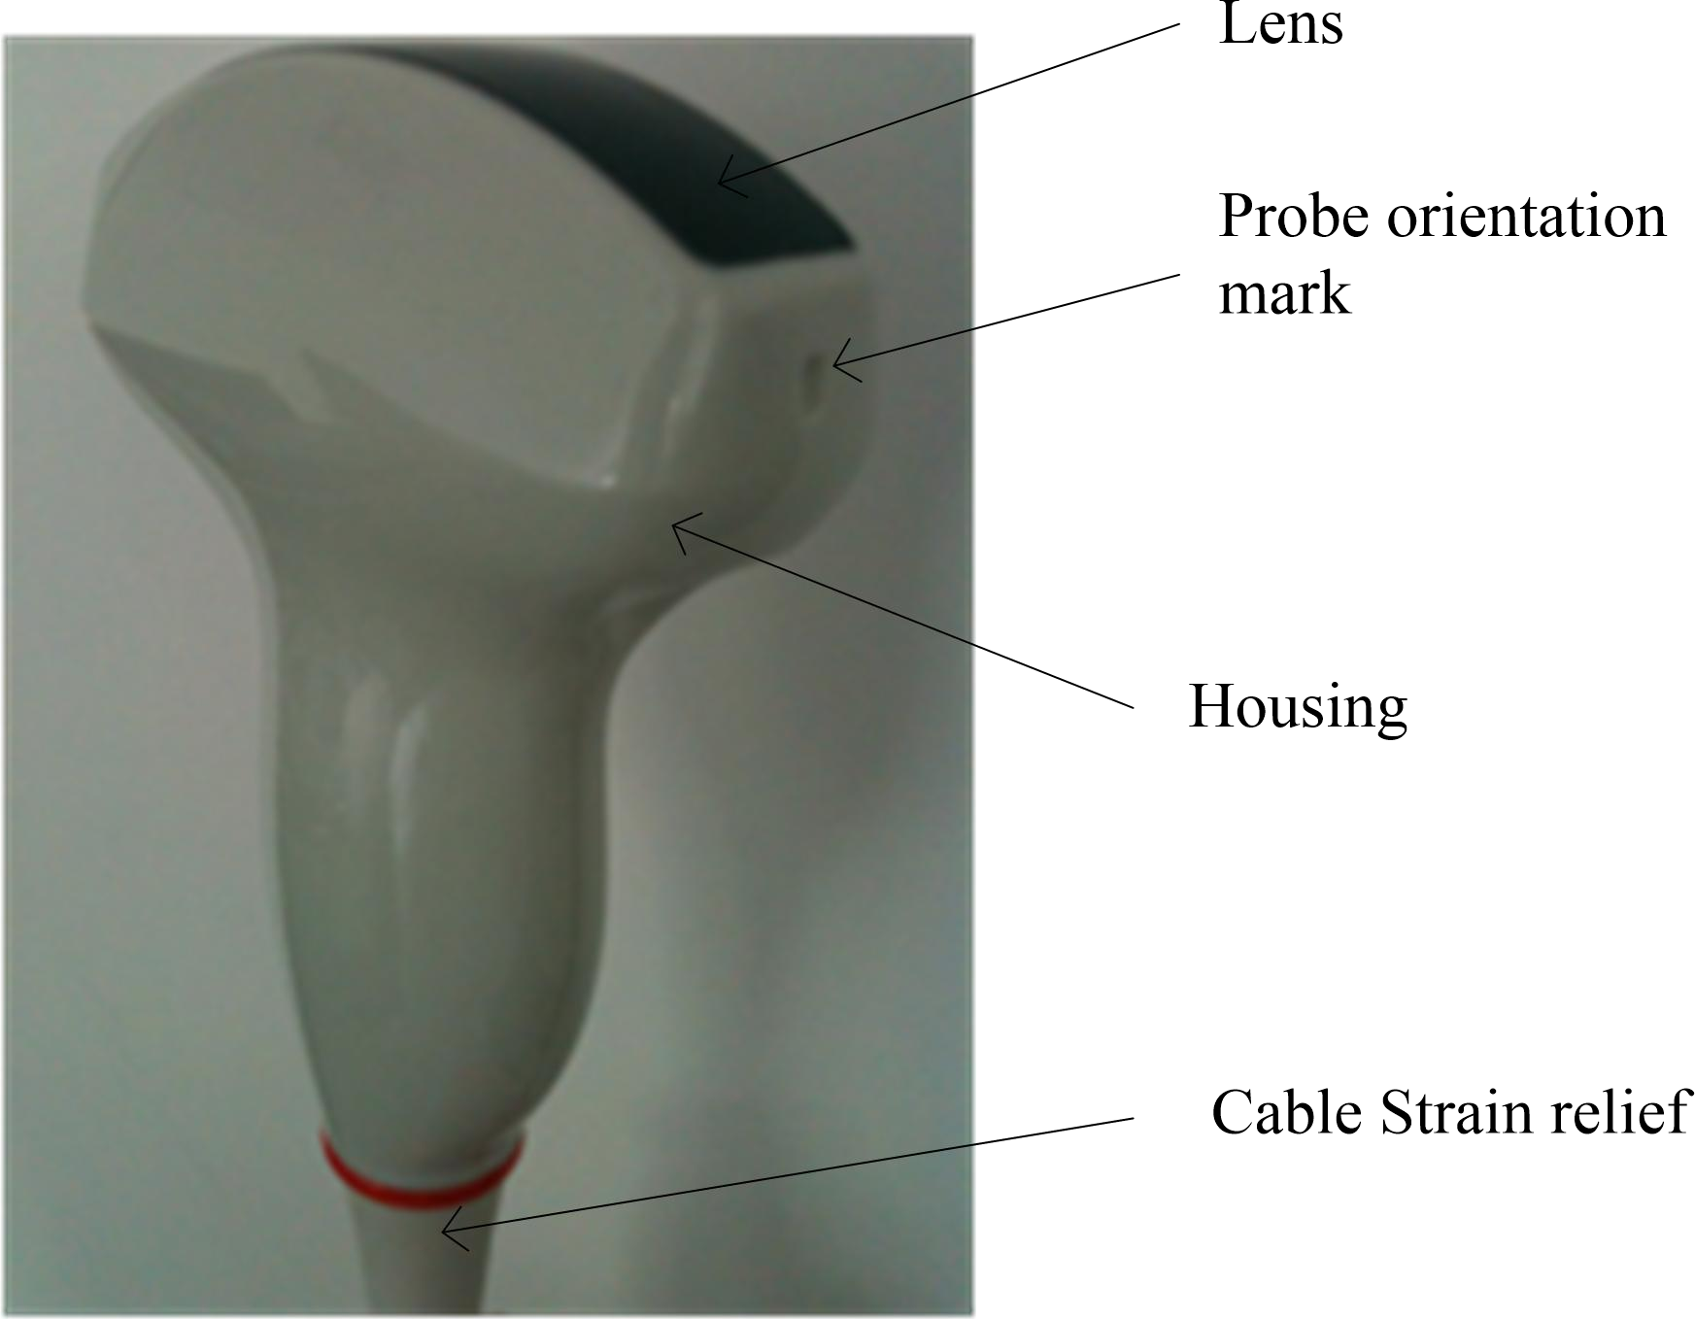

Before each use, inspect the lens, the probe housing and the cable. Check whether there is damaged area that might allow liquid into the probe. When connected to this device, needs to test the functionality of the probe.

Note:

Only qualified ultrasound gel is approved for use.

## 15.2 Special handling instructions

Using protective sheaths:

Protective barrier may be required to minimize disease

transmission.

Use of legally marketed, sterile probe sheath is strongly recommended for intro cavity and intra operative procedures.

Instructions

Each probe sheath kit consists of a flexible and elastic sheath which can cover the probe and cable.

 DO NOT use an expired sheath. Before using probe sheaths, verify whether the term of validity has expired. Also read sheath document careful to avoid allergic reaction in sensitive individuals.

## 15.3 Probe handling and infection control

This information is intended to increase user awareness of the risks of disease transmission associated with using this equipment and provide guidance in making decisions directly affecting the safety of the patient as well as the equipment user.

Diagnostic ultrasound systems utilize ultrasound energy that must be coupled to the patient by direct physical contact. Depending on the type of examination, this contact occurs with a variety of tissues ranging from intact skin in a routine exam to re-circulating blood in a surgical procedure. The level of risk of infection varies greatly with the type of contact.

One of the most effective ways to prevent transmission between patients is with single use or disposable devices. However, ultrasound transducers are complex and expensive devices that must be reused between patients. It is very important, therefore, to minimize the risk of disease

Risk of Infection: ALWAYS clean and disinfect the probe

between patients to the level appropriate for the type of examination and use cleared probe sheaths where appropriate.

Adequate cleaning and disinfection are necessary to prevent

disease transmission. It is the responsibility of the equipment user to verify and maintain the effectiveness of the infection control procedures in use. Always use sterile, legally marketed probe sheaths for intra-cavitary and intra-operative procedures.

## 15.4 Probe Safety

Ultrasound probes are highly sensitive medical devices that can easily be damaged by improper handling. DO NOT use a damaged or defective probe. Failure to follow these precautions can result in serious injury and equipment damage.

## 15.5 Cleaning and disinfecting probes

You MUST disconnect the probe from the ELITECH prior to cleaning/disinfecting the probe. Failure to do so could damage the system.

There is no limit to the number of times the probe can be cleaned and sanitized, and cleaning and sanitizing will not affect the performance of the probe. If a professional doctor finds any performance problems after cleaning and disinfecting the probe, please contact the manufacturer immediately.

**Cleaning Procedure**

1. Before Disinfection Cleaning procedure
2. Disconnect the probe from the unit.
3. Remove the coupling gel by wiping the probe lens with a soft cloth or paper towel.
4. Wipe the probe and cable with a soft cloth or paper towel moisten in Medizyme Enzymatic Detergent (<80 °F/27 °C).
5. Wipe the probe and cable with a soft cloth or paper towel moisten in clean water until all cleaner is removed.
6. Wipe dry with a soft cloth or paper towel.

|  |  |  |
| --- | --- | --- |
| **Cleaning and disinfectants name** | **Intended Use** | **Manufacturer** |
| Medizyme Enzymatic Detergent | Cleaning | Medicom |

To minimize the risk of infection from blood-borne pathogens,

you must handle the probe and all disposables which have contacted blood, other potentially infectious materials, mucous membranes, and non-intact skin in accordance with infection control procedures. You must wear protective gloves when handling potentially infectious material. Use a face shield and gown if there is a risk of splashing or splatter.

### 15.5.2 Disinfecting probes

Disinfecting probes

Although representing a necessary step in protecting patients and employees from disease transmission, liquid chemical germicides must also be selected to minimize potential damage to the transducer. It is important to use germicides of probe recommended by ELITECH company.

Below is the list of germicides for each probe:

|  |  |  |
| --- | --- | --- |
| Cleaning and disinfectants name | Intended Use | Manufacturer |
| Cidex OPA | High-level disinfection | Johnson & Johnson |
| OxivirR Tb | Low-level disinfection | Diversey |

**High Level Disinfection:**

1. Immerse the head of probe completely in Cidex OPA Solution for a minimum of 5 minutes at 20°C (68°F) or higher to destroy all pathogenic microorganisms.
2. Remove the probe from the solution and rinse thoroughly by immersing it for a minimum of 1 minute in duration in a large volume (e.g. 2 gallons) of sterile water. Flush all lumens with large volumes (not less than 100 mL) of rinse water.
3. Repeat the procedure for a total of THREE (3) RINSES, with water discarded after every rinse.

**Low Level Disinfection:**

1. Apply OxivirR Tb undiluted to surfaces by spray, cloth or disposable wipe.
2. All surfaces must remain visibly wet for 1 minute for viruses and bacteria. For fungi, surfaces must remain visibly wet for 10 minutes.
3. Allow to air dry.

**Returning/shipping probes and repair parts**

When return a probe or part for service, needs to clean and disinfect the probe or part prior to packing and shipping this device. Ensure that the follow probe cleaning and disinfection instruction. This ensures that the employees in the transportation industry as well as the people who receive the package are protected from any risk.

### 15.5.3 Inspect probes

Cleaning and sanitizing will not affect the performance of probes. After cleaning and sanitizing, please check probes:

Visually inspect the appearance of the probe to see if it is in good condition.

Connect the probe to the ELITECH and check the image quality, if there is nothing abnomal, indicates that the probe is normal and can be used. If the image quality is not so good, please contact the manufacturer immediately.

## 15.6 Coupling gels

Do not use gels (lubricants) that are not recommended. They may damage the probe and void the warranty.

In order to assure optimal transmission of energy between the patient and probe, a conductive gel or couplant must be applied liberally to the patient where scanning will be performed.

Note:

We do not recommend that the operator use colored ultrasound gel. Long-term use may cause discoloration of the probe housing, although the discoloration does not affect the performance and functionality of the probe.

**PT. SINKO PRIMA ALLOY**

TAMBAK OSOWILANGUN NO.61

PERGUDANGAN OSOWILANGUN PERMAI BLOK E7-E8

SURABAYA - 60191

TLP. 031-7492882,74828816,7482835

[sinkoprima@gmail.com](mailto:sinkoprima@gmail.com?subject=technical%20report)

[teknik.sinkoprima@gmail.com](mailto:mailtoteknik.sinkoprima@gmail.com?subject=technical%20report)

Website: <http://www.elitech.co.id>

Nomor Dokumen : SPA-BM/PROD-205

Tanggal Terbit : 13 Maret 2024

Revisi : 00